01 / PROJECT STUDIO

Define a learning challenge.
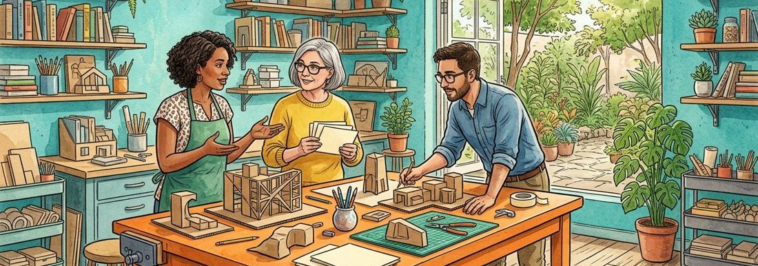
Figure 1. Fictional illustration, not a site record.
This studio course uses a fictional tabletop display project to practise planning, critique and iteration. The result is a learning artifact, not an approved product or installation.
Challenge: communicate three ideas using a small paper model. The audience and setting are invented so learners can focus on how choices connect to an intention.

Challenge / audience assumption / learning goal
Working record: Write the challenge in one sentence and name the skill you want to practise. Keep your first attempt and your revised version so the change remains visible.
QUESTION FOR THE NEXT READER
Write the challenge in one sentence and name the skill you want to practise.
QUESTION | Write the challenge in one sentence and name the skill you want to practise.

02 / PROJECT STUDIO

Agree a learning contract.
Figure 1. Fictional illustration, not a site record.
A learning contract describes how the exercise will be approached and what kind of feedback will help. It does not assign real employment duties or grant formal certification.
A learner might commit to keeping two alternatives, recording one reason for each choice and asking for feedback about clarity rather than taste.

Practice commitment / feedback request / boundary
Working record: Write three commitments that you can actually observe in your own process. Keep your first attempt and your revised version so the change remains visible.
QUESTION FOR THE NEXT READER
Write three commitments that you can actually observe in your own process.
QUESTION | Write three commitments that you can actually observe in your own process.

03 / PROJECT STUDIO

Split the challenge into questions.

Figure 2. Fictional illustration, not a site record.
Break the broad task into questions about message, form and interpretation. Keep tasks distinct from questions so activity does not become a substitute for learning.
Make three cards: What should a viewer notice first? Which arrangement supports that intention? What would show that the message remains unclear?

Message question / form question / evaluation question
Working record: Turn one broad challenge into three answerable design questions. Keep your first attempt and your revised version so the change remains visible.
QUESTION FOR THE NEXT READER
Turn one broad challenge into three answerable design questions.
QUESTION | Turn one broad challenge into three answerable design questions.

04 / PROJECT STUDIO

Map the resources you have.
Figure 2. Fictional illustration, not a site record.
Separate supplied materials, borrowed references and missing information. This exercise provides illustrations and a document structure, not a real workshop inventory.
A fictional resource list might contain paper, a pencil and an example image. A real making session would need its own material suitability and appropriate setting checks.

Available / reference / missing / needs review
Working record: Build a resource map without presenting invented supplies as a real allocation. Keep your first attempt and your revised version so the change remains visible.
QUESTION FOR THE NEXT READER
Build a resource map without presenting invented supplies as a real allocation.
QUESTION | Build a resource map without presenting invented supplies as a real allocation.

05 / PROJECT STUDIO

Make the work visible.
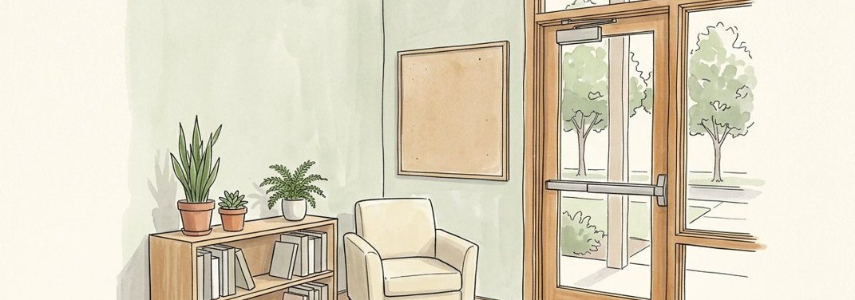
Figure 3. Fictional illustration, not a site record.
Use a small task board to distinguish proposed work, work being tried and work ready for discussion. A status is a local learning record, not an official project approval.
Move draft three labels from proposed to trying only after you begin the draft. Keep an unresolved question attached to work that is ready for feedback.

Proposed / trying / discuss / unresolved
Working record: Place three learning tasks on the board and explain one status choice. Keep your first attempt and your revised version so the change remains visible.
QUESTION FOR THE NEXT READER
Place three learning tasks on the board and explain one status choice.
QUESTION | Place three learning tasks on the board and explain one status choice.

06 / PROJECT STUDIO

Keep a process log.
Figure 3. Fictional illustration, not a site record.
Record a choice while its context is still available. A process log is more informative when it includes a rejected option and the reason for the rejection.
Entry: tried a circular arrangement to suggest equal importance; rejected it because the starting point became hard to find. This is a design judgement, not a measured user result.

Attempt / reason / observed issue / next move
Working record: Write two dated-by-version entries rather than inventing a real project calendar. Keep your first attempt and your revised version so the change remains visible.
QUESTION FOR THE NEXT READER
Write two dated-by-version entries rather than inventing a real project calendar.
QUESTION | Write two dated-by-version entries rather than inventing a real project calendar.

07 / PROJECT STUDIO

Ask for a focused critique.
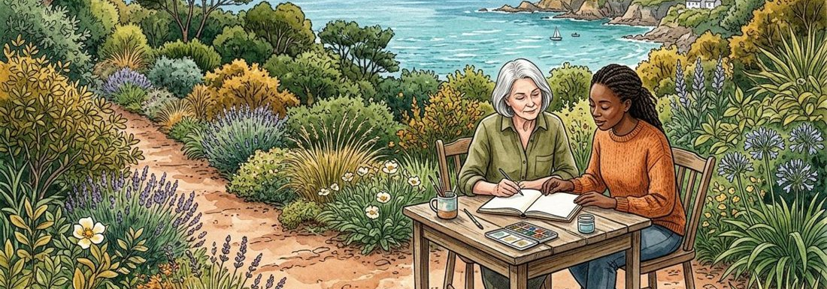
Figure 4. Fictional illustration, not a site record.
Present the intention, one artifact and one question. Focused critique makes it easier to distinguish a preference from a concern about the stated goal.
Instead of Do you like it? ask Which label did you notice first, and what in the arrangement drew your attention? Use invented peer responses for this document exercise.

Intention / artifact / question / feedback note
Working record: Draft a critique request that a peer could answer specifically. Keep your first attempt and your revised version so the change remains visible.
QUESTION FOR THE NEXT READER
Draft a critique request that a peer could answer specifically.
QUESTION | Draft a critique request that a peer could answer specifically.

08 / PROJECT STUDIO

Compare an iteration.
Figure 4. Fictional illustration, not a site record.
Show what changed, why it changed and which question remains open. A later version is not automatically better; it may exchange one strength for another.
Moving the first label upward may clarify the starting point while reducing symmetry. Record that trade-off rather than claiming the revision solved everything.

Version A / version B / reason / trade-off
Working record: Document one change and one unresolved consequence. Keep your first attempt and your revised version so the change remains visible.
QUESTION FOR THE NEXT READER
Document one change and one unresolved consequence.
QUESTION | Document one change and one unresolved consequence.

09 / PROJECT STUDIO

Explain the artifact.
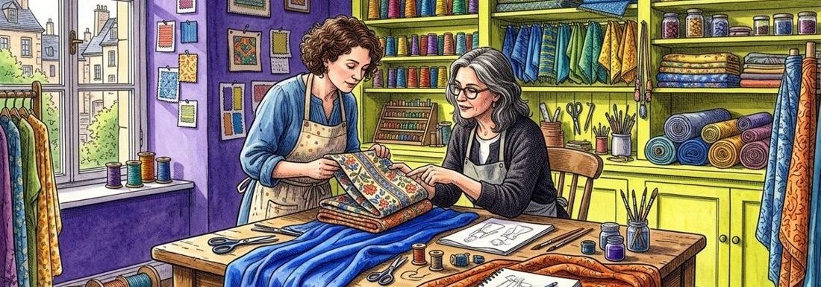
Figure 5. Fictional illustration, not a site record.
A short outcome statement connects the challenge, the selected approach and the limits of the result. Do not claim real audience validation when the course used invented examples.
The statement can describe the intended reading order and point to the layout that supports it. It should also say that no real audience study was supplied.

Challenge / approach / supporting artifact / limit
Working record: Write an outcome statement that another learner can inspect against the artifact. Keep your first attempt and your revised version so the change remains visible.
QUESTION FOR THE NEXT READER
Write an outcome statement that another learner can inspect against the artifact.
QUESTION | Write an outcome statement that another learner can inspect against the artifact.

10 / PROJECT STUDIO

Plan the next learning cycle.
Figure 5. Fictional illustration, not a site record.
Close by choosing a question that arose from the work rather than adding every possible improvement to an endless list. A focused next cycle is easier to evaluate.
If the starting point remains unclear, the next exercise might compare two label arrangements using a consistent observation prompt. That is a proposed learning task, not a scheduled real study.

Lesson / next question / proposed exercise / evidence need
Working record: Choose one next cycle and explain why it follows from this one. Keep your first attempt and your revised version so the change remains visible.
QUESTION FOR THE NEXT READER
Choose one next cycle and explain why it follows from this one.
QUESTION | Choose one next cycle and explain why it follows from this one.

