01 / STORY WORKSHOP

Give the story a working intention.
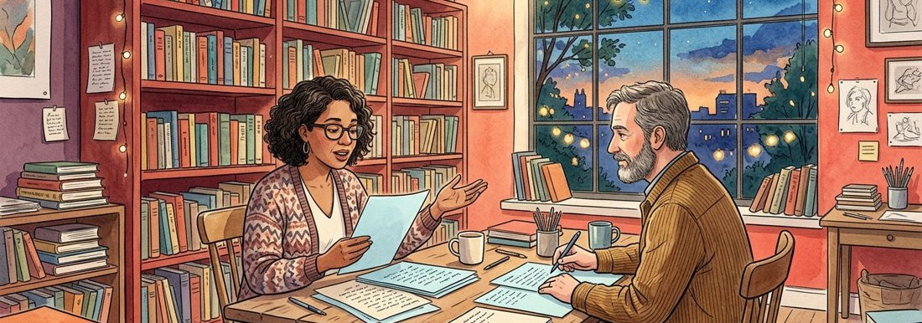
Figure 1. Fictional illustration, not a site record.
This writing workshop develops one short fictional scene through drafts, margin comments and revision. Begin with an effect you want the reader to experience rather than a polished plot.
Working intention: a reader gradually recognises that two friends disagree about a shared memory. This is a creative premise, not an account of real people.

Intended effect / scene boundary / open question
Working record: Write a one-sentence intention and one thing the scene will deliberately leave unresolved. Keep your first attempt and your revised version so the change remains visible.
QUESTION FOR THE NEXT READER
Write a one-sentence intention and one thing the scene will deliberately leave unresolved.
QUESTION | Write a one-sentence intention and one thing the scene will deliberately leave unresolved.

02 / STORY WORKSHOP

Build a character through choices.
Figure 1. Fictional illustration, not a site record.
Describe what a character wants in this scene, what they avoid and what they do when those wants conflict. A list of personality adjectives is not yet a dramatic action.
Mara wants to return a notebook but avoids explaining why she kept it. She places it on the far edge of the table. That action gives the reader something to interpret.

Want / avoidance / visible action
Working record: Create two actions that reveal different sides of the same fictional character. Keep your first attempt and your revised version so the change remains visible.
QUESTION FOR THE NEXT READER
Create two actions that reveal different sides of the same fictional character.
QUESTION | Create two actions that reveal different sides of the same fictional character.

03 / STORY WORKSHOP

Map the scene’s usable space.
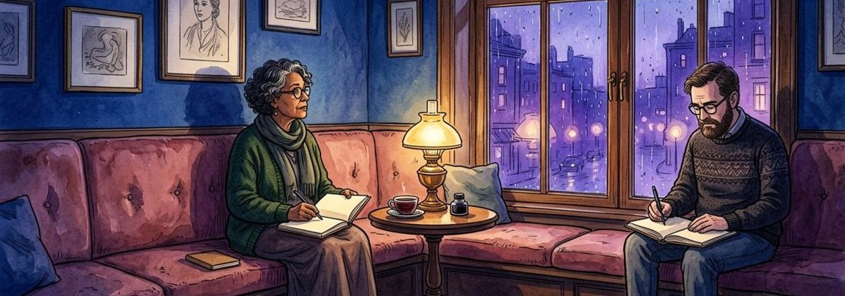
Figure 2. Fictional illustration, not a site record.
Choose a few spatial anchors that matter to the action. The map is an author’s aid, not a measured plan or a claim about an actual room.
A table separates two chairs; a window faces the rain; a door interrupts the conversation. Only mention an object if it affects attention, movement or meaning.

Anchor / relation / narrative use
Working record: List three anchors and the moment when each becomes relevant. Keep your first attempt and your revised version so the change remains visible.
QUESTION FOR THE NEXT READER
List three anchors and the moment when each becomes relevant.
QUESTION | List three anchors and the moment when each becomes relevant.

04 / STORY WORKSHOP

Raise a specific tension.
Figure 2. Fictional illustration, not a site record.
A scene gains tension when a character’s next action becomes harder or more consequential. Escalation need not mean danger; it can be a growing mismatch between what is said and intended.
Mara says she found the notebook yesterday. Her friend notices an older bookmark inside it. The new detail complicates the explanation without requiring the narrator to announce a lie.

Initial situation / complication / choice
Working record: Add one complication that changes what the character can comfortably say next. Keep your first attempt and your revised version so the change remains visible.
QUESTION FOR THE NEXT READER
Add one complication that changes what the character can comfortably say next.
QUESTION | Add one complication that changes what the character can comfortably say next.

05 / STORY WORKSHOP

Draft before polishing.
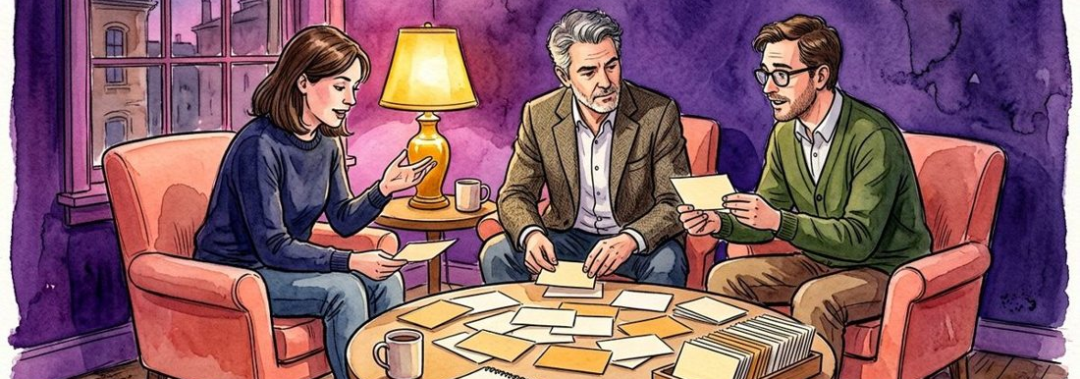
Figure 3. Fictional illustration, not a site record.
Write a short first version with a beginning action, a change and a closing beat. Leave sentence-level refinement until the sequence is readable.
An opening might place the notebook on the table. The change could be a question about the bookmark. The closing beat might be a character choosing not to answer.

Opening action / turning beat / ending image
Working record: Draft a short scene using those three beats in your own words. Keep your first attempt and your revised version so the change remains visible.
QUESTION FOR THE NEXT READER
Draft a short scene using those three beats in your own words.
QUESTION | Draft a short scene using those three beats in your own words.

06 / STORY WORKSHOP

Let dialogue carry a second meaning.
Figure 3. Fictional illustration, not a site record.
For each line, separate the spoken words from what the speaker hopes to achieve. Subtext should emerge through context rather than a secret motive invented after every sentence.
Line: You kept the blue cover. Surface meaning concerns an object; possible intention is to ask whether a shared memory still matters. Both interpretations require support from the surrounding scene.

Spoken line / intended move / contextual clue
Working record: Annotate two lines and remove any explanation already obvious from the dialogue. Keep your first attempt and your revised version so the change remains visible.
QUESTION FOR THE NEXT READER
Annotate two lines and remove any explanation already obvious from the dialogue.
QUESTION | Annotate two lines and remove any explanation already obvious from the dialogue.

07 / STORY WORKSHOP

Choose who can know what.
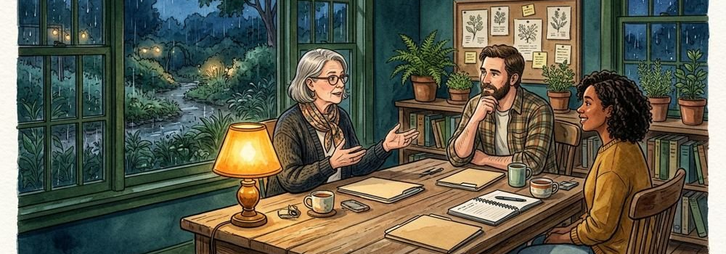
Figure 4. Fictional illustration, not a site record.
Point of view determines which perceptions and thoughts the text can present directly. A change of perspective should be deliberate and easy for a reader to follow.
From Mara’s close perspective, the friend’s silence is observable but the friend’s private intention is not. Replace certainty about that intention with an action or Mara’s own tentative interpretation.

Observer / available knowledge / unavailable thought
Working record: Find one sentence that knows too much and rewrite it from the chosen viewpoint. Keep your first attempt and your revised version so the change remains visible.
QUESTION FOR THE NEXT READER
Find one sentence that knows too much and rewrite it from the chosen viewpoint.
QUESTION | Find one sentence that knows too much and rewrite it from the chosen viewpoint.

08 / STORY WORKSHOP

Make the revision visible.
Figure 4. Fictional illustration, not a site record.
Compare an earlier passage with a revised one and name the change in effect. Do not describe every edit as improvement; choose a specific intention to test.
Before: She was nervous. After: She turned the notebook until its spine faced her. The revision replaces a label with an action but may leave more room for ambiguity.

Before / after / intended effect / trade-off
Working record: Rewrite one labelled emotion as an action and record what the change loses or gains. Keep your first attempt and your revised version so the change remains visible.
QUESTION FOR THE NEXT READER
Rewrite one labelled emotion as an action and record what the change loses or gains.
QUESTION | Rewrite one labelled emotion as an action and record what the change loses or gains.

09 / STORY WORKSHOP

Assemble a small portfolio.
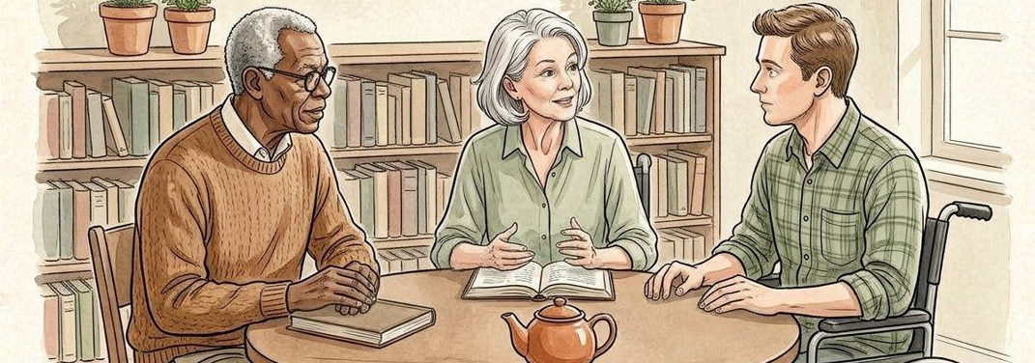
Figure 5. Fictional illustration, not a site record.
Collect the scene intention, first draft, two annotations and revised draft. The portfolio should allow a reader to follow the writing decisions without mistaking fiction for testimony.
Use version labels and a brief change note. Keep any real personal material out of the exercise unless you have independently resolved appropriate permissions.

Artifact / version / purpose / change note
Working record: Select four artifacts that best show how the scene developed. Keep your first attempt and your revised version so the change remains visible.
QUESTION FOR THE NEXT READER
Select four artifacts that best show how the scene developed.
QUESTION | Select four artifacts that best show how the scene developed.

10 / STORY WORKSHOP

Write an author’s reflection.
Figure 5. Fictional illustration, not a site record.
Reflect on a decision rather than judging whether you are a good writer. Explain one choice, its effect and a question you would test in another draft.
You might keep the unanswered question at the end because it sustains uncertainty, while noting that another reader may need one clearer clue earlier in the scene.

Choice / effect / uncertainty / next draft
Working record: Describe one deliberate trade-off and a concrete next revision. Keep your first attempt and your revised version so the change remains visible.
QUESTION FOR THE NEXT READER
Describe one deliberate trade-off and a concrete next revision.
QUESTION | Describe one deliberate trade-off and a concrete next revision.

