01 / VISUAL LITERACY

Read an image in layers.
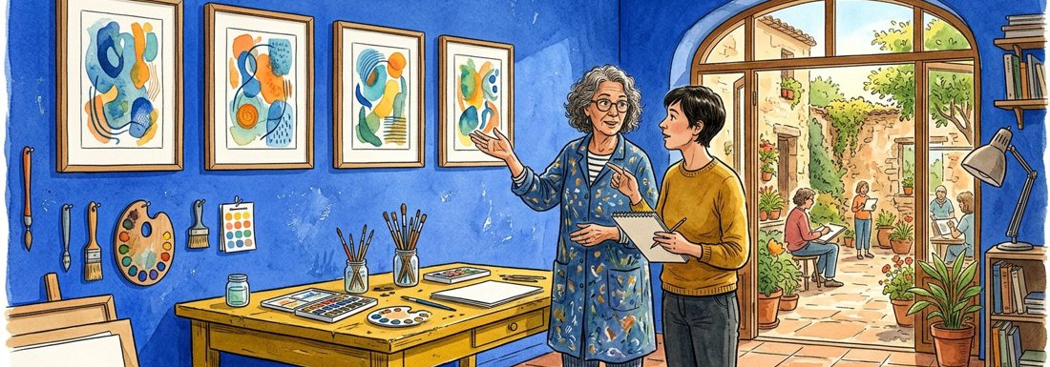
Figure 1. Fictional illustration, not a site record.
This course treats visual reading as a sequence of description, attention and interpretation. The illustrations are authored images, not documentary evidence of real places.
Start with what is present, then ask how it is arranged, then consider possible meanings. Keep those three layers visible in your notes.

Visible elements / arrangement / possible reading
Working record: Describe the classroom image in three sentences, one for each layer. Keep your first attempt and your revised version so the change remains visible.
QUESTION FOR THE NEXT READER
Describe the classroom image in three sentences, one for each layer.
QUESTION | Describe the classroom image in three sentences, one for each layer.

02 / VISUAL LITERACY

Mark the composition.
Figure 1. Fictional illustration, not a site record.
Locate the largest shapes and their relationship to the frame. Describe position and proportion in ordinary language rather than claiming exact measurements from a stylised illustration.
A bright table may sit low in the frame while a dark wall forms the background. The contrast can guide attention without proving which object matters to the people shown.

Foreground / middle ground / background / focal area
Working record: Sketch a simple composition map using no more than five labelled shapes. Keep your first attempt and your revised version so the change remains visible.
QUESTION FOR THE NEXT READER
Sketch a simple composition map using no more than five labelled shapes.
QUESTION | Sketch a simple composition map using no more than five labelled shapes.

03 / VISUAL LITERACY

Build a colour vocabulary.
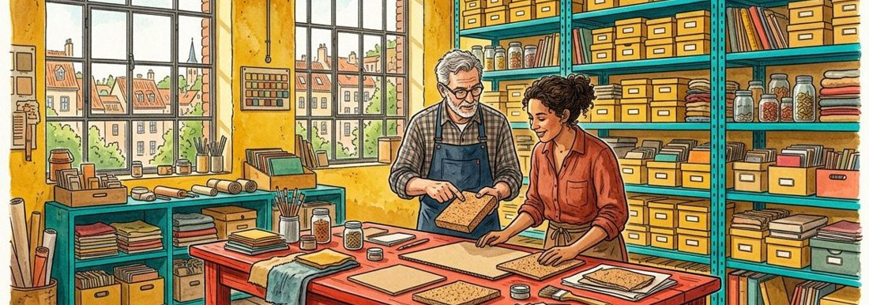
Figure 2. Fictional illustration, not a site record.
Name hue, relative lightness and contrast separately. A colour description is more precise when it explains a relationship instead of assigning a universal mood.
Cobalt blue beside mustard yellow creates a strong visible contrast. Calling that contrast cheerful is an interpretation that another viewer may not share.

Colour pair / contrast / tentative association
Working record: Describe two colour relationships and label any emotional association as your interpretation. Keep your first attempt and your revised version so the change remains visible.
QUESTION FOR THE NEXT READER
Describe two colour relationships and label any emotional association as your interpretation.
QUESTION | Describe two colour relationships and label any emotional association as your interpretation.

04 / VISUAL LITERACY

Trace the order of attention.
Figure 2. Fictional illustration, not a site record.
Record where you looked first, second and third, then ask which visible features might explain that route. Your viewing order is a personal observation, not a population result.
A pale sheet against a dark tabletop may attract attention through contrast. Another reader may notice a face first. Neither route is a measured general rule.

First noticed / next noticed / visible cue
Working record: Write your attention sequence and compare it with a second possible route. Keep your first attempt and your revised version so the change remains visible.
QUESTION FOR THE NEXT READER
Write your attention sequence and compare it with a second possible route.
QUESTION | Write your attention sequence and compare it with a second possible route.

05 / VISUAL LITERACY

Distinguish object from symbol.
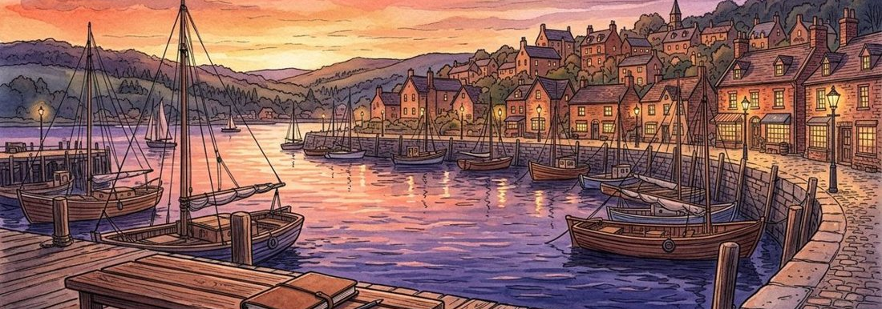
Figure 3. Fictional illustration, not a site record.
An object can support more than one symbolic reading. Connect a proposed meaning to the image and its context rather than treating a symbol as a fixed dictionary entry.
An open notebook might suggest learning, unfinished work or simply a useful tabletop object. The image alone does not decide among those readings.

Object / possible meaning / supporting clue / uncertainty
Working record: Offer two readings of one object without selecting a definitive meaning. Keep your first attempt and your revised version so the change remains visible.
QUESTION FOR THE NEXT READER
Offer two readings of one object without selecting a definitive meaning.
QUESTION | Offer two readings of one object without selecting a definitive meaning.

06 / VISUAL LITERACY

Compare two visual choices.
Figure 3. Fictional illustration, not a site record.
Use the same comparison dimensions for both images. A consistent comparison is easier to inspect than a sequence of personal preferences.
Compare where the brightest area appears, how figures are grouped and which edges are cropped. Avoid turning a compositional difference into a claim about actual behaviour.

Dimension / image A / image B / interpretation
Working record: Complete a three-row comparison using composition, contrast and grouping. Keep your first attempt and your revised version so the change remains visible.
QUESTION FOR THE NEXT READER
Complete a three-row comparison using composition, contrast and grouping.
QUESTION | Complete a three-row comparison using composition, contrast and grouping.

07 / VISUAL LITERACY

Ask where the image came from.
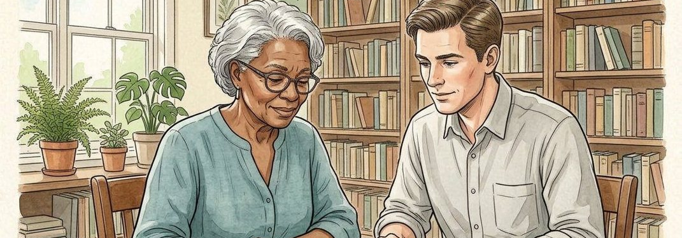
Figure 4. Fictional illustration, not a site record.
Record authorship, production method and what the source actually supplies. These case illustrations are AI-generated editorial images, with individual provenance listed alongside the document.
A source note establishes how an asset was selected; it does not establish that the depicted lesson took place. Keep illustration provenance separate from claims about a real subject.

Asset / production method / source note / evidence limit
Working record: Write a caption that identifies an illustration without presenting it as a photograph of an event. Keep your first attempt and your revised version so the change remains visible.
QUESTION FOR THE NEXT READER
Write a caption that identifies an illustration without presenting it as a photograph of an event.
QUESTION | Write a caption that identifies an illustration without presenting it as a photograph of an event.

08 / VISUAL LITERACY

Name the edge of interpretation.
Figure 4. Fictional illustration, not a site record.
List what cannot be established from the image. Being explicit about the boundary makes a visual analysis more useful, not less imaginative.
Attendance, accessibility, learning outcomes and relationships between the figures are not supplied by the illustration. These would require relevant independent information.

Interpretation / missing context / needed source
Working record: Choose one tempting claim and name the source that would be needed to examine it. Keep your first attempt and your revised version so the change remains visible.
QUESTION FOR THE NEXT READER
Choose one tempting claim and name the source that would be needed to examine it.
QUESTION | Choose one tempting claim and name the source that would be needed to examine it.

09 / VISUAL LITERACY

Compose a short visual analysis.

Figure 5. Fictional illustration, not a site record.
Bring description, arrangement and interpretation into a compact paragraph. Mark the transition between an observable feature and your proposed reading.
A useful sentence might begin The bright table contrasts with the darker wall, followed by I read this as a focus on shared work. The wording keeps the interpretation attributable to the reader.

Description / arrangement / interpretation / boundary
Working record: Write a short analysis with one clearly marked interpretive sentence. Keep your first attempt and your revised version so the change remains visible.
QUESTION FOR THE NEXT READER
Write a short analysis with one clearly marked interpretive sentence.
QUESTION | Write a short analysis with one clearly marked interpretive sentence.

10 / VISUAL LITERACY

Keep a visual reading archive.
Figure 5. Fictional illustration, not a site record.
Save the source note, composition map, comparison and final analysis together. The archive records your reading process rather than certifying a correct interpretation.
Use an earlier and later caption to show how your language became more precise. Record one question that the images could not answer.

Artifact / revision / lesson / next question
Working record: Choose one sentence whose evidence boundary became clearer and explain the revision. Keep your first attempt and your revised version so the change remains visible.
QUESTION FOR THE NEXT READER
Choose one sentence whose evidence boundary became clearer and explain the revision.
QUESTION | Choose one sentence whose evidence boundary became clearer and explain the revision.

