01 / SCENARIO PRACTICE

Practise judgement under an information gap.
SOURCE | DISCUSSION ROUTE | A / seek clarification
SOURCE | REHEARSAL BOUNDARY | 3 conceptual choices; no predicted outcome or score.
CHOICE | Task | Recognise the missing source and its significance.
CHOICE | Practice focus | Explain a choice without pretending certainty.
CHOICE | Boundary | No real incident, assessment score or approved procedure.

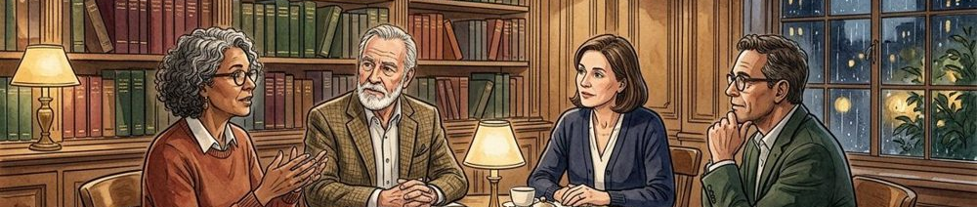
Figure 1. Fictional illustration, not a site record.
A colleague wants to share a short explanation whose key claim has no identifiable source. Your task is to make the uncertainty visible before deciding what to do next.
The exercise offers three discussion routes: seek clarification, proceed on an assumption or pause the handoff. None predicts an actual outcome. The aim is to explain a choice and examine its consequences.

Rehearsal objective
Participants may pass on a role or pause the exercise. No real colleague, confidential draft or operational incident is involved.
QUESTION FOR THE NEXT READER
What information would change your first response?

02 / SCENARIO PRACTICE

Read the scenario as written.
SOURCE | DISCUSSION ROUTE | B / proceed on an assumption
SOURCE | REHEARSAL BOUNDARY | 3 conceptual choices; no predicted outcome or score.
CHOICE | Known | A draft contains a benefit claim without a source.
CHOICE | Unknown | Meaning, supporting evidence and sharing authority.
CHOICE | Decision point | Choose how to handle the gap before the handoff.

Figure 1. Fictional illustration, not a site record.
The draft says the new note format reduces review effort. A colleague asks you to pass it to another team. The original source and the intended meaning of effort are absent.
You do not know whether the claim is true, who could verify it or whether sharing has been authorised. Keep those unknowns intact rather than giving the scenario an invented backstory.

Starting conditions
The exercise begins before any handoff. Its uncertainty is deliberate; it is not evidence that a real team failed to follow a process.
QUESTION FOR THE NEXT READER
Which missing fact matters to the immediate decision?

03 / SCENARIO PRACTICE

Separate the roles in the conversation.
SOURCE | DISCUSSION ROUTE | C / pause and name the condition
SOURCE | REHEARSAL BOUNDARY | 3 conceptual choices; no predicted outcome or score.
CHOICE | Requester | Explain the intended purpose without inventing evidence.
CHOICE | Reviewer | Identify the unresolved source and meaning questions.
CHOICE | Observer | Record visible choices and untested assumptions.

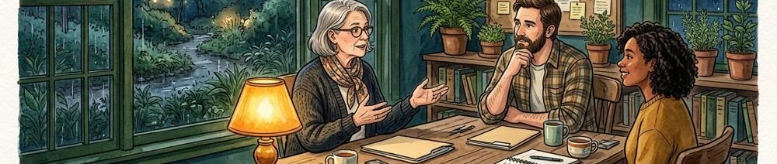
Figure 2. Fictional illustration, not a site record.
The requester wants the draft to move. The reviewer wants the claim to be interpretable. The observer records the questions and assumptions that become visible.
Rotate roles only by agreement. An observer should describe the exercise, not evaluate a participant’s character. Avoid bringing in personal or confidential workplace examples that others have not agreed to discuss.

Role cards
Requester: explain the intended handoff. Reviewer: name what is missing. Observer: distinguish stated facts from assumptions introduced during the conversation.
QUESTION FOR THE NEXT READER
What does each role need to understand before continuing?

04 / SCENARIO PRACTICE

Keep the starting facts in view.
SOURCE | DISCUSSION ROUTE | A / seek clarification
SOURCE | REHEARSAL BOUNDARY | 3 conceptual choices; no predicted outcome or score.
CHOICE | Supplied fact | The review-effort claim lacks a traceable source.
CHOICE | Unavailable answer | No timeframe or verification route is supplied.
CHOICE | Variation rule | Mark any added condition as hypothetical.

Figure 2. Fictional illustration, not a site record.
The only supplied facts are the wording of the claim, the request to share and the absence of source and definition information. There is no actual deadline or manager instruction.
A participant may ask a question whose answer is unavailable. Mark it as unresolved. The facilitator should not reward a confident guess by turning it into a new fact halfway through the exercise.

Information discipline
Use a separate note for any hypothetical variation. Say explicitly when a variation changes the scenario rather than silently rewriting the starting conditions.
QUESTION FOR THE NEXT READER
Which statement in the discussion is an assumption, not a supplied fact?

05 / SCENARIO PRACTICE

Choose a route and explain why.
SOURCE | DISCUSSION ROUTE | B / proceed on an assumption
SOURCE | REHEARSAL BOUNDARY | 3 conceptual choices; no predicted outcome or score.
CHOICE | Route A | Ask for meaning and source before the handoff.
CHOICE | Route B | Proceed while the source remains an assumption.
CHOICE | Route C | Pause and name the condition needed to continue.

A / Clarify / page 6
B / Trace the assumption / page 7
C / Pause and review / page 8

Figure 3. Fictional illustration, not a site record.
Route A asks the requester to clarify the claim. Route B passes the draft forward while assuming it is acceptable. Route C pauses the handoff and identifies the unresolved condition.
Use the route links to inspect a possible consequence or discussion prompt. You can return here and compare the other routes. The branches are not a scored test or a prediction of what a real colleague will do.

Branch decision / return here to compare
A goes to consequence discussion on page 6; B to assumption observation on page 7; C to pause-and-review debrief on page 8.
QUESTION FOR THE NEXT READER
What makes your choice reasonable given the information actually supplied?

06 / SCENARIO PRACTICE

Route A: examine clarification.
SOURCE | DISCUSSION ROUTE | C / pause and name the condition
SOURCE | REHEARSAL BOUNDARY | 3 conceptual choices; no predicted outcome or score.
CHOICE | Question asked | Define review effort and identify the source.
CHOICE | Possible limit | The requester may not have the needed information.
CHOICE | Record | Keep the unanswered condition visible.

Return to the decision / page 5
Figure 3. Fictional illustration, not a site record.
Asking for the source can reveal whether the claim has a reviewable basis. It may also show that the requester cannot answer yet. The exercise supplies no actual reply.
Rehearse a concise question: what does review effort mean here, and what material supports that statement? Then discuss what to record if the answer remains unavailable.

Consequence discussion
Clarification can make uncertainty more inspectable; it does not guarantee agreement, a correct claim or a successful handoff. Return to page 5 to compare another route.
QUESTION FOR THE NEXT READER
How would you preserve the gap if the question receives no answer?

07 / SCENARIO PRACTICE

Route B: observe the assumption.
SOURCE | DISCUSSION ROUTE | A / seek clarification
SOURCE | REHEARSAL BOUNDARY | 3 conceptual choices; no predicted outcome or score.
CHOICE | Visible choice | The draft moves without source clarification.
CHOICE | Assumption | Acceptability is inferred, not established.
CHOICE | Repair question | What qualification should accompany the handoff?

Return to the decision / page 5
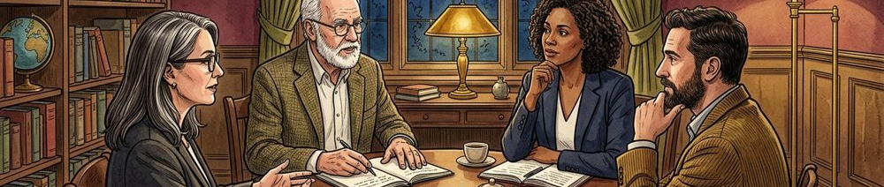
Figure 4. Fictional illustration, not a site record.
Passing the draft on can make the claim appear settled even when its source remains unknown. That is a possible interpretation, not an observed consequence in this fictional exercise.
Ask the observer to identify exactly when an assumption becomes part of the handoff. Discuss how a receiving person could distinguish reviewed meaning from an unconfirmed statement.

Observation record
Record the wording and the missing qualification, not a judgement about the participant. Return to page 5 to inspect the other choices.
QUESTION FOR THE NEXT READER
What might the next reader reasonably believe has been checked?

08 / SCENARIO PRACTICE

Route C: debrief a pause.
SOURCE | DISCUSSION ROUTE | B / proceed on an assumption
SOURCE | REHEARSAL BOUNDARY | 3 conceptual choices; no predicted outcome or score.
CHOICE | Reason | The claim’s meaning and source are unresolved.
CHOICE | Reconsideration condition | An appropriate source and definition become available.
CHOICE | Limit | This is a rehearsal, not an actual operational instruction.

Return to the decision / page 5
Figure 4. Fictional illustration, not a site record.
Pausing can preserve a review boundary, but a pause without a reason may leave another person unable to act. Explain both the unresolved condition and the information that would permit reconsideration.
Rehearse a bounded message: the claim needs a defined outcome and a traceable source before this review can continue. No actual release rule or escalation authority is established by this exercise.

Pause-and-review discussion
Discuss whether the pause is proportionate to the hypothetical task. Return to page 5 to compare how clarification or an unqualified handoff changes the conversation.
QUESTION FOR THE NEXT READER
What would make the pause informative rather than merely obstructive?

09 / SCENARIO PRACTICE

Replay one changed condition.
SOURCE | DISCUSSION ROUTE | C / pause and name the condition
SOURCE | REHEARSAL BOUNDARY | 3 conceptual choices; no predicted outcome or score.
CHOICE | Variation | One explicitly hypothetical condition, agreed before replay.
CHOICE | Observation | How the stated reason changes with the new information.
CHOICE | Comparison | Inspect reasoning, not confidence or speed.

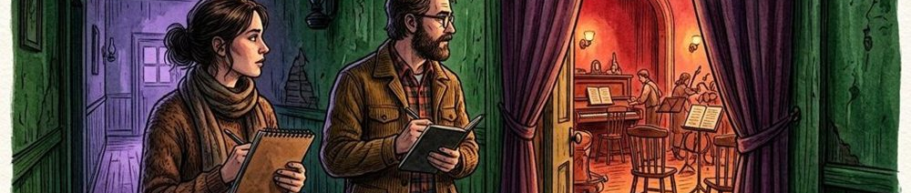
Figure 5. Fictional illustration, not a site record.
Choose one variation: the requester provides a source, the claim is rephrased as an intention or the destination is limited to a private review. Change only one condition at a time.
State how the variation differs from the original scenario. Rehearse the conversation again, then compare the information used in each choice. A more fluent second attempt is not automatically a better decision.

Replay plan
Keep observations about questions, qualifications and handoffs. Do not convert the exercise into an undisclosed performance assessment.
QUESTION FOR THE NEXT READER
Which changed fact genuinely changes the reason for your choice?

10 / SCENARIO PRACTICE

Transfer the question, not the fictional outcome.
SOURCE | DISCUSSION ROUTE | A / seek clarification
SOURCE | REHEARSAL BOUNDARY | 3 conceptual choices; no predicted outcome or score.
CHOICE | Learning question | How can an unresolved condition travel with a draft?
CHOICE | Practice opportunity | A suitable invented handoff or agreed sample.
CHOICE | Transfer boundary | Actual responsibilities and procedures must be checked.

Figure 5. Fictional illustration, not a site record.
A useful transfer question is: what remains unverified, and how will the next person know? Apply it only within the real task, authority and review process that actually exist.
The three routes do not establish a universal response. Record a learning question and an appropriate next practice opportunity. Keep the fictional scenario separate from any confidential or actual incident account.

Transfer record
If a real situation raises specialist or organisational concerns, use the relevant agreed support route rather than treating this workbook as operational authority.
QUESTION FOR THE NEXT READER
Where could this question help without replacing the actual procedure?

