01 / SKILLS PORTFOLIO

Choose a capability that can be examined.
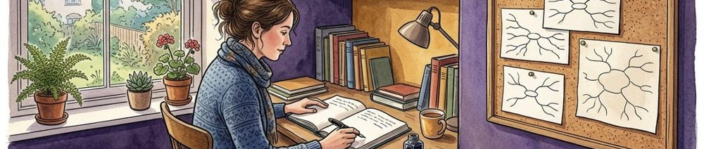
EVIDENCE CELL | PORTFOLIO MODEL | Task | Artifact | Assessment boundary
A01 / clarity / not assessed | 3 attempts × 4 dimensions = 12 unassessed cells, not zero scores. | Explain the passage-question connection. | A short explanation with source context. | No learner rating or competence decision supplied.

Figure 1. Fictional illustration, not a site record.
The practice focus is explaining why a passage belongs in a draft. A useful goal names an inspectable task rather than promising to become confident or excellent.
This portfolio uses three proposed attempts and four review dimensions. All evidence cells are not assessed. It provides a way to organise learning artifacts, not a score or an assessment of a real learner.

Learning goal
Proposed goal: connect a passage to a working question while preserving its source and a relevant limitation. Define any actual programme requirements separately.
QUESTION FOR THE NEXT READER
What artifact would make progress discussable without reducing it to a label?

02 / SKILLS PORTFOLIO

Break the task into review dimensions.
EVIDENCE CELL | PORTFOLIO MODEL | Clarity and context | Qualification | Revision rationale
A01 / source-context / not assessed | 3 attempts × 4 dimensions = 12 unassessed cells, not zero scores. | Explain the connection and retain the source. | Show a condition that affects interpretation. | Explain why a change was made.

Figure 1. Fictional illustration, not a site record.
Clarity asks whether the intended connection is understandable. Source context asks whether the material can be traced. Qualification asks whether limits are visible. Revision rationale asks why a change was made.
These four dimensions guide conversation about an artifact. They are not validated criteria or weighted scores. A real assessment would need an appropriate design, responsibilities and evidence beyond this template.

Four dimensions, no automatic grade
Use the same dimensions across proposed attempts so changes can be discussed. Do not infer improvement from a completed row or a longer explanation.
QUESTION FOR THE NEXT READER
Which dimension needs the most explicit evidence in this task?

03 / SKILLS PORTFOLIO

Plan three attempts with a purpose.
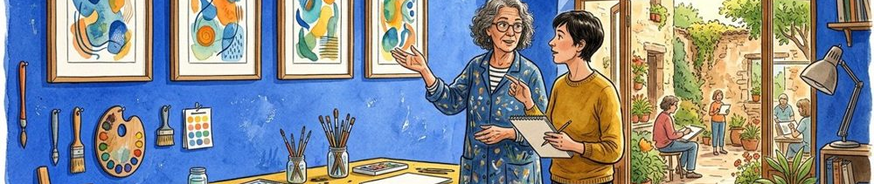
EVIDENCE CELL | PORTFOLIO MODEL | Attempt one | Attempt two | Attempt three
A01 / qualification / not assessed | 3 attempts × 4 dimensions = 12 unassessed cells, not zero scores. | An initial explanation of one invented passage. | A revision with a stated reason. | A suitable transfer example with visible limits.

Figure 2. Fictional illustration, not a site record.
Attempt one makes an initial explanation visible. Attempt two revises after suitable feedback. Attempt three applies the idea to another invented passage or context.
The attempts are proposed, not completed work. Agree a feasible scope and appropriate reviewer before using real materials. A repeated task does not guarantee learning, and a changed task may require different support.

Practice sequence
Keep the source, working question and artifact version with each attempt. Those details make later comparison more meaningful than a sequence of dates alone.
QUESTION FOR THE NEXT READER
What should remain comparable, and what should change?

04 / SKILLS PORTFOLIO

Observe an example without copying its authority.
EVIDENCE CELL | PORTFOLIO MODEL | Connection | Limit | Learning use
A01 / revision-rationale / not assessed | 3 attempts × 4 dimensions = 12 unassessed cells, not zero scores. | The passage is linked to a working question. | Relevance and source context remain to be checked. | Annotate the reasoning before trying your own wording.

Figure 2. Fictional illustration, not a site record.
Example explanation: I saved this passage to explore how a note carries its original question. It may help this draft, but the source context still needs checking.
The example shows a connection and a qualification. It does not prove that the passage is relevant or that its interpretation is correct. Ask what makes the explanation inspectable before borrowing its sentence pattern.

Example annotation
Mark where the working question appears, where source context is named and where uncertainty remains. The annotation is a reading aid, not evidence of the learner’s own capability.
QUESTION FOR THE NEXT READER
Which part of the example should be questioned rather than imitated?

05 / SKILLS PORTFOLIO

Keep the first attempt as evidence of a starting point.

EVIDENCE CELL | PORTFOLIO MODEL | Artifact status | Review focus | Record boundary
A02 / clarity / not assessed | 3 attempts × 4 dimensions = 12 unassessed cells, not zero scores. | No learner artifact supplied in this example. | Inspect the passage-question connection. | A saved file is not an assessed capability.

Figure 3. Fictional illustration, not a site record.
Write a short explanation for an invented passage and attach the working question. Keep the original wording so a later revision can be understood.
This portfolio supplies no actual learner attempt. If adapting it, agree what may be retained and shared. Do not populate evidence cells with ratings merely because a file has been uploaded or a page completed.

Attempt A01 / proposed
Ask a suitable reviewer to identify what can be understood from the artifact and what remains unclear. The first attempt need not be polished to support a useful conversation.
QUESTION FOR THE NEXT READER
What does the actual artifact show, and what can it not show?

06 / SKILLS PORTFOLIO

Make feedback attributable and specific.
EVIDENCE CELL | PORTFOLIO MODEL | Version | Visible feature | Question
A02 / source-context / not assessed | 3 attempts × 4 dimensions = 12 unassessed cells, not zero scores. | Identify the exact artifact being discussed. | Name what the explanation makes understandable. | Which part of the passage supports the connection?

Figure 3. Fictional illustration, not a site record.
A useful feedback note identifies the artifact version, describes a visible feature and asks a question that can inform revision. It should be possible to distinguish the reviewer’s words from the learner’s interpretation.
No actual reviewer, feedback event or consent arrangement exists in this template. Avoid retaining unnecessary personal information, and agree the permitted use of any real feedback record.

Feedback record
Example question: which part of the passage supports this connection? It prompts inspection without declaring the explanation good or bad.
QUESTION FOR THE NEXT READER
Can the learner identify a concrete revision from this feedback?

07 / SKILLS PORTFOLIO

Show the revision and its reason.

EVIDENCE CELL | PORTFOLIO MODEL | Revision | Rationale | Review boundary
A02 / qualification / not assessed | 3 attempts × 4 dimensions = 12 unassessed cells, not zero scores. | No actual revised artifact supplied. | Explain how the change addresses the task. | Newer does not automatically mean better.

Figure 4. Fictional illustration, not a site record.
A second attempt should make the changed wording and the reason for the change visible. The learner may disagree with feedback while still explaining the decision.
Do not label the revision improved simply because it is newer. Inspect the same dimensions and note any new uncertainty introduced. The source matrix keeps A02 not assessed until appropriate real evidence exists.

Attempt A02 / proposed
Retain the first version beside the revision. A useful rationale explains how the change addresses a task condition rather than merely making the language sound more confident.
QUESTION FOR THE NEXT READER
What changed in the reasoning, not only the phrasing?

08 / SKILLS PORTFOLIO

Organise evidence so a reviewer can inspect it.
EVIDENCE CELL | PORTFOLIO MODEL | Matrix | Cell status | Sharing boundary
A02 / revision-rationale / not assessed | 3 attempts × 4 dimensions = 12 unassessed cells, not zero scores. | 3 proposed attempts × 4 review dimensions. | All 12 are not assessed, not failing scores. | No actual learner records or permissions supplied.

Figure 4. Fictional illustration, not a site record.
For each proposed attempt, retain the artifact, its question, source context, any agreed feedback and the learner’s revision rationale. Keep missing material explicitly absent.
The illustrative matrix has twelve cells: three attempts across four dimensions, all not assessed. It contains no scores, grades or evidence of a real person’s growth. Do not convert not assessed into zero ability.

Portfolio evidence index
A well-organised folder helps review; it does not itself prove capability. Check the permitted retention and sharing arrangements before collecting actual learner material.
QUESTION FOR THE NEXT READER
Can another suitable reviewer find the evidence without assuming what it proves?

09 / SKILLS PORTFOLIO

Reflect with evidence and uncertainty.
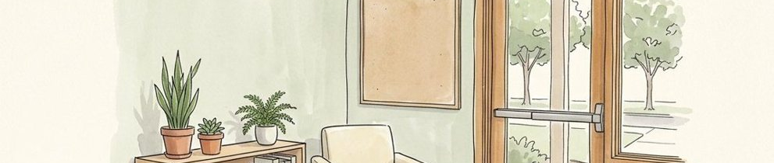
EVIDENCE CELL | PORTFOLIO MODEL | Notice | Question | Distinguish
A03 / clarity / not assessed | 3 attempts × 4 dimensions = 12 unassessed cells, not zero scores. | Identify a specific feature of the explanation. | Name what still needs source or context review. | Self-reflection is not an authorised competence judgement.

Figure 5. Fictional illustration, not a site record.
Ask what the artifact helped you understand, what changed after review and what remains difficult to explain. Refer to the wording rather than relying only on a general feeling of confidence.
Self-reflection is valuable but is not the same as an independent assessment. Keep the learner’s account, the artifact and a reviewer’s interpretation distinct. This example includes none of those actual records.

Evidence-aware reflection
A useful statement can acknowledge an unresolved condition. Avoid turning the portfolio into a required success story or treating uncertainty as a personal deficit.
QUESTION FOR THE NEXT READER
Which reflection can be connected to an inspectable part of the artifact?

10 / SKILLS PORTFOLIO

Choose the next learning cycle.
EVIDENCE CELL | PORTFOLIO MODEL | Next task | Support | Outcome boundary
A03 / source-context / not assessed | 3 attempts × 4 dimensions = 12 unassessed cells, not zero scores. | Apply the explanation method to a suitable new sample. | Agree an appropriate reviewer and permitted record. | No certificate, grade or validated growth supplied.

Figure 5. Fictional illustration, not a site record.
For a third attempt, select another invented passage and explain what transfers from the earlier task and what requires fresh judgement. Carry the source and qualification checks forward.
The portfolio does not award a completion badge or claim lasting capability. Agree the next task, suitable support and how its evidence may be reviewed under any actual programme requirements.

Attempt A03 / next cycle
A sensible next step may be more practice, different support or a narrower task. No fixed progression threshold or certification is established by this template.
QUESTION FOR THE NEXT READER
What new artifact would answer the most important remaining question?

