01 / CAMPAIGN PLAYBOOK

State the campaign’s purpose plainly.

Figure 1. Fictional illustration, not a site record.
Open Table Studio is a fictional creative-workshop concept. The campaign purpose is to help an interested person understand the proposed experience before deciding whether to ask a question.
No actual event, registration service or public programme is established. Plan the communication around informed choice rather than urgency, scarcity or an unsupported promise of personal transformation.

Purpose and audience action
The proposed primary action is to read the workshop outline. A real campaign must verify the outline, destination and operational information before publishing.
QUESTION FOR THE NEXT READER
What must a reader understand before taking the next step?
01 | TOUCHPOINT REGISTER | 1 / poster / discover
02 | JOURNEY BOUNDARY | 6 planned touchpoints; sequence is not measured behaviour.
03 | Purpose | Explain a proposed shared creative-workshop experience.
04 | Reader action | Review the outline before considering an enquiry.
05 | Operational boundary | No actual event, booking or availability supplied.

02 / CAMPAIGN PLAYBOOK

Treat the journey as a hypothesis.
Figure 1. Fictional illustration, not a site record.
A person may discover the idea, inspect the outline and ask a practical question. Another may begin with a recommendation or leave without taking any next step.
The six-touchpoint plan is a conceptual sequence, not a funnel observed in analytics. Do not assume every person follows the same path or that one contact caused a later decision.

A map, not measured behaviour
Use the journey to identify information needs. Revisit it after appropriate observation rather than presenting the planning sequence as a conversion model.
QUESTION FOR THE NEXT READER
Where might a real reader enter, skip or leave this sequence?
01 | TOUCHPOINT REGISTER | 2 / social-post / discover
02 | JOURNEY BOUNDARY | 6 planned touchpoints; sequence is not measured behaviour.
03 | Discover | Encounter a concise description of the idea.
04 | Consider | Inspect the proposed experience and relevant limits.
05 | Ask | Seek information that the outline does not resolve.

03 / CAMPAIGN PLAYBOOK

Give each touchpoint one job.
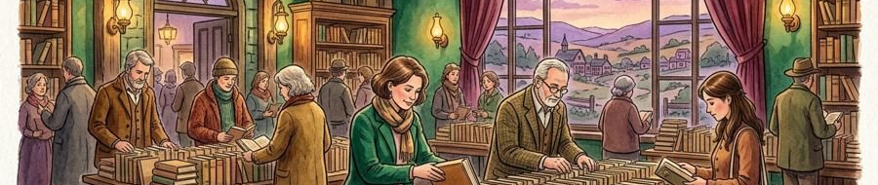
Figure 2. Fictional illustration, not a site record.
A poster introduces the idea. A social post points to the outline. The outline explains the concept. An email, enquiry reply and follow-up answer progressively more specific questions.
All six touchpoints remain planned. Their order numbers express the model only; no dates, delivery, audience exposure or actual contacts are recorded.

Touchpoints with an information role
Avoid repeating the same promotional sentence at every stage. Keep the core meaning stable while adding the detail appropriate to the reader’s question.
QUESTION FOR THE NEXT READER
What question does this touchpoint answer that the previous one did not?
01 | TOUCHPOINT REGISTER | 3 / concept-outline / consider
02 | JOURNEY BOUNDARY | 6 planned touchpoints; sequence is not measured behaviour.
03 | Awareness assets | Poster and social post introduce the concept.
04 | Explanation assets | Outline and email clarify the proposed experience.
05 | Conversation assets | Enquiry reply and follow-up address open questions.

04 / CAMPAIGN PLAYBOOK

Let the message develop honestly.
Figure 2. Fictional illustration, not a site record.
First say what the concept is. Then explain what a participant might do. Finally clarify the conditions that would matter before any real commitment.
The message should gain specificity without gaining unsupported certainty. A journey map cannot justify changing proposed to available or may to will merely because a reader moves to a later touchpoint.

Information progression
Keep the concept status visible throughout the sequence. No later-stage copy should imply a real booking, confirmed timetable or promised outcome.
QUESTION FOR THE NEXT READER
Does the next message add useful detail rather than pressure?
01 | TOUCHPOINT REGISTER | 4 / email / consider
02 | JOURNEY BOUNDARY | 6 planned touchpoints; sequence is not measured behaviour.
03 | Opening message | Explore a proposed shared creative-workshop format.
04 | Explanation | Read the outline and the questions still unresolved.
05 | Later conversation | Check actual arrangements before any commitment.

05 / CAMPAIGN PLAYBOOK

Build assets around the reader’s task.

Figure 3. Fictional illustration, not a site record.
The campaign needs a concise introduction, an accessible concept outline and a practical response guide. Each asset should support a distinct information need.
The illustrations in this template are fictional scenes, not photographs of a real programme or participants. Confirm actual image permissions, source rights and accessible alternatives when adapting the assets.

An asset is more than a format
Keep a source and qualification with any claim repeated across assets. A visually polished poster does not make an unsupported statement safer to distribute.
QUESTION FOR THE NEXT READER
Which asset is necessary for a useful next step?
01 | TOUCHPOINT REGISTER | 5 / enquiry-reply / ask
02 | JOURNEY BOUNDARY | 6 planned touchpoints; sequence is not measured behaviour.
03 | Introduction | A short concept description with an honest action.
04 | Outline | Proposed experience, limits and unresolved arrangements.
05 | Response guide | Specific questions and verified operational answers.

06 / CAMPAIGN PLAYBOOK

Coordinate channels without inventing a schedule.
Figure 3. Fictional illustration, not a site record.
Use one source of truth for the concept description and operational status. Channel adaptations should link back to the same current explanation.
No publication times or assigned people are supplied. A real coordination plan needs responsibilities, review gates, destination checks and a correction method before distribution begins.

Relative sequence, not release dates
The touchpoint register contains six distinct roles, all planned. Neither the order numbers nor channel names establish actual delivery or permission to contact anyone.
QUESTION FOR THE NEXT READER
Who would be responsible for keeping each adaptation accurate?
01 | TOUCHPOINT REGISTER | 6 / follow-up / ask
02 | JOURNEY BOUNDARY | 6 planned touchpoints; sequence is not measured behaviour.
03 | Shared reference | One current outline with visible version status.
04 | Channel owner | Not assigned; confirm responsibility before release.
05 | Correction route | Update the source and every affected adaptation.

07 / CAMPAIGN PLAYBOOK

Write replies that respect the question.
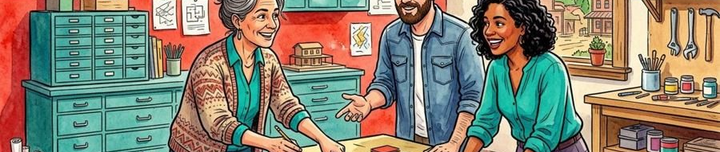
Figure 4. Fictional illustration, not a site record.
If asked whether the workshop is available, say that this is a concept example and no actual booking information is supplied. Do not substitute enthusiasm for an answer.
If asked about accessibility, price or requirements, identify the missing information and the appropriate person or source that would need to confirm it. Do not promise a reply time without a real service arrangement.

A bounded response script
Thank the reader for the specific question, state what is known and distinguish what remains unconfirmed. Collect no personal information without an appropriate purpose and permission.
QUESTION FOR THE NEXT READER
Does the reply answer the question without inventing an arrangement?
01 | TOUCHPOINT REGISTER | 1 / poster / discover
02 | JOURNEY BOUNDARY | 6 planned touchpoints; sequence is not measured behaviour.
03 | Availability reply | No actual event or booking is established here.
04 | Practical enquiry | Price, access and requirements need real confirmation.
05 | Response boundary | No contact service or reply-time promise supplied.

08 / CAMPAIGN PLAYBOOK

Define a measure before collecting it.
Figure 4. Fictional illustration, not a site record.
A real campaign review might examine delivered messages, visits to the outline or practical questions received. Each has a different denominator and interpretation.
The six planned touchpoints are not six interactions. No reach, clicks, enquiries or conversions are supplied. Establish a legitimate collection purpose, relevant definitions and appropriate privacy safeguards before measuring.

Do not turn the map into a funnel report
A later enquiry does not by itself establish which touchpoint caused it. Keep attribution assumptions separate from observed counts.
QUESTION FOR THE NEXT READER
Which observation would tell us whether the explanation was useful?
01 | TOUCHPOINT REGISTER | 2 / social-post / discover
02 | JOURNEY BOUNDARY | 6 planned touchpoints; sequence is not measured behaviour.
03 | Planning count | 6 touchpoints, all planned, none delivered.
04 | Missing outcome | No observed audience or response data supplied.
05 | Attribution boundary | Sequence does not establish causation or conversion.

09 / CAMPAIGN PLAYBOOK

Check the points where trust can break.

Figure 5. Fictional illustration, not a site record.
A misleading availability claim, inaccessible explanation or unverified image can undermine the campaign before any response is measured. Review the whole path, not only the first asset.
Scarcity language and social proof need an actual basis. The template supplies no limited places, endorsements, partner approvals or participant results. Do not add them as decorative persuasion.

Release checks with stop conditions
Pause if an essential destination does not work, if the operational status is unclear or if the relevant permission is missing. A checklist is not a certification.
QUESTION FOR THE NEXT READER
Which unresolved issue should stop this campaign from being shared?
01 | TOUCHPOINT REGISTER | 3 / concept-outline / consider
02 | JOURNEY BOUNDARY | 6 planned touchpoints; sequence is not measured behaviour.
03 | Truth check | Concept status remains visible at every touchpoint.
04 | Access check | The actual explanation and action are accessible.
05 | Rights check | Distribution and participant permissions are verified.

10 / CAMPAIGN PLAYBOOK

Close the loop with a useful question.
Figure 5. Fictional illustration, not a site record.
After an actual campaign, ask which explanation helped people make an informed decision and which practical question kept returning. Keep the review tied to the original purpose.
This example contains no delivered activity or results. Its final page is a review method, not a success report. Preserve source versions and distinguish observations from the team’s interpretation.

A learning loop, not a victory slide
Choose a revision that improves the next explanation. Do not claim that the campaign worked simply because the planned assets were produced.
QUESTION FOR THE NEXT READER
What should change before the next real communication?
01 | TOUCHPOINT REGISTER | 4 / email / consider
02 | JOURNEY BOUNDARY | 6 planned touchpoints; sequence is not measured behaviour.
03 | Observe | Record actual delivery and appropriately collected questions.
04 | Interpret | Separate information gaps from assumptions about demand.
05 | Revise | Improve the source outline and affected touchpoints.

