01 / FOUNDER NARRATIVE

Start with a small frustration.
Figure 1. Fictional illustration, not a site record.
ILLUSTRATIVE SPOKEN DRAFT
We started with a small frustration: a useful note can lose its meaning when the context around it disappears. Margin is our fictional concept for keeping a reading note beside the question that gave it purpose. We are here to explain that direction and the evidence we would need before asking anyone to believe a larger story.

Speaker / evidence note — not a performance claim
Open with a concrete tension, not an invented customer testimonial. Margin and the founder voice are fictional. No real origin story, launch or customer experience is established by this script.
Keep the fictional status visible. Replace illustrative material only with appropriately sourced, verified information; proposed questions are not completed diligence.
QUESTION FOR THE NEXT READER
How do you know this is a problem worth solving?

Opening image | A reading note detached from its original question.
Founder premise | Margin links notes to the questions that prompted them.
Source boundary | No real founder history or customer account supplied.

02 / FOUNDER NARRATIVE

Make the problem recognisable.
Figure 1. Fictional illustration, not a site record.
ILLUSTRATIVE SPOKEN DRAFT
Imagine returning to a note that says useful passage but not why it mattered. The problem we want to explore is not a shortage of tools; it is the gap between saving a reference and recovering its intended use. That situation is our design premise, not measured demand.

Speaker / evidence note — not a performance claim
Pause after the example. A real pitch would need appropriate evidence about the intended reader and context. Do not describe the imagined situation as a study finding or a universal behaviour.
Keep the fictional status visible. Replace illustrative material only with appropriately sourced, verified information; proposed questions are not completed diligence.
QUESTION FOR THE NEXT READER
Which real source would distinguish a recurring need from an appealing anecdote?
Problem scene | A reader revisits a useful note without its context.
Intended reader | Readers returning to their own working material.
Evidence still needed | Observe actual retrieval tasks before claiming a recurring need.

03 / FOUNDER NARRATIVE

Explain the founder’s reason to care.
Figure 2. Fictional illustration, not a site record.
ILLUSTRATIVE SPOKEN DRAFT
Our interest is in the moment when a reader moves from collecting material to making a careful point. We want the document to show both the reference and the question attached to it. That is the commitment behind this concept, rather than a claim that our background guarantees a successful business.

Speaker / evidence note — not a performance claim
Use an authentic biography only after replacing the fictional voice with verified context. No credentials, employment history, specialist expertise or founder-market fit is supplied here.
Keep the fictional status visible. Replace illustrative material only with appropriately sourced, verified information; proposed questions are not completed diligence.
QUESTION FOR THE NEXT READER
What experience genuinely prepares the team to investigate this problem?
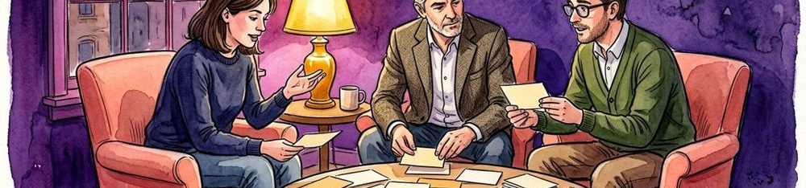
Personal motivation | Interest in preserving context while reading and drafting.
Relevant experience to verify | Relevant work and experience must be checked before use.
Unproven inference | Personal concern does not establish a market.

04 / FOUNDER NARRATIVE

Introduce the change in approach.
Figure 2. Fictional illustration, not a site record.
ILLUSTRATIVE SPOKEN DRAFT
The proposed shift is simple: keep the note, its source and its intended use together. Instead of presenting another place to collect everything, we would explore a smaller structure that helps a reader explain why one item belongs in the next conversation.

Speaker / evidence note — not a performance claim
This is a product intention, not a demonstration of implemented software. Keep the difference between a proposed workflow and a working capability explicit when adapting the script.
Keep the fictional status visible. Replace illustrative material only with appropriately sourced, verified information; proposed questions are not completed diligence.
QUESTION FOR THE NEXT READER
What would a first working demonstration need to show?
Proposed change | Keep a note and its purpose visible together.
Workflow hypothesis | Context may make later review more useful.
Capability not verified | No implemented product or working capability verified.

05 / FOUNDER NARRATIVE

Walk through one use situation.
Figure 3. Fictional illustration, not a site record.
ILLUSTRATIVE SPOKEN DRAFT
A reader selects a passage, writes the question it raises and records what would need checking before the passage supports a claim. The useful result would be a more inspectable note, not an automatic conclusion. This short walkthrough illustrates the intended experience; it is not a tested user journey.

Speaker / evidence note — not a performance claim
Point to a clearly labelled concept artifact if one exists. The illustrations are editorial references, not product screenshots, user research or evidence that a real person completed the workflow.
Keep the fictional status visible. Replace illustrative material only with appropriately sourced, verified information; proposed questions are not completed diligence.
QUESTION FOR THE NEXT READER
Which part of the walkthrough is most uncertain in a real setting?
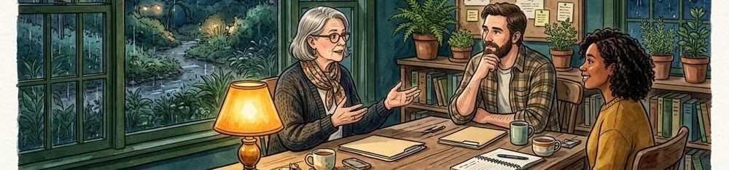
Use situation | Revisit a note while drafting a short explanation.
Concept artifact | A proposed note-and-question card, not a working product.
Validation question | Can a reader explain why the note was saved?

06 / FOUNDER NARRATIVE

Say what progress would mean.
Figure 3. Fictional illustration, not a site record.
ILLUSTRATIVE SPOKEN DRAFT
At this stage, progress would mean learning whether the proposed structure addresses a specific reader task. We would want to see the question become clearer, the reference remain traceable and the limits stay visible. We are not reporting customers, retention or revenue in this fictional narrative.

Speaker / evidence note — not a performance claim
Do not substitute a polished illustration for traction. If real progress is later added, retain its unit, period, denominator and supporting source beside the claim.
Keep the fictional status visible. Replace illustrative material only with appropriately sourced, verified information; proposed questions are not completed diligence.
QUESTION FOR THE NEXT READER
What evidence would change the direction rather than merely decorate the story?
Learning signal | A reader can recover the intended purpose of a note.
Source to collect | A consented observation with the original task context.
Claim not yet supported | Usage, adoption and customer value remain unproven.

07 / FOUNDER NARRATIVE

Keep the business hypothesis separate.
Figure 4. Fictional illustration, not a site record.
ILLUSTRATIVE SPOKEN DRAFT
The business question is whether a defined group would value this support enough to adopt it under sustainable conditions. We have not established a price, willingness to pay or a repeatable acquisition route. Those are hypotheses to investigate, not facts hidden inside a compelling founder story.

Speaker / evidence note — not a performance claim
A real business model needs verified context and relevant unit definitions. This document supplies no market size, revenue forecast, customer commitment or investment return.
Keep the fictional status visible. Replace illustrative material only with appropriately sourced, verified information; proposed questions are not completed diligence.
QUESTION FOR THE NEXT READER
Who might pay, for what, and what source would support that answer?
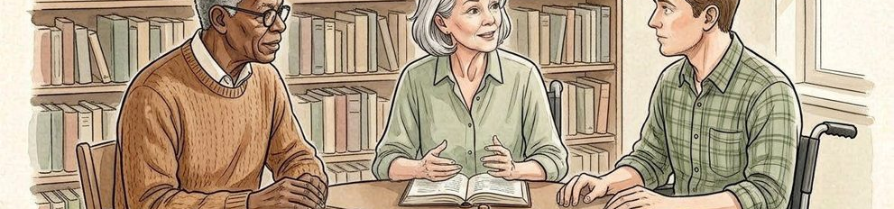
Value hypothesis | Contextual notes might reduce repeated interpretation work.
Adoption hypothesis | Readers may choose to maintain note-question connections.
Commercial evidence gap | No buyer, price or payment evidence supplied.

08 / FOUNDER NARRATIVE

Show the roles the work requires.
Figure 4. Fictional illustration, not a site record.
ILLUSTRATIVE SPOKEN DRAFT
The work would need product judgement, contextual inquiry and careful handling of source boundaries. We can describe those responsibilities without pretending that a complete team has been appointed. The next conversation should ask which capabilities are actually present and which need support.

Speaker / evidence note — not a performance claim
Replace role categories with named people only when their involvement and biographies are confirmed. This template contains no appointments, endorsements or staffing commitments.
Keep the fictional status visible. Replace illustrative material only with appropriately sourced, verified information; proposed questions are not completed diligence.
QUESTION FOR THE NEXT READER
Which missing capability would most affect the next step?
Product responsibility | Define the note-and-context interaction.
Inquiry responsibility | Plan appropriate inquiry and preserve source limitations.
Role to confirm | Names, availability and relevant experience require verification.

09 / FOUNDER NARRATIVE

Connect resources to learning gates.
Figure 5. Fictional illustration, not a site record.
ILLUSTRATIVE SPOKEN DRAFT
Our illustrative planning model allocates 100 teaching units: 45 to discovery, 35 to a prototype question and 20 to review. These are not currency, a real budget or an amount we are raising. The point is to connect each proposed resource category with a question that must be answered before a larger commitment.

Speaker / evidence note — not a performance claim
The model JSON/CSV preserves the 45+35+20=100 arithmetic. A real financing ask needs an actual entity, verified plan, terms and appropriate advice outside this fictional script.
Keep the fictional status visible. Replace illustrative material only with appropriately sourced, verified information; proposed questions are not completed diligence.
QUESTION FOR THE NEXT READER
What decision should each resource category make possible?

Learning gate | Review whether a prototype answers the context question.
Proposed resource use | 45 discovery / 35 prototype-question / 20 review teaching units.
Actual ask not supplied | 100 teaching units are not currency or an investment ask.

10 / FOUNDER NARRATIVE

Close with an honest invitation.
Figure 5. Fictional illustration, not a site record.
ILLUSTRATIVE SPOKEN DRAFT
If the problem and the proposed learning route seem worth investigating, the next step is a focused conversation about evidence, responsibilities and the right conditions for further work. We would rather leave you with one clear question than imply a level of progress we have not established.

Speaker / evidence note — not a performance claim
End on the specific response sought. This is not an offer of securities, a promise of funding or a request to act on invented terms. Preserve the fictional-source note in shared copies.
Keep the fictional status visible. Replace illustrative material only with appropriately sourced, verified information; proposed questions are not completed diligence.
QUESTION FOR THE NEXT READER
What would you need to see before continuing this conversation?
Conversation requested | Discuss what evidence should come before a larger claim.
Open condition | No commitment or financing agreement is established.
Next proof artifact | A small, inspectable concept and its unresolved questions.

