01 / ROUNDTABLE BRIEF

What are you building?
01 | Short answer | Common Page is a fictional shared-context document concept.
02 | Evidence boundary | No operating product or customer activity established.
03 | Follow-up question | Which task needs its context kept visible?

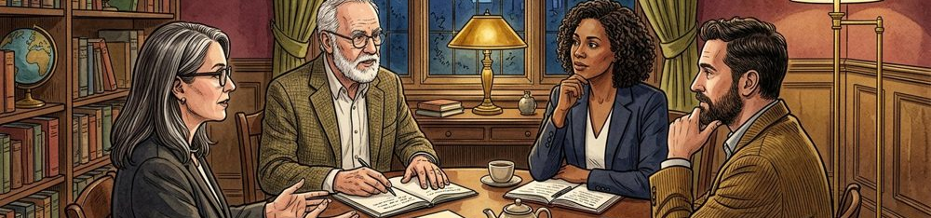
Figure 1. Fictional illustration, not a site record.
ILLUSTRATIVE SPOKEN DRAFT
We are exploring Common Page, a fictional concept for keeping a discussion question beside the material it refers to. The aim is a more inspectable conversation. This is a concept explanation, not a claim that a deployed product or a real company has been established.

Speaker / evidence note — not a performance claim
Follow-up: what would a first useful artifact demonstrate? Keep a short answer available before adding detail. The module index is a navigation aid, not a timed agenda or a record of an actual investor meeting.
Keep the fictional status visible. Replace illustrative material only with appropriately sourced, verified information; proposed questions are not completed diligence.
QUESTION FOR THE NEXT READER
What is the smallest claim that accurately describes the current concept?

02 / ROUNDTABLE BRIEF

Why does this problem matter?
01 | Problem premise | Shared material can become difficult to interpret later.
02 | Relevant context | Understand the original task and the later reader's need.
03 | Source to seek | Seek appropriate observations, not an invented testimonial.

Figure 1. Fictional illustration, not a site record.
ILLUSTRATIVE SPOKEN DRAFT
A reference can be hard to interpret when its intended use is missing. That is our working premise. We would need appropriate evidence about a defined context before calling it a recurring need, a market opportunity or a reason that a real customer should pay.

Speaker / evidence note — not a performance claim
Follow-up: whose task are we discussing? Do not replace evidence with a founder’s confidence or a fictional anecdote presented as a testimonial.
Keep the fictional status visible. Replace illustrative material only with appropriately sourced, verified information; proposed questions are not completed diligence.
QUESTION FOR THE NEXT READER
Which source would make the problem statement more than a plausible story?

03 / ROUNDTABLE BRIEF

What would the product actually do?
01 | Proposed workflow | Keep material beside its purpose and review questions.
02 | Unverified capability | Implementation and reliability have not been demonstrated.
03 | Demonstration needed | An inspectable interaction with explicit limitations.

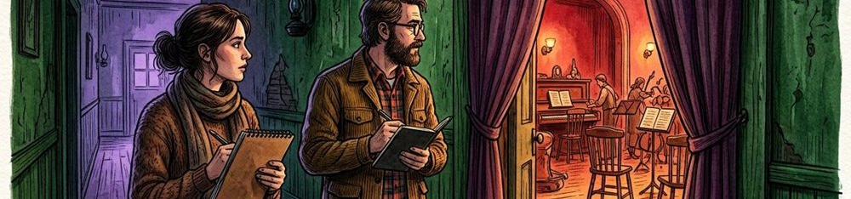
Figure 2. Fictional illustration, not a site record.
ILLUSTRATIVE SPOKEN DRAFT
The proposed experience connects a passage, a question and a source note. That is an intended workflow. We have not supplied a working implementation, a validated user journey or a capability benchmark, so we should not imply that the illustration demonstrates those things.

Speaker / evidence note — not a performance claim
Follow-up: which interaction is most uncertain? Use a clearly labelled concept artifact when available; do not describe an editorial image as a product screenshot.
Keep the fictional status visible. Replace illustrative material only with appropriately sourced, verified information; proposed questions are not completed diligence.
QUESTION FOR THE NEXT READER
Which capability could you responsibly demonstrate today?

04 / ROUNDTABLE BRIEF

What do you know about the market?
01 | Audience question | Which people and organisations face this task?
02 | Existing alternative | Manual notes or existing document practices may be enough.
03 | Market evidence gap | No market size, demand or competitive research supplied.

Figure 2. Fictional illustration, not a site record.
ILLUSTRATIVE SPOKEN DRAFT
We have not supplied a market study or a verified market-size estimate. The useful starting question is which organisation has this task, what alternatives it already uses and under what conditions a different approach would matter. We should earn a market claim through relevant sources.

Speaker / evidence note — not a performance claim
Follow-up: what is the credible manual alternative? No competitor performance, customer segment size or growth rate is established by the module register.
Keep the fictional status visible. Replace illustrative material only with appropriately sourced, verified information; proposed questions are not completed diligence.
QUESTION FOR THE NEXT READER
What would establish a specific market boundary?

05 / ROUNDTABLE BRIEF

How could the model earn revenue?
01 | Offering hypothesis | A defined offering could be explored as a hypothesis.
02 | Buyer question | Who would choose it, and under which conditions?
03 | Payment evidence needed | No price, contracts, invoices or revenue supplied.

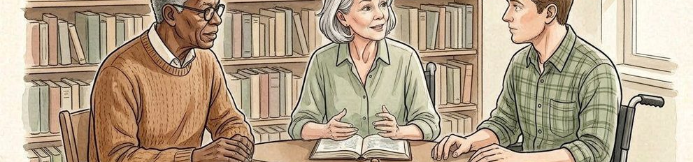
Figure 3. Fictional illustration, not a site record.
ILLUSTRATIVE SPOKEN DRAFT
The commercial hypothesis is that a defined service could be valuable under sustainable payment conditions. We have not established the offering, price, buyer or acquisition route. Activity, interest and revenue are different categories, and none should be substituted for another.

Speaker / evidence note — not a performance claim
Follow-up: what exactly would someone pay for? This script includes no transaction, signed contract, revenue forecast or statement of actual willingness to pay.
Keep the fictional status visible. Replace illustrative material only with appropriately sourced, verified information; proposed questions are not completed diligence.
QUESTION FOR THE NEXT READER
Which evidence would be most useful before discussing a revenue model?

06 / ROUNDTABLE BRIEF

Who is responsible for the work?
01 | Confirmed role information | No named appointments or verified team experience supplied.
02 | Capability gap | Product, technical and inquiry responsibilities need definition.
03 | Appointment to verify | Check availability, authority and relevant experience before sharing.

Figure 3. Fictional illustration, not a site record.
ILLUSTRATIVE SPOKEN DRAFT
The work would need product judgement, implementation and contextual review. Those are role categories, not appointments. A real team discussion should identify confirmed experience, involvement and gaps without borrowing credibility from invented biographies or unverified endorsements.

Speaker / evidence note — not a performance claim
Follow-up: which capability is missing? Replace role labels with people only when their involvement and relevant background are confirmed.
Keep the fictional status visible. Replace illustrative material only with appropriately sourced, verified information; proposed questions are not completed diligence.
QUESTION FOR THE NEXT READER
Which missing responsibility could block the next useful step?

07 / ROUNDTABLE BRIEF

What are you asking investors to support?
01 | Discussion request | Discuss support for resolving the next evidence gap.
02 | Learning purpose | Define and inspect a bounded learning activity.
03 | Terms not supplied | No investment amount, valuation or agreed terms supplied.


Figure 4. Fictional illustration, not a site record.
ILLUSTRATIVE SPOKEN DRAFT
In this fictional conversation, the request is to examine the learning plan and the evidence it would need. No real funding amount, valuation, security, runway or agreed terms are supplied. A genuine financing request would need its own verified context and appropriate review.

Speaker / evidence note — not a performance claim
Follow-up: what decision should the next artifact enable? Keep an invitation to discuss separate from a securities offer or an implication that funding is committed.
Keep the fictional status visible. Replace illustrative material only with appropriately sourced, verified information; proposed questions are not completed diligence.
QUESTION FOR THE NEXT READER
What would turn a broad resource request into an inspectable plan?

08 / ROUNDTABLE BRIEF

What could make this fail?
01 | Key assumption | People may not need the proposed shared-context interaction.
02 | Disconfirming evidence | A credible alternative may solve the task more simply.
03 | Revise condition | Revise or stop if appropriate inquiry rejects the premise.

Figure 4. Fictional illustration, not a site record.
ILLUSTRATIVE SPOKEN DRAFT
The problem may not matter enough, a simpler alternative may be better, or maintenance could outweigh the benefit. Those possibilities should be visible before a financing conversation becomes a persuasive story. We would want evidence that can change our view, not only confirm it.

Speaker / evidence note — not a performance claim
Follow-up: which result would make us stop or revise? The list is a discussion aid, not a complete risk assessment or a guarantee that other risks are absent.
Keep the fictional status visible. Replace illustrative material only with appropriately sourced, verified information; proposed questions are not completed diligence.
QUESTION FOR THE NEXT READER
Which assumption would you test first if you wanted to challenge the concept?

09 / ROUNDTABLE BRIEF

What difficult question remains unanswered?
01 | Unanswered question | Whether the concept addresses a sufficiently useful task.
02 | Why it matters | Without that evidence, build and business claims are premature.
03 | Next source | An appropriately scoped task observation or concept review.


Figure 5. Fictional illustration, not a site record.
ILLUSTRATIVE SPOKEN DRAFT
The hardest question is whether the proposed structure improves a real task enough to justify adoption and maintenance. We cannot answer that from this template. A useful response is to name the gap, explain why it matters and identify the next appropriate source.

Speaker / evidence note — not a performance claim
Follow-up: what would we bring back to a second conversation? An unanswered question should stay open rather than being disguised as a confident forecast.
Keep the fictional status visible. Replace illustrative material only with appropriately sourced, verified information; proposed questions are not completed diligence.
QUESTION FOR THE NEXT READER
Which answer should be deferred until evidence exists?

10 / ROUNDTABLE BRIEF

What happens after this conversation?
01 | Question to carry forward | Which uncertainty deserves the next bounded inquiry?
02 | Responsibility to confirm | Agree who can obtain and review the appropriate evidence.
03 | Sharing boundary | No real meeting, commitment or permission to share implied.

Figure 5. Fictional illustration, not a site record.
ILLUSTRATIVE SPOKEN DRAFT
We would record the questions raised, confirm who is responsible for any next discussion and identify a suitable artifact to review. That is not a promise of a second meeting, a funding commitment or a completed diligence process. The useful outcome is a clearer evidence request.

Speaker / evidence note — not a performance claim
Follow-up: what may be shared and with whom? Real confidentiality, rights and investment arrangements need their own authorised processes outside this fictional brief.
Keep the fictional status visible. Replace illustrative material only with appropriately sourced, verified information; proposed questions are not completed diligence.
QUESTION FOR THE NEXT READER
What exact response would make a next conversation worthwhile?

