01 / TECHNICAL THESIS

Make the technical thesis inspectable.
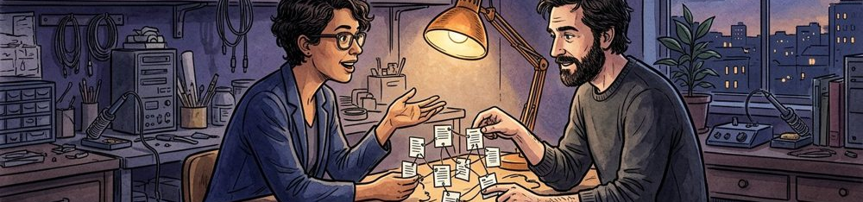
Technical thesis | Intended review task | Capability boundary
Trace Index proposes linking references to source context. | Help a human inspect an unresolved source relationship. | A concept, not demonstrated code or validated performance.

Figure 1. Fictional illustration, not a site record.
ILLUSTRATIVE SPOKEN DRAFT
Trace Index is our fictional concept for making the relationship between a document passage and its source easier to inspect. The thesis is that a small, explicit reference structure could support better review. We are presenting a design intention, not claiming a deployed or independently tested system.

Speaker / evidence note — not a performance claim
Use the scope statement before any architecture discussion. No production software, performance benchmark, customer integration or proprietary technical advantage is supplied.
Keep the fictional status visible. Replace illustrative material only with appropriately sourced, verified information; proposed questions are not completed diligence.
QUESTION FOR THE NEXT READER
What would count as evidence that this design helps a real review task?

02 / TECHNICAL THESIS

Describe the technical problem narrowly.
Problem boundary | Reviewer task | Unsupported promise
A reviewer may lose the context of a reference. | Inspect the reference, intended passage and unresolved context. | No claim of automated truth detection or full accuracy.

Figure 1. Fictional illustration, not a site record.
ILLUSTRATIVE SPOKEN DRAFT
A passage can travel farther than its source context. The problem we want to explore is how a reviewer locates that context and sees what it can support. We are not proposing that software can decide whether every statement is true.

Speaker / evidence note — not a performance claim
Avoid turning a broad information-quality concern into a claim of verified demand. The fictional problem statement needs real contextual evidence before it can describe an actual market or workflow.
Keep the fictional status visible. Replace illustrative material only with appropriately sourced, verified information; proposed questions are not completed diligence.
QUESTION FOR THE NEXT READER
Which part of the problem should remain a human judgement?

03 / TECHNICAL THESIS

Compare a credible alternative.

Manual baseline | Proposed difference | Comparison question
A person keeps source notes and reviews them manually. | A proposed explicit relationship between reference and passage. | Does that relationship help review compared with a simple note?

Figure 2. Fictional illustration, not a site record.
ILLUSTRATIVE SPOKEN DRAFT
A careful manual reference list may already solve part of the task. Our concept should be compared with that baseline, not with a deliberately weak alternative. The question is whether the proposed structure adds useful traceability without creating more maintenance than the task warrants.

Speaker / evidence note — not a performance claim
No comparative test has been performed. The baseline is an option for evaluation, not a claim that manual work is ineffective or that an actual competitor lacks capability.
Keep the fictional status visible. Replace illustrative material only with appropriately sourced, verified information; proposed questions are not completed diligence.
QUESTION FOR THE NEXT READER
What would make the simpler alternative preferable?

04 / TECHNICAL THESIS

Separate the architecture into roles.
Stage input | Proposed output | Validation gap
Capture a reference and its source context. | Link the reference to a passage; expose review questions. | All three conceptual stages remain not-tested.

Figure 2. Fictional illustration, not a site record.
ILLUSTRATIVE SPOKEN DRAFT
The design has three proposed roles: capture a reference, link it to a passage and present it for review. These are conceptual stages, not an implemented pipeline. Each stage should have a clear input, an output and an explicit limit.

Speaker / evidence note — not a performance claim
The exported stage register contains three untested design hypotheses. It provides no code, deployment architecture, throughput figures or passing test results.
Keep the fictional status visible. Replace illustrative material only with appropriately sourced, verified information; proposed questions are not completed diligence.
QUESTION FOR THE NEXT READER
Which stage has the most important untested assumption?

05 / TECHNICAL THESIS

Describe validation before quoting performance.
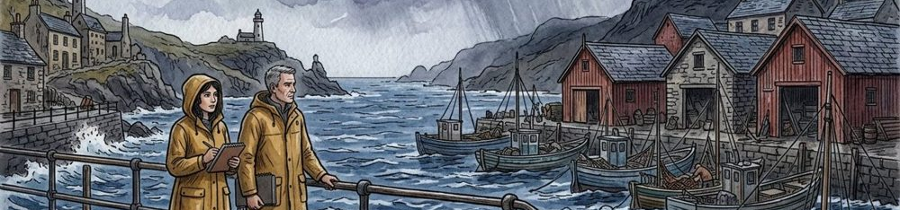
Validation question | Test material needed | Result not supplied
Can a reviewer identify and inspect a source relationship? | Appropriate examples, a manual baseline and an evaluation rule. | No benchmark, latency, accuracy or test result supplied.

Figure 3. Fictional illustration, not a site record.
ILLUSTRATIVE SPOKEN DRAFT
A useful proof plan would ask whether a reviewer can find the intended source, recognise a stale reference and understand an unresolved link. We have not run those checks, so we are not reporting accuracy, latency or reliability.

Speaker / evidence note — not a performance claim
All stage evidence statuses are not-tested. A proposed test is not a successful test, and a worked diagram is not a benchmark or a security review.
Keep the fictional status visible. Replace illustrative material only with appropriately sourced, verified information; proposed questions are not completed diligence.
QUESTION FOR THE NEXT READER
Which failure would be most informative for the next design decision?

06 / TECHNICAL THESIS

State the limits of the mechanism.
Mechanism limit | Human review role | Specialist review question
A reference link cannot prove that a statement is true. | A person must assess meaning and source appropriateness. | Security, privacy and specialist review remain unresolved.

Figure 3. Fictional illustration, not a site record.
ILLUSTRATIVE SPOKEN DRAFT
A link can point to a source without establishing the quality of that source or the truth of a claim. Review also depends on context, permissions and interpretation. Those boundaries are part of the product idea rather than an inconvenient footnote.

Speaker / evidence note — not a performance claim
No guarantee of correctness, compliance, safety, privacy or security is provided. Appropriate independent review would be required for any real implementation.
Keep the fictional status visible. Replace illustrative material only with appropriately sourced, verified information; proposed questions are not completed diligence.
QUESTION FOR THE NEXT READER
What conclusion must the interface avoid making automatically?

07 / TECHNICAL THESIS

Connect the mechanism to a use situation.
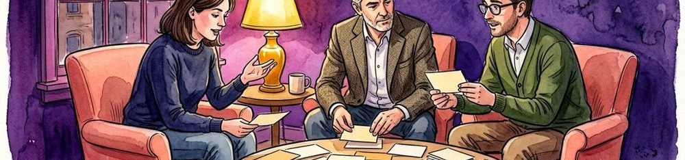
Use situation | Proposed interaction | Real artifact needed
A writer checks a passage before sharing a document. | Inspect the proposed reference link and its context. | An inspectable prototype, not an asserted deployed system.

Figure 4. Fictional illustration, not a site record.
ILLUSTRATIVE SPOKEN DRAFT
Imagine a reader asking why a passage supports a proposal. The concept would aim to show the associated reference and the unresolved question. That is a proposed use situation, not a record of a customer successfully using a working product.

Speaker / evidence note — not a performance claim
The watercolor scenes are editorial illustrations, not interface captures or a product demonstration. Add real artifacts only with accurate provenance and verified capability descriptions.
Keep the fictional status visible. Replace illustrative material only with appropriately sourced, verified information; proposed questions are not completed diligence.
QUESTION FOR THE NEXT READER
What would a first demonstration need to make visible?

08 / TECHNICAL THESIS

Identify the capability needed to build.
Build responsibility | Review responsibility | Unconfirmed role
Implement the smallest inspectable source-link interaction. | Design evaluation and retain unresolved failure cases. | No named technical team or confirmed appointments supplied.

Figure 4. Fictional illustration, not a site record.
ILLUSTRATIVE SPOKEN DRAFT
The work would need product judgement, implementation expertise and appropriate review of how source material is handled. We can name those roles without pretending that the team is staffed or that specialist approvals already exist.

Speaker / evidence note — not a performance claim
No biographies, patents, proprietary rights or appointments are supplied. Verify any real team or intellectual-property statement independently before adding it to a financing narrative.
Keep the fictional status visible. Replace illustrative material only with appropriately sourced, verified information; proposed questions are not completed diligence.
QUESTION FOR THE NEXT READER
Which missing capability could change the technical scope?

09 / TECHNICAL THESIS

Frame the next technical gate.
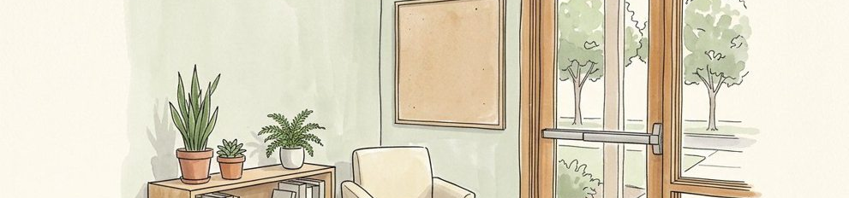
Gate question | Required artifact | Funding discussion boundary
Can a prototype make source context easier to inspect? | A bounded prototype with documented limitations and test material. | No actual funding ask, valuation or investment terms supplied.

Figure 5. Fictional illustration, not a site record.
ILLUSTRATIVE SPOKEN DRAFT
The next gate should answer one decision-relevant question using suitable material, not promise a launch date unsupported by the work. Resources would be discussed against that gate and its dependencies. No actual funding amount or implementation commitment is supplied here.

Speaker / evidence note — not a performance claim
Keep proposed architecture, test plans and financing terms separate. There is no evidence of a deployed system or an investment arrangement in the stage register.
Keep the fictional status visible. Replace illustrative material only with appropriately sourced, verified information; proposed questions are not completed diligence.
QUESTION FOR THE NEXT READER
What result would justify moving beyond the current concept?

10 / TECHNICAL THESIS

Close on a falsifiable direction.
Thesis challenge | Alternative outcome | Next proof conversation
Does the explicit link help more than the manual baseline? | If not, revise the mechanism or reject the hypothesis. | Discuss the smallest credible test, not promised performance.

Figure 5. Fictional illustration, not a site record.
ILLUSTRATIVE SPOKEN DRAFT
The useful invitation is to challenge the thesis: can a small reference structure help a defined review task enough to justify its cost and maintenance? We should be prepared for a simpler approach to win. That is the discipline we want the next conversation to examine.

Speaker / evidence note — not a performance claim
Preserve the untested status of every stage and the absence of benchmarks. This fictional script is not an investment recommendation or a technical certification.
Keep the fictional status visible. Replace illustrative material only with appropriately sourced, verified information; proposed questions are not completed diligence.
QUESTION FOR THE NEXT READER
What evidence could persuade you that the proposed approach is unnecessary?

