01 / PROJECT COVER

A place to begin a shared conversation.
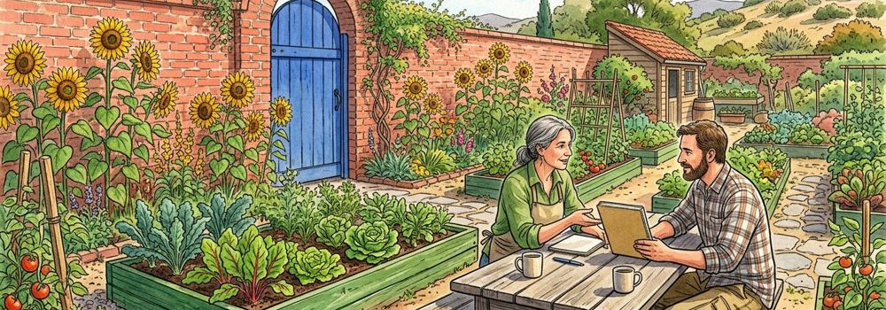
Figure 1. Fictional illustration, not a site record.
COMMON GROUND is an editable project-document template for discussing a fictional neighbourhood garden. It gives a proposal a clear reading order without pretending that a real site or project has been approved.
Prepared as an illustrative concept, version 1.0. All people and places in the artwork are invented. The reader should replace the example prose with appropriately sourced project information before using this document in a real setting.

Document boundary
This is a conversation starter, not a completed feasibility study. No site dimensions, budget, permissions, delivery dates, participant findings or verified environmental outcomes are supplied.
QUESTION FOR THE NEXT READER
What does the next reader need to know before discussing the idea?

02 / CONTENTS & READING GUIDE

Read the idea, then read its limits.
Figure 1. Fictional illustration, not a site record.
This document separates intention, imagined context, unresolved questions and a responsible handoff. The ten-page structure can support a real discussion only after the example content has been replaced and checked.
01 Cover · 02 Reading guide · 03 Project brief · 04 Context boundary · 05 Concept narrative · 06 Roles and questions · 07 Review sequence · 08 Decision register · 09 Handoff · 10 Appendix. These are document page numbers, not project milestones.

How to use the template
Read pages 3–5 for the proposed conversation, pages 6–8 for unresolved responsibilities and pages 9–10 for sharing and source boundaries. Editing the browser copy does not grant real-world permission.
QUESTION FOR THE NEXT READER
Which part of the document would help your reader orient first?

03 / PROJECT BRIEF

State the intention without promising an outcome.
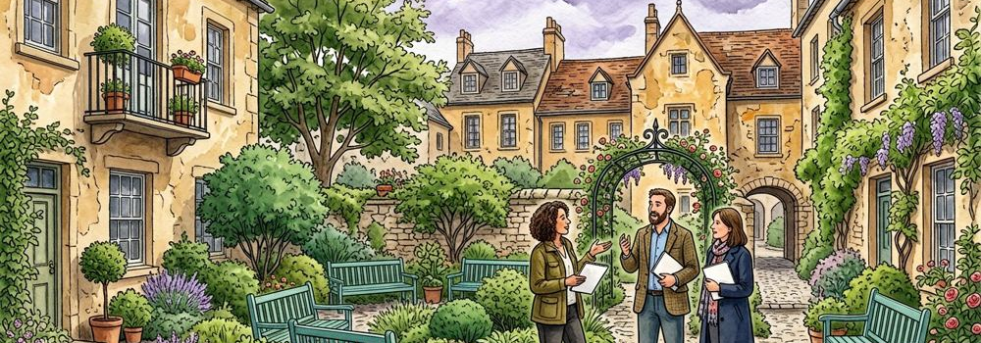
Figure 2. Fictional illustration, not a site record.
The fictional proposal imagines a small shared garden as a setting for conversation, reflection and neighbourly connection. These are intentions to explore, not measured benefits or promises about a real community.
A useful brief identifies the intended conversation, the people responsible for checking assumptions and the evidence still needed. This example does not identify a real venue, owner, participant group or delivery team.

Working brief
Explore whether a shared outdoor place could support a locally meaningful activity. Keep alternatives open. Any real project would need context-specific review, appropriate sources and responsible decision-makers.
QUESTION FOR THE NEXT READER
What evidence would distinguish an attractive idea from a suitable real proposal?

04 / CONTEXT BOUNDARY

An illustrated courtyard is not a survey.
Figure 2. Fictional illustration, not a site record.
The images show invented courtyards and meeting spaces. They supply a visual tone but do not establish dimensions, access routes, land ownership, weather conditions, soil properties or existing community needs.
Do not infer facts from the number of people drawn, the placement of planting beds or the apparent width of a path. A real context section should name its actual sources, dates, scope and limitations.

Source placeholder
Insert verified project-specific sources here only after they have been obtained and reviewed. Until then, label the context as unknown. Missing information is not the same as a positive or negative finding.
QUESTION FOR THE NEXT READER
Which tempting statement would rely only on something drawn in the picture?

05 / CONCEPT NARRATIVE

Keep the experience provisional.
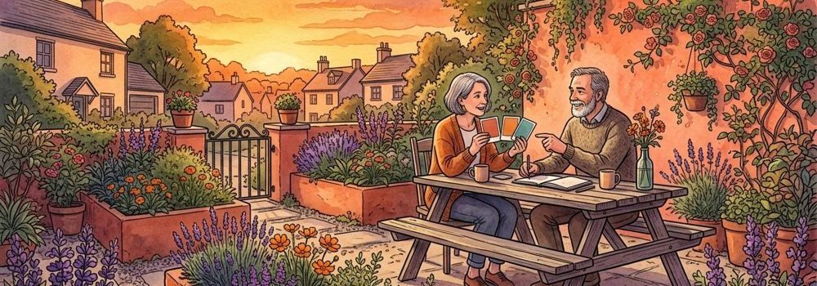
Figure 3. Fictional illustration, not a site record.
Imagine arriving at a welcoming shared space where a person could pause and join a conversation. This narrative explores an atmosphere. It is not a specification, a tested user journey or an approved layout.
The proposed character of the space might be calm, informal and adaptable. Different people could read the same atmosphere differently. The example does not stand in for consultation or evidence about actual users.

Alternatives worth retaining
A real discussion might compare different settings or activities before selecting a direction. Keep the reason for considering each alternative visible, and avoid calling an early preference a confirmed design decision.
QUESTION FOR THE NEXT READER
What alternative would help test the intention rather than merely repeat it?

06 / ROLES & OPEN QUESTIONS

A role label does not appoint a person.
Figure 3. Fictional illustration, not a site record.
A project document can identify categories of responsibility without inventing real appointments. This example distinguishes a concept writer, a source reviewer and the person authorised to make real project decisions.
No named person has accepted a task in this template. A real handoff should confirm responsibilities outside the document, with appropriate local review. Browser notes are not a participant-management or approval system.

Responsibility questions
Who can verify the context? Who can assess the relevant requirements? Who can authorise a real decision? Who should be told what remains unresolved? Record verified answers separately when they exist.
QUESTION FOR THE NEXT READER
Which question should go to a responsible reviewer rather than be answered by the artwork?

07 / REVIEW SEQUENCE

Sequence questions, not invented deadlines.
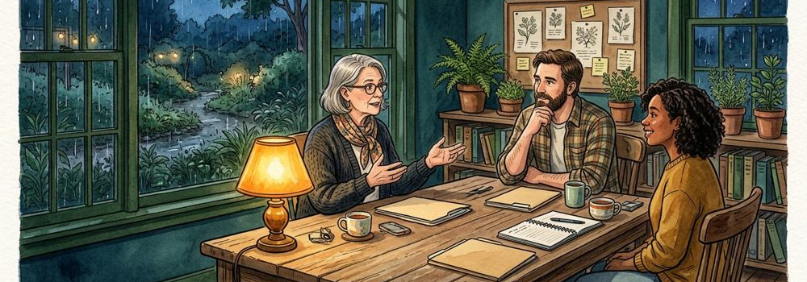
Figure 4. Fictional illustration, not a site record.
A provisional review sequence can help a reader understand dependencies. Begin by clarifying the intention, then identify missing sources, seek appropriate review and record what remains unresolved before any real commitment.
No duration, cost or delivery date is supplied. The order here is a reading aid, not a real project schedule. Do not convert these headings into promised milestones without a separate, responsible planning process.

Proposed discussion order
Clarify → source → review → record → hand over. Returning to an earlier question is allowed. A later heading does not imply that earlier work was completed or approved.
QUESTION FOR THE NEXT READER
What would need to be known before moving from discussion to commitment?

08 / DECISION REGISTER

Separate a question from a decision.
Figure 4. Fictional illustration, not a site record.
Use a register to distinguish proposed choices, missing evidence and decisions actually authorised elsewhere. The sample rows below are open questions only; none records an approval or a real project outcome.
Example A: What context is missing? Status: open. Example B: Who should review the intention? Status: unassigned. Example C: What alternative deserves discussion? Status: not selected. These are invented examples, not operational records.

Register fields
Question / source needed / responsible reviewer / current status / next clarification. Do not enter personal or sensitive participant information in this browser-local template. A tidy table does not verify its contents.
QUESTION FOR THE NEXT READER
Which word in a register could accidentally imply approval that has not occurred?

09 / HANDOFF & VERSION NOTE

Send the document with its boundary attached.
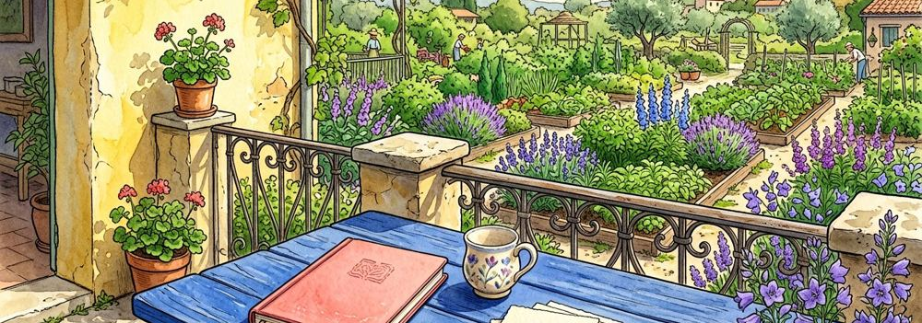
Figure 5. Fictional illustration, not a site record.
A useful handoff states the current purpose, source status, open questions and intended response. It does not imply that a real venue, budget, permission or technical review has been secured.
Current HTML and DOCX exports include browser text edits. JSON preserves the edit record and private note. Original PDF and DOCX downloads are fixed source versions, not automatically rewritten by browser editing. Review private notes before sharing them.

Suggested handoff note
This is a fictional concept document for discussion. Please respond to the stated question and identify any missing source needed for a real project. No approval or commitment is requested or implied by this template.
QUESTION FOR THE NEXT READER
Which version and question do you intend the next reader to receive?

10 / APPENDIX & SOURCE CHECK

Leave a clear starting point for the next version.
Figure 5. Fictional illustration, not a site record.
Appendix checklist: confirm the document purpose; label every illustration as fictional; retain source limitations; identify unresolved questions; check that the shared version contains the intended text and no private information.
Five independent watercolours are used across ten pages. Repeated placements are not extra illustrations. No external study, real site data, cost model or certification is represented. The document is editable, but edits do not create evidence.

Before a real use
Replace fictional examples with appropriately sourced content and seek the relevant responsible review. Keep a version record outside this browser if the project needs formal document control. Local storage is only a convenience.
QUESTION FOR THE NEXT READER
What must be verified before this example becomes a real project document?

