01 / EXHIBITION GUIDE

Offer a curatorial question.

WORK-CARD INDEX | VENUE BOUNDARY | Invitation | Structure | Boundary
W01 / Window Note / Z01 | 3 conceptual zones, 6 fictional work cards; no installed works. | Notice how context changes what an object seems to mean. | Three conceptual zones with two authored work cards each. | No actual exhibition, installed work or venue established.

Figure 1. Fictional illustration, not a site record.
Ways of Noticing is a fictional exhibition about how an object changes when its context changes. The guide invites visitors to notice, connect and revisit rather than follow one authorised interpretation.
The three zones are conceptual groupings, not rooms in a real building. The illustrations are sourced fictional scenes, not photographs of installed works or proof that an exhibition exists.

Curatorial intention
Six authored work cards support the narrative. They do not establish ownership, artist permission, availability or any right to display real material.
QUESTION FOR THE NEXT READER
What question should remain open as the visitor moves between the zones?

02 / EXHIBITION GUIDE

Read the exhibition as an invitation.
WORK-CARD INDEX | VENUE BOUNDARY | Notice | Connect | Revisit
W02 / Unnamed Shelf / Z01 | 3 conceptual zones, 6 fictional work cards; no installed works. | Describe what is visible before explaining it. | Consider what a neighbouring object or label changes. | Return to an earlier interpretation with a new question.

Figure 1. Fictional illustration, not a site record.
A familiar object may become strange when a label is removed. Two ordinary things may acquire a relationship when placed beside each other. Returning to an earlier display may change the first interpretation.
This introductory text offers a way to look, not a claim about how every visitor responds. A real guide should distinguish curatorial interpretation, artist statements and factual object information with appropriate sources.

Theme introduction
Begin anywhere that suits the actual setting. The guide provides no physical access route, capacity rule or guarantee that a proposed sequence is suitable for a real visitor.
QUESTION FOR THE NEXT READER
Which detail would you look at again after reading a different label?

03 / EXHIBITION GUIDE

Use the route map as a choice.

WORK-CARD INDEX | VENUE BOUNDARY | Zone One / page 4 | Zone Two / page 5 | Zone Three / page 6
W03 / Label Exchange / Z02 | 3 conceptual zones, 6 fictional work cards; no installed works. | Notice: describe the object before its explanation. | Connect: examine an object-label relationship. | Revisit: reconsider a first interpretation.

Z01 / Notice / page 4
Z02 / Connect / page 5
Z03 / Revisit / page 6
Figure 2. Fictional illustration, not a site record.
Zone One asks what is visible. Zone Two asks what a relationship adds. Zone Three asks how a later view changes an earlier one. Use the zone links to explore the guide in any order.
The links are document navigation, not directions through an actual venue. A real exhibition needs appropriate location, access and operational information supplied by its organisers. Do not infer exits or safe walking routes from this conceptual map.

Three-zone index
Pages 4, 5 and 6 describe the zones; each returns here. Moving through all three is optional and does not constitute a completed learning or access assessment.
QUESTION FOR THE NEXT READER
Which zone offers the most useful starting question for you?

04 / EXHIBITION GUIDE

Zone One: look before interpreting.
WORK-CARD INDEX | VENUE BOUNDARY | W01 / Window Note | W02 / Unnamed Shelf | Viewing question
W04 / Paired Traces / Z02 | 3 conceptual zones, 6 fictional work cards; no installed works. | An authored prompt about a framed fragment. | An authored prompt about an object without a settled label. | Which visible detail precedes your interpretation?

Return to the zone index / page 3
Figure 2. Fictional illustration, not a site record.
The first authored pair is Window Note and Unnamed Shelf. One card suggests a framed fragment; the other suggests an ordinary object presented without a settled label. Neither is an actual exhibited artwork.
Ask what can be described from the imagined arrangement and what would be an inference. A visitor may notice a different detail or decline the prompt. The guide should not turn that difference into a judgement about attention or taste.

Notice / W01 and W02
Return to the zone index to change the sequence. The cards are narrative devices, not evidence of artist intent or object provenance.
QUESTION FOR THE NEXT READER
What can you describe without deciding what it means?

05 / EXHIBITION GUIDE

Zone Two: let a relationship become visible.
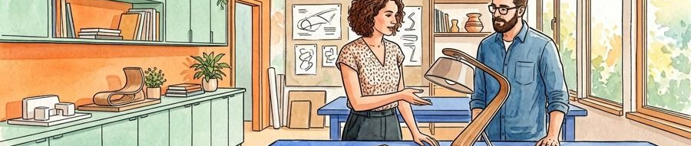
WORK-CARD INDEX | VENUE BOUNDARY | W03 / Label Exchange | W04 / Paired Traces | Viewing question
W05 / Return Card / Z03 | 3 conceptual zones, 6 fictional work cards; no installed works. | An imagined object with two alternative descriptions. | Two authored objects considered in relation. | Which part of the meaning comes from the pairing?

Return to the zone index / page 3
Figure 3. Fictional illustration, not a site record.
Label Exchange and Paired Traces ask what happens when an object is placed beside a different explanation or another object. The imagined relationship is the work of the prompt, not a documented installation.
Compare the two cards without deciding that one reading is correct. In a real exhibition, changes to an artist’s description or display context would require appropriate agreement and care.

Connect / W03 and W04
A label can supply context and can also constrain interpretation. Distinguish a curatorial proposition from a factual claim that needs verification.
QUESTION FOR THE NEXT READER
What does the relationship add that neither element carries alone?

06 / EXHIBITION GUIDE

Zone Three: return with another question.
WORK-CARD INDEX | VENUE BOUNDARY | W05 / Return Card | W06 / Changed Margin | Viewing question
W06 / Changed Margin / Z03 | 3 conceptual zones, 6 fictional work cards; no installed works. | A prompt to re-read an earlier description. | A prompt about an added contextual note. | What changed in your question rather than in the object?

Return to the zone index / page 3
Figure 3. Fictional illustration, not a site record.
Return Card and Changed Margin invite a second look at an earlier note. The object need not change for the visitor’s question to change. These are authored work-card ideas, not observed visitor responses.
Compare what you first described with what now seems worth asking. Do not require a visitor to report a personal memory or a transformed experience. Revisiting can leave an interpretation unresolved.

Revisit / W05 and W06
Return to the index or stop here. The guide does not define an ideal duration, a correct path or a guaranteed emotional effect.
QUESTION FOR THE NEXT READER
Which earlier assumption would you now hold more tentatively?

07 / EXHIBITION GUIDE

Write a work description with clear source classes.

WORK-CARD INDEX | VENUE BOUNDARY | Identify | Distinguish | Rights boundary
W01 / Window Note / Z01 | 3 conceptual zones, 6 fictional work cards; no installed works. | Use the authored work ID and its fictional status. | Separate a description from an interpretive question. | No actual artist, object or display permission supplied.

Figure 4. Fictional illustration, not a site record.
A useful description identifies the work, distinguishes factual information from interpretation and offers a question without prescribing the visitor’s response. Do not invent an artist quotation to make a label sound authoritative.
The six work titles in this guide are authored examples. No actual medium, date, collection, artist agreement or provenance record is supplied. The illustrative scenes must not be described as documentation of these imagined works.

Work-card method
For a real object, verify the relevant facts and permitted wording. Keep any interpretation attributable to the person or organisation responsible for it.
QUESTION FOR THE NEXT READER
Would a visitor know which part is information and which part is a proposition?

08 / EXHIBITION GUIDE

Create a discussion point without a compulsory answer.
WORK-CARD INDEX | VENUE BOUNDARY | Prompt | Choice | Recording boundary
W02 / Unnamed Shelf / Z01 | 3 conceptual zones, 6 fictional work cards; no installed works. | Which label changed the question you asked? | Consider the question privately or respond through an actual agreed route. | No visitor permission or response collection established.

Figure 4. Fictional illustration, not a site record.
A discussion point might ask visitors to compare two labels or describe an overlooked detail. It should offer a way to participate without requiring public speech or personal disclosure.
This guide supplies no actual station, staff arrangement or access service. Real organisers should confirm the relevant space, materials and response options before promising them in public information.

Optional conversation
Use an open question and make any recording purpose explicit. A written response should not silently become permission to quote or publish a visitor’s words.
QUESTION FOR THE NEXT READER
What would make this invitation genuinely optional and understandable?

09 / EXHIBITION GUIDE

Ask for feedback on the guide, not a desired reaction.
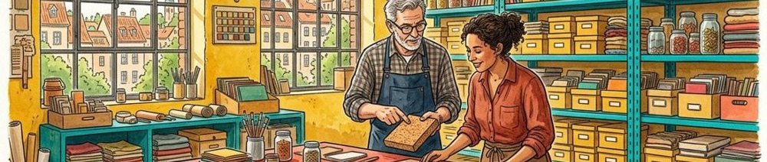
WORK-CARD INDEX | VENUE BOUNDARY | Clarity question | Missing information | Evidence boundary
W03 / Label Exchange / Z02 | 3 conceptual zones, 6 fictional work cards; no installed works. | Which description was easiest to interpret? | What context would have helped? | No actual visitor response or measured impact supplied.

Figure 5. Fictional illustration, not a site record.
A useful feedback question asks which explanation was clear or what information was missing. It does not require the visitor to say that the exhibition was inspiring or transformative.
No visitor data, satisfaction score or attendance figure exists in this example. If feedback is collected in a real setting, explain its purpose and appropriate record use, and retain the limits of any interpretation.

Visitor feedback prompt
Separate comments about navigation, wording, context and the works themselves. A positive comment about one part does not validate the whole experience.
QUESTION FOR THE NEXT READER
What information would help someone understand the actual exhibition better?

10 / EXHIBITION GUIDE

Review the curatorial argument.
WORK-CARD INDEX | VENUE BOUNDARY | Narrative review | Source review | Operational review
W04 / Paired Traces / Z02 | 3 conceptual zones, 6 fictional work cards; no installed works. | Does the sequence invite notice, connection and reconsideration? | Which actual object facts and rights would need verification? | Venue and access information need real organiser input.

Figure 5. Fictional illustration, not a site record.
Ask whether the three zones make the exhibition question inspectable and whether the guide keeps room for alternative readings. A coherent narrative can still omit relevant facts or perspectives.
This version reports no actual exhibition or audience result. Retain earlier wording when revising a work card, and distinguish a change in interpretation from a correction to a verified fact.

Curatorial reflection
Carry forward one narrative revision, one source question and one actual operational detail to check before adapting the proposal. A cleaner map is not proof of a better visitor experience.
QUESTION FOR THE NEXT READER
What should be revised before this proposal could support a real exhibition?

