01 / DISCOVERY MAP

Start with a learning decision.
TREE ELEMENT | HYPOTHESIS RECORD
TREE NODE | O00 / outcome / intended
EVIDENCE BOUNDARY | 7 authored nodes: 1 outcome, 2 opportunities, 4 untested hypotheses.
Decision | Choose which uncertainty to investigate before implementation.
Boundary | No actual users, market demand or release commitment established.
Artifact | A versioned tree with questions attached to each hypothesis.

Figure 1. Fictional illustration, not a site record.
Context Library is an invented concept for keeping a short note beside the passage that prompted it. Discovery asks whether the relationship is understandable before proposing a product roadmap.
The outcome O00 is to make the passage-note relationship inspectable. It is a design intention, not a measured improvement or evidence that a real audience needs this service.

Exploration charter
The tree has one outcome, two opportunity branches and four hypotheses. Its structure makes assumptions traceable without turning them into findings.
QUESTION FOR THE NEXT READER
What decision could a small inquiry change?
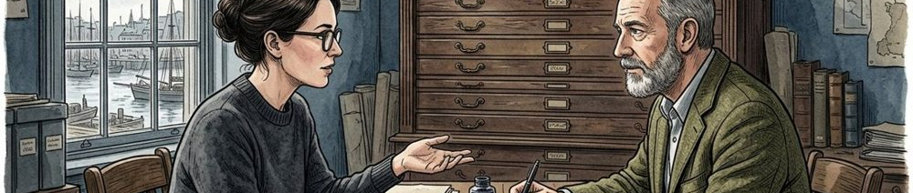

02 / DISCOVERY MAP

Map a context without inventing a persona.
TREE ELEMENT | HYPOTHESIS RECORD
TREE NODE | O01 / opportunity / unvalidated
EVIDENCE BOUNDARY | 7 authored nodes: 1 outcome, 2 opportunities, 4 untested hypotheses.
Situation | A reader returns to a saved note and its source passage.
Unknown | Whether the missing relationship is actually a recurring difficulty.
Control | Hold passage, note and task wording constant across examples.

Figure 1. Fictional illustration, not a site record.
Imagine a reader returning to a note after the surrounding passage has been forgotten. The scenario identifies a possible context for inquiry, not a representative user profile.
Separate the moment of writing from the moment of return. A note that seems clear during writing may lack enough context later; that possibility requires investigation rather than an invented quotation.

Context map
Use the same invented passage across alternatives so that a changing example does not explain differences attributed to the design.
QUESTION FOR THE NEXT READER
What distinguishes the writing moment from the return moment?

03 / DISCOVERY MAP

Describe the problem before a feature.
TREE ELEMENT | HYPOTHESIS RECORD
TREE NODE | O02 / opportunity / unvalidated
EVIDENCE BOUNDARY | 7 authored nodes: 1 outcome, 2 opportunities, 4 untested hypotheses.
O01 | Recover the context needed to interpret a note.
O02 | Understand whether a note is provisional or revised.
Exclusion | No evidence that either opportunity represents a known population.

Figure 2. Fictional illustration, not a site record.
Opportunity O01 asks how a returning reader might recover relevant context. O02 asks how a reader might understand a note's revision status. Both are authored problem statements.
Neither branch requires a particular interface. A source excerpt, a reference link or a clear explanation could address O01 in different ways. Do not select a solution by how neatly it fits the tree.

Problem framing
A branch is worth keeping only if the proposed inquiry can reveal something about it. Remove redundant labels rather than counting more branches as progress.
QUESTION FOR THE NEXT READER
Could the problem still be discussed without naming a screen?
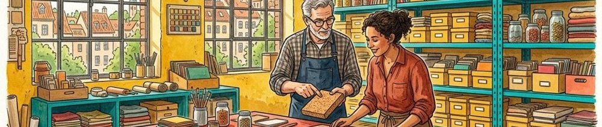

04 / DISCOVERY MAP

Keep the tree's parent links explicit.
TREE ELEMENT | HYPOTHESIS RECORD
TREE NODE | H11 / hypothesis / untested
EVIDENCE BOUNDARY | 7 authored nodes: 1 outcome, 2 opportunities, 4 untested hypotheses.
Root | O00, an intended outcome rather than a metric.
Children | O01 and O02, both unvalidated opportunities.
Leaves | H11, H12, H21 and H22, all untested hypotheses.

Figure 2. Fictional illustration, not a site record.
O00 connects to O01 and O02. Hypotheses H11 and H12 belong to O01; H21 and H22 belong to O02. Every non-root node has exactly one parent.
A single parent keeps this small teaching tree readable. It does not claim that real needs are independent. Cross-cutting uncertainty belongs in a note rather than a duplicate node presented as new evidence.

Opportunity branches
The source register stores seven nodes with unique IDs. Parent references must exist, and traversing them must reach O00 without a cycle.
QUESTION FOR THE NEXT READER
Can another reader reconstruct the tree from the register alone?

05 / DISCOVERY MAP

Make each hypothesis refutable.
TREE ELEMENT | HYPOTHESIS RECORD
TREE NODE | H12 / hypothesis / untested
EVIDENCE BOUNDARY | 7 authored nodes: 1 outcome, 2 opportunities, 4 untested hypotheses.
H11 / H12 | Compare an excerpt and a source link for context recovery.
H21 / H22 | Compare a status label and a change note for revision meaning.
Status | All four remain untested; no actual outcomes recorded.

Figure 3. Fictional illustration, not a site record.
H11 proposes that an adjacent source excerpt helps recover context. H12 proposes that an explicit source link does so. Neither is a claim that one treatment works.
H21 proposes that a visible revision label helps explain status. H22 proposes that a brief change note helps explain what changed. A reader may misunderstand either treatment even when the designer finds it obvious.

Solution hypotheses
An inquiry should allow a treatment to be confusing or unnecessary. A question that only asks which version looks attractive cannot establish comprehension.
QUESTION FOR THE NEXT READER
What observation would make this hypothesis less plausible?
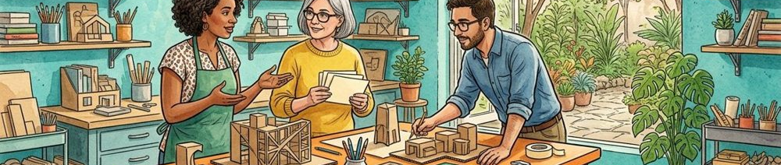

06 / DISCOVERY MAP

Ask a question that does not supply its answer.
TREE ELEMENT | HYPOTHESIS RECORD
TREE NODE | H21 / hypothesis / untested
EVIDENCE BOUNDARY | 7 authored nodes: 1 outcome, 2 opportunities, 4 untested hypotheses.
Prompt | Explain what the note refers to and what remains unclear.
Probe | Which part of the artifact informed that interpretation?
Avoid | Do not ask whether the proposed improvement is successful.

Figure 3. Fictional illustration, not a site record.
A useful research question asks how a reader explains the relation between a note and its passage. It does not ask whether the new context feature is helpful.
Prepare prompts that allow uncertainty, disagreement and an unexpected explanation. Ask what the person inspected before naming the intended cue; otherwise the prompt may teach the answer being evaluated.

Question design
Keep the researcher's hypothesis outside the initial task. Record later clarification separately from an unaided interpretation.
QUESTION FOR THE NEXT READER
Would the wording still make sense if the hypothesis were wrong?

07 / DISCOVERY MAP

Match the method to the uncertainty.
TREE ELEMENT | HYPOTHESIS RECORD
TREE NODE | H22 / hypothesis / untested
EVIDENCE BOUNDARY | 7 authored nodes: 1 outcome, 2 opportunities, 4 untested hypotheses.
Method | An optional future walkthrough of two authored alternatives.
Observation | Record interpretation and the cue used, not just preference.
Limit | No actual sessions, recruitment or longitudinal evidence exist.

Figure 4. Fictional illustration, not a site record.
A small artifact walkthrough could explore whether the connection is understandable. It would not establish market size, sustained use or a statistically reliable preference between treatments.
Show a paper concept or a clearly bounded prototype, describe what it can and cannot do, and use an appropriate participation arrangement. This document schedules no actual session or recruitment.

Method boundary
An unimplemented control cannot support a conclusion about its response time or reliability. Keep concept interpretation separate from functional usability.
QUESTION FOR THE NEXT READER
What could this method legitimately teach?


08 / DISCOVERY MAP

Record a trade-off as a hypothesis too.
TREE ELEMENT | HYPOTHESIS RECORD
TREE NODE | O00 / outcome / intended
EVIDENCE BOUNDARY | 7 authored nodes: 1 outcome, 2 opportunities, 4 untested hypotheses.
Candidate | Explore the adjacent excerpt first for a bounded walkthrough.
Reason | The relationship is visible without another navigation step.
Revisit | Retain the link alternative until interpretation has been examined.

Figure 4. Fictional illustration, not a site record.
An excerpt might preserve context while making the card longer. A link might keep the card compact while requiring another step. These are design tensions, not measured costs.
Choose what the next inquiry needs to distinguish. A temporary choice can narrow an experiment without becoming an approved product direction. Explain why the other alternative is retained or deferred.

Trade-off record
Do not give invented reach, confidence or effort scores to make a choice look objective. Unknown evidence stays unknown.
QUESTION FOR THE NEXT READER
Which assumption carries the temporary decision?

09 / DISCOVERY MAP

Keep a learning ledger separate from the tree.
TREE ELEMENT | HYPOTHESIS RECORD
TREE NODE | O01 / opportunity / unvalidated
EVIDENCE BOUNDARY | 7 authored nodes: 1 outcome, 2 opportunities, 4 untested hypotheses.
Current | Four untested hypotheses and no collected observations.
Future | Link any permitted observation to task and artifact version.
Rule | Separate raw observation, interpretation and proposed action.

Figure 5. Fictional illustration, not a site record.
The authored tree contains no observed findings. A later ledger should link an observation to its task, artifact version, source permission and the hypothesis it informs.
A single comment should not silently become a finding about everyone. Preserve counterexamples and distinguish what was said from a researcher's explanation of why it happened.

Learning synthesis
A hypothesis can remain uncertain after a useful session. Avoid treating the completion of research activities as validation.
QUESTION FOR THE NEXT READER
What source would justify changing a node's status?
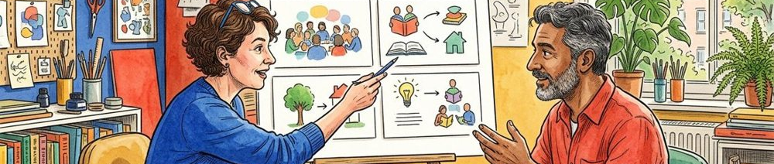

10 / DISCOVERY MAP

Choose the next question, not a launch date.
TREE ELEMENT | HYPOTHESIS RECORD
TREE NODE | O02 / opportunity / unvalidated
EVIDENCE BOUNDARY | 7 authored nodes: 1 outcome, 2 opportunities, 4 untested hypotheses.
Next | Prepare a clearly labeled excerpt-versus-link concept comparison.
Open | Revision meaning, real contexts and long-term usefulness remain unknown.
Handoff | Carry the tree version, scope exclusions and unanswered questions.

Figure 5. Fictional illustration, not a site record.
The next step is to prepare a bounded comparison for O01 and review whether its task wording exposes the intended uncertainty. No real release date or staffing commitment follows.
Check the tree, the source boundary and the planned participation process before any study. Keep O02 visible so that a convenient first inquiry does not erase the revision-status question.

Exploration handoff
Share the source register and the reason for the next inquiry. A successor should be able to disagree without reconstructing missing assumptions.
QUESTION FOR THE NEXT READER
What remains unlearned after this workbook?

