01 / PROTOTYPE STUDY

Choose a question the prototype can expose.
Figure 1. Fictional illustration, not a site record.
This plan asks whether an invented Context Card lets a reader explain a note's source relationship and the available context change. It is a plan for inquiry, not a completed usability report.
Three tasks are crossed with three observation checkpoints. All nine cells are unrecorded. No participant identities, recruitment, session dates or results are supplied.

Study intention
The intended output is a traceable record of what an actual artifact might reveal under a bounded task. It is not a success-rate target.
QUESTION FOR THE NEXT READER
Which uncertainty requires observation rather than another opinion?
01 | OBSERVATION CELL | T01 / first-interpretation
02 | STUDY BOUNDARY | 3 tasks × 3 checkpoints; 9 unrecorded cells. No participant data.
03 | Question | How is the note-source relationship interpreted?
04 | Scope | A future walkthrough of a clearly labeled paper concept.
05 | Current | Three tasks, nine empty cells and no actual sessions.

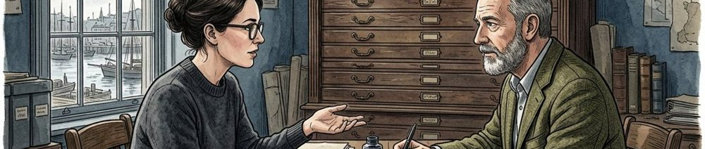

02 / PROTOTYPE STUDY

Describe what the prototype cannot do.
Figure 1. Fictional illustration, not a site record.
The paper concept represents a note, its source reference and alternate context panels. It has no live save, network retrieval, authentication or assistive-technology implementation.
A facilitator may substitute an authored panel after a participant describes an intended action, if that procedure is explained. The substitution is not a working response-time or reliability test.

Fidelity boundary
Do not interpret a missing implementation as a participant error. Separate artifact limitations, task ambiguity and observed interaction difficulty.
QUESTION FOR THE NEXT READER
Could a result be caused by the prototype's limitation?
01 | OBSERVATION CELL | T01 / attempted-action
02 | STUDY BOUNDARY | 3 tasks × 3 checkpoints; 9 unrecorded cells. No participant data.
03 | Represents | Content grouping and proposed context states.
04 | Does not run | Saving, source retrieval or a real navigation service.
05 | Procedure | Any panel substitution must be explained and recorded.

03 / PROTOTYPE STUDY

Set a scenario without teaching the cue.
Figure 2. Fictional illustration, not a site record.
Invite a future participant to imagine returning to a note written beside an invented passage. Ask what the note refers to before pointing to the source reference or expansion action.
The scenario must not imply that a good reader will choose a particular route. Participation and recording arrangements must be established for a real study; this template grants no permission to collect data.

Scenario setup
Use non-sensitive invented material. Avoid requiring personal reading history or private documents merely to make a task feel realistic.
QUESTION FOR THE NEXT READER
Does the setup reveal the answer it is meant to investigate?
01 | OBSERVATION CELL | T01 / unresolved-question
02 | STUDY BOUNDARY | 3 tasks × 3 checkpoints; 9 unrecorded cells. No participant data.
03 | Context | Return to an authored note after a fictional interval.
04 | Material | Use the same invented passage and note across tasks.
05 | Choice | Any real participation or recording needs a separate arrangement.



04 / PROTOTYPE STUDY

Give each task an inspectable goal.
Figure 2. Fictional illustration, not a site record.
T01 asks the reader to explain which passage the note concerns. T02 asks how they would reveal more context. T03 asks what they would do when context is unavailable.
Read one task at a time without naming the intended control. The script records a goal and a boundary, not a compulsory sequence or a declared success event.

Task scripts
A participant may choose a route the designer did not anticipate. Record the route before deciding whether the task or artifact needs revision.
QUESTION FOR THE NEXT READER
Can the goal be understood without a button name?
01 | OBSERVATION CELL | T02 / first-interpretation
02 | STUDY BOUNDARY | 3 tasks × 3 checkpoints; 9 unrecorded cells. No participant data.
03 | T01 | Explain which source passage the note concerns.
04 | T02 | Describe how to reveal more of the note's context.
05 | T03 | Explain the next step when context is unavailable.

05 / PROTOTYPE STUDY

Separate observation from interpretation.
Figure 3. Fictional illustration, not a site record.
The checkpoints are first interpretation, attempted action and unresolved question. A permitted record should capture what happened at each checkpoint before explaining why it may have happened.
Do not infer confusion from a pause without further context. A quiet reader, an incomplete paper panel and an unclear task can produce similar outward behavior for different reasons.

Observation vocabulary
Keep quotations distinct from paraphrases and mark any facilitator intervention. The source matrix currently contains neither quotations nor observed actions.
QUESTION FOR THE NEXT READER
Could another researcher distinguish the event from its explanation?
01 | OBSERVATION CELL | T02 / attempted-action
02 | STUDY BOUNDARY | 3 tasks × 3 checkpoints; 9 unrecorded cells. No participant data.
03 | First interpretation | Record the initial explanation in permitted form.
04 | Attempted action | Record the action or described intention and any intervention.
05 | Unresolved question | Record what remains uncertain without inventing a cause.



06 / PROTOTYPE STUDY

Leave unobserved cells genuinely empty.
Figure 3. Fictional illustration, not a site record.
The matrix crosses T01, T02 and T03 with the three checkpoints, yielding nine planned cells. Each has status unrecorded and a null observation; none means a failed task.
Do not fill empty cells with plausible behavior to make the report look finished. A real session may produce no relevant observation at a checkpoint, which should be represented explicitly and separately.

Recording matrix
A future record needs task, artifact version, session reference and an appropriate permission basis. This workbook contains no actual session identifiers.
QUESTION FOR THE NEXT READER
Can an empty field be mistaken for a result?
01 | OBSERVATION CELL | T02 / unresolved-question
02 | STUDY BOUNDARY | 3 tasks × 3 checkpoints; 9 unrecorded cells. No participant data.
03 | Rows | Three task IDs, each with three planned checkpoints.
04 | Values | All nine observations remain null and unrecorded.
05 | Meaning | Absence of a record is not failure, zero time or dissatisfaction.

07 / PROTOTYPE STUDY

Cluster only after preserving the source records.
Figure 4. Fictional illustration, not a site record.
Potential themes might concern source association, action wording or unavailable-context explanation. These are planning categories, not findings derived from participants.
A real synthesis should retain links to the observations it groups, preserve exceptions and distinguish artifact issues from task-script issues. Frequency alone cannot establish severity without context.

Issue synthesis
Do not report that most people struggled when no sessions occurred. Avoid inventing severity ratings or completion percentages from an empty matrix.
QUESTION FOR THE NEXT READER
What observation would support the proposed theme?
01 | OBSERVATION CELL | T03 / first-interpretation
02 | STUDY BOUNDARY | 3 tasks × 3 checkpoints; 9 unrecorded cells. No participant data.
03 | Candidate theme | Source relationship may require a clearer explanation.
04 | Evidence state | No observed records support or contradict that possibility.
05 | Rule | Preserve traceable exceptions rather than forcing every note into a theme.

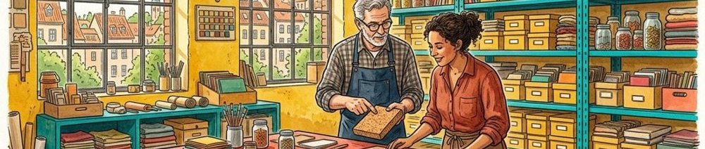

08 / PROTOTYPE STUDY

Connect a revision to a specific uncertainty.
Figure 4. Fictional illustration, not a site record.
If a future record suggests the source relation is unclear, a revised panel could change the reference placement while keeping wording constant. That is a proposed next comparison, not a validated fix.
Record the version difference and the question it addresses. Changing task wording, content and layout at once can obscure what explains an observed difference.

Iteration plan
A cleaner drawing is not evidence of improved usability. Any claim about improvement needs an appropriate comparison and a transparent boundary.
QUESTION FOR THE NEXT READER
What would a follow-up task distinguish?
01 | OBSERVATION CELL | T03 / attempted-action
02 | STUDY BOUNDARY | 3 tasks × 3 checkpoints; 9 unrecorded cells. No participant data.
03 | Hypothetical change | Adjust reference placement without changing note wording.
04 | Control | Retain the same passage and task goal.
05 | Status | No actual issue, revision result or measured improvement exists.

09 / PROTOTYPE STUDY

Make the limitations part of the result format.
Figure 5. Fictional illustration, not a site record.
Even a completed small walkthrough would be bounded by its artifact, tasks, participants and setting. This plan has additional limits because it has not been executed at all.
Paper panels cannot establish persistence, live latency, keyboard operation or assistive-technology behavior. No claim about a population, business outcome or accessibility conformance follows from this plan.

Study limits
Keep missing evidence visible in the handoff. A reader should not have to infer that a polished matrix is empty of participant data.
QUESTION FOR THE NEXT READER
Which conclusion is outside the method's reach?
01 | OBSERVATION CELL | T03 / unresolved-question
02 | STUDY BOUNDARY | 3 tasks × 3 checkpoints; 9 unrecorded cells. No participant data.
03 | Not measured | Task completion, time, error rate or satisfaction.
04 | Not tested | Live behavior, keyboard access or assistive technology.
05 | Not inferred | Population preference, adoption or business value.



10 / PROTOTYPE STUDY

Prepare the next study without announcing findings.
Figure 5. Fictional illustration, not a site record.
The next step is to review the task script and the paper panels for misleading cues, then establish a real participation and recording process if the study proceeds.
Keep the unrecorded matrix as a planning fixture. Any future data must be versioned and sourced rather than silently overwriting null cells while retaining this document's claim that no sessions occurred.

Research handoff
Share the question, artifact limits, task goals and observation vocabulary together. A successor should know both what to collect and what not to conclude.
QUESTION FOR THE NEXT READER
What is required before any cell becomes evidence?
01 | OBSERVATION CELL | T01 / first-interpretation
02 | STUDY BOUNDARY | 3 tasks × 3 checkpoints; 9 unrecorded cells. No participant data.
03 | Prepare | Review task wording and clearly label the paper concept.
04 | Arrange | Establish actual participation, recording and data-handling terms.
05 | Preserve | Version the fixture before adding real observations.

