01 / FIELD SCHOOL

A course in noticing carefully.
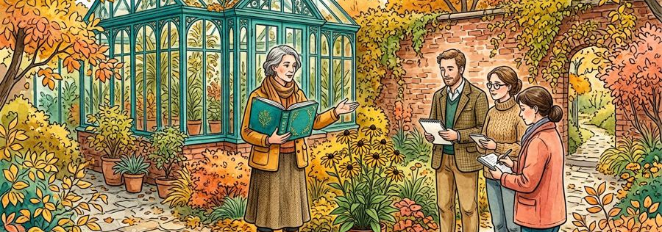
Figure 1. Fictional illustration, not a site record.
Learn to distinguish a visible detail from the explanation you attach to it. The garden scenes are prompts for adult discussion, not a real field class or a verified site.
The learning objective is to write one observation, identify one assumption and ask one source-aware question. Completion is a personal practice record, not an accredited qualification.

Practice response
Use this section to record a bounded response to the question below. Retain the distinction between the fictional example, your interpretation and any separate evidence a real use would require.
QUESTION FOR THE NEXT READER
Write an observation without naming a cause.
PRACTISE | Write an observation without naming a cause.
RESPONSE | Observation / assumption / source / next question

02 / FIELD SCHOOL

Read the learning route.
Figure 1. Fictional illustration, not a site record.
The ten-page route moves from description to interpretation, comparison and reflection. Read the numbered headings in order or return to the exercise that addresses your current question.
Pages 3–4 practise neutral description. Pages 5–6 separate interpretation and context. Pages 7–8 compare wording and rehearse feedback. Pages 9–10 collect a bounded response and a next question.

Practice response
Use this section to record a bounded response to the question below. Retain the distinction between the fictional example, your interpretation and any separate evidence a real use would require.
QUESTION FOR THE NEXT READER
Mark the exercise you want to revisit.
PRACTISE | Mark the exercise you want to revisit.
RESPONSE | Observation / assumption / source / next question

03 / FIELD SCHOOL

Describe before explaining.
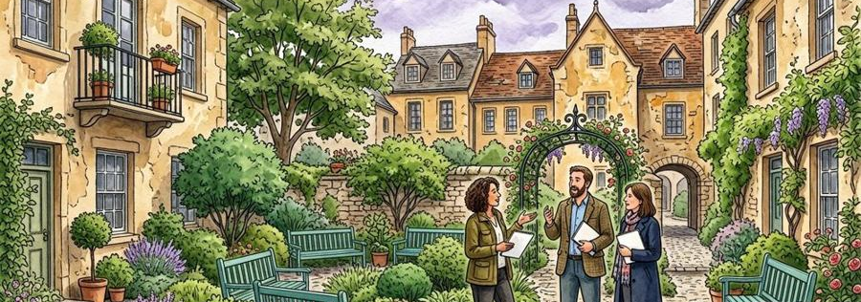
Figure 2. Fictional illustration, not a site record.
Choose one visible object in the illustration. Describe its shape, colour and relative position using ordinary language rather than a story about why it is there.
For example, a blue gate is a visible detail. Calling the gate welcoming is an interpretation. Both may be useful, but they answer different questions and should not be merged into one finding.

Practice response
Use this section to record a bounded response to the question below. Retain the distinction between the fictional example, your interpretation and any separate evidence a real use would require.
QUESTION FOR THE NEXT READER
Write two sentences labelled detail and interpretation.
PRACTISE | Write two sentences labelled detail and interpretation.
RESPONSE | Observation / assumption / source / next question

04 / FIELD SCHOOL

Keep the frame in view.
Figure 2. Fictional illustration, not a site record.
The picture has an edge. Anything outside that edge is not supplied by the exercise. A path disappearing behind a wall does not establish a destination, distance or accessible route.
Practise naming one missing piece of context beside each observation. The aim is not to make the illustration less engaging; it is to make the limits of your description readable.

Practice response
Use this section to record a bounded response to the question below. Retain the distinction between the fictional example, your interpretation and any separate evidence a real use would require.
QUESTION FOR THE NEXT READER
Name information that the frame does not supply.
PRACTISE | Name information that the frame does not supply.
RESPONSE | Observation / assumption / source / next question

05 / FIELD SCHOOL

Offer more than one interpretation.
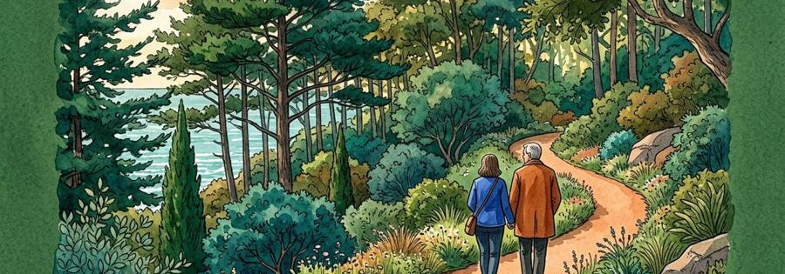
Figure 3. Fictional illustration, not a site record.
An empty bench could suggest quiet, an unoccupied moment or simply an artistic choice. The exercise contains no attendance record or statement of local preference.
Write two plausible readings without choosing a winner. A useful interpretation remains connected to a visible detail while admitting what would need a separate source.

Practice response
Use this section to record a bounded response to the question below. Retain the distinction between the fictional example, your interpretation and any separate evidence a real use would require.
QUESTION FOR THE NEXT READER
Offer a second reading of the same detail.
PRACTISE | Offer a second reading of the same detail.
RESPONSE | Observation / assumption / source / next question

06 / FIELD SCHOOL

Ask a source-aware question.
Figure 3. Fictional illustration, not a site record.
Turn an interpretation into a question that could be clarified with appropriate evidence. Keep the request narrow enough that another reader understands what information is missing.
Replace Is this a good garden? with What real context would help us understand how this place is used? The latter does not invent a result or assume that the fictional place actually exists.

Practice response
Use this section to record a bounded response to the question below. Retain the distinction between the fictional example, your interpretation and any separate evidence a real use would require.
QUESTION FOR THE NEXT READER
Rewrite a broad judgement as a bounded question.
PRACTISE | Rewrite a broad judgement as a bounded question.
RESPONSE | Observation / assumption / source / next question

07 / FIELD SCHOOL

Compare two descriptions.
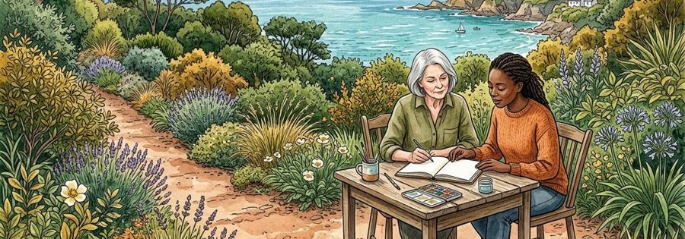
Figure 4. Fictional illustration, not a site record.
Read a short neutral description beside a more interpretive one. Identify which words introduce an assumption about use, mood or intent.
The comparison is between sentences, not between real places or learner ability. No score, ranking or claim about participant performance is supplied.

Practice response
Use this section to record a bounded response to the question below. Retain the distinction between the fictional example, your interpretation and any separate evidence a real use would require.
QUESTION FOR THE NEXT READER
Underline one word that reaches beyond the picture.
PRACTISE | Underline one word that reaches beyond the picture.
RESPONSE | Observation / assumption / source / next question

08 / FIELD SCHOOL

Practise generous feedback.
Figure 4. Fictional illustration, not a site record.
Respond to another invented description by naming what is clear and asking what remains uncertain. This is a writing exercise, not an assessment of a real person.
Try the response I can locate the blue gate; I cannot tell which source supports the claimed mood. Specific feedback is easier to act on than a global judgement such as good or bad.

Practice response
Use this section to record a bounded response to the question below. Retain the distinction between the fictional example, your interpretation and any separate evidence a real use would require.
QUESTION FOR THE NEXT READER
Write one acknowledgement and one clarification question.
PRACTISE | Write one acknowledgement and one clarification question.
RESPONSE | Observation / assumption / source / next question

09 / FIELD SCHOOL

Collect a learning response.
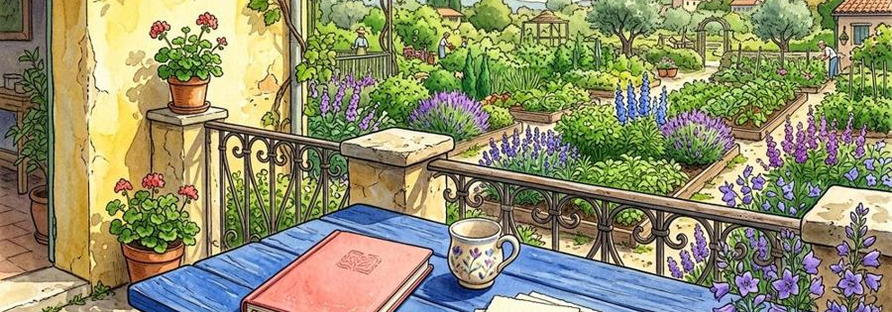
Figure 5. Fictional illustration, not a site record.
Bring together one observation, one assumption, one missing source and one next question. Keep the response compact enough that a reader can check each part.
This response sheet is evidence of what you wrote in the exercise, not evidence that the illustrated setting has been studied. Do not include personal information about other participants.

Practice response
Use this section to record a bounded response to the question below. Retain the distinction between the fictional example, your interpretation and any separate evidence a real use would require.
QUESTION FOR THE NEXT READER
Complete the four-part response in your own words.
PRACTISE | Complete the four-part response in your own words.
RESPONSE | Observation / assumption / source / next question

10 / FIELD SCHOOL

Leave with a better question.
Figure 5. Fictional illustration, not a site record.
Review which distinction became clearer: description versus interpretation, absence versus zero, or an attractive story versus a supported claim.
Keep an earlier sentence and a revised sentence if that helps your reflection. This template supplies no passing grade or certificate; the useful outcome is a more precise question.

Practice response
Use this section to record a bounded response to the question below. Retain the distinction between the fictional example, your interpretation and any separate evidence a real use would require.
QUESTION FOR THE NEXT READER
Name one question you can now ask more clearly.
PRACTISE | Name one question you can now ask more clearly.
RESPONSE | Observation / assumption / source / next question

