01 / FORM STUDY

Explain a form, not an electrical product.
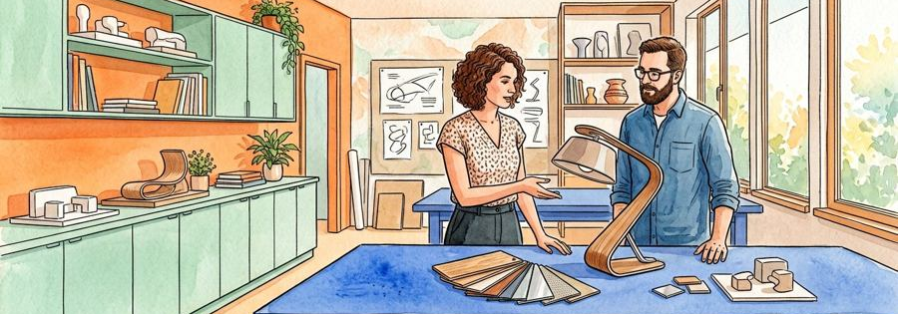
Figure 1. Fictional illustration, not a site record.
FORM STUDY explores the visual character of an imagined unpowered desk-lamp object. It is a concept document, not a working lamp design or engineering instruction.
The purpose is to make a design intention, alternative and evidence gap understandable. No wiring, power system, dimensions, test result or supplier is supplied.

Design hypothesis
Use this section to record a bounded response to the question below. Retain the distinction between the fictional example, your interpretation and any separate evidence a real use would require.
QUESTION FOR THE NEXT READER
What can this concept document legitimately describe?
INTENTION | MISSING EVIDENCE
Visual form only | No engineering or material tests
NEXT SOURCE | What can this concept document legitimately describe?

02 / FORM STUDY

Read the design argument.
Figure 1. Fictional illustration, not a site record.
The document moves from intention to context question, form, material appearance, alternatives, requirements and handoff. Keep the distinction between a sketch and a specification.
The artwork shows a studio atmosphere. It cannot establish physical stability, lighting performance, electrical safety, manufacturing feasibility or actual user preference.

Design hypothesis
Use this section to record a bounded response to the question below. Retain the distinction between the fictional example, your interpretation and any separate evidence a real use would require.
QUESTION FOR THE NEXT READER
Which claim would need a separate specialist source?
INTENTION | MISSING EVIDENCE
Visual form only | No engineering or material tests
NEXT SOURCE | Which claim would need a separate specialist source?

03 / FORM STUDY

Define the intended interaction.

Figure 2. Fictional illustration, not a site record.
Imagine an object that is easy to recognise as a focused desk companion. This is a visual intention, not a tested usability result or a claim about actual users.
A real design brief would need a clear use context and appropriately obtained evidence. The template does not invent participant needs or research findings.

Design hypothesis
Use this section to record a bounded response to the question below. Retain the distinction between the fictional example, your interpretation and any separate evidence a real use would require.
QUESTION FOR THE NEXT READER
What context would shape a real interaction question?
INTENTION | MISSING EVIDENCE
Visual form only | No engineering or material tests
NEXT SOURCE | What context would shape a real interaction question?

04 / FORM STUDY

Describe the form in ordinary language.
Figure 2. Fictional illustration, not a site record.
Discuss the relationship of base, stem and shade as a visual composition. Avoid supplying dimensions or implying that the depicted proportions have been engineered.
A form can appear balanced without being physically stable. The distinction should remain visible in any caption or shared excerpt.

Design hypothesis
Use this section to record a bounded response to the question below. Retain the distinction between the fictional example, your interpretation and any separate evidence a real use would require.
QUESTION FOR THE NEXT READER
Which visual adjective could be mistaken for a tested property?
INTENTION | MISSING EVIDENCE
Visual form only | No engineering or material tests
NEXT SOURCE | Which visual adjective could be mistaken for a tested property?

05 / FORM STUDY

Treat materials as unverified appearances.
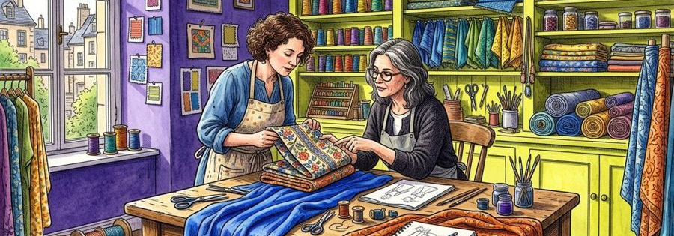
Figure 3. Fictional illustration, not a site record.
A surface may look metallic, matte or translucent in the illustration. Those appearances do not identify composition, durability or a safe application.
No material sample, supplier declaration or test is supplied. Use appearance language and record the real source that would be needed before selection.

Design hypothesis
Use this section to record a bounded response to the question below. Retain the distinction between the fictional example, your interpretation and any separate evidence a real use would require.
QUESTION FOR THE NEXT READER
What source would identify an actual material?
INTENTION | MISSING EVIDENCE
Visual form only | No engineering or material tests
NEXT SOURCE | What source would identify an actual material?

06 / FORM STUDY

Keep an alternative concept visible.
Figure 3. Fictional illustration, not a site record.
Compare a more compact visual form with a more open one as two imagined directions. Neither is a tested solution or a production-ready design.
An alternative helps clarify the intended character. It does not prove superiority, cost advantage or suitability for a real setting.

Design hypothesis
Use this section to record a bounded response to the question below. Retain the distinction between the fictional example, your interpretation and any separate evidence a real use would require.
QUESTION FOR THE NEXT READER
Which intention does the alternative test?
INTENTION | MISSING EVIDENCE
Visual form only | No engineering or material tests
NEXT SOURCE | Which intention does the alternative test?

07 / FORM STUDY

Turn requirements into questions.

Figure 4. Fictional illustration, not a site record.
A concept matrix can record an intention, the missing evidence and the type of responsible reviewer needed. It should not show unperformed tests as passed.
Example: intended clarity; evidence unknown; source to seek a suitable real evaluation. This is a question record, not a compliance or engineering checklist.

Design hypothesis
Use this section to record a bounded response to the question below. Retain the distinction between the fictional example, your interpretation and any separate evidence a real use would require.
QUESTION FOR THE NEXT READER
Which requirement cannot be verified here?
INTENTION | MISSING EVIDENCE
Visual form only | No engineering or material tests
NEXT SOURCE | Which requirement cannot be verified here?

08 / FORM STUDY

Separate the concept from validation.
Figure 4. Fictional illustration, not a site record.
The document supplies no prototype test, photometric result, electrical review or manufacturing analysis. A realistic illustration does not replace those activities.
Do not operate equipment, build an electrical device or infer safe instructions from this template. Appropriate specialist work would be separate from the visual concept.

Design hypothesis
Use this section to record a bounded response to the question below. Retain the distinction between the fictional example, your interpretation and any separate evidence a real use would require.
QUESTION FOR THE NEXT READER
What must a qualified real process evaluate?
INTENTION | MISSING EVIDENCE
Visual form only | No engineering or material tests
NEXT SOURCE | What must a qualified real process evaluate?

09 / FORM STUDY

Prepare a source-aware handoff.

Figure 5. Fictional illustration, not a site record.
Share the intended visual direction, retained alternative and unresolved evidence together. The next reader should not have to guess which claims remain assumptions.
A concept handoff is not permission to manufacture, procure or operate a product. No approval, certification or supplier commitment is supplied.

Design hypothesis
Use this section to record a bounded response to the question below. Retain the distinction between the fictional example, your interpretation and any separate evidence a real use would require.
QUESTION FOR THE NEXT READER
Which phrase prevents a premature production claim?
INTENTION | MISSING EVIDENCE
Visual form only | No engineering or material tests
NEXT SOURCE | Which phrase prevents a premature production claim?

10 / FORM STUDY

Keep the next design question open.
Figure 5. Fictional illustration, not a site record.
Close with the question that would most improve the design brief if appropriately investigated. Do not imply that the object is ready for sale or use.
All five illustrations are visual references; repeated placements do not increase their count. The native document remains editable without turning its assumptions into evidence.

Design hypothesis
Use this section to record a bounded response to the question below. Retain the distinction between the fictional example, your interpretation and any separate evidence a real use would require.
QUESTION FOR THE NEXT READER
What should the next responsible reviewer clarify first?
INTENTION | MISSING EVIDENCE
Visual form only | No engineering or material tests
NEXT SOURCE | What should the next responsible reviewer clarify first?

