01 / LOCAL TABLE

Plan the questions before the business.
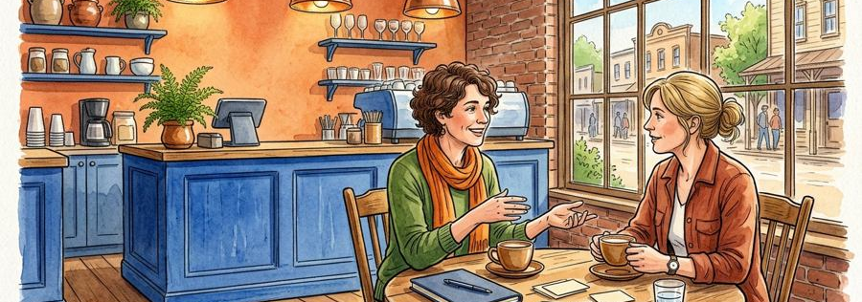
Figure 1. Fictional illustration, not a site record.
LOCAL TABLE is a fictional neighbourhood cafe concept used to practise a transparent business-plan document. No cafe, venue, staff or customer base is established.
The document separates an intended experience from unverified demand, a simplified arithmetic model and the responsible work a real business would require.

Assumption record
Use this section to record a bounded response to the question below. Retain the distinction between the fictional example, your interpretation and any separate evidence a real use would require.
QUESTION FOR THE NEXT READER
What decision can this example responsibly support?
ASSUMPTION | What decision can this example responsibly support?
EVIDENCE STATUS | Unknown / not established by this template

02 / LOCAL TABLE

Read intention, model and limits together.
Figure 1. Fictional illustration, not a site record.
The plan moves through purpose, customer question, offer, alternatives, resource categories, arithmetic and review. Its numbers are invented teaching units.
Do not share the arithmetic table without its assumptions. A plan can be legible and still contain important unknowns that prevent a real commitment.

Assumption record
Use this section to record a bounded response to the question below. Retain the distinction between the fictional example, your interpretation and any separate evidence a real use would require.
QUESTION FOR THE NEXT READER
Which limitation belongs beside the model?
ASSUMPTION | Which limitation belongs beside the model?
EVIDENCE STATUS | Unknown / not established by this template

03 / LOCAL TABLE

Define the intended experience.

Figure 2. Fictional illustration, not a site record.
Imagine a small place for a pause and a conversation over a drink. This is an experience intention, not evidence of a viable location or customer preference.
A real plan would need context-specific sources. The illustration cannot establish footfall, local competition, opening conditions or willingness to pay.

Assumption record
Use this section to record a bounded response to the question below. Retain the distinction between the fictional example, your interpretation and any separate evidence a real use would require.
QUESTION FOR THE NEXT READER
What would need to be learned about the real context?
ASSUMPTION | What would need to be learned about the real context?
EVIDENCE STATUS | Unknown / not established by this template

04 / LOCAL TABLE

Ask a customer question without inventing a persona.
Figure 2. Fictional illustration, not a site record.
The fictional question is whether a proposed experience addresses a meaningful task for people in a particular context. No customer interviews are supplied.
Do not attribute preferences to a demographic group or turn an invented conversation into a testimonial. Keep the missing evidence explicit.

Assumption record
Use this section to record a bounded response to the question below. Retain the distinction between the fictional example, your interpretation and any separate evidence a real use would require.
QUESTION FOR THE NEXT READER
Which source would clarify the proposed customer task?
ASSUMPTION | Which source would clarify the proposed customer task?
EVIDENCE STATUS | Unknown / not established by this template

05 / LOCAL TABLE

Describe the offer provisionally.

Figure 3. Fictional illustration, not a site record.
A simple imagined offer might combine a drink, a place to sit and a readable description of the experience. No actual menu, price or service promise is supplied.
The purpose is to discuss coherence, not to claim operational readiness. Suitability, permissions and responsible delivery arrangements remain separate questions.

Assumption record
Use this section to record a bounded response to the question below. Retain the distinction between the fictional example, your interpretation and any separate evidence a real use would require.
QUESTION FOR THE NEXT READER
Which part of the offer is still only a premise?
ASSUMPTION | Which part of the offer is still only a premise?
EVIDENCE STATUS | Unknown / not established by this template

06 / LOCAL TABLE

List resource categories before totals.
Figure 3. Fictional illustration, not a site record.
Potential categories include venue arrangements, staffing, supplies, maintenance and relevant reviews. This example does not supply actual costs.
An omitted category is not a zero cost. A short decorative budget would hide uncertainty rather than resolve it.

Assumption record
Use this section to record a bounded response to the question below. Retain the distinction between the fictional example, your interpretation and any separate evidence a real use would require.
QUESTION FOR THE NEXT READER
Which cost category is missing from the simplified model?
ASSUMPTION | Which cost category is missing from the simplified model?
EVIDENCE STATUS | Unknown / not established by this template

07 / LOCAL TABLE

Use transparent teaching arithmetic.

Figure 4. Fictional illustration, not a site record.
Assume 30 fictional transactions at 8 teaching units each: 30 × 8 = 240 units. Assume 30 × 3 = 90 variable units and 120 fixed units; the model leaves 30 units.
The calculation excludes taxes and many real categories. It is not profit, a currency forecast or evidence that a cafe is viable. None of the quantities is observed demand.

Assumption record
Use this section to record a bounded response to the question below. Retain the distinction between the fictional example, your interpretation and any separate evidence a real use would require.
QUESTION FOR THE NEXT READER
Which assumption would most change this arithmetic?
INVENTED MODEL | TEACHING UNITS ONLY
30 × 8 − 30 × 3 − 120 | 30 remainder, not profit
20 × 8 − 20 × 3 − 120 | −20 remainder, not forecast

08 / LOCAL TABLE

Compare a different model input.
Figure 4. Fictional illustration, not a site record.
Keeping the same invented unit values but using 20 transactions gives 160 units, 60 variable units and 120 fixed units, leaving negative 20 units.
This is a sensitivity illustration, not a forecast range or a complete financial analysis. The example shows why a result depends on assumptions.

Assumption record
Use this section to record a bounded response to the question below. Retain the distinction between the fictional example, your interpretation and any separate evidence a real use would require.
QUESTION FOR THE NEXT READER
What changes when the assumed quantity changes?
INVENTED MODEL | TEACHING UNITS ONLY
30 × 8 − 30 × 3 − 120 | 30 remainder, not profit
20 × 8 − 20 × 3 − 120 | −20 remainder, not forecast

09 / LOCAL TABLE

State a learning gate instead of a launch date.

Figure 5. Fictional illustration, not a site record.
A next step could seek relevant context, clarify requirements and assign responsible review. It is not a promise to open a venue or commit funds.
Keep dependencies visible. A real business plan would need suitable sources, responsible people and separate legal, financial and operational processes.

Assumption record
Use this section to record a bounded response to the question below. Retain the distinction between the fictional example, your interpretation and any separate evidence a real use would require.
QUESTION FOR THE NEXT READER
What evidence is needed before any real commitment?
ASSUMPTION | What evidence is needed before any real commitment?
EVIDENCE STATUS | Unknown / not established by this template

10 / LOCAL TABLE

Keep the model attached to the handoff.
Figure 5. Fictional illustration, not a site record.
Share the invented inputs, arithmetic, omissions and intended question together. Do not describe the remainder as actual profit or an approved budget.
No funding, lease, permission or commercial outcome is supplied. The value of the document is its readable assumptions, not a claim of readiness.

Assumption record
Use this section to record a bounded response to the question below. Retain the distinction between the fictional example, your interpretation and any separate evidence a real use would require.
QUESTION FOR THE NEXT READER
Which statement could mislead if the assumptions were removed?
ASSUMPTION | Which statement could mislead if the assumptions were removed?
EVIDENCE STATUS | Unknown / not established by this template

