01 / OPEN SATURDAY

An invitation to discuss an event idea.

Figure 1. Fictional illustration, not a site record.
OPEN SATURDAY imagines a community book-exchange conversation. The title is a fictional name, not a real date, opening announcement or invitation to attend.
The document organises purpose, imagined experience, roles and open questions. It does not establish that any real event can proceed.

Planning question
Use this section to record a bounded response to the question below. Retain the distinction between the fictional example, your interpretation and any separate evidence a real use would require.
QUESTION FOR THE NEXT READER
What is being proposed rather than announced?
CONCEPT ORDER: NOT A REAL TIMED PROGRAMME | Introduce → explore: Clarify purpose and questions | Exchange → close: What is being proposed rather than announced?

02 / OPEN SATURDAY

Read the event concept in order.
Figure 1. Fictional illustration, not a site record.
Begin with purpose and audience question, then the imagined exchange, responsibilities, communication and handoff. Separate the concept from a real operational plan.
The reading order is not a timed running sheet. No times, duration, venue capacity, staffing requirement or turnout estimate is supplied.

Planning question
Use this section to record a bounded response to the question below. Retain the distinction between the fictional example, your interpretation and any separate evidence a real use would require.
QUESTION FOR THE NEXT READER
Which section requires separate responsible review?
CONCEPT ORDER: NOT A REAL TIMED PROGRAMME | Introduce → explore: Clarify purpose and questions | Exchange → close: Which section requires separate responsible review?

03 / OPEN SATURDAY

Name the purpose without claiming demand.

Figure 2. Fictional illustration, not a site record.
The fictional purpose is to create a setting in which people could exchange books and conversation. That is an intention, not a measured community need.
No participant research or commitment exists. A real organiser would need context-specific evidence and an appropriate review process before making public promises.

Planning question
Use this section to record a bounded response to the question below. Retain the distinction between the fictional example, your interpretation and any separate evidence a real use would require.
QUESTION FOR THE NEXT READER
What would establish a meaningful real purpose?
CONCEPT ORDER: NOT A REAL TIMED PROGRAMME | Introduce → explore: Clarify purpose and questions | Exchange → close: What would establish a meaningful real purpose?

04 / OPEN SATURDAY

Describe an imagined arrival.
Figure 2. Fictional illustration, not a site record.
Imagine a reader encountering a clear explanation of the concept and choosing whether to join a conversation. This is not a route or access instruction for a real venue.
The illustration supplies atmosphere only. It cannot establish usable entrances, capacities, emergency arrangements or accessibility.

Planning question
Use this section to record a bounded response to the question below. Retain the distinction between the fictional example, your interpretation and any separate evidence a real use would require.
QUESTION FOR THE NEXT READER
Which arrival question cannot be answered from the scene?
CONCEPT ORDER: NOT A REAL TIMED PROGRAMME | Introduce → explore: Clarify purpose and questions | Exchange → close: Which arrival question cannot be answered from the scene?

05 / OPEN SATURDAY

Keep the exchange rules provisional.

Figure 3. Fictional illustration, not a site record.
A concept discussion might ask how books would be described, what choices participants would have and what information would need to be available. No operating rules are approved.
Do not turn the example into instructions for handling real property or participant records. Appropriate responsibilities and conditions would need separate clarification.

Planning question
Use this section to record a bounded response to the question below. Retain the distinction between the fictional example, your interpretation and any separate evidence a real use would require.
QUESTION FOR THE NEXT READER
Which rule would require real contextual review?
CONCEPT ORDER: NOT A REAL TIMED PROGRAMME | Introduce → explore: Clarify purpose and questions | Exchange → close: Which rule would require real contextual review?

06 / OPEN SATURDAY

Use role categories honestly.
Figure 3. Fictional illustration, not a site record.
Possible categories include concept writer, source reviewer, venue contact and communication reviewer. These labels do not appoint people or confirm that they consented to a task.
A real event would require agreed responsibilities outside this template. Do not fill gaps with invented names or imply an approval through a tidy table.

Planning question
Use this section to record a bounded response to the question below. Retain the distinction between the fictional example, your interpretation and any separate evidence a real use would require.
QUESTION FOR THE NEXT READER
Who could verify a real responsibility?
CONCEPT ORDER: NOT A REAL TIMED PROGRAMME | Introduce → explore: Clarify purpose and questions | Exchange → close: Who could verify a real responsibility?

07 / OPEN SATURDAY

Sequence the discussion without a clock.
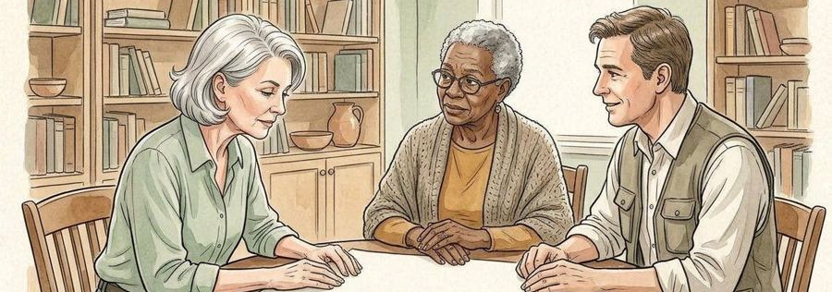
Figure 4. Fictional illustration, not a site record.
The concept sequence is introduce, explore, exchange questions and close. These are discussion headings, not times or technical cues.
A real programme would require appropriate planning and review. This document gives no schedule, operational procedure or promise about what happens on an actual day.

Planning question
Use this section to record a bounded response to the question below. Retain the distinction between the fictional example, your interpretation and any separate evidence a real use would require.
QUESTION FOR THE NEXT READER
What dependency must be clarified before scheduling?
CONCEPT ORDER: NOT A REAL TIMED PROGRAMME | Introduce → explore: Clarify purpose and questions | Exchange → close: What dependency must be clarified before scheduling?

08 / OPEN SATURDAY

Communicate only what exists.
Figure 4. Fictional illustration, not a site record.
A draft message should label the idea as under discussion and state the response being sought. It should not announce a confirmed venue, booking or attendance opportunity.
The example contains no real registration, ticket or checkout. A call to action must match something that actually exists in the intended context.

Planning question
Use this section to record a bounded response to the question below. Retain the distinction between the fictional example, your interpretation and any separate evidence a real use would require.
QUESTION FOR THE NEXT READER
Which phrase could accidentally announce a real event?
CONCEPT ORDER: NOT A REAL TIMED PROGRAMME | Introduce → explore: Clarify purpose and questions | Exchange → close: Which phrase could accidentally announce a real event?

09 / OPEN SATURDAY

Collect questions, not invented outcomes.
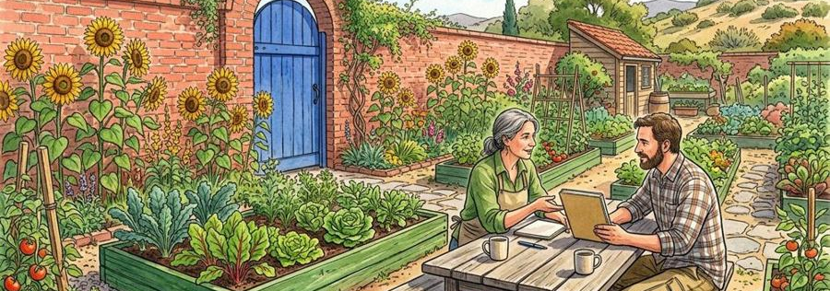
Figure 5. Fictional illustration, not a site record.
After a fictional concept discussion, record what remains unclear and what type of source is needed. Do not report a turnout, satisfaction score or completed event.
Any real evaluation would need its own method and responsible data handling. No participant identifiers are needed in this document.

Planning question
Use this section to record a bounded response to the question below. Retain the distinction between the fictional example, your interpretation and any separate evidence a real use would require.
QUESTION FOR THE NEXT READER
What would a responsible real evaluation require?
CONCEPT ORDER: NOT A REAL TIMED PROGRAMME | Introduce → explore: Clarify purpose and questions | Exchange → close: What would a responsible real evaluation require?

10 / OPEN SATURDAY

Leave the concept ready for review.
Figure 5. Fictional illustration, not a site record.
The handoff states purpose, fictional status, unresolved conditions and the response requested. It does not declare the event ready to run.
No date, venue, permissions, safety process or access approval is supplied. Keep those boundaries visible wherever the concept is shared.

Planning question
Use this section to record a bounded response to the question below. Retain the distinction between the fictional example, your interpretation and any separate evidence a real use would require.
QUESTION FOR THE NEXT READER
What remains outside the scope of this planning document?
CONCEPT ORDER: NOT A REAL TIMED PROGRAMME | Introduce → explore: Clarify purpose and questions | Exchange → close: What remains outside the scope of this planning document?

