01 / SHIFT READY

Train a handoff, not a technical operation.

Figure 1. Fictional illustration, not a site record.
SHIFT READY practises a source-aware document handoff. It is a fictional adult training example with no machinery, hazardous task or operational permission.
The learner practises checking purpose, version, source and next question before sharing a document. Completion of a worksheet is not certification.

Practice checkpoint
Use this section to record a bounded response to the question below. Retain the distinction between the fictional example, your interpretation and any separate evidence a real use would require.
QUESTION FOR THE NEXT READER
What makes a handoff understandable to another reader?
PRACTICE CHECK | NOT CERTIFICATION
[ ] Purpose / version | Identify the actual copy
[ ] Source / next action | What makes a handoff understandable to another reader?

02 / SHIFT READY

Follow the practice sequence.
Figure 1. Fictional illustration, not a site record.
Read the purpose, inspect an example, practise a check, compare a revision and rehearse the handoff. Return to an earlier step when context is missing.
The ten pages are learning sections, not a timed shift schedule. No employer, trainer or participant has been appointed by this template.

Practice checkpoint
Use this section to record a bounded response to the question below. Retain the distinction between the fictional example, your interpretation and any separate evidence a real use would require.
QUESTION FOR THE NEXT READER
Which practice step would you repeat?
PRACTICE CHECK | NOT CERTIFICATION
[ ] Purpose / version | Identify the actual copy
[ ] Source / next action | Which practice step would you repeat?

03 / SHIFT READY

Identify the document purpose.

Figure 2. Fictional illustration, not a site record.
Before changing a file, state what it is for and who is expected to respond. A proposal, a draft note and an authorised record have different meanings.
The practice file is fictional. Calling it a final version would not make its claims verified. A clear purpose label reduces avoidable ambiguity.

Practice checkpoint
Use this section to record a bounded response to the question below. Retain the distinction between the fictional example, your interpretation and any separate evidence a real use would require.
QUESTION FOR THE NEXT READER
What response does this document actually request?
PRACTICE CHECK | NOT CERTIFICATION
[ ] Purpose / version | Identify the actual copy
[ ] Source / next action | What response does this document actually request?

04 / SHIFT READY

Read the version label.
Figure 2. Fictional illustration, not a site record.
A local file name is an organisational aid, not proof that the content is current. Check the document context rather than relying only on a confident title.
For the exercise, distinguish original source, edited copy and exported copy. Browser editing does not rewrite the original download automatically.

Practice checkpoint
Use this section to record a bounded response to the question below. Retain the distinction between the fictional example, your interpretation and any separate evidence a real use would require.
QUESTION FOR THE NEXT READER
Which copy are you about to share?
PRACTICE CHECK | NOT CERTIFICATION
[ ] Purpose / version | Identify the actual copy
[ ] Source / next action | Which copy are you about to share?

05 / SHIFT READY

Keep the source with the statement.

Figure 3. Fictional illustration, not a site record.
A factual statement should retain enough context for another reader to understand its origin and limitation. The training scene itself is not a source study.
In the practice example, rewrite A successful project as A fictional concept under discussion. The revised statement avoids inventing an outcome.

Practice checkpoint
Use this section to record a bounded response to the question below. Retain the distinction between the fictional example, your interpretation and any separate evidence a real use would require.
QUESTION FOR THE NEXT READER
Which source supports the sentence you are checking?
PRACTICE CHECK | NOT CERTIFICATION
[ ] Purpose / version | Identify the actual copy
[ ] Source / next action | Which source supports the sentence you are checking?

06 / SHIFT READY

Use a short check without inventing approval.
Figure 3. Fictional illustration, not a site record.
The practice check asks purpose, version, source and next action. Marking a box records what you checked, not that a responsible authority approved the document.
A real organisation may need a separate control process. This template supplies none and should not be presented as an audit or compliance system.

Practice checkpoint
Use this section to record a bounded response to the question below. Retain the distinction between the fictional example, your interpretation and any separate evidence a real use would require.
QUESTION FOR THE NEXT READER
What does a checked box mean in this exercise?
PRACTICE CHECK | NOT CERTIFICATION
[ ] Purpose / version | Identify the actual copy
[ ] Source / next action | What does a checked box mean in this exercise?

07 / SHIFT READY

Escalate an unanswered question.
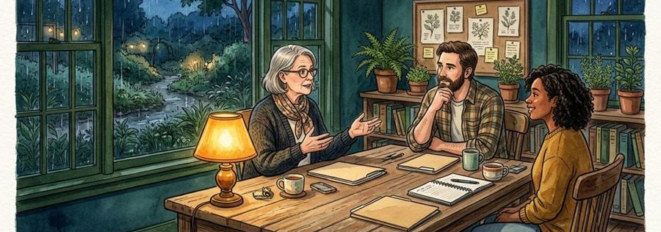
Figure 4. Fictional illustration, not a site record.
When the source or authority is unclear, keep the question open and identify the type of responsible reviewer needed. Do not guess an answer to complete the form.
An escalation note should identify the passage and missing context. It does not require personal or sensitive participant information.

Practice checkpoint
Use this section to record a bounded response to the question below. Retain the distinction between the fictional example, your interpretation and any separate evidence a real use would require.
QUESTION FOR THE NEXT READER
Which question belongs with a reviewer?
PRACTICE CHECK | NOT CERTIFICATION
[ ] Purpose / version | Identify the actual copy
[ ] Source / next action | Which question belongs with a reviewer?

08 / SHIFT READY

Practise a correction.
Figure 4. Fictional illustration, not a site record.
Change one ambiguous sentence and explain why. Keep the correction separate from the evidence history so a reader does not assume new research occurred.
A useful correction might clarify that a number is fictional or a date is not supplied. Do not convert an assumption into a measured result.

Practice checkpoint
Use this section to record a bounded response to the question below. Retain the distinction between the fictional example, your interpretation and any separate evidence a real use would require.
QUESTION FOR THE NEXT READER
What misunderstanding does the correction prevent?
PRACTICE CHECK | NOT CERTIFICATION
[ ] Purpose / version | Identify the actual copy
[ ] Source / next action | What misunderstanding does the correction prevent?

09 / SHIFT READY

Rehearse a two-sentence handoff.

Figure 5. Fictional illustration, not a site record.
State the document purpose and version in the first sentence. State the open question and requested response in the second.
Example: This is a fictional concept draft for discussion. Please identify the source needed to clarify the stated assumption. No approval is implied.

Practice checkpoint
Use this section to record a bounded response to the question below. Retain the distinction between the fictional example, your interpretation and any separate evidence a real use would require.
QUESTION FOR THE NEXT READER
Write a bounded handoff in two sentences.
PRACTICE CHECK | NOT CERTIFICATION
[ ] Purpose / version | Identify the actual copy
[ ] Source / next action | Write a bounded handoff in two sentences.

10 / SHIFT READY

Record a learning reflection.
Figure 5. Fictional illustration, not a site record.
Review which check was easiest to overlook and what reminder would help next time. The reflection belongs to this writing practice, not a real competency assessment.
Do not issue a passing mark or certificate from this template. Keep the next practice question visible and retain only information appropriate to share.

Practice checkpoint
Use this section to record a bounded response to the question below. Retain the distinction between the fictional example, your interpretation and any separate evidence a real use would require.
QUESTION FOR THE NEXT READER
What will you check first in your next handoff?
PRACTICE CHECK | NOT CERTIFICATION
[ ] Purpose / version | Identify the actual copy
[ ] Source / next action | What will you check first in your next handoff?

