01 / STILLWATER

Propose a conversation, not a finished room.

Figure 1. Fictional illustration, not a site record.
STILLWATER explores an imagined shared reading corner as a proposal for discussion. Its scenes establish visual tone, not a real site or approved design.
The proposal asks whether a small reading-focused setting is worth investigating. It does not claim that a venue, budget, operator or responsible reviewer has been appointed.

Condition for discussion
Use this section to record a bounded response to the question below. Retain the distinction between the fictional example, your interpretation and any separate evidence a real use would require.
QUESTION FOR THE NEXT READER
State the decision this discussion could responsibly inform.
PROPOSED | State the decision this discussion could responsibly inform.
CONDITION | Source and responsible review remain to be established

02 / STILLWATER

Use the proposal in three passes.
Figure 1. Fictional illustration, not a site record.
First read the intention, then the unresolved conditions, then the proposed handoff. A persuasive image should not hide a missing source.
Pages 3–5 explain the idea and alternatives. Pages 6–8 distinguish responsibilities, resources and review questions. Pages 9–10 identify the response sought and the limits of the proposal.

Condition for discussion
Use this section to record a bounded response to the question below. Retain the distinction between the fictional example, your interpretation and any separate evidence a real use would require.
QUESTION FOR THE NEXT READER
Choose a question for each reading pass.
PROPOSED | Choose a question for each reading pass.
CONDITION | Source and responsible review remain to be established

03 / STILLWATER

Define the problem without inventing demand.
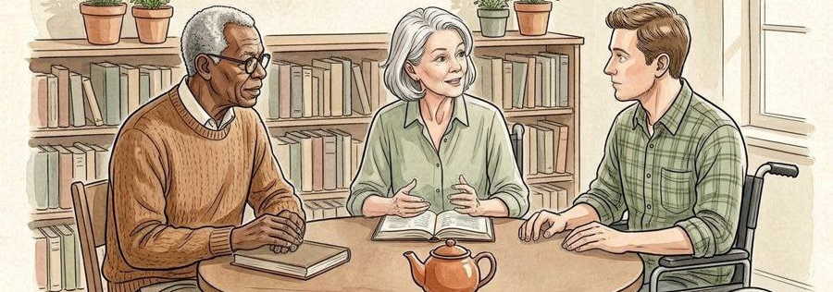
Figure 2. Fictional illustration, not a site record.
The imagined issue is a desire for a quieter place to read together. That desire is a premise for the exercise, not a measured community need.
A real problem statement would identify its source and scope. Until such evidence exists, use language such as intention to explore rather than unmet demand has been proven.

Condition for discussion
Use this section to record a bounded response to the question below. Retain the distinction between the fictional example, your interpretation and any separate evidence a real use would require.
QUESTION FOR THE NEXT READER
Which source would establish a real need?
PROPOSED | Which source would establish a real need?
CONDITION | Source and responsible review remain to be established

04 / STILLWATER

Describe the proposed experience.
Figure 2. Fictional illustration, not a site record.
Imagine arriving, finding a place to pause and choosing whether to read alone or join a conversation. This narrative is not a tested user journey.
The sequence helps a reader discuss atmosphere and purpose. It does not supply an approved route, furniture arrangement, capacity or rule for operating a real space.

Condition for discussion
Use this section to record a bounded response to the question below. Retain the distinction between the fictional example, your interpretation and any separate evidence a real use would require.
QUESTION FOR THE NEXT READER
Which part of the experience remains an assumption?
PROPOSED | Which part of the experience remains an assumption?
CONDITION | Source and responsible review remain to be established

05 / STILLWATER

Keep an alternative beside the favourite.

Figure 3. Fictional illustration, not a site record.
Compare a dedicated reading corner with a temporary reading session in an existing room. Both are fictional options rather than confirmed plans.
An alternative is useful when it tests the same intention under different conditions. Do not turn a preferred image into evidence that the preferred option is feasible.

Condition for discussion
Use this section to record a bounded response to the question below. Retain the distinction between the fictional example, your interpretation and any separate evidence a real use would require.
QUESTION FOR THE NEXT READER
What would make the alternative worth investigating?
PROPOSED | What would make the alternative worth investigating?
CONDITION | Source and responsible review remain to be established

06 / STILLWATER

Separate responsibilities from appointments.
Figure 3. Fictional illustration, not a site record.
The concept writer can state the idea, a source reviewer can check evidence and an authorised decision-maker can address a real commitment. These are role categories only.
No person has accepted a task through this template. Confirm actual responsibility outside the document before presenting a named owner or a reviewed decision.

Condition for discussion
Use this section to record a bounded response to the question below. Retain the distinction between the fictional example, your interpretation and any separate evidence a real use would require.
QUESTION FOR THE NEXT READER
Who would need to review a real proposal?
PROPOSED | Who would need to review a real proposal?
CONDITION | Source and responsible review remain to be established

07 / STILLWATER

Name the missing resource categories.

Figure 4. Fictional illustration, not a site record.
This example supplies no prices. Venue arrangements, staffing, furniture, maintenance and appropriate reviews remain separate questions.
A short list of attractive objects is not a budget. Record unknown categories explicitly rather than inserting invented totals to make the document look finished.

Condition for discussion
Use this section to record a bounded response to the question below. Retain the distinction between the fictional example, your interpretation and any separate evidence a real use would require.
QUESTION FOR THE NEXT READER
Which omitted cost category could change the discussion?
PROPOSED | Which omitted cost category could change the discussion?
CONDITION | Source and responsible review remain to be established

08 / STILLWATER

Record the conditions for a next step.
Figure 4. Fictional illustration, not a site record.
A next conversation could clarify source quality, responsibility and the range of options. It is not permission to purchase, install or operate anything.
Use a condition such as obtain relevant site information rather than a promise such as open next month. A condition makes the dependency visible without inventing a schedule.

Condition for discussion
Use this section to record a bounded response to the question below. Retain the distinction between the fictional example, your interpretation and any separate evidence a real use would require.
QUESTION FOR THE NEXT READER
What must be clarified before commitment?
PROPOSED | What must be clarified before commitment?
CONDITION | Source and responsible review remain to be established

09 / STILLWATER

Ask for a bounded response.

Figure 5. Fictional illustration, not a site record.
Invite a reader to identify a missing source, challenge an assumption or suggest a relevant alternative. Do not ask the document to stand in for formal approval.
A useful response identifies the passage being discussed and the kind of evidence needed. Agreeing with an image is not the same as accepting a real project responsibility.

Condition for discussion
Use this section to record a bounded response to the question below. Retain the distinction between the fictional example, your interpretation and any separate evidence a real use would require.
QUESTION FOR THE NEXT READER
What exact response would improve the next draft?
PROPOSED | What exact response would improve the next draft?
CONDITION | Source and responsible review remain to be established

10 / STILLWATER

Retain the proposal boundary.
Figure 5. Fictional illustration, not a site record.
Attach the fictional-source note, current version and unresolved conditions whenever the proposal is shared. The pictures remain illustrations even after the text is edited.
A real proposal requires its own verified context and appropriate decision process. This template organises a conversation; it does not certify feasibility, funding or compliance.

Condition for discussion
Use this section to record a bounded response to the question below. Retain the distinction between the fictional example, your interpretation and any separate evidence a real use would require.
QUESTION FOR THE NEXT READER
Which boundary must travel with the exported document?
PROPOSED | Which boundary must travel with the exported document?
CONDITION | Source and responsible review remain to be established

