KEPLER ORBIT ELEMENTS TO ECI CARTESIAN COORDINATES CONVERSION

Elliptical Case (02/02/02)

Compute orbital position and velocity at time t given the orbital elements.
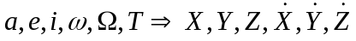
where  is the right ascension of the ascending node.

- Compute the mean anomaly, MA, (0° → 360°),
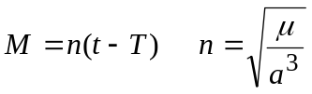

- Compute the eccentric anomaly, EA, (0° → 360°),

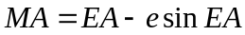

- Compute the true anomaly, , (0° → 360°),
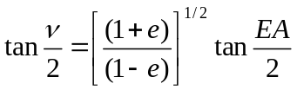
nu = 2 * atan(sqrt((1 + e) / (1 - e)) * tan(ea / 2))

If EA < 180° then < 180° (There is no need to do a quadrant check. The equation above will automatically yield the correct value of .)

- Compute the radius, r,
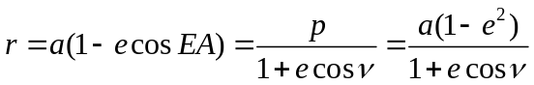
r = a * (1 - e * cos(ea))

- Compute the specific angular momentum, h,
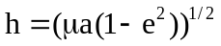
h = sqrt(mu * a * (1 - e ** 2))

- Compute the position components, X,Y,Z

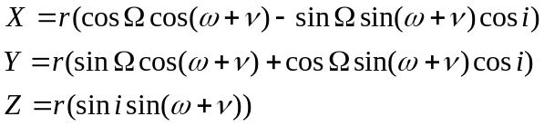

x = r * (cos(Ω) * cos(ω + nu) - sin(Ω) * sin(ω + nu) * cos(i))
y = r * (sin(Ω) * cos(ω + nu) + cos(Ω) * sin(ω + nu) * cos(i))
z = r * (sin(i) * sin(ω + nu))

7. Compute the velocity components,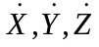

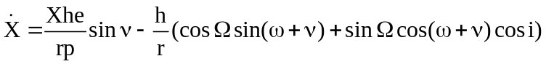
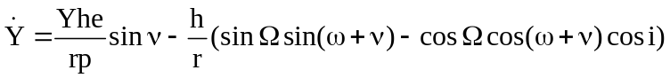
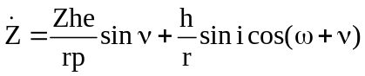
p = a * (1 - e ** 2)
dx = (x * h * e / (r * p)) * sin(nu) - (h / r) * (cos(Ω) * sin(ω + nu) + sin(Ω) * cos(ω + nu) * cos(i))
dy = (y * h * e / (r * p)) * sin(nu) - (h / r) * (sin(Ω) * sin(ω + nu) - cos(Ω) * cos(ω + nu) * cos(i))
dz = (z * h * e / (r * p)) * sin(nu) + (h / r) * (cos(ω + nu) * sin(i))

8. To obtain ECF (Earth Centered and Fixed) coordinates

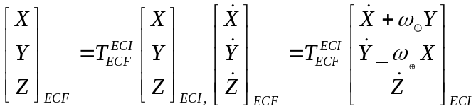

where 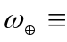rotation rate of the earth (7.2921158553 x 10⁻⁵ rad/sec)

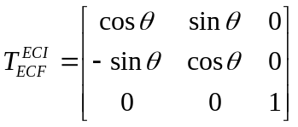

is the Greenwich hour angle of the Earth's prime meridian, i.e. the angle between the inertial X-axis and the ECF X-axis.

