Data Structures aND Algorithms (95-771) - Homework 1

Name: Licia Bordignon
Andrew ID: lbordign
Date: 27 Jan, 2026
- The name and assignment information are included as comments at the beginning of every source file

Part 1 – Object Node Project
In the directory Part1_ObjectNodeProject there are three working main routines:
- ObjectNode.java→ > src > edu > colorado > nodes > ObjectNode.java
- SinglyLinkedList.java→ >src > edu > cmu > andrew > lbordign > SinglyLinkedList.java
- OrderedLinkedListOfIntegers.java→ >src > edu > cmu > andrew > lbordign > OrderedLinkedListOfIntegers.java
Commpents describing big theta of each routine and preconditions and postconditions where appropriate are included in the files.
Screenshots demonstrating program execution:
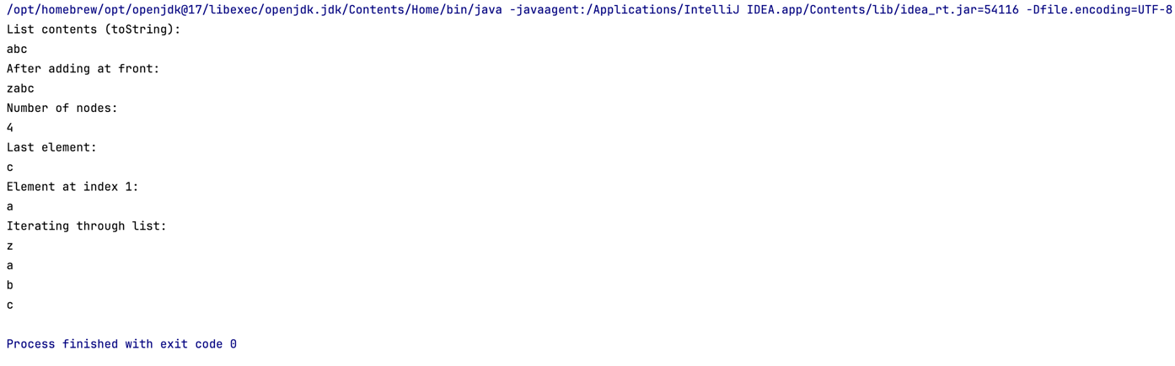
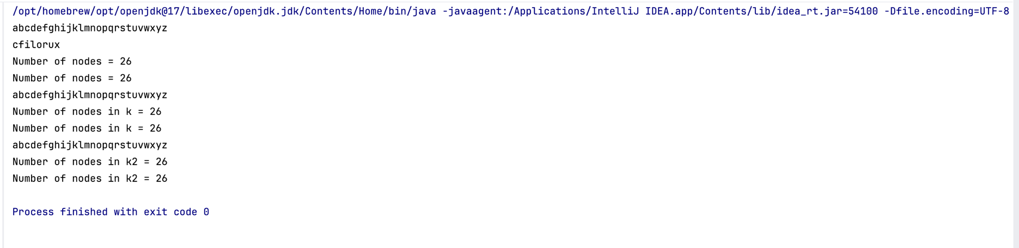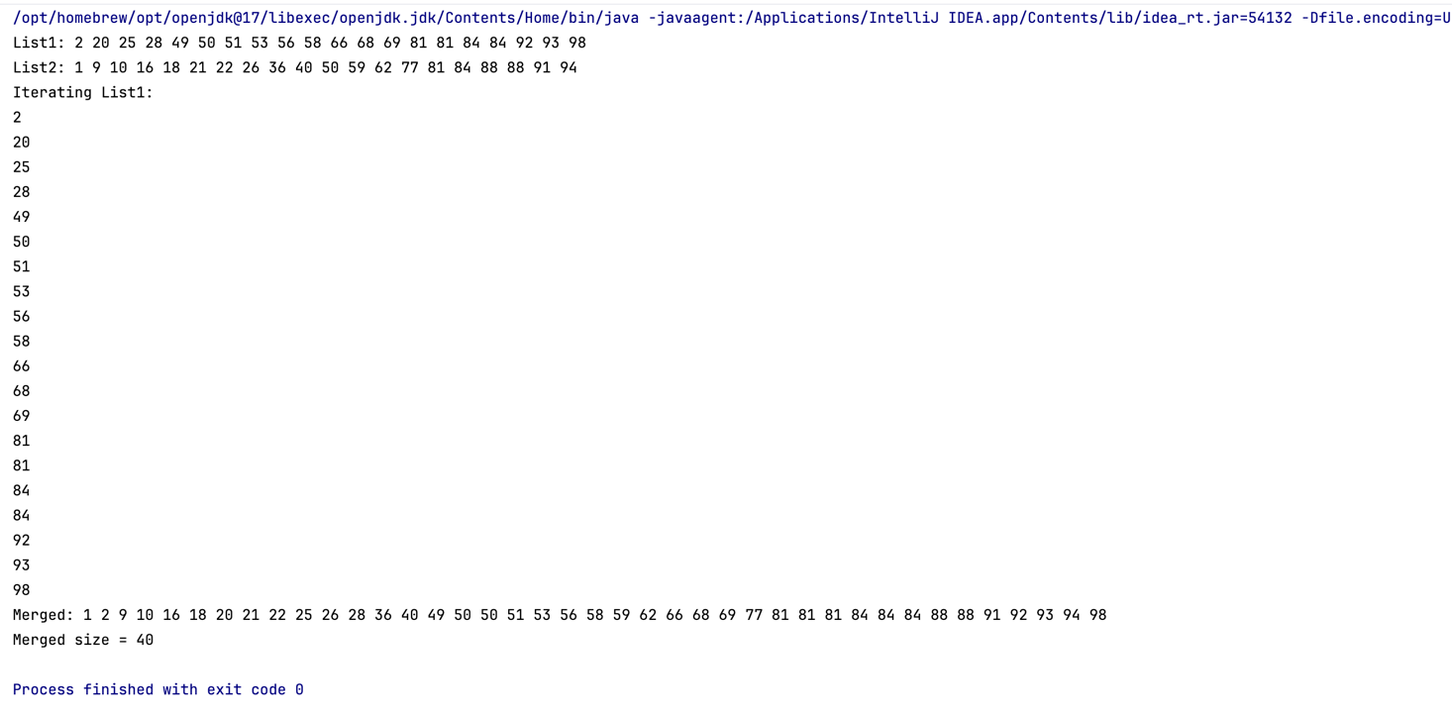

Part 2 – Merkle Hellman Knapsack Crypto Project
The main code for this part is located in:
Part2_MerkleHellman-Knapsack-Crypto-Project > src > MerkleHellman.java
The code uses the singly linked lists from Part 1 to hold BigIntegers and it includes comments describing how key generation and the Merkle Hellman Knapsack cryptography is being performed.
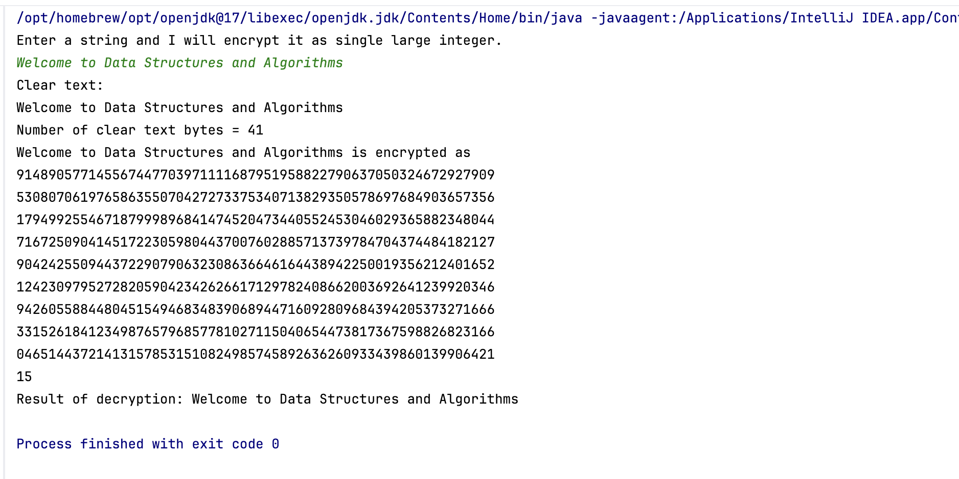
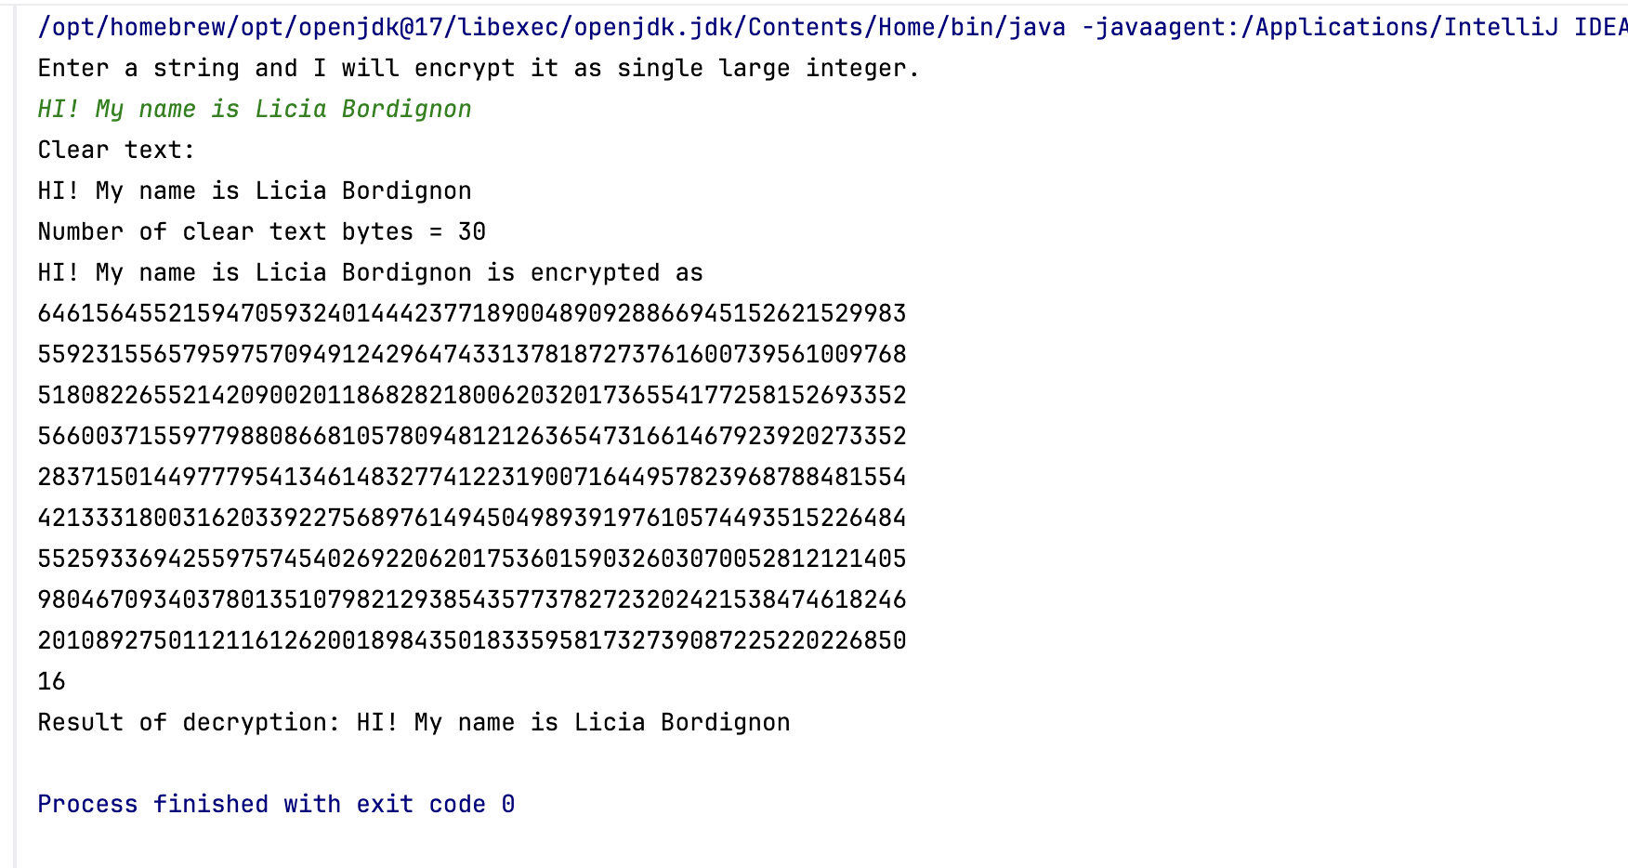
Screenshots demonstrating program execution:
Example execution 1: “HI! My name is Licia Bordignon”

Example execution 2: “Welcome to Data Structures and Algorithms”
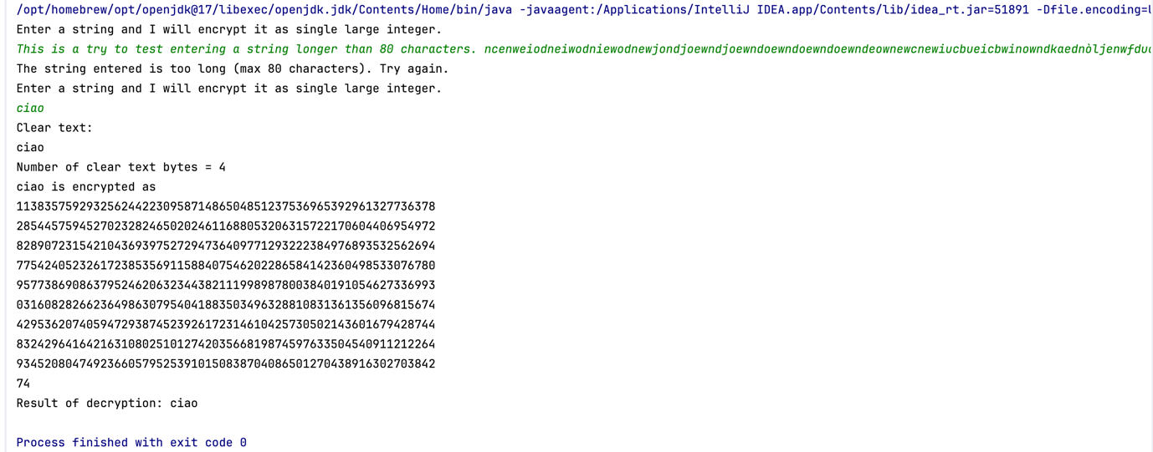
Example execution 3. This example demonstrates the program’s behavior when the user enters a string that exceeds the maximum allowed length of 80 characters. “This is a try to test entering a string longer than 80 characters. ncenwei….”
The program correctly detects that the input is too long, prints an error message informing the user that the string exceeds the allowed length, and prompts the user to try again. The user then enters a valid string, "ciao". After displaying the encrypted value and the result of the decryption, the program terminates normally.

Part 3 – Merkle Tree Project
The main code for this part is located in:
Part3_MerkleTreeProject > src > MerkleTree.java
The implementation uses the singly linked list classes developed in Part 1 and includes comments describing the Merkle tree building process. The Merkle roots for the provided files are generated by running the program, as shown in the screenshots below. These computed Merkle roots are also included as comments within the main routine. Among the provided files, the one whose Merkle root matches the required value is CrimeLatLonXY.csv.
Screenshots demonstrating program execution:
smallFile.txt
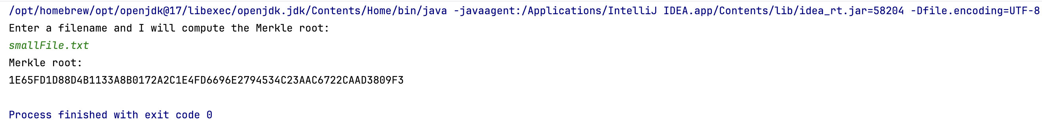

CrimeLatLonXY.csv → this file has the Merkel root that we seek ✅
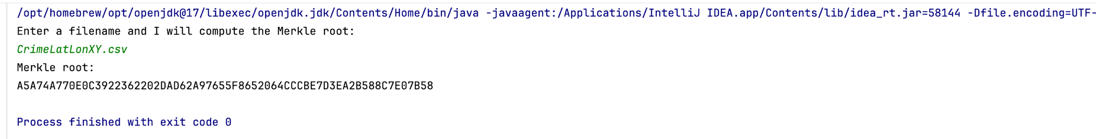
CrimeLatLonXY1990_Size2.csv
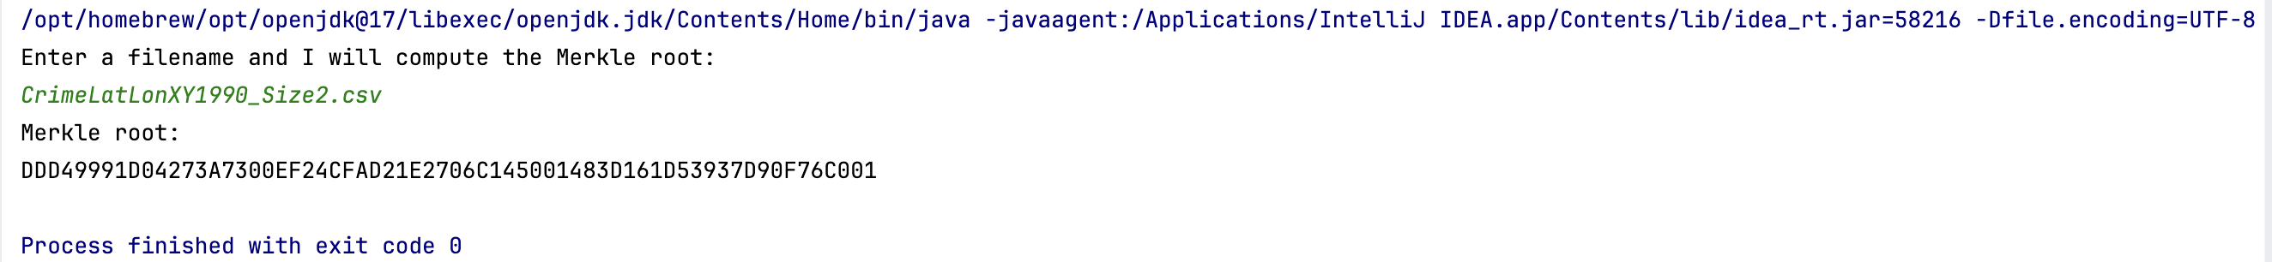
CrimeLatLonXY1990_Size3.csv
