Figures

## LH plots

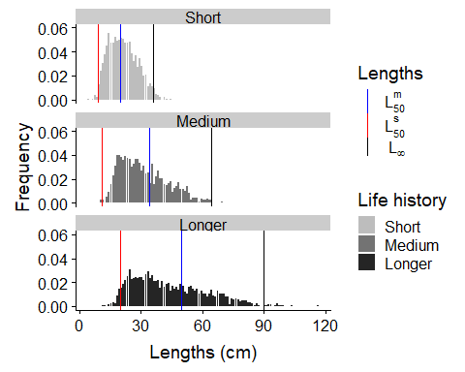

## SPR

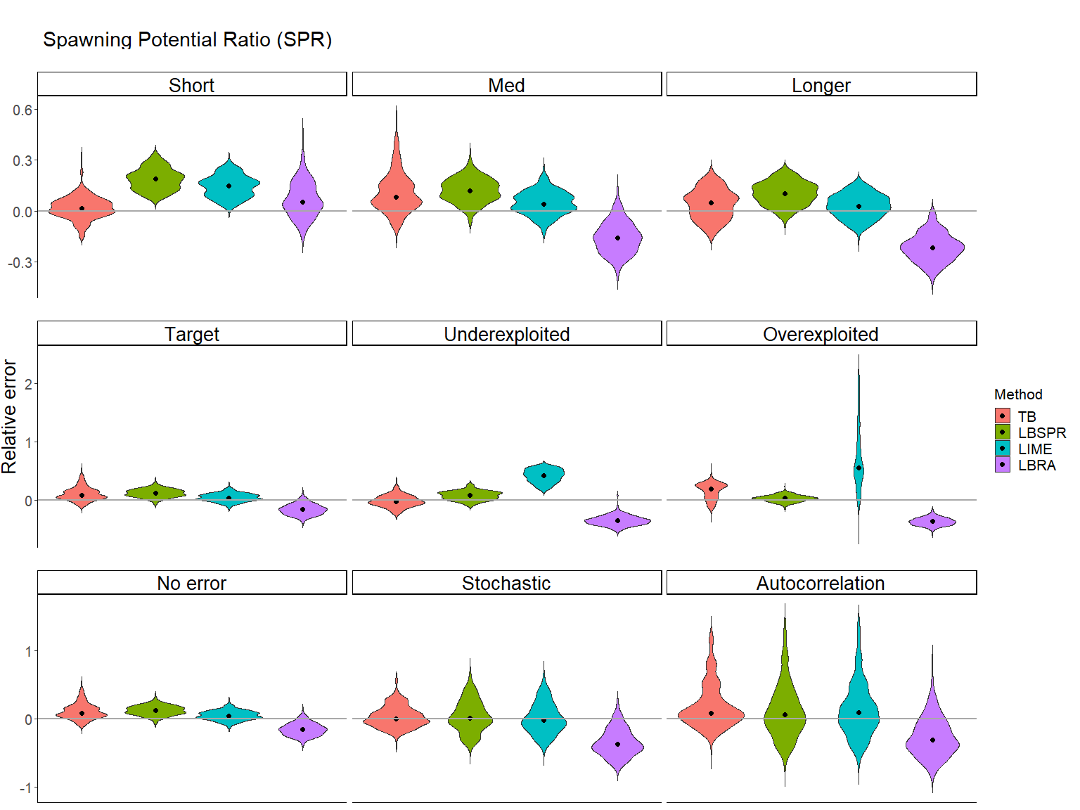

## FFmsy

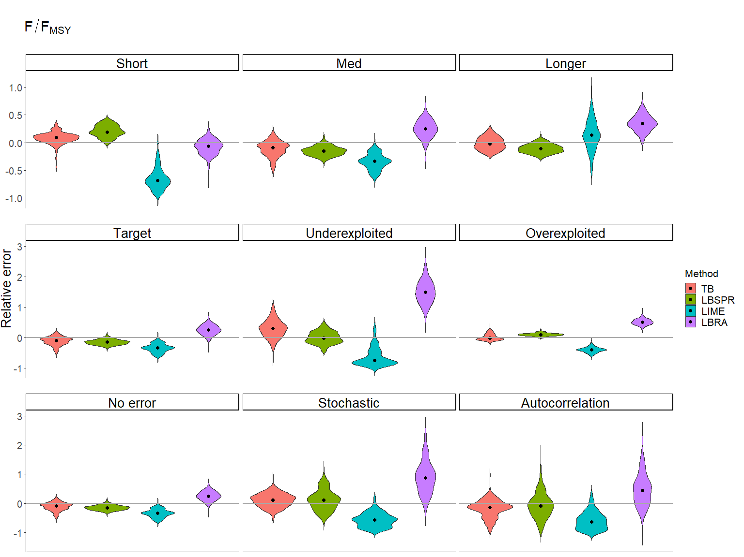

## FM

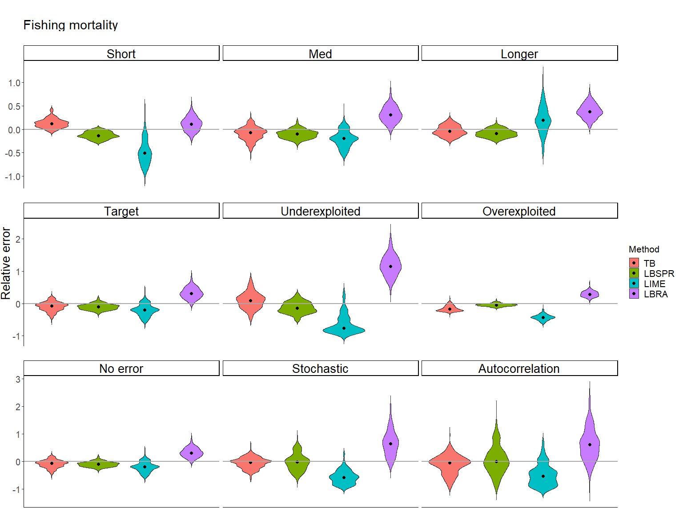

## Fmsy

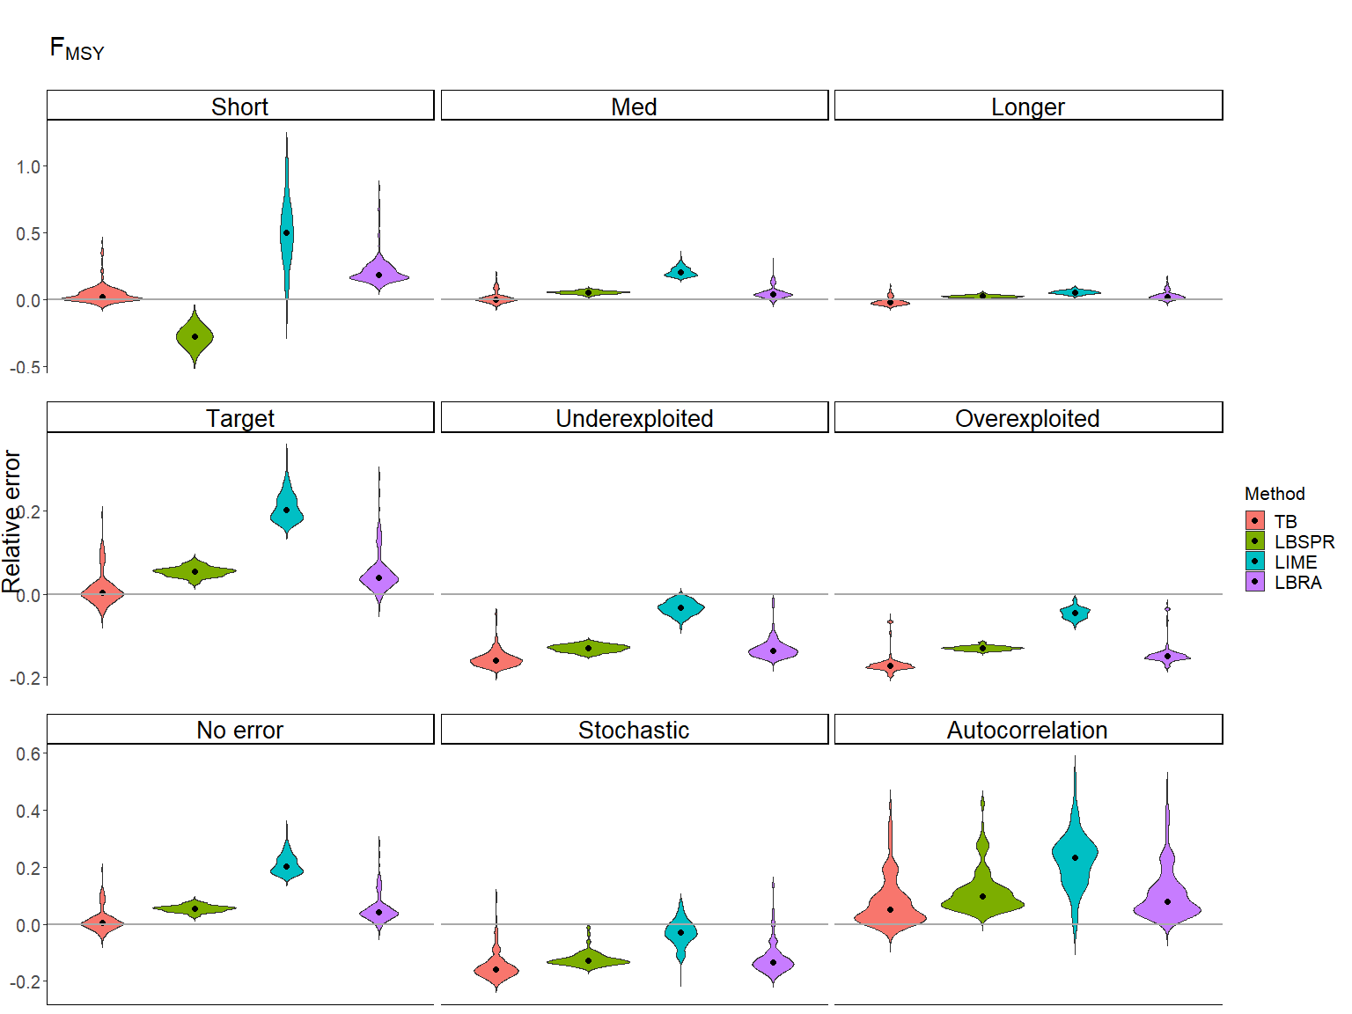

## SPRmsy

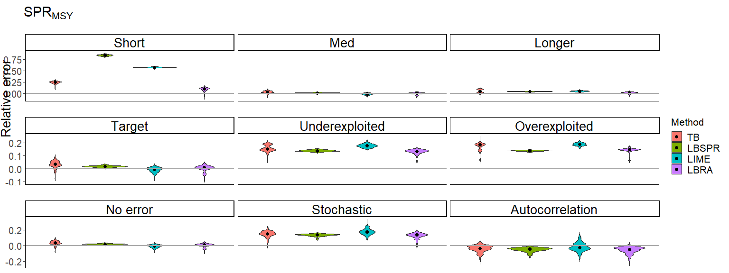

## Tables

## files

### SPR

|  |  |  |  |  |  |  |  |  |  |
| --- | --- | --- | --- | --- | --- | --- | --- | --- | --- |
|  | Short | Medium | Longer | Target | Underexploited | Overexploited | No Error | Stochastic | Autocorrelation |
| TB MRE | 0.016 | 0.081 | 0.048 | 0.081 | -0.023 | 0.197 | 0.081 | 0.003 | 0.076 |
| LBSPR MRE | 0.188 | 0.121 | 0.102 | 0.121 | 0.081 | 0.035 | 0.121 | 0.007 | 0.056 |
| LIME MRE | 0.149 | 0.042 | 0.029 | 0.042 | 0.424 | 0.559 | 0.042 | -0.023 | 0.089 |
| LBRA MRE | 0.054 | -0.159 | -0.215 | -0.159 | -0.350 | -0.364 | -0.159 | -0.377 | -0.315 |
| TB MARE | 0.043 | 0.084 | 0.073 | 0.084 | 0.066 | 0.197 | 0.084 | 0.099 | 0.147 |
| LBSPR MARE | 0.188 | 0.121 | 0.102 | 0.121 | 0.082 | 0.044 | 0.121 | 0.150 | 0.218 |
| LIME MARE | 0.149 | 0.062 | 0.057 | 0.062 | 0.424 | 0.559 | 0.062 | 0.163 | 0.226 |
| LBRA MARE | 0.074 | 0.159 | 0.215 | 0.159 | 0.350 | 0.364 | 0.159 | 0.377 | 0.337 |

### FFmsy

|  |  |  |  |  |  |  |  |  |  |
| --- | --- | --- | --- | --- | --- | --- | --- | --- | --- |
|  | Short | Medium | Longer | Target | Underexploited | Overexploited | No error | Stochastic | Autocorrelation |
| TB MRE | 0.091 | -0.091 | -0.022 | -0.091 | 0.298 | -0.018 | -0.091 | 0.112 | -0.142 |
| LBSPR MRE | 0.189 | -0.148 | -0.111 | -0.148 | -0.022 | 0.096 | -0.148 | 0.105 | -0.089 |
| LIME MRE | -0.684 | -0.334 | 0.138 | -0.334 | -0.752 | -0.400 | -0.334 | -0.568 | -0.644 |
| LBRA MRE | -0.066 | 0.247 | 0.343 | 0.247 | 1.484 | 0.505 | 0.247 | 0.867 | 0.448 |
| TB MARE | 0.096 | 0.114 | 0.089 | 0.114 | 0.306 | 0.075 | 0.114 | 0.197 | 0.190 |
| LBSPR MARE | 0.189 | 0.148 | 0.111 | 0.148 | 0.145 | 0.096 | 0.148 | 0.223 | 0.282 |
| LIME MARE | 0.684 | 0.334 | 0.188 | 0.334 | 0.752 | 0.400 | 0.334 | 0.568 | 0.644 |
| LBRA MARE | 0.098 | 0.253 | 0.343 | 0.253 | 1.484 | 0.505 | 0.253 | 0.867 | 0.469 |

### FM

|  |  |  |  |  |  |  |  |  |  |
| --- | --- | --- | --- | --- | --- | --- | --- | --- | --- |
|  | Short | Medium | Longer | Target | Underexploited | Overexploited | No error | Stochastic | Autocorrelation |
| TB MRE | 0.123 | -0.069 | -0.045 | -0.069 | 0.088 | -0.178 | -0.069 | -0.038 | -0.055 |
| LBSPR MRE | -0.140 | -0.100 | -0.088 | -0.100 | -0.150 | -0.045 | -0.100 | -0.025 | 0.000 |
| LIME MRE | -0.511 | -0.198 | 0.194 | -0.198 | -0.762 | -0.432 | -0.198 | -0.592 | -0.541 |
| LBRA MRE | 0.110 | 0.312 | 0.379 | 0.312 | 1.152 | 0.289 | 0.312 | 0.642 | 0.607 |
| TB MARE | 0.123 | 0.112 | 0.091 | 0.112 | 0.175 | 0.178 | 0.112 | 0.149 | 0.185 |
| LBSPR MARE | 0.140 | 0.100 | 0.088 | 0.100 | 0.150 | 0.045 | 0.100 | 0.200 | 0.300 |
| LIME MARE | 0.511 | 0.198 | 0.219 | 0.198 | 0.762 | 0.432 | 0.198 | 0.592 | 0.543 |
| LBRA MARE | 0.126 | 0.312 | 0.379 | 0.312 | 1.152 | 0.289 | 0.312 | 0.642 | 0.615 |

### Fmsy

|  |  |  |  |  |  |  |  |  |  |
| --- | --- | --- | --- | --- | --- | --- | --- | --- | --- |
|  | Short | Medium | Longer | Target | Underexploited | Overexploited | No error | Stochastic | Autocorrelation |
| TB MRE | 0.021 | 0.004 | -0.022 | 0.004 | -0.158 | -0.172 | 0.004 | -0.159 | 0.050 |
| LBSPR MRE | -0.277 | 0.055 | 0.026 | 0.055 | -0.128 | -0.129 | 0.055 | -0.128 | 0.097 |
| LIME MRE | 0.498 | 0.203 | 0.055 | 0.203 | -0.032 | -0.045 | 0.203 | -0.030 | 0.231 |
| LBRA MRE | 0.186 | 0.040 | 0.023 | 0.040 | -0.135 | -0.149 | 0.040 | -0.135 | 0.079 |
| TB MARE | 0.027 | 0.016 | 0.026 | 0.016 | 0.158 | 0.172 | 0.016 | 0.159 | 0.050 |
| LBSPR MARE | 0.277 | 0.055 | 0.026 | 0.055 | 0.128 | 0.129 | 0.055 | 0.128 | 0.097 |
| LIME MARE | 0.498 | 0.203 | 0.055 | 0.203 | 0.032 | 0.045 | 0.203 | 0.034 | 0.231 |
| LBRA MARE | 0.186 | 0.040 | 0.023 | 0.040 | 0.135 | 0.149 | 0.040 | 0.136 | 0.079 |

### SPRmsy

|  |  |  |  |  |  |  |  |  |  |
| --- | --- | --- | --- | --- | --- | --- | --- | --- | --- |
|  | Short | Medium | Longer | Target | Underexploited | Overexploited | No error | Stochastic | Autocorrelation |
| TB MRE | 0.251 | 0.034 | 0.042 | 0.034 | 0.151 | 0.184 | 0.034 | 0.153 | -0.037 |
| LBSPR MRE | 0.840 | 0.017 | 0.047 | 0.017 | 0.138 | 0.139 | 0.017 | 0.138 | -0.047 |
| LIME MRE | 0.579 | -0.005 | 0.051 | -0.005 | 0.177 | 0.188 | -0.005 | 0.175 | -0.026 |
| LBRA MRE | 0.106 | 0.008 | 0.024 | 0.008 | 0.135 | 0.147 | 0.008 | 0.135 | -0.048 |
| TB MARE | 0.251 | 0.036 | 0.045 | 0.036 | 0.151 | 0.184 | 0.036 | 0.153 | 0.037 |
| LBSPR MARE | 0.840 | 0.017 | 0.047 | 0.017 | 0.138 | 0.139 | 0.017 | 0.138 | 0.047 |
| LIME MARE | 0.579 | 0.011 | 0.051 | 0.011 | 0.177 | 0.188 | 0.011 | 0.175 | 0.038 |
| LBRA MARE | 0.106 | 0.014 | 0.025 | 0.014 | 0.135 | 0.147 | 0.014 | 0.135 | 0.048 |