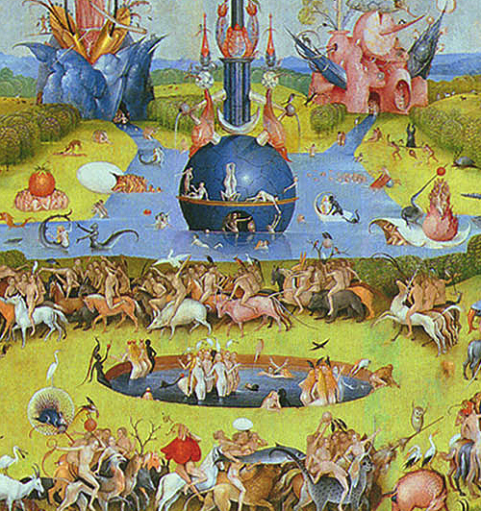“Hot, Flat, and Crowded,”

by Thomas Friedman

Calling for a green revolution in America that will touch every area of the globe.

By: Lydia Auch

March 16th, 2016

IN AN AMERICA that is consumed with consumerism, content with complacency, and captivated by the latest craze, finding a voice to challenge our static views is nearly hopeless. But Thomas Friedman somehow does the impossible in his book “Hot, Flat, and Crowded” where he explains how globalization has produced an alarmingly unstable planet. Essentially a call to arms, this book illustrates why a green revolution is needed in America and across the globe.

A book on the topic of global warming, overuse, and the effects of a rapidly growing population on the Earth may seem like one that is beating a dead horse. Nearly every person knows the terms “global warming” and “sustainability” but that doesn't mean that significant progress has been made by society on these two fronts. In writing this book, Friedman has moved us one step closer. Friedman, a three-time Pulizer Prize winner, is primarily a political and international reporter. Yet in this book, he once again shows his skill adapting to writing a larger text while still maintaining his clear and concise voice.

The book “Hot, Flat, and Crowded” explains that the world is not only flat – where few barriers exist between nations and individuals on an economic level – but it is also crowded due to the rising global population. The combination of the sheer number of people and the possibility for many more of those people to gain access to an “American” level of consumerism makes the world alarmingly hot. Divided into five parts, this book lays out an easy to follow progression of when globalization became a problem, how the world got to that point, how to move forward, and how America compares to and contends with another world power, China.

Quotable

- What good is it to have wind-powered lights to brighten the night if you can't see anything green during the day? Just because we can't sell shares in nature doesn't mean it has no value.”

- “Sustainability is today’s freedom crusade, because the next generation will not live free—will not have the freedom to pursue its economic dreams or to delight in all that nature has to offer—if our approach to the financial world and the natural are not grounded in sustainable values.”

- “And [global warmings'] effects on human well-being are and undoubtedly will remain far more negative than positive. A more accurate, albeit more cumbersome, label than ‘global warming’ is ‘global climatic disruption.’

With more of the world's population desiring the middle-class American lifestyle complete with a car, a refrigerator, and an air-conditioner, the global demand for energy is soaring. Friedman argues that ending America's addiction to oil is more than just an environmental necessity. It is equally important to reduce oil dependence as a strategic and economic imperative. He insists that the largest stride the US could make would be to take a commanding lead in the clean energy industry, reducing dependency on oil dictators and radical terrorists and transforming the global economy through the power of the US marketplace. Using witty and charismatic chapter titles such as, “Global Weirding”, “Dumb As We Wanna Be”, and “Fill 'Er Up with Dictators”, it's easy to forget the book is filled with dense evidence and tricky to navigate political loopholes. The writing prowess of Friedman, is hardly more evident than when he connects Sunni Islam, Twitter, and energy-saving environmentalists under the banner of one chapter without batting an eye.

What might be the most impressive part of “Hot, Flat, and Crowded” is that a reader thinks he is getting a book about environmental conservation when instead he gets an engrossing novel examining complicated political relationships, the intricacies of global banking, the critical values of sustainable behavior, and an argument for immediate innovation. This book not only touches the middle-class citizen for whom conservation is already a daily consideration but also the hardheaded executive who make makes all decisions based on a profit margin. Friedmans' detailed research does air on the side of complex, technical detail that can become overwhelming but the effect is minor against the columnist style of writing that Friedman is so comfortable with. Whoever's hands this book ends up in should be prepared for eye opening information and the subsequent internal conflict that comes when one hears a message that needs to be heard.

\*Image taken from book cover.