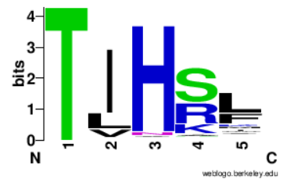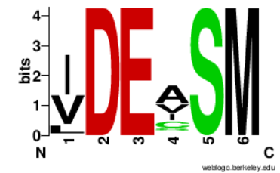
Sequences of motif Ic (left) and II (right) among the Pif1-like deep-sea proteins

