AI-POWERED ANALYTICS GENERATION PLATFORM
Introduction
In today’s data-driven world, organizations across industries generate vast volumes of data on a daily basis. This data can come from multiple sources such as customer interactions, business transactions, sensors, and digital platforms. While the availability of data has increased significantly, the ability to extract meaningful insights from it remains a challenge. Traditional data analysis requires technical expertise in areas such as programming, statistics, and data visualization tools. As a result, many non-technical users find it difficult to interpret data effectively and make informed decisions.
To address this challenge, this project proposes the development of an AI-powered analytics platform designed to simplify and democratize data analysis. The primary objective of the platform is to enable users, regardless of their technical background, to easily explore and analyze datasets. Users can upload structured data files, such as CSV or Excel files, directly into the system. Once the data is uploaded, the platform leverages artificial intelligence to process and understand the dataset.
One of the key features of the system is its natural language interaction capability. Instead of writing complex queries or code, users can simply ask questions in plain English, such as “What are the top-selling products?” or “Show sales trends over time.” The AI engine interprets these queries, analyzes the data accordingly, and generates relevant outputs. These outputs may include summaries, key insights, and visual representations like charts and graphs.
Additionally, the platform automatically generates dashboards that present data in a clear and visually appealing manner. These dashboards help users quickly identify patterns, trends, and anomalies without requiring manual effort. By integrating data processing, analysis, and visualization into a single system, the platform reduces the time and complexity involved in decision-making.
Overall, this AI-powered analytics platform aims to bridge the gap between complex data analysis tools and non-technical users. By combining artificial intelligence with an intuitive user interface, the system enhances accessibility, improves efficiency, and empowers users to make data-driven decisions with confidence.

Problem Statement
In today’s world, a large amount of data is generated every day. However, many users find it difficult to analyze this data because they do not have technical knowledge of tools like SQL, Python, or data visualization software.
Most existing data analysis tools are complex and require users to write queries, clean data, and create charts manually. This process takes time and can be confusing, especially for non-technical users. As a result, people often depend on experts to understand their data.
Because of this, there is a gap between having data and actually using it effectively. Many users are unable to gain useful insights from their data.
Therefore, there is a need for a simple and intelligent system that can automatically analyze data and present clear insights in an easy-to-understand way, without requiring technical skills.

Objectives
• To build a user-friendly web platform for data analysis
• To enable natural language interaction with data
• To generate automated insights using AI
• To visualize data through charts and dashboards
• To maintain user-specific data and chat history

Scope of the Project
The system is designed to work with structured datasets and provide useful insights using AI. It makes data analysis easy, even for users who do not have technical knowledge.
Users can upload files like CSV or Excel into the platform. After uploading, the system will automatically read and understand the data. Users can then ask questions in simple language, and the system will give answers based on the data.
The platform will show results in both text and visual form, such as charts and graphs. This helps users understand the data more clearly.
The system is mainly built for small to medium-sized datasets, so it can give quick results without needing powerful systems. It is useful for students, analysts, and businesses who want fast and easy insights from their data.
Overall, the platform focuses on making data analysis simple, fast, and easy for everyone.

Methodology / System Architecture
The system follows a multi-layered architecture to make data processing smooth and organized.
- Frontend: This is the user interface where users interact with the system. Users can upload datasets, ask questions, and view results here.
- Backend: The backend handles all requests from the frontend. It processes data, manages logic, and connects different parts of the system.
- AI Engine: This part analyzes the data and generates insights, answers, and summaries based on user queries.
- Database: The database stores user information, uploaded datasets, and chat history for future use.

Architecture

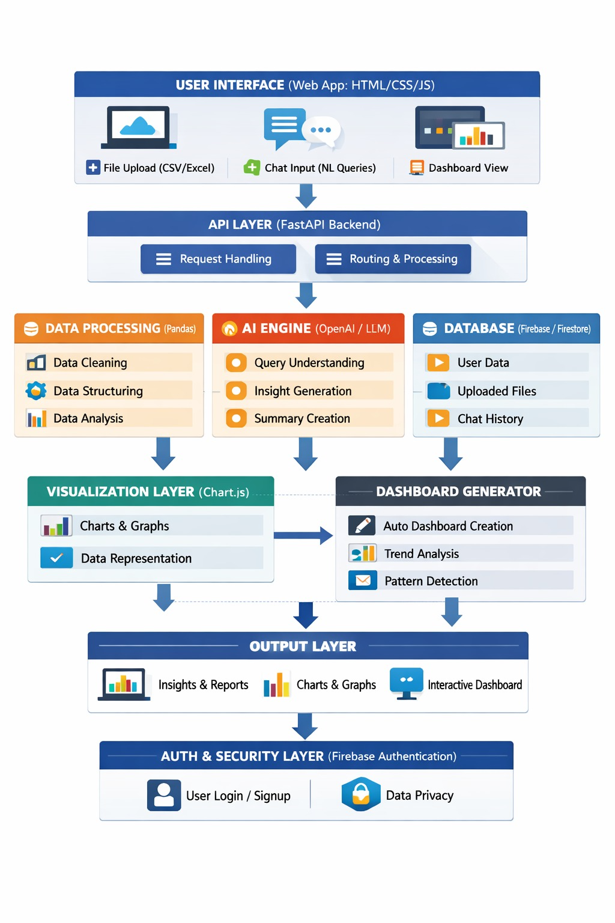

Use Case Diagram
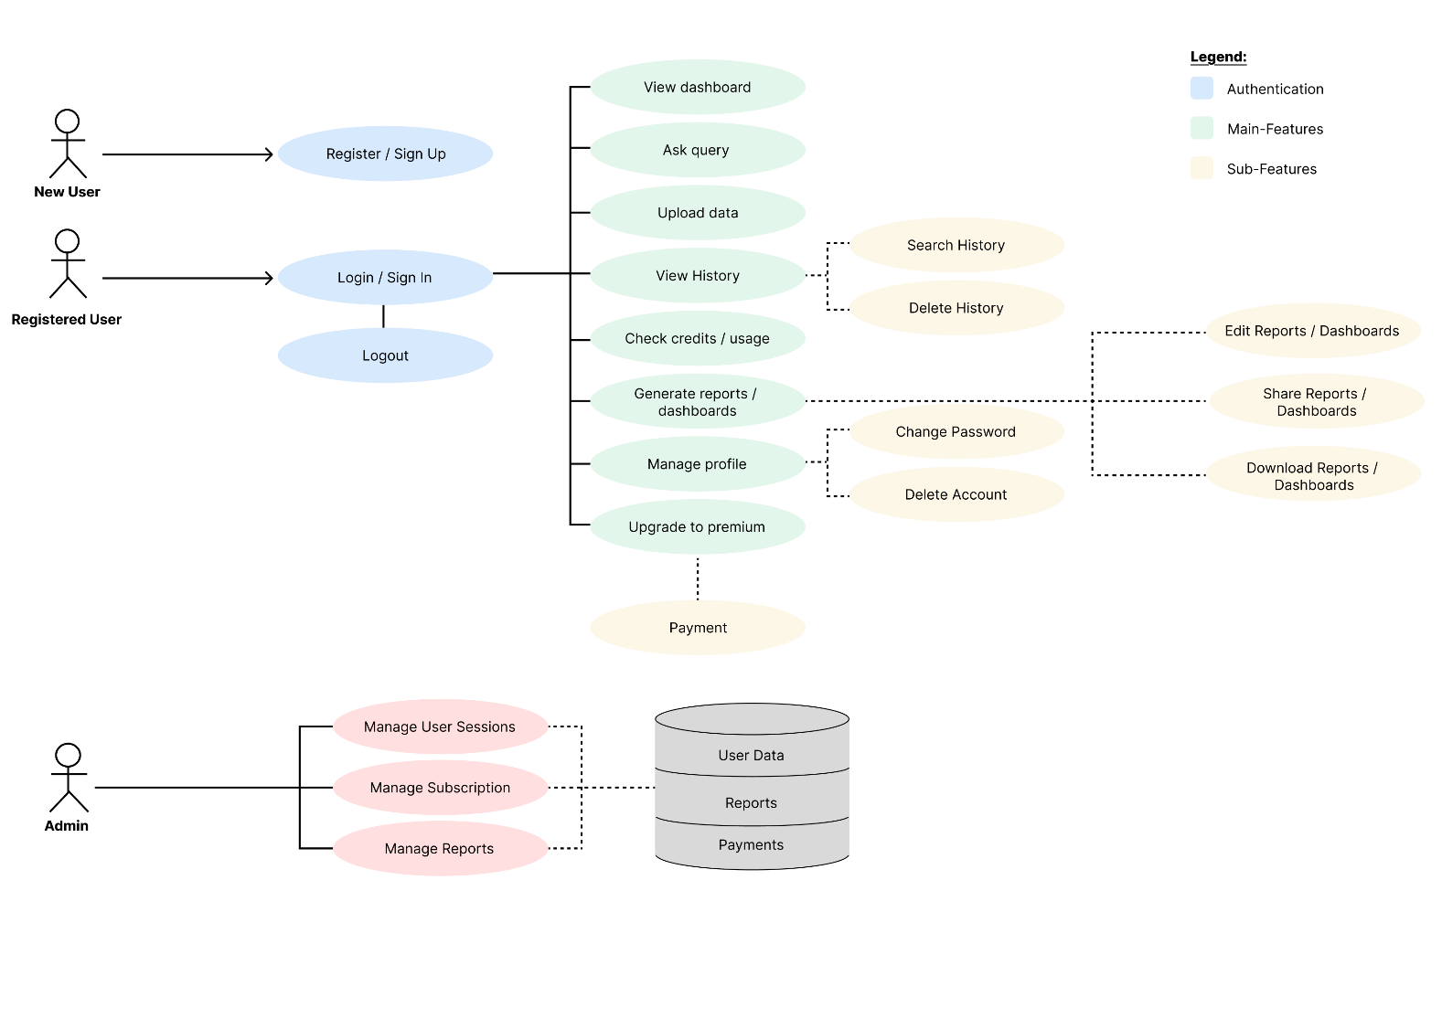
Working
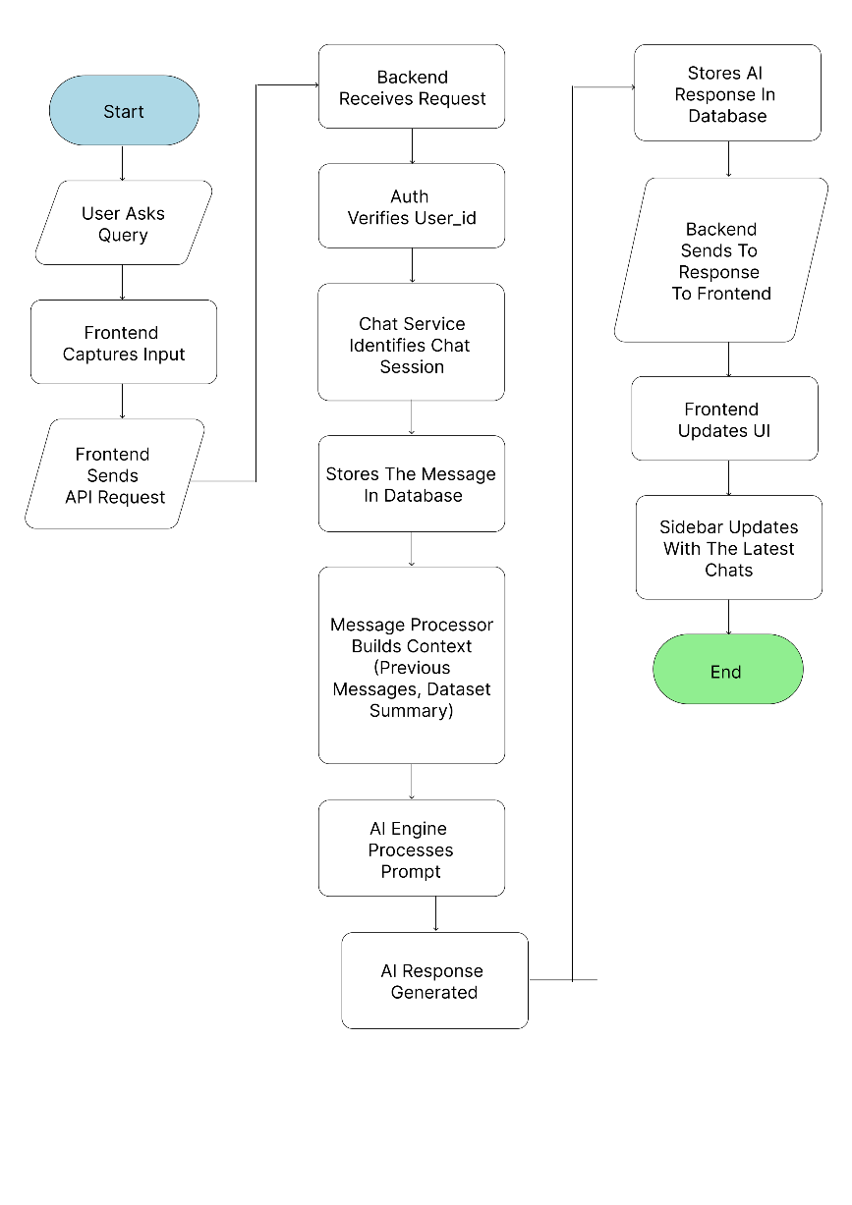

Tools and Technologies
Frontend:
- HTML – Structure of web pages
- CSS – Styling and layout design
- JavaScript – Client-side logic and API communication
Backend:
- FastAPI – Handles API requests, data processing and AI integration
Database & Authentication:
- Firebase Authentication – User login and signup
- Cloud Firestore – Stores user data, chat history and datasets
AI & Analytics:
- OpenAPI – Generates insights and answers user queries
Data Processing:
- Pandas – Data cleaning and analysis
Data Visualization:
- Chart.js – Generates charts and graphs
Development Tools
- Visual Studio Code – Code editor
- Git – Version control
- GitHub – Code hosting
Deployment:
- GoDaddy – Frontend hosting
- Amazon Web Services – Backend/cloud services

Expected Outcome
The final system will enable users to analyze data easily without requiring any technical expertise in programming or data science. By providing a simple and intuitive interface, users can upload their datasets and interact with them using natural language queries. The platform will automatically process the data and generate meaningful insights, eliminating the need for manual analysis.
In addition to textual insights, the system will create visual representations such as charts and graphs, helping users better understand patterns, trends, and relationships within the data. It will also generate interactive dashboards that present key information in a clear and organized manner. These dashboards allow users to quickly explore different aspects of their data without needing advanced analytical skills.
By automating the processes of data analysis and visualization, the system significantly reduces the time and effort required to derive conclusions. This not only improves efficiency but also enhances the accuracy and consistency of results. Ultimately, the platform supports faster and more informed decision-making, making data-driven insights accessible to a wider range of users across different domains.

Future enhancement:
1.Real-time Data Integration:
Now – User upload static files
In Future: Connect live data sources
2. Advanced forecasting and predictions:
Predict future trends using AI
3. Multi-user Collaboration
Now – One user works alone
In Future – Multiple users can share same dashboards, work together and comment on data
4. Integration with External Platforms
Instead of uploading files manually:
Connect directly to platforms like:
- Google Analytics
- Shopify
- Stripe
5.Mobile Application Support
Now – Only web platform
In Future - Build mobile app (Android/iOS)

Pages we have now:
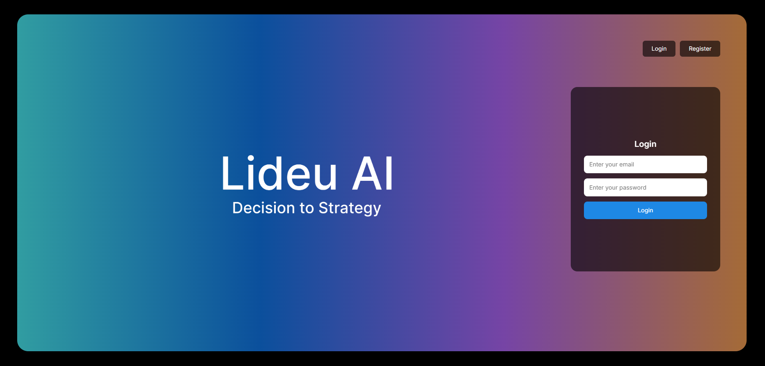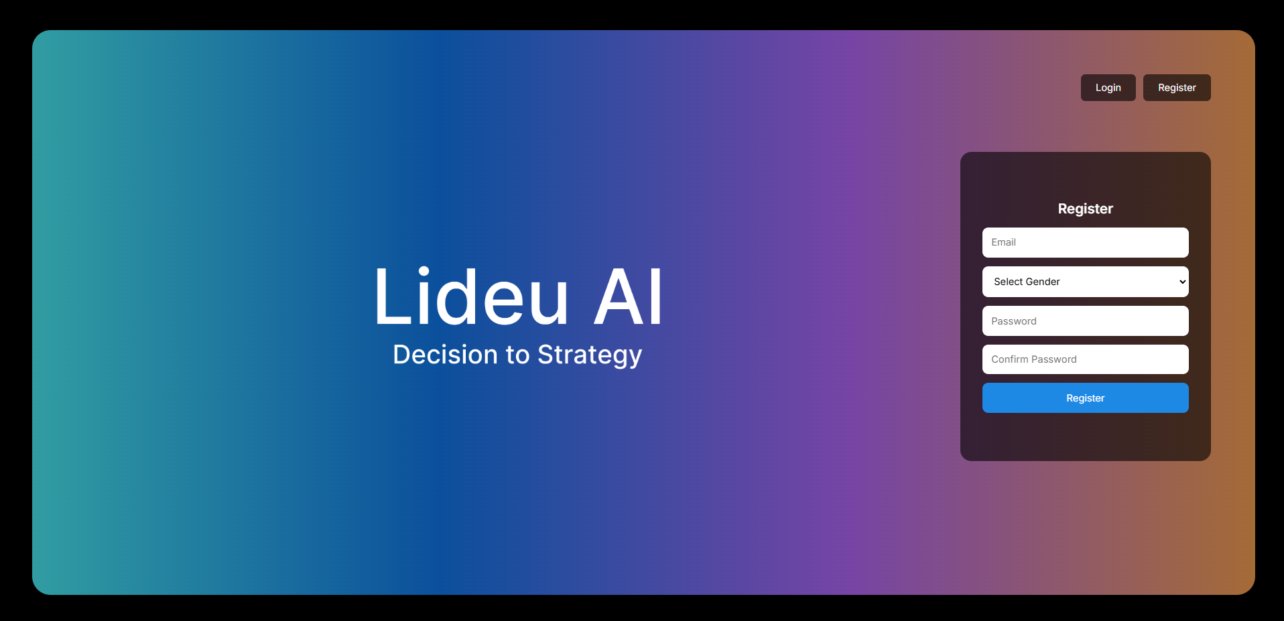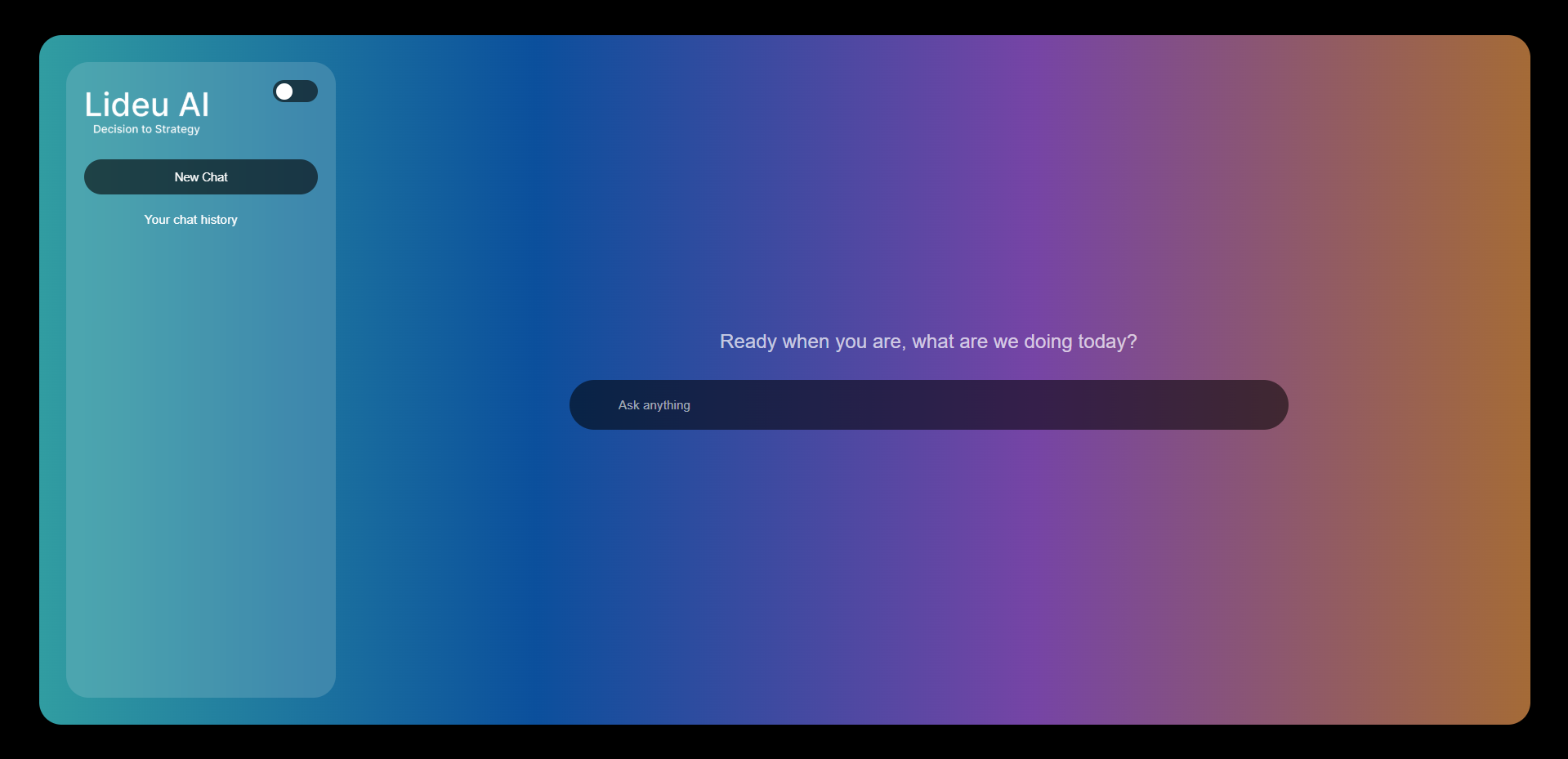


Login.html

