

|  |
| --- |
| Business Template  **POLITICAL CAMPAIGN** |
|  |

Contents

1 Business Description 3

1.1 Business background 3

1.2 Problems. Current Situation 3

1.3 The benefits of implementing a database. Project Vision 3

2 Model description 3

2.1 Definitions & Acronyms 3

2.2 Logical Scheme 3

2.3 Objects 3

# 

# Business Description

## Business background

Here is a Logical Data Model on Political Campaign topic, prepared by independent commission. This model contains the following sections as voters, campaign donors, contribution, volunteers, events, finances, survey results and problems.

## Problems. Current Situation

Data is scattered in spreadsheets, email threads, and messenger notes. The same people and places appear multiple times under different spellings; events do not link back to donations or attendance; survey responses are hard to aggregate; and issues are not tied to the exact context (event or survey).

## the Benefits of implementing a database. Project Vision

For the convenience of users, the data logical model was chosen to store all data about a political company. This model clearly demonstrates the links between different sectors with information. M:N bridges model reality and carry link data; 3NF removes redundancy and anomalies by ensuring each attribute depends on the key—and only the key.

A normalized relational database (3NF) will:

* Remove duplication and inconsistent records (single source of truth for people/locations/types).
* Connect facts to context (who donated at which event; who attended; which issues arose).
* Enable analytics: turnout per event, fundraising by channel, volunteer utilization, survey insights.
* Provide clear governance with primary/foreign keys, unique constraints, and auditable facts.

# Model description

## Definitions & Acronyms

3NF – Third Normal Form: every non-key attribute depends on the key, the whole key, and nothing but the key.

M:N – Many-to-many relationship, implemented via bridge tables.

PK – Primary Key. FK – Foreign Key. UQ – Unique constraint.

## Logical Scheme

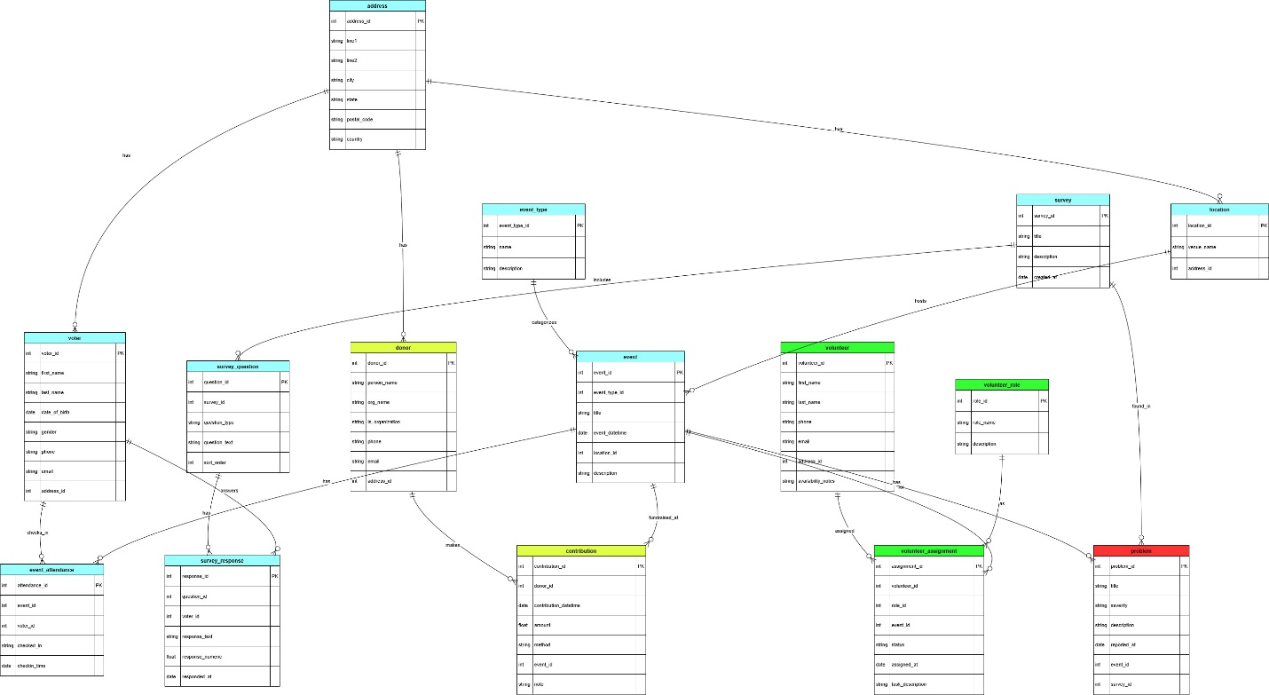

## Objects

|  |  |  |  |
| --- | --- | --- | --- |
| **Table Name** | **Field name** | **Field Description** | **Data Type** |
| address | address_id | <identifier>, PK | BIGSERIAL |
|  | line1 | <address line> | VARCHAR(120) |
|  | line2 | <address line> | VARCHAR(120) |
|  | city | <city> | VARCHAR(80) |
|  | state | <state/region> | VARCHAR(80) |
|  | postal_code | <zip/postal> | VARCHAR(20) |
|  | country | <country> | VARCHAR(80) |

|  |  |  |  |
| --- | --- | --- | --- |
| **Table Name** | **Field name** | **Field Description** | **Data Type** |
| event_type | event_type_id | <identifier>, PK | SERIAL |
|  | name | Type name (rally, town hall, social, etc.), UQ/NOT NULL | VARCHAR(60) |
|  | description | Details | TEXT |

|  |  |  |  |
| --- | --- | --- | --- |
| **Table Name** | **Field name** | **Field Description** | **Data Type** |
| location | location_id | <identifier>, PK | BIGSERIAL |
|  | venue_name | Venue label, NOT NULL | VARCHAR(120) |
|  | address_id | FK to address(address_id), NOT NULL | BIGINT |

|  |  |  |  |
| --- | --- | --- | --- |
| **Table Name** | **Field name** | **Field Description** | **Data Type** |
| voter | voter_id | <identifier>, PK | BIGSERIAL |
|  | first_name | First name, NOT NULL | VARCHAR(60) |
|  | last_name | Last name, NOT NULL | VARCHAR(60) |
|  | date_of_birth | Date of birth | DATE |
|  | gender | Gender | VARCHAR(20) |
|  | phone | Phone | VARCHAR(30) |
|  | email | Email, UNIQUE | VARCHAR(120) |
|  | address_id | FK to address(address_id) | BIGINT |

|  |  |  |  |
| --- | --- | --- | --- |
| **Table Name** | **Field name** | **Field Description** | **Data Type** |
| donor | donor_id | <identifier>, PK | BIGSERIAL |
|  | person_name | Individual donor name | VARCHAR(120) |
|  | org_name | Organization name | VARCHAR(160) |
|  | is_organization | Flag, NOT NULL; CHECK with names | BOOLEAN |
|  | phone | Phone | VARCHAR(30) |
|  | email | Email, UNIQUE | VARCHAR(120) |
|  | address_id | FK to address(address_id) | BIGINT |

|  |  |  |  |
| --- | --- | --- | --- |
| **Table Name** | **Field name** | **Field Description** | **Data Type** |
| volunteer | volunteer_id | <identifier>, PK | BIGSERIAL |
|  | first_name | First name, NOT NULL | VARCHAR(60) |
|  | last_name | Last name, NOT NULL | VARCHAR(60) |
|  | phone | Phone | VARCHAR(30) |
|  | email | Email, UNIQUE | VARCHAR(120) |
|  | address_id | FK to address(address_id) | BIGINT |
|  | availability_notes | Availability notes | TEXT |

|  |  |  |  |
| --- | --- | --- | --- |
| **Table Name** | **Field name** | **Field Description** | **Data Type** |
| volunteer_role | role_id | <identifier>, PK | SERIAL |
|  | role_name | Role (canvasser, speaker, media, etc.), UQ/NOT NULL | VARCHAR(60) |
|  | description | Details | TEXT |

|  |  |  |  |
| --- | --- | --- | --- |
| **Table Name** | **Field name** | **Field Description** | **Data Type** |
| event | event_id | <identifier>, PK | BIGSERIAL |
|  | event_type_id | FK to event_type(event_type_id), NOT NULL | INT |
|  | title | Event title, NOT NULL | VARCHAR(160) |
|  | event_datetime | Start datetime, NOT NULL | TIMESTAMP |
|  | location_id | FK to location(location_id), NOT NULL | BIGINT |
|  | description | Details | TEXT |

|  |  |  |  |
| --- | --- | --- | --- |
| **Table Name** | **Field name** | **Field Description** | **Data Type** |
| contribution | contribution_id | <identifier>, PK | BIGSERIAL |
|  | donor_id | FK to donor(donor_id), NOT NULL | BIGINT |
|  | contribution_datetime | When donated, DEFAULT now() | TIMESTAMP |
|  | amount | Amount, > 0 | NUMERIC(12,2) |
|  | method | Payment method, NOT NULL | VARCHAR(30) |
|  | event_id | Optional FK to event(event_id) | BIGINT |
|  | note | Notes | TEXT |

|  |  |  |  |
| --- | --- | --- | --- |
| **Table Name** | **Field name** | **Field Description** | **Data Type** |
| volunteer_assignment (M:N Volunteer↔Event with Role) | assignment_id | <identifier>, PK | BIGSERIAL |
|  | volunteer_id | FK to volunteer(volunteer_id), NOT NULL | BIGINT |
|  | role_id | FK to volunteer_role(role_id), NOT NULL | INT |
|  | event_id | FK to event(event_id), NOT NULL | BIGINT |
|  | status | assigned/confirmed/done, DEFAULT 'assigned' | VARCHAR(20) |
|  | assigned_at | Timestamp, DEFAULT now() | TIMESTAMP |
|  | task_description | Task details | TEXT |

|  |  |  |  |
| --- | --- | --- | --- |
| **Table Name** | **Field name** | **Field Description** | **Data Type** |
| event_attendance (M:N Voter↔Event) | attendance_id | <identifier>, PK | BIGSERIAL |
|  | event_id | FK to event(event_id), NOT NULL | BIGINT |
|  | voter_id | FK to voter(voter_id), NOT NULL | BIGINT |
|  | checked_in | Check-in flag, DEFAULT FALSE | BOOLEAN |
|  | checkin_time | When checked in | TIMESTAMP |

|  |  |  |  |
| --- | --- | --- | --- |
| **Table Name** | **Field name** | **Field Description** | **Data Type** |
| survey | survey_id | <identifier>, PK | BIGSERIAL |
|  | title | Survey name, NOT NULL | VARCHAR(160) |
|  | description | Details | TEXT |
|  | created_at | Created at, DEFAULT now() | TIMESTAMP |

|  |  |  |  |
| --- | --- | --- | --- |
| **Table Name** | **Field name** | **Field Description** | **Data Type** |
| survey_question | question_id | <identifier>, PK | BIGSERIAL |
|  | survey_id | FK to survey(survey_id) ON DELETE CASCADE, NOT NULL | BIGINT |
|  | question_type | single / multi / text / number, NOT NULL | VARCHAR(20) |
|  | question_text | The question, NOT NULL | TEXT |
|  | sort_order | Display order, DEFAULT 1 | INT |

|  |  |  |  |
| --- | --- | --- | --- |
| **Table Name** | **Field name** | **Field Description** | **Data Type** |
| survey_response (M:N Voter↔SurveyQuestion) | response_id | <identifier>, PK | BIGSERIAL |
|  | question_id | FK to survey_question(question_id) ON DELETE CASCADE, NOT NULL | BIGINT |
|  | voter_id | Responder, FK to voter(voter_id) | BIGINT |
|  | response_text | Text answer | TEXT |
|  | response_numeric | Numeric answer | NUMERIC(12,4) |
|  | responded_at | Timestamp, DEFAULT now() | TIMESTAMP |

|  |  |  |  |
| --- | --- | --- | --- |
| **Table Name** | **Field name** | **Field Description** | **Data Type** |
| problem | problem_id | <identifier>, PK | BIGSERIAL |
|  | title | Issue title, NOT NULL | VARCHAR(160) |
|  | severity | low/medium/high/critical, NOT NULL | VARCHAR(10) |
|  | description | Details | TEXT |
|  | reported_at | When reported, DEFAULT now() | TIMESTAMP |
|  | event_id | Context: event, FK to event(event_id) | BIGINT |
|  | survey_id | Context: survey, FK to survey(survey_id) | BIGINT |

**Comments on table relationships**

Address→{Voter, Donor, Location}: 1→N (reuse addresses).

EventType→Event, Location→Event: 1→N.

Donor→Contribution: 1→N; optional Event→Contribution links fundraising to particular events.

Volunteer↔Event via VolunteerAssignment (includes Role, Status, AssignedAt).

Voter↔Event via EventAttendance (unique per voter per event).

Survey→Question→Response; Voter↔Question via SurveyResponse.

Problem links to either Event or Survey (or both).