Business Template

POLITICAL CAMPAIGN

Contents
1 Business Description 3
1.1 Business background 3
1.2 Problems. Current Situation 3
1.3 The benefits of implementing a database. Project Vision 3
2 Model description 3
2.1 Definitions & Acronyms 3
2.2 Logical Scheme 3
2.3 Objects 3

Business Description

Business background
Here is a Logical Data Model on Political Campaign topic, prepared by independent commission. This model contains the following sections as voters, campaign donors, contribution, volunteers, events, finances, survey results and problems.

Problems. Current Situation
Data is scattered in spreadsheets, email threads, and messenger notes. The same people and places appear multiple times under different spellings; events do not link back to donations or attendance; survey responses are hard to aggregate; and issues are not tied to the exact context (event or survey).

the Benefits of implementing a database. Project Vision
For the convenience of users, the data logical model was chosen to store all data about a political company. This model clearly demonstrates the links between different sectors with information. M:N bridges model reality and carry link data; 3NF removes redundancy and anomalies by ensuring each attribute depends on the key—and only the key.
A normalized relational database (3NF) will:
- Remove duplication and inconsistent records (single source of truth for people/locations/types).
- Connect facts to context (who donated at which event; who attended; which issues arose).
- Enable analytics: turnout per event, fundraising by channel, volunteer utilization, survey insights.
- Provide clear governance with primary/foreign keys, unique constraints, and auditable facts.

Model description

Definitions & Acronyms
3NF – Third Normal Form: every non-key attribute depends on the key, the whole key, and nothing but the key.
M:N – Many-to-many relationship, implemented via bridge tables.
PK – Primary Key. FK – Foreign Key. UQ – Unique constraint.

Logical Scheme
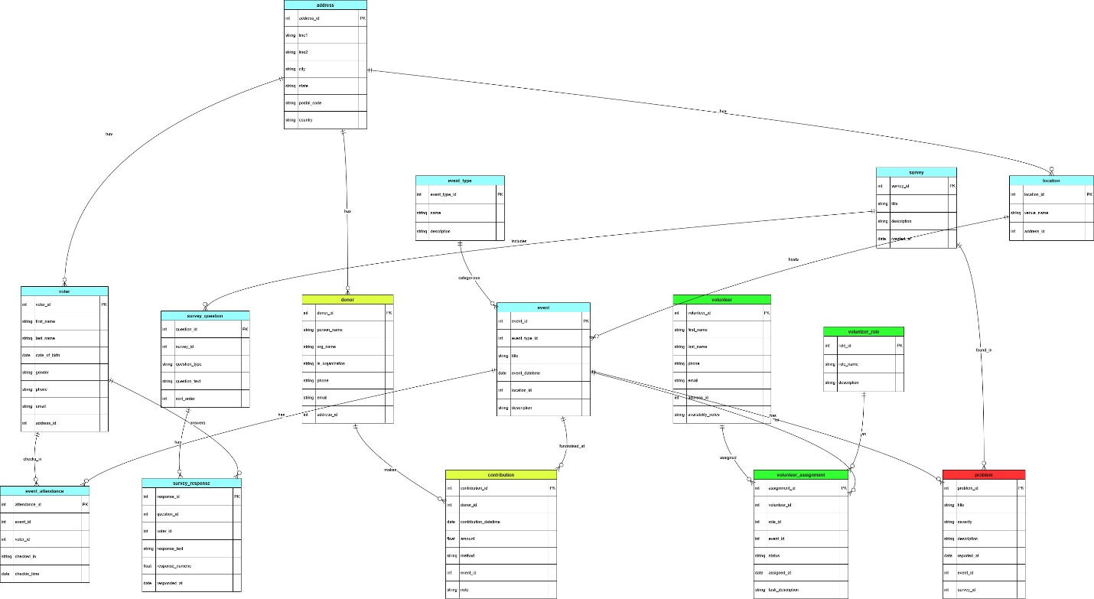

Objects

Table Name | Field name | Field Description | Data Type
address | address_id | <identifier>, PK | BIGSERIAL
 | line1 | <address line> | VARCHAR(120)
 | line2 | <address line> | VARCHAR(120)
 | city | <city> | VARCHAR(80)
 | state | <state/region> | VARCHAR(80)
 | postal_code | <zip/postal> | VARCHAR(20)
 | country | <country> | VARCHAR(80)

Table Name | Field name | Field Description | Data Type
event_type | event_type_id | <identifier>, PK | SERIAL
 | name | Type name (rally, town hall, social, etc.), UQ/NOT NULL | VARCHAR(60)
 | description | Details | TEXT

Table Name | Field name | Field Description | Data Type
location | location_id | <identifier>, PK | BIGSERIAL
 | venue_name | Venue label, NOT NULL | VARCHAR(120)
 | address_id | FK to address(address_id), NOT NULL | BIGINT

Table Name | Field name | Field Description | Data Type
voter | voter_id | <identifier>, PK | BIGSERIAL
 | first_name | First name, NOT NULL | VARCHAR(60)
 | last_name | Last name, NOT NULL | VARCHAR(60)
 | date_of_birth | Date of birth | DATE
 | gender | Gender | VARCHAR(20)
 | phone | Phone | VARCHAR(30)
 | email | Email, UNIQUE | VARCHAR(120)
 | address_id | FK to address(address_id) | BIGINT

Table Name | Field name | Field Description | Data Type
donor | donor_id | <identifier>, PK | BIGSERIAL
 | person_name | Individual donor name | VARCHAR(120)
 | org_name | Organization name | VARCHAR(160)
 | is_organization | Flag, NOT NULL; CHECK with names | BOOLEAN
 | phone | Phone | VARCHAR(30)
 | email | Email, UNIQUE | VARCHAR(120)
 | address_id | FK to address(address_id) | BIGINT

Table Name | Field name | Field Description | Data Type
volunteer | volunteer_id | <identifier>, PK | BIGSERIAL
 | first_name | First name, NOT NULL | VARCHAR(60)
 | last_name | Last name, NOT NULL | VARCHAR(60)
 | phone | Phone | VARCHAR(30)
 | email | Email, UNIQUE | VARCHAR(120)
 | address_id | FK to address(address_id) | BIGINT
 | availability_notes | Availability notes | TEXT

Table Name | Field name | Field Description | Data Type
volunteer_role | role_id | <identifier>, PK | SERIAL
 | role_name | Role (canvasser, speaker, media, etc.), UQ/NOT NULL | VARCHAR(60)
 | description | Details | TEXT

Table Name | Field name | Field Description | Data Type
event | event_id | <identifier>, PK | BIGSERIAL
 | event_type_id | FK to event_type(event_type_id), NOT NULL | INT
 | title | Event title, NOT NULL | VARCHAR(160)
 | event_datetime | Start datetime, NOT NULL | TIMESTAMP
 | location_id | FK to location(location_id), NOT NULL | BIGINT
 | description | Details | TEXT

Table Name | Field name | Field Description | Data Type
contribution | contribution_id | <identifier>, PK | BIGSERIAL
 | donor_id | FK to donor(donor_id), NOT NULL | BIGINT
 | contribution_datetime | When donated, DEFAULT now() | TIMESTAMP
 | amount | Amount, > 0 | NUMERIC(12,2)
 | method | Payment method, NOT NULL | VARCHAR(30)
 | event_id | Optional FK to event(event_id) | BIGINT
 | note | Notes | TEXT

Table Name | Field name | Field Description | Data Type
volunteer_assignment (M:N Volunteer↔Event with Role) | assignment_id | <identifier>, PK | BIGSERIAL
 | volunteer_id | FK to volunteer(volunteer_id), NOT NULL | BIGINT
 | role_id | FK to volunteer_role(role_id), NOT NULL | INT
 | event_id | FK to event(event_id), NOT NULL | BIGINT
 | status | assigned/confirmed/done, DEFAULT 'assigned' | VARCHAR(20)
 | assigned_at | Timestamp, DEFAULT now() | TIMESTAMP
 | task_description | Task details | TEXT

Table Name | Field name | Field Description | Data Type
event_attendance (M:N Voter↔Event) | attendance_id | <identifier>, PK | BIGSERIAL
 | event_id | FK to event(event_id), NOT NULL | BIGINT
 | voter_id | FK to voter(voter_id), NOT NULL | BIGINT
 | checked_in | Check-in flag, DEFAULT FALSE | BOOLEAN
 | checkin_time | When checked in | TIMESTAMP

Table Name | Field name | Field Description | Data Type
survey | survey_id | <identifier>, PK | BIGSERIAL
 | title | Survey name, NOT NULL | VARCHAR(160)
 | description | Details | TEXT
 | created_at | Created at, DEFAULT now() | TIMESTAMP

Table Name | Field name | Field Description | Data Type
survey_question | question_id | <identifier>, PK | BIGSERIAL
 | survey_id | FK to survey(survey_id) ON DELETE CASCADE, NOT NULL | BIGINT
 | question_type | single / multi / text / number, NOT NULL | VARCHAR(20)
 | question_text | The question, NOT NULL | TEXT
 | sort_order | Display order, DEFAULT 1 | INT

Table Name | Field name | Field Description | Data Type
survey_response (M:N Voter↔SurveyQuestion) | response_id | <identifier>, PK | BIGSERIAL
 | question_id | FK to survey_question(question_id) ON DELETE CASCADE, NOT NULL | BIGINT
 | voter_id | Responder, FK to voter(voter_id) | BIGINT
 | response_text | Text answer | TEXT
 | response_numeric | Numeric answer | NUMERIC(12,4)
 | responded_at | Timestamp, DEFAULT now() | TIMESTAMP

Table Name | Field name | Field Description | Data Type
problem | problem_id | <identifier>, PK | BIGSERIAL
 | title | Issue title, NOT NULL | VARCHAR(160)
 | severity | low/medium/high/critical, NOT NULL | VARCHAR(10)
 | description | Details | TEXT
 | reported_at | When reported, DEFAULT now() | TIMESTAMP
 | event_id | Context: event, FK to event(event_id) | BIGINT
 | survey_id | Context: survey, FK to survey(survey_id) | BIGINT

Comments on table relationships
Address→{Voter, Donor, Location}: 1→N (reuse addresses).
EventType→Event, Location→Event: 1→N.
Donor→Contribution: 1→N; optional Event→Contribution links fundraising to particular events.
Volunteer↔Event via VolunteerAssignment (includes Role, Status, AssignedAt).
Voter↔Event via EventAttendance (unique per voter per event).
Survey→Question→Response; Voter↔Question via SurveyResponse.
Problem links to either Event or Survey (or both).

