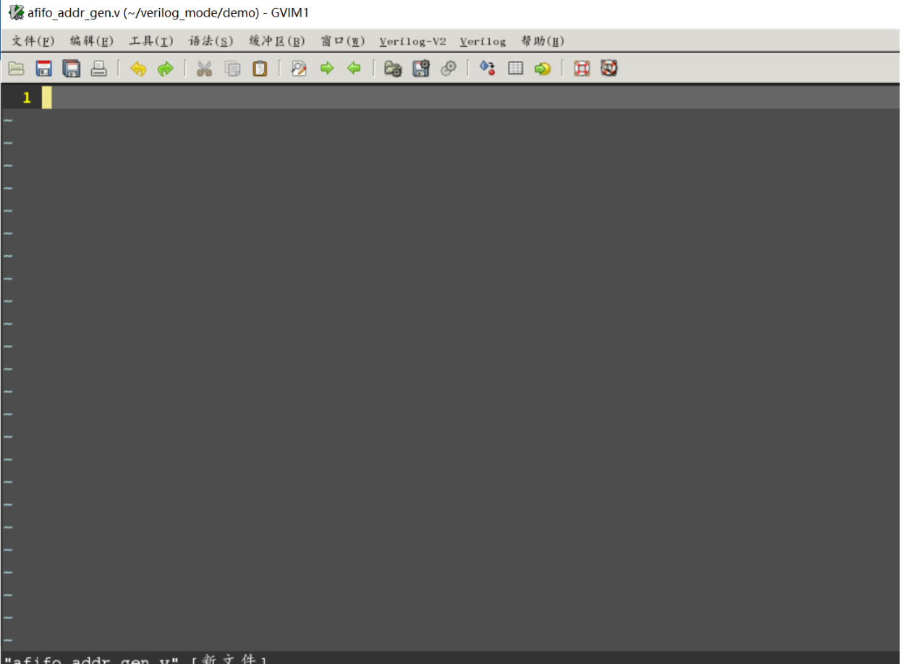
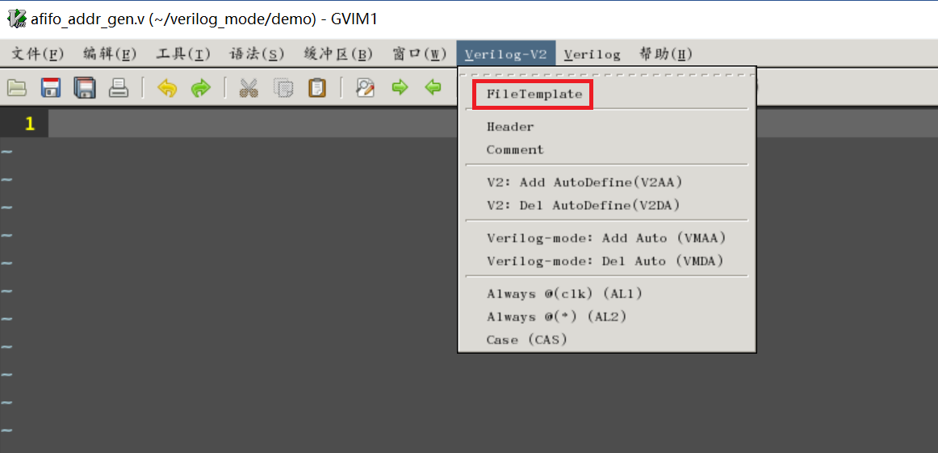

//=========================================
//Created by :lidong
//Filename :afifo_addr_gen.v
//Author :lidong(RDC)
//Created On :2024-07-01 21:14
//Last Modified :
//Update Count :
//Description :
//
//
//=========================================
//
module afifo_addr_gen #(
parameter integer DW_IN = 10,
parameter integer DW_OUT = 12
)
(
//=========================================
//ports declared by Verilog-mode tool
//=========================================
/*autoinput("^clk\|^rst")*/

/*autoinput("^din\([0-1]\)_\(a\|b\)")*/

/*autooutput("^dout_*")*/

//=========================================
// ports declared by user
//=========================================
// input/output to/from internal logic block
input din_vld,
output dout_vld,

// output from inter-connection of internal instance
output [11:0] inter_out0_a,
output [11:0] inter_out0_b,
);
//===========================
//Local parameters
//===========================
//
//===========================
//Local wires and registers
//===========================
/*autologic*/

/*autodefine*/

// User define
wire userdef0;
wire userdef1;
// End of user define
//
//===========================
//Main code begins here
//===========================
//

/*
module0 auto_template (
.clk (clk ),
.rst_n (rst_n ),
.din_vld (inter_vld@ ),
.din_a (din@_a[] ),
.din_b (din@_b[] ),
.dout\(.*\) (inter_out@\1[] ),
.debug (inter_con ),
);
*/
module0 # (
.DW_IN (DW_IN ),
.DW_OUT (DW_OUT),
) inst0 (/*autoinst*/);

//=========================================
//Verilog-mode Setting:
//Local Variables:
//verilog-library-files: (
//"./test.v"
//)
//verilog-library-directories: (
//"."
//".."
//)
//verilog-auto-inst-param-value: t
//End:
//=========================================
endmodule

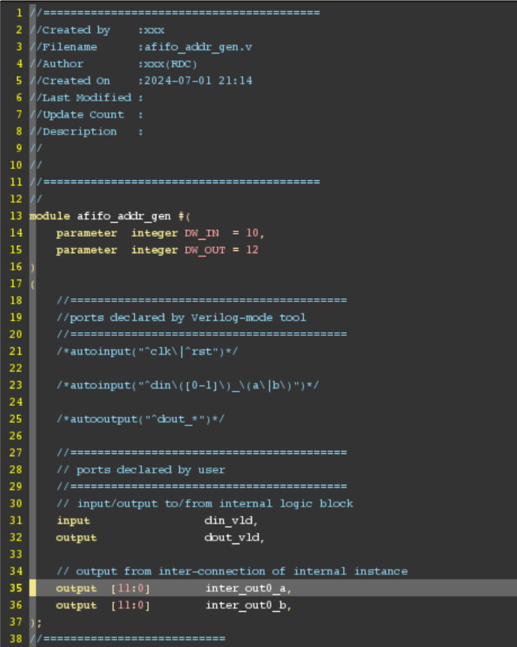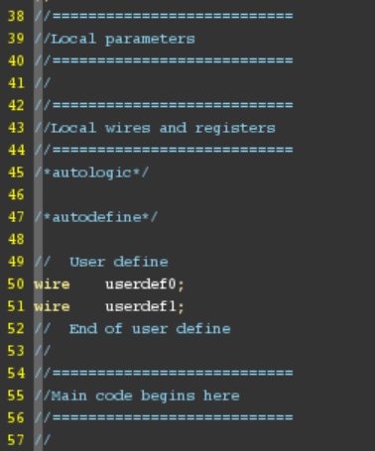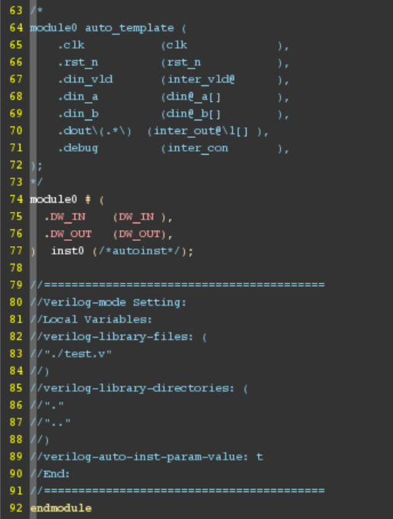
选中空白行，再执行
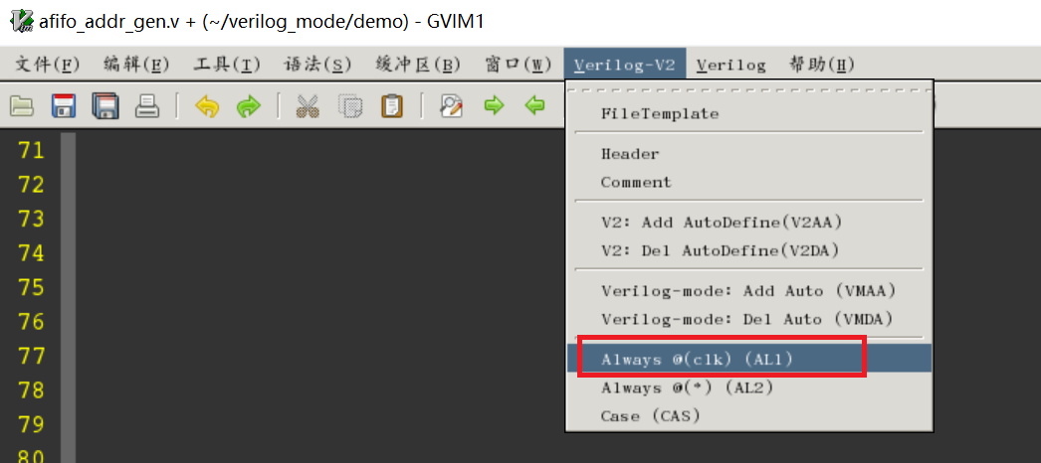
自动添加块语句
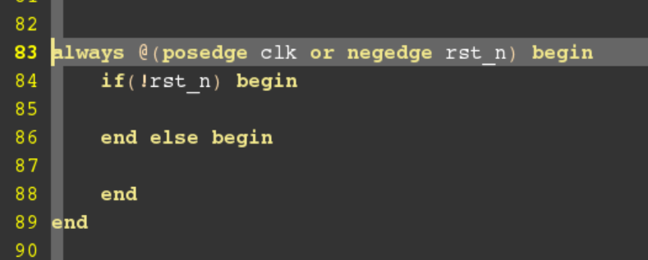

手动编辑后的代码：
//=========================================
//Created by :xxx
//Filename :afifo_addr_gen.v
//Author :xxx(RDC)
//Created On :2024-07-01 21:14
//Last Modified :
//Update Count :
//Description :
//
//
//=========================================
//
module afifo_addr_gen #(
parameter integer AW = 4 //The width of address
)
(
//=========================================
//ports declared by Verilog-mode tool
//=========================================
/*autoinput("^clk\|^rst")*/

/*autoinput("^din\([0-1]\)_\(a\|b\)")*/

/*autooutput("^dout_*")*/

//=========================================
// ports declared by user
//=========================================
// input/output to/from internal logic block
input srst,
input en, //write or read enable signal
output flag, //full or empty flag

// output from inter-connection of internal instance
output [AW:0] bptr,
output [AW:0] gptr,
output [AW:0] bptr_next,
output [AW:0] gptr_next
);
//===========================
//Local parameters
//===========================
//
//===========================
//Local wires and registers
//===========================
/*autologic*/

/*autodefine*/

// User define
wire userdef0;
wire userdef1;
// End of user define
//
//===========================
//Main code begins here
//===========================
//
assign ram_en = (en & (~flag));
assign bptr_next[AW:0] = bptr[AW:0] + ram_ren;
assign gptr_next[AW:0] = {1'd0,bptr_next[AW:1]}^bptr_next[AW:0];
always@( posedge clk or negedge rst_n ) begin
if( !rst_n) begin
bptr[AW:0] <= {(AW+1){1'b0}};
gptr[AW:0] <= {(AW+1){1'b0}};
end else if( srst ) begin
bptr[AW:0] <= {(AW+1){1'b0}};
gptr[AW:0] <= {(AW+1){1'b0}};
end else begin
bptr[AW:0] <= bptr_next[AW:0];
gptr[AW:0] <= gptr_next[AW:0];
end
end

//=========================================
//Verilog-mode Setting:
//Local Variables:
//verilog-library-files: (
//"./test.v"
//)
//verilog-library-directories: (
//"."
//".."
//)
//verilog-auto-inst-param-value: t
//End:
//=========================================
endmodule
进行V2AA后
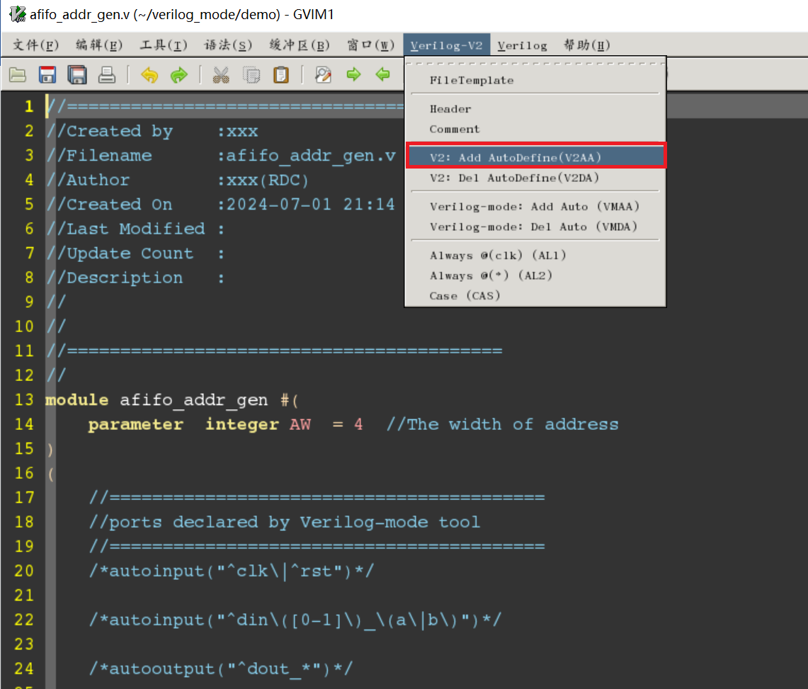
端口输出是寄存器类型的，自动补充logic
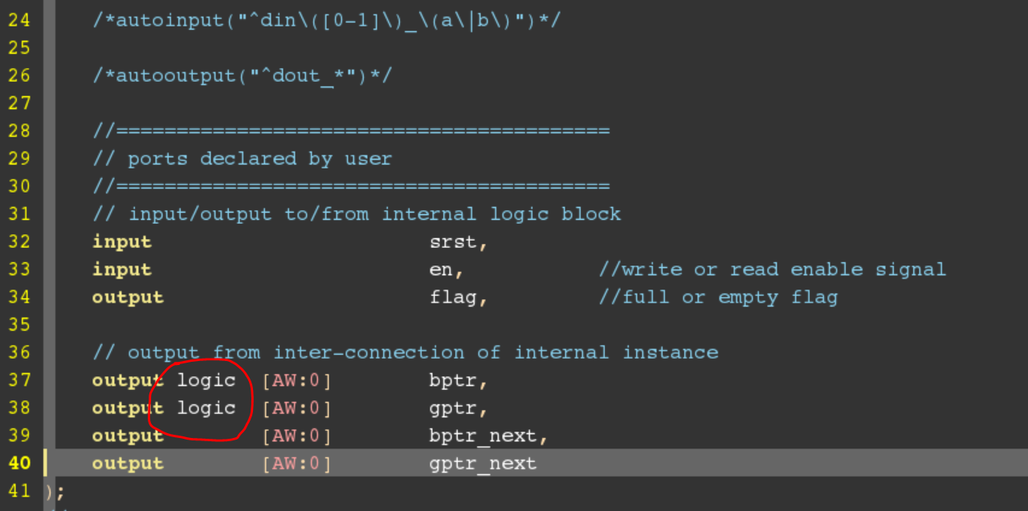
自动定义中间信号
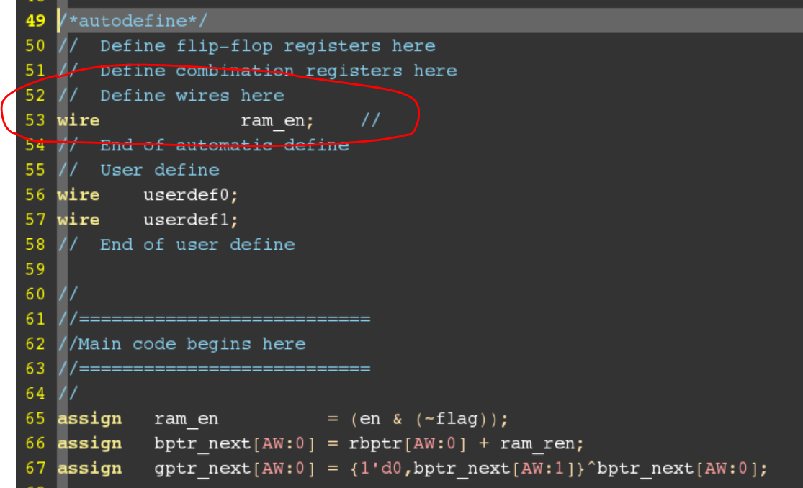
最终手动补齐其它代码：
//=========================================
//Created by :xxx
//Filename :afifo_addr_gen.v
//Author :xxx(RDC)
//Created On :2024-07-01 21:14
//Last Modified :
//Update Count :
//Description :
//
//
//=========================================
//
module afifo_addr_gen #(
parameter integer AW = 4 //The width of address
)
(
//=========================================
//ports declared by Verilog-mode tool
//=========================================
/*autoinput("^clk\|^rst")*/
input clk,
input rst_n,

/*autoinput("^din\([0-1]\)_\(a\|b\)")*/

/*autooutput("^dout_*")*/

//=========================================
// ports declared by user
//=========================================
// input/output to/from internal logic block
input srst,
input en, //write or read enable signal
output flag, //full or empty flag

// output from inter-connection of internal instance
output logic [AW:0] bptr,
output logic [AW:0] gptr,
output [AW:0] bptr_next,
output [AW:0] gptr_next
);
//===========================
//Local parameters
//===========================
//
//===========================
//Local wires and registers
//===========================
/*autologic*/

/*autodefine*/
// Define flip-flop registers here
// Define combination registers here
// Define wires here
wire ram_en; //
// End of automatic define
// User define
// End of user define

//
//===========================
//Main code begins here
//===========================
assign ram_en = (en & (~flag));
assign bptr_next[AW:0] = bptr[AW:0] + ram_ren;
assign gptr_next[AW:0] = {1'd0,bptr_next[AW:1]}^bptr_next[AW:0];

always@( posedge clk or negedge rst_n ) begin
if( !rst_n) begin
bptr[AW:0] <= {(AW+1){1'b0}};
gptr[AW:0] <= {(AW+1){1'b0}};
end else if( srst ) begin
bptr[AW:0] <= {(AW+1){1'b0}};
gptr[AW:0] <= {(AW+1){1'b0}};
end else begin
bptr[AW:0] <= bptr_next[AW:0];
gptr[AW:0] <= gptr_next[AW:0];
end
end
//=========================================
//Verilog-mode Setting:
//Local Variables:
//verilog-library-files: (
//"./test.v"
//)
//verilog-library-directories: (
//"."
//".."
//)
//verilog-auto-inst-param-value: t
//End:
//=========================================
Endmodule

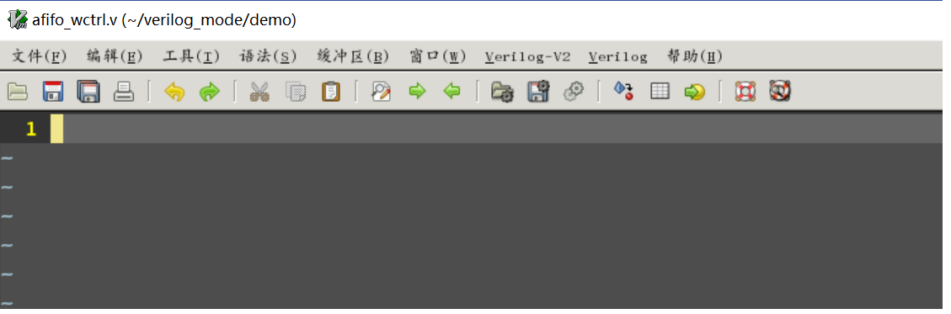
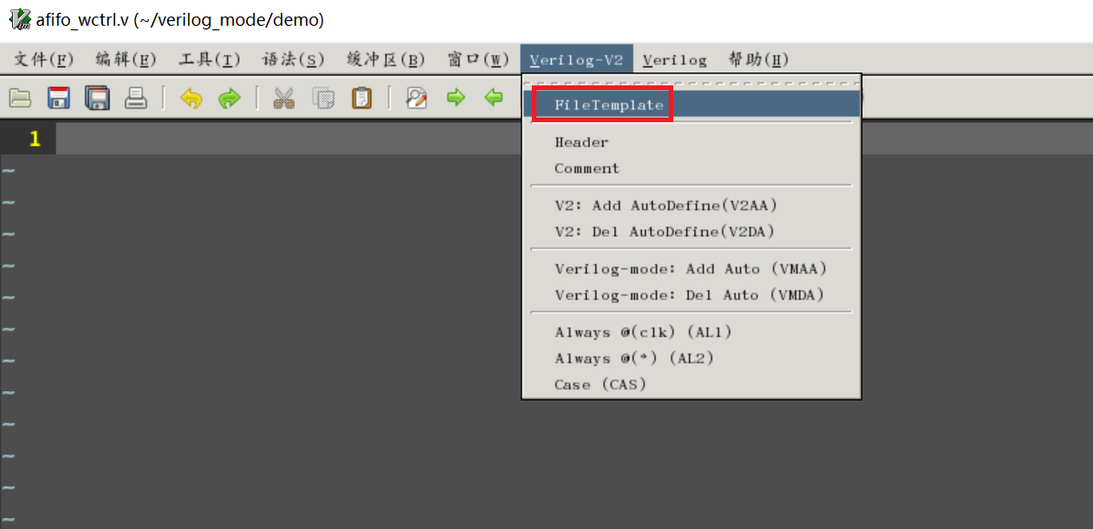
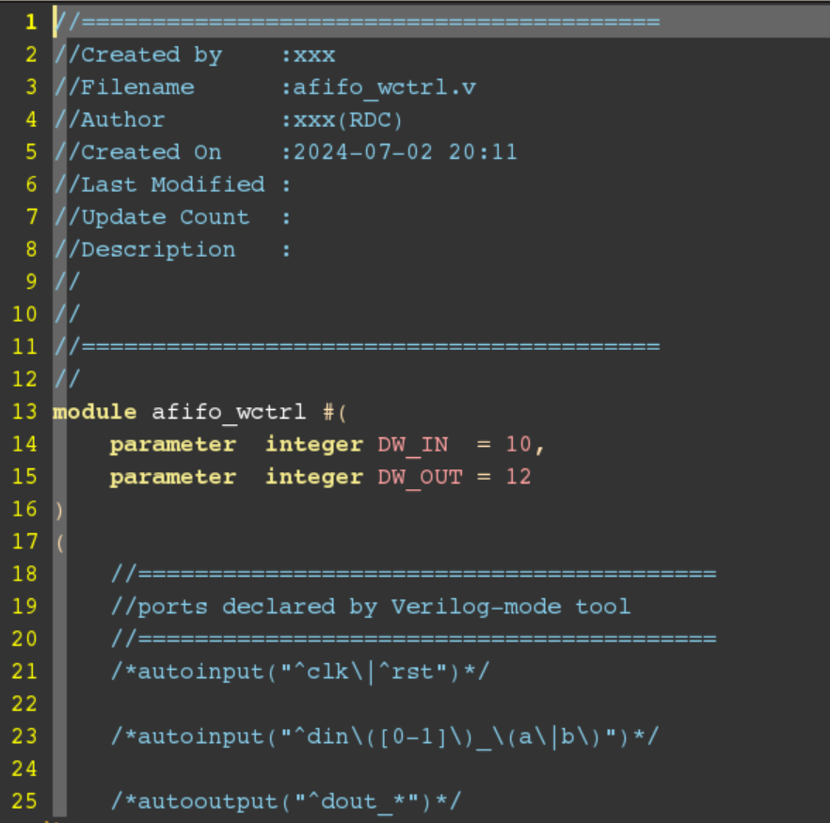
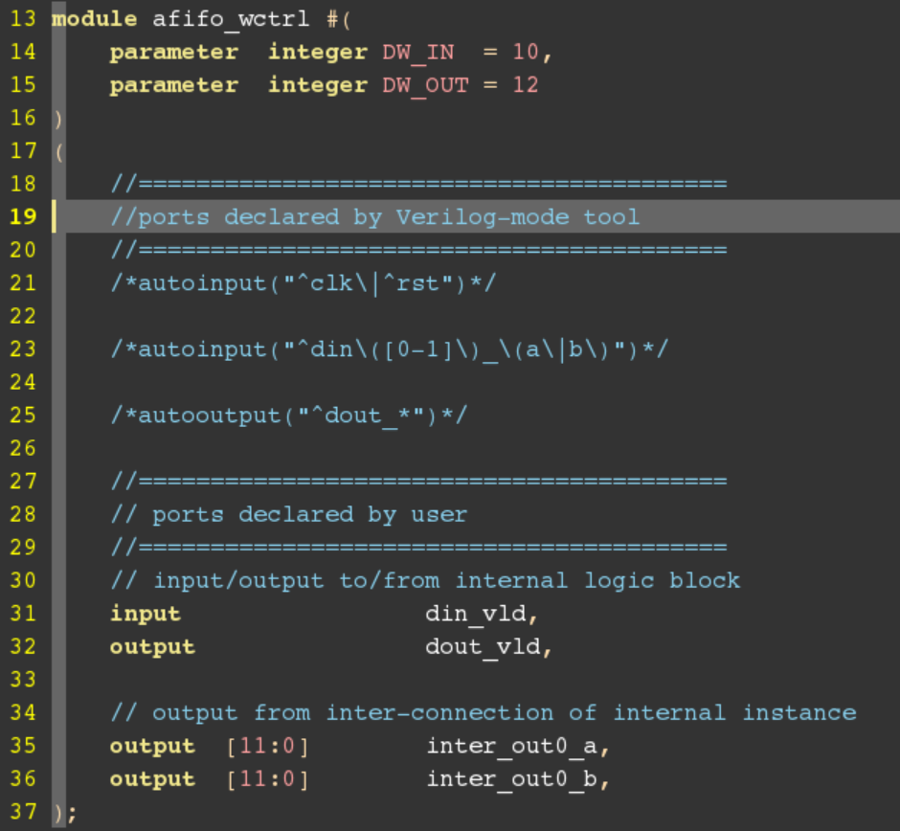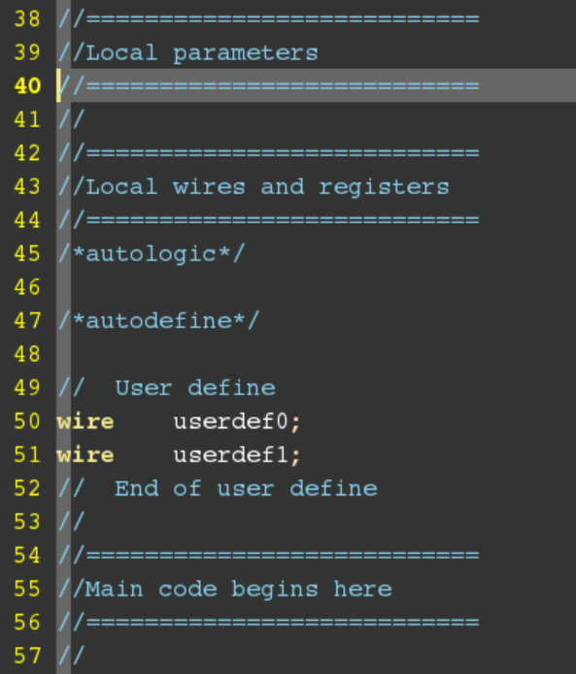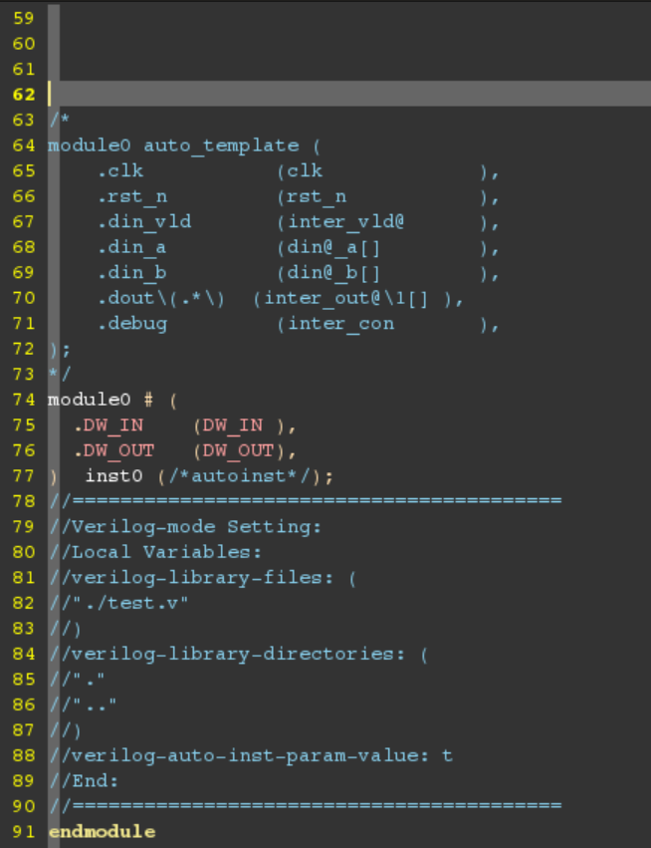
//=========================================
//Created by :xxx
//Filename :afifo_wctrl.v
//Author :xxx(RDC)
//Created On :2024-07-02 20:11
//Last Modified :
//Update Count :
//Description :
//
//
//=========================================
//
module afifo_wctrl #(
parameter integer DW_IN = 10,
parameter integer DW_OUT = 12
)
(
//=========================================
//ports declared by Verilog-mode tool
//=========================================
/*autoinput("^clk\|^rst")*/

/*autoinput("^din\([0-1]\)_\(a\|b\)")*/

/*autooutput("^dout_*")*/

//=========================================
// ports declared by user
//=========================================
// input/output to/from internal logic block
input din_vld,
output dout_vld,

// output from inter-connection of internal instance
output [11:0] inter_out0_a,
output [11:0] inter_out0_b,
);
//===========================
//Local parameters
//===========================
//
//===========================
//Local wires and registers
//===========================
/*autologic*/

/*autodefine*/

// User define
wire userdef0;
wire userdef1;
// End of user define
//
//===========================
//Main code begins here
//===========================
//

/*
module0 auto_template (
.clk (clk ),
.rst_n (rst_n ),
.din_vld (inter_vld@ ),
.din_a (din@_a[] ),
.din_b (din@_b[] ),
.dout\(.*\) (inter_out@\1[] ),
.debug (inter_con ),
);
*/
module0 # (
.DW_IN (DW_IN ),
.DW_OUT (DW_OUT),
) inst0 (/*autoinst*/);

//=========================================
//Verilog-mode Setting:
//Local Variables:
//verilog-library-files: (
//"./test.v"
//)
//verilog-library-directories: (
//"."
//".."
//)
//verilog-auto-inst-param-value: t
//End:
//=========================================
endmodule

选择空白处，执行
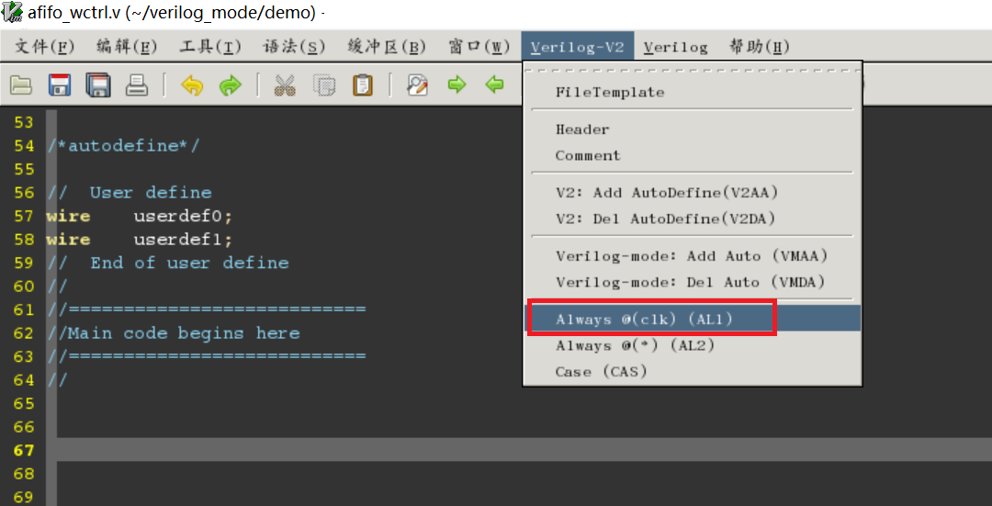
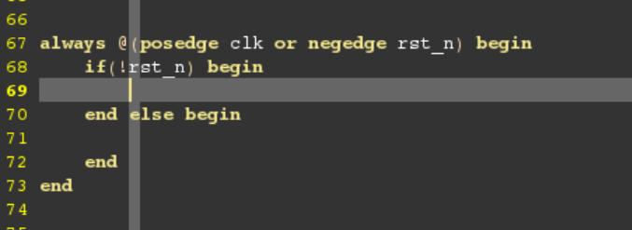
手动编辑后的代码：
//=========================================
//Created by :xxx
//Filename :afifo_wctrl.v
//Author :xxx(RDC)
//Created On :2024-07-02 20:11
//Last Modified :
//Update Count :
//Description :
//
//
//=========================================
//
module afifo_wctrl #(
parameter integer AW = 4,
parameter integer ALFULL = 12,

)
(
//=========================================
//ports declared by Verilog-mode tool
//=========================================
/*autoinput("^clk\|^rst")*/
input wclk,
input wrst_n,
input wsrst,

/*autoinput("^din\([0-1]\)_\(a\|b\)")*/

/*autooutput("^dout_*")*/

//=========================================
// ports declared by user
//=========================================
// input/output to/from internal logic block
input winc,
output [AW:0] r2w_gptr,

// output from inter-connection of internal instance
output [AW:0] wgptr, // Gray write address for sync to read clock domain
output [AW-1:0] waddr, // Write address for memory
output wfull, // Write full flag
output wafull // Write almost full flag

);
//===========================
//Local parameters
//===========================
//
//===========================
//Local wires and registers
//===========================
/*autologic*/

/*autodefine*/

// User define
// End of user define
//
//===========================
//Main code begins here
//===========================
// 写指针产生
assign ram_wen = (winc & (~wfull)); //非满且写的时候，产生memory写使能
assign wbptr_next[AW:0] = wbptr[AW:0] + ram_wen; //非满且写的时候，写指针加一
assign wgptr_next[AW:0] = {1'd0,wbptr_next[AW:1]}^wbptr_next[AW:0]; //写指针二进制转格雷码
always@( posedge wclk or negedge wrst_n ) begin
if( !wrst_n) begin
wbptr[AW:0] <= {(AW+1){1'b0}};
wgptr[AW:0] <= {(AW+1){1'b0}};
end else if( wsrst) begin
wbptr[AW:0] <= {(AW+1){1'b0}};
wgptr[AW:0] <= {(AW+1){1'b0}};
end else begin
wbptr[AW:0] <= wbptr_next[AW:0];
wgptr[AW:0] <= wgptr_next[AW:0];
end
end

// 满/将满标志产生
assign wfull_tmp = (wgptr_next[AW:0] == {~r2w_gptr[AW:AW-1],r2w_gptr[AW-2:0]});
assign awfull_tmp = ((wbptr_next[AW:0] - r2w_gptr[AW:0]) > ALFULL);
always@( posedge wclk or negedge wrst_n ) begin
if( !wrst_n) begin
wfull <= 1'b0;
awfull <= 1'b0;
end else if( wsrst) begin
wfull <= 1'b0;
awfull <= 1'b0;
end else begin
wfull <= wfull_tmp;
awfull <= awfull_tmp;
end
end

//=========================================
//Verilog-mode Setting:
//Local Variables:
//verilog-library-files: (
//"./test.v"
//)
//verilog-library-directories: (
//"."
//".."
//)
//verilog-auto-inst-param-value: t
//End:
//=========================================
endmodule

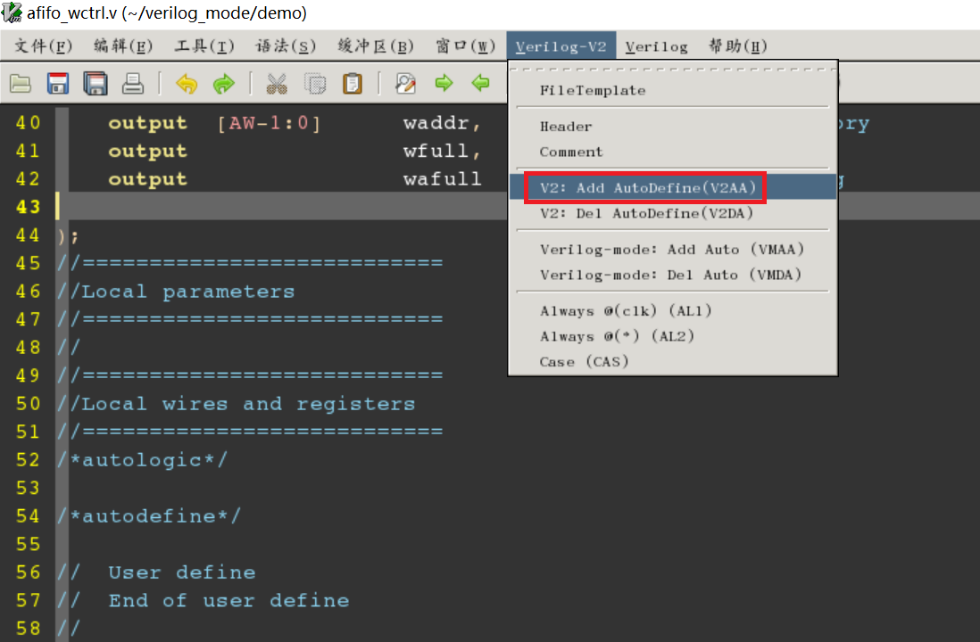
执行完后：
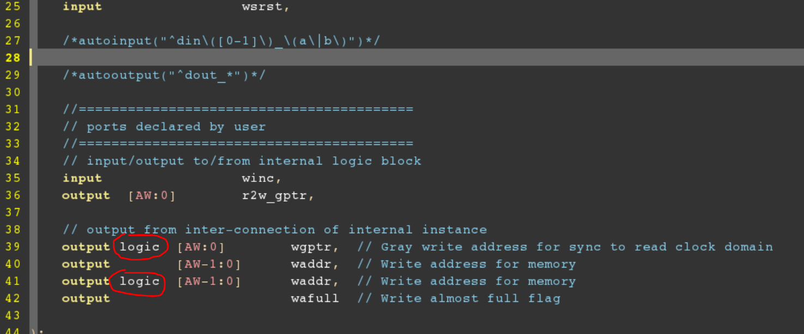
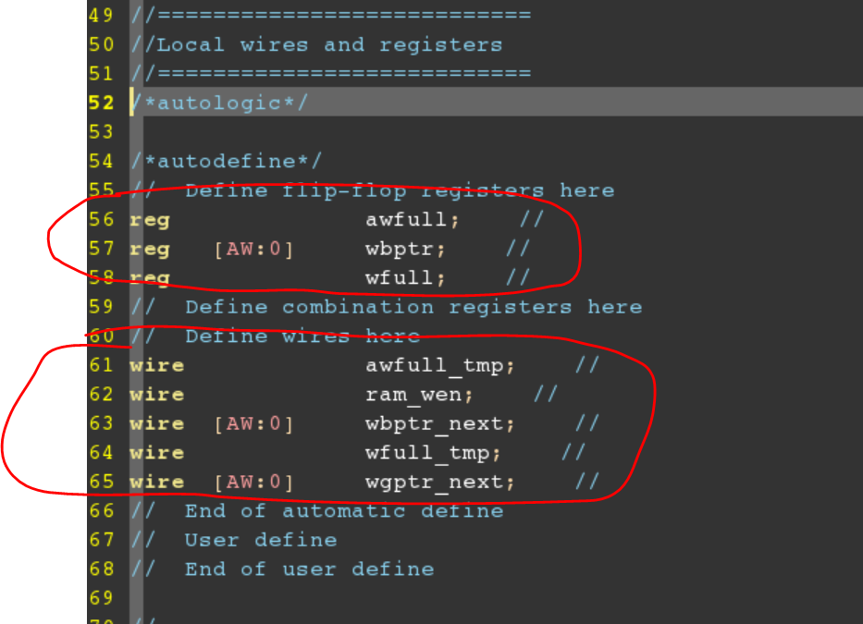
//=========================================
//Created by :xxx
//Filename :afifo_wctrl.v
//Author :xxx(RDC)
//Created On :2024-07-02 20:11
//Last Modified :
//Update Count :
//Description :
//
//
//=========================================
//
module afifo_wctrl #(
parameter integer AW = 4,
parameter integer ALFULL = 12,

)
(
//=========================================
//ports declared by Verilog-mode tool
//=========================================
/*autoinput("^clk\|^rst")*/
input wclk,
input wrst_n,
input wsrst,

/*autoinput("^din\([0-1]\)_\(a\|b\)")*/

/*autooutput("^dout_*")*/

//=========================================
// ports declared by user
//=========================================
// input/output to/from internal logic block
input winc,
output [AW:0] r2w_gptr,

// output from inter-connection of internal instance
output logic [AW:0] wgptr, // Gray write address for sync to read clock domain
output [AW-1:0] waddr, // Write address for memory
output logic [AW-1:0] waddr, // Write address for memory
output wafull // Write almost full flag

);
//===========================
//Local parameters
//===========================
//
//===========================
//Local wires and registers
//===========================
/*autologic*/

/*autodefine*/
// Define flip-flop registers here
reg awfull; //
reg [AW:0] wbptr; //
reg wfull; //
// Define combination registers here
// Define wires here
wire awfull_tmp; //
wire ram_wen; //
wire [AW:0] wbptr_next; //
wire wfull_tmp; //
wire [AW:0] wgptr_next; //
// End of automatic define
// User define
// End of user define

//
//===========================
//Main code begins here
//===========================
// 写指针产生
assign ram_wen = (winc & (~wfull)); //非满且写的时候，产生memory写使能
assign wbptr_next[AW:0] = wbptr[AW:0] + ram_wen; //非满且写的时候，写指针加一
assign wgptr_next[AW:0] = {1'd0,wbptr_next[AW:1]}^wbptr_next[AW:0]; //写指针二进制转格雷码
always@( posedge wclk or negedge wrst_n ) begin
if( !wrst_n) begin
wbptr[AW:0] <= {(AW+1){1'b0}};
wgptr[AW:0] <= {(AW+1){1'b0}};
end else if( wsrst) begin
wbptr[AW:0] <= {(AW+1){1'b0}};
wgptr[AW:0] <= {(AW+1){1'b0}};
end else begin
wbptr[AW:0] <= wbptr_next[AW:0];
wgptr[AW:0] <= wgptr_next[AW:0];
end
end

// 满/将满标志产生
assign wfull_tmp = (wgptr_next[AW:0] == {~r2w_gptr[AW:AW-1],r2w_gptr[AW-2:0]});
assign awfull_tmp = ((wbptr_next[AW:0] - r2w_gptr[AW:0]) > ALFULL);
always@( posedge wclk or negedge wrst_n ) begin
if( !wrst_n) begin
wfull <= 1'b0;
awfull <= 1'b0;
end else if( wsrst) begin
wfull <= 1'b0;
awfull <= 1'b0;
end else begin
wfull <= wfull_tmp;
awfull <= awfull_tmp;
end
end

//=========================================
//Verilog-mode Setting:
//Local Variables:
//verilog-library-files: (
//"./test.v"
//)
//verilog-library-directories: (
//"."
//".."
//)
//verilog-auto-inst-param-value: t
//End:
//=========================================
endmodule

