Android Wifi Module

Figure 1 illustrates the android wifi system.

Applications can use the API provided by WifiManager to manage all aspects of Wi-Fi connectivity, such as enable or disable Wi-Fi\ request a scan for access points\ return a list of all the networks configured and so on. And Wifiservice will broadcast WIFI_STATE_CHANGED_ACTION when wifi is enabled\disabled.

WifiService responsible for initiating and closing wpa_supplicant\WifiMonitor monitor thread, and send the commands to wpa_supplicant. WifiMonitor is responsible for receiving event notifications from wpa_supplicant. Then WifiStateTracker broadcast actions.

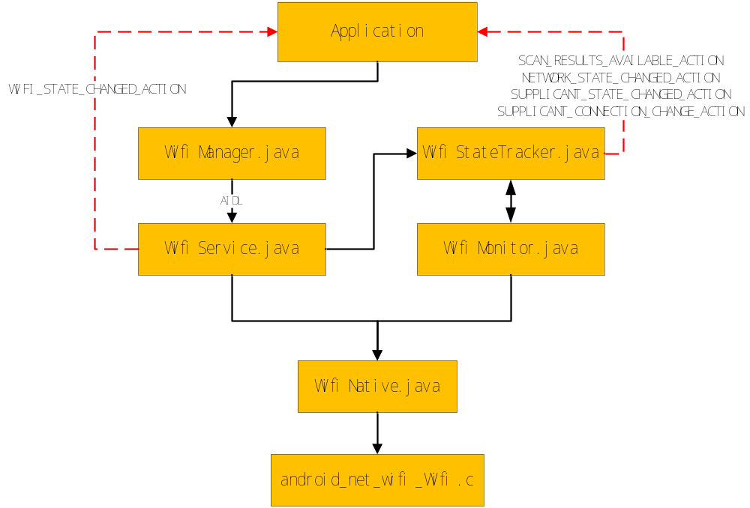

Figure 1 Android wifi system

WifiManager provides the primary API for managing all aspects of Wi-Fi connectivity. It deals with several categories of items:
- The list of configured networks. The list can be viewed and updated, and attributes of individual entries can be modified.
- The currently active Wi-Fi network, if any. Connectivity can be established or torn down, and dynamic information about the state of the network can be queried.
- Results of access point scans, containing enough information to make decisions about what access point to connect to.
- It defines the names of various Intent actions that are broadcast upon any sort of change in Wi-Fi state.
WifiService handles remote WiFi operation requests by implementing the IWifiManager interface(aidl). It also creates a WifiMonitor to listen for Wifi-related events.

WifiStateTracker track the state of Wifi connectivity. All event handling is done here, and all changes in connectivity state are initiated here.

WifiMonitor listens for events from the wpa_supplicant server, and passes them on to the WifiStateTracker for handling. Runs in its own thread.

WifiNative calls for sending requests to the supplicant daemon

The event which WifiStateTracker handles:
- WIFI_STATE_CHANGED_ACTION: Broadcast intent action indicating that Wi-Fi has been enabled, disabled, enabling, disabling, or unknown.
- SUPPLICANT_STATE_CHANGED_ACTION: Broadcast intent action indicating that the state of establishing a connection to an access point has changed. One extra provides the new SupplicantState.
- SUPPLICANT_CONNECTION_CHANGE_ACTION: Broadcast intent action indicating that a connection to the supplicant has been established (and it is now possible to perform Wi-Fi operations) or the connection to the supplicant has been lost.
- SCAN_RESULTS_AVAILABLE_ACTION: An access point scan has completed, and results are available from the supplicant.
- RSSI_CHANGED_ACTION: The RSSI (signal strength) has changed.
- NETWORK_STATE_CHANGED_ACTION: Broadcast intent action indicating that the state of Wi-Fi connectivity has changed.
- NETWORK_IDS_CHANGED_ACTION: The network IDs of the configured networks could have changed.

The following text is only about two aspects of Wi-Fi connectivity, but the others have similar action.

Figure 2 illustrates the process for enabling wifi
- Application call the setWifiEnabled() fuction of WifiManager.
- Call setWifiEnabled() function of WifiService by implementing the IWifiManager interface(aidl).
- WifiService sends a message MESSAGE_ENABLE_WIFI to itself.
- WifiHandler in WifiService obtains the message and start handling.
- Call setWifiEnabledBlocking() which will load wifi driver\start wpa_supplicant\start event loop\update the status.
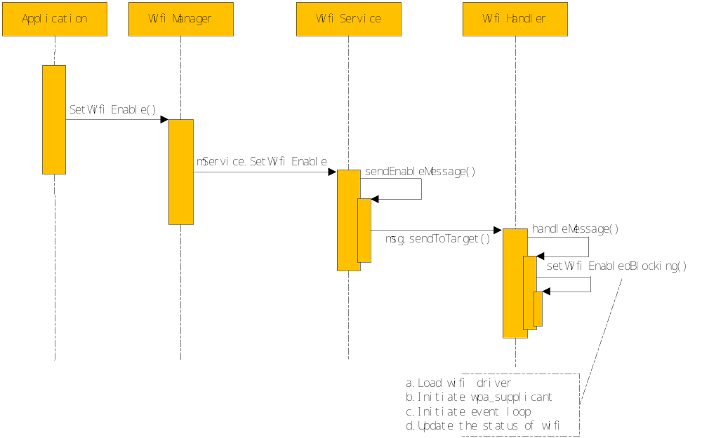
Figure 2 Steps in Enabling Wifi

Figure 3 illustrates the process for scaning wifi
- Application call the startScan() fuction of WifiManager.
- Call startScan() function of WifiService by implementing the IWifiManager interface(aidl).
- Call scanCommand() function() of WifiNative.
- Call android_net_wifi_scanCommand() of android_net_wifi_Wifi.
- Call doBooleanCommand() of android_net_wifi_Wifi.
- Wifimonitor wait for event and get CTRL-EVENT-SCAN-RESULTS event.
- handleEvent() of WifiMonitor handles the event and call notifyScanResultsAvailable() of WifiStateTracker.
- WifiStateTracker send a message to itself and handlemessage.
- Broadcast SCAN_RESULTS_AVAILABLE_ACTION.
- Application receive the broadcast.
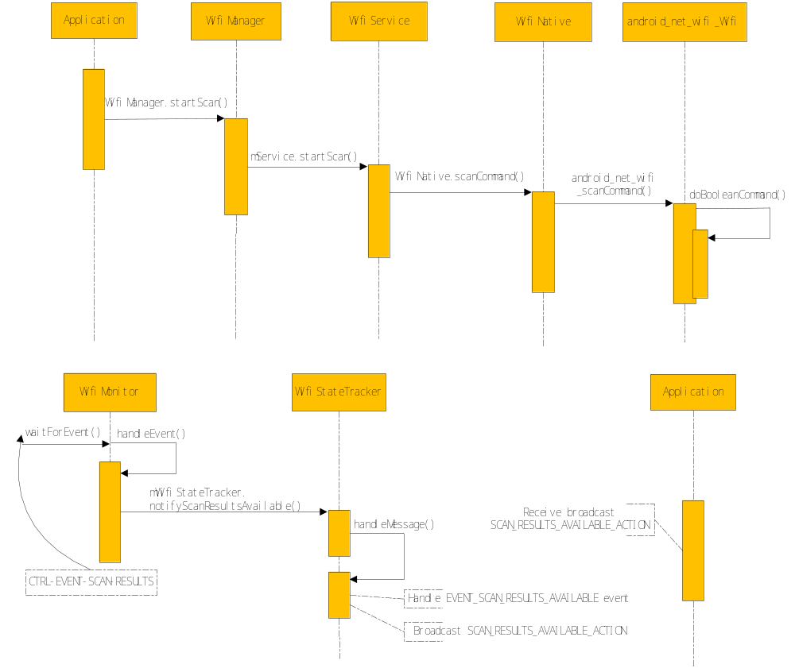Figure 3 Steps in Starting Scan and Getting Scan-Results Event

