<https://www.fpga4fun.com/Counters4.html>

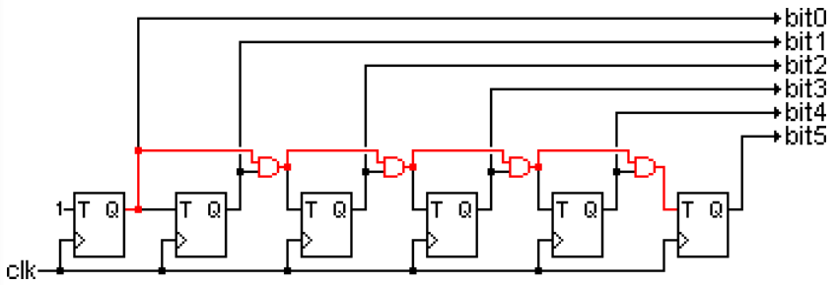

 A Full adder can be made by combining two half adder circuits together (a half adder is a circuit that adds two input bits and outputs a sum bit and a carry bit).

