

**Dr.Cook – Interactive Recipe Website**

Lidor Kupershmid – 318187416

Aviv Aytek – 206713604

Lidor Anfinger – 206953895

Dror Hershkovitz – 206891459

**Direct link to the website**[**:**](:%20%20https:/doctor-cook.up.railway.app/recipes)  [**https://doctor-cook.up.railway.app/recipes**](https://doctor-cook.up.railway.app/recipes) **Link to the repository:** [**https://github.com/lidor1997/Doctor-Cook-Web-Project/tree/main**](https://github.com/lidor1997/Doctor-Cook-Web-Project/tree/main)

**Assignments**

|  |  |  |
| --- | --- | --- |
| שם חבר הצוות | משימות שהוקצו | משימות שהושלמו |
| לידור קופרשמיד 318187416 - מהנדס מערכת | פיתוח צד לקוח: יישום ממשק משתמש לחיפוש ולכניסה למערכת | הכל הושלם בהצלחה. |
| לידור אנפינגר 206953895 (מילואים) | בדיקות: כתיבת בדיקות יחידה עבור רכיבי צד לקוח | הכל הושלם בהצלחה. |
| דרור הרשקוביץ 206891459 (מילואים) | אינטגרציה צד לקוח וצד שרת: חיבור צד לקוח ל-API של השרת | הכל הושלם בהצלחה. |
| אביב אייטק 206713604 | פיתוח צד שרת: יצירת REST API לחיפוש מתכונים ולניהול משתמשים | הכל הושלם בהצלחה. |

**Requirements**

**Functional requirements - FR:**

* The system must support voice commands.
* The system must allow users to search a desired meal.
* The system must provide detailed, step-by-step instructions for recipes, including ingredients, preparation, and cooking methods.
* The system must allow users to set multiple cooking timers for different recipe steps and notify users when each timer completes.
* The system must allow users to rank recipes.
* The system must support dark-light mode

**Non-Functional requirement – NFR:**

* The search for a meal can be by type or by name.
* The system should be simple and clear so that anyone, even beginners, can use it without confusion.
* The website must adapt to different screen sizes, ensuring it looks and functions well on desktops, tablets, and mobile devices.
* The web application must display user-friendly error messages  
   ("Page not found", "Connection error") whenever an issue occurs.
* Each recipe should have picture and description of preparation.
* The ingredients should change as the number of dishes change.
* The voice commands support English language.

**Use Case Diagram**

**System** **Architecture**

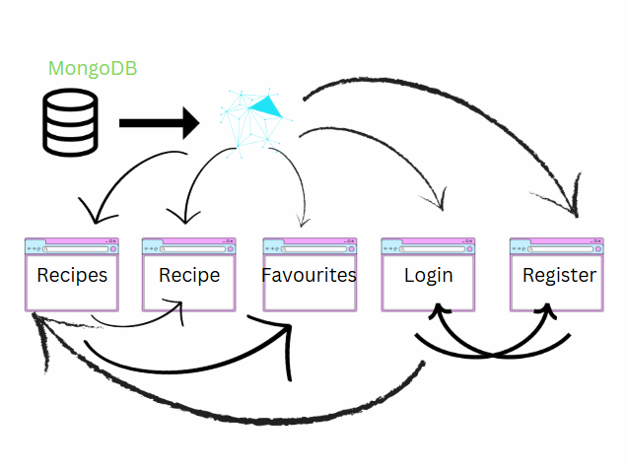

**File and Folder Diagram**

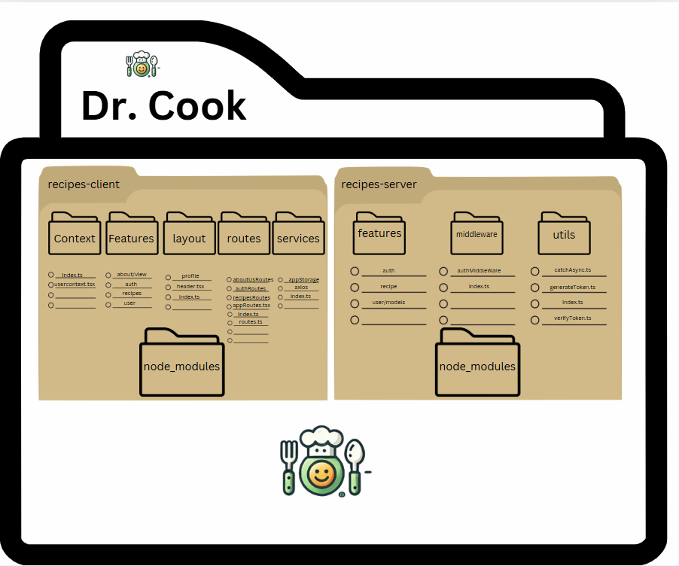

**Project Structure**

Client-Side:

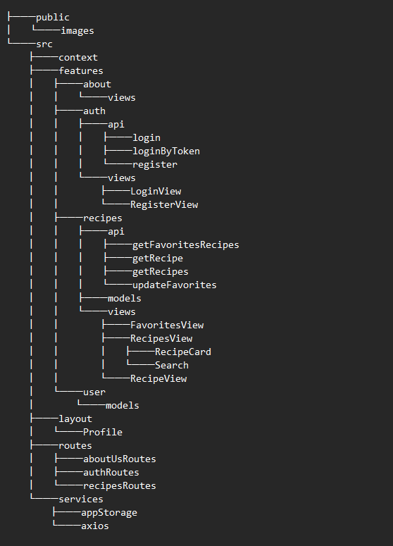

Server-Side:

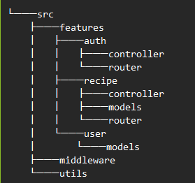

**MongoDB Structure**

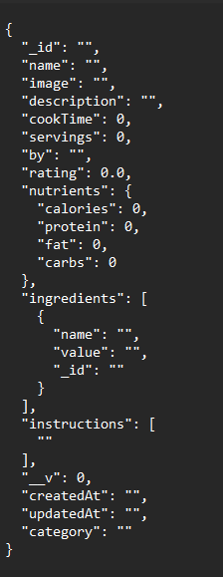**Recipes**

* **_id**: Unique identifier for the recipe.
* **name**: The name of the recipe
* **image**: URL of an image representing the dish.
* **description**: A short description of the recipe.
* **cookTime**: The time required to prepare and cook the dish (in minutes).
* **servings**: The number of people the recipe serves.
* **by**: The name of the recipe creator or chef.
* **rating**: The average rating of the recipe
* **nutrients**: An object containing key nutritional values:
* **calories**: The calorie count per serving.
* **protein**: The amount of protein
* **fat**: The amount of fat
* **carbs**: The amount of carbohydrates
* **ingredients**: An array of ingredient objects, each containing:
* **name**: The name of the ingredient.
* **value**: The quantity required
* **_id**: Unique identifier for the ingredient.
* **instructions**: An array of step-by-step cooking instructions.
* **__v**: Version key (used in MongoDB for document
* **createdAt**: Timestamp of when the recipe was created.
* **updatedAt**: Timestamp of the last update to the recipe.
* **category**: The category of the recipe

* **id**: Unique identifier for the user.
* **name:** The full name of the user.
* **username**: The user's chosen username for login.
* **password**: Hashed password for authentication security.
* **createdAt**: Timestamp of when the user account was created.
* **updatedAt**: Timestamp of the last update to the user account.
* **__v**: Version key (used in MongoDB for document versioning).
* **favorites**: An array of recipe IDs that the user has marked as favorites.

**Users**