<https://www.ibm.com/communities/analytics/watson-analytics-blog/predictive-insights-in-the-telco-customer-churn-data-set/>

# Using Customer Behavior Data to Improve Customer Retention

 McKinley Stacker IV

 Apr 15, 2015  40826

We’ve uploaded some sample data sets in the IBM Watson Analytics community for you to work with as you learn more about Watson Analytics. This expert blog uses the [Telco Customer Churn data set](https://community.watsonanalytics.com/wp-content/uploads/2015/03/WA_Fn-UseC_-Telco-Customer-Churn.csv?cm_mc_uid=69935033363515266084359&cm_mc_sid_50200000=69650671526608435948&cm_mc_sid_52640000=87743891526608435956). [WA_Fn-UseC_-Telco-Customer-Churn](https://community.watsonanalytics.com/wp-content/uploads/2015/03/WA_Fn-UseC_-Telco-Customer-Churn.xlsx)

## What’s in the Telco Customer Churn data set?

This data set provides info to help you predict behavior to retain customers. You can analyze all relevant customer data and develop focused customer retention programs.

A telecommunications company is concerned about the number of customers leaving their landline business for cable competitors. They need to understand who is leaving. Imagine that you’re an analyst at this company and you have to find out who is leaving and why.

The data set includes information about:

* Customers who left within the last month – the column is called Churn
* Services that each customer has signed up for – phone, multiple lines, internet, online security, online backup, device protection, tech support, and streaming TV and movies
* Customer account information – how long they’ve been a customer, contract, payment method, paperless billing, monthly charges, and total charges
* Demographic info about customers – gender, age range, and if they have partners and dependents

## If you don’t have the data set…

1. Go to <https://community.watsonanalytics.com/resources/>
2. Download the [**Telco Customer Churn**](https://community.watsonanalytics.com/wp-content/uploads/2015/03/WA_Fn-UseC_-Telco-Customer-Churn.csv) sample data file.
3. In Watson Analytics, tap **Add** and upload Telco Customer Churn.  
   The filename is a bit longer: WA_Fn-UseC_-Telco-Customer-Churn.csv.

[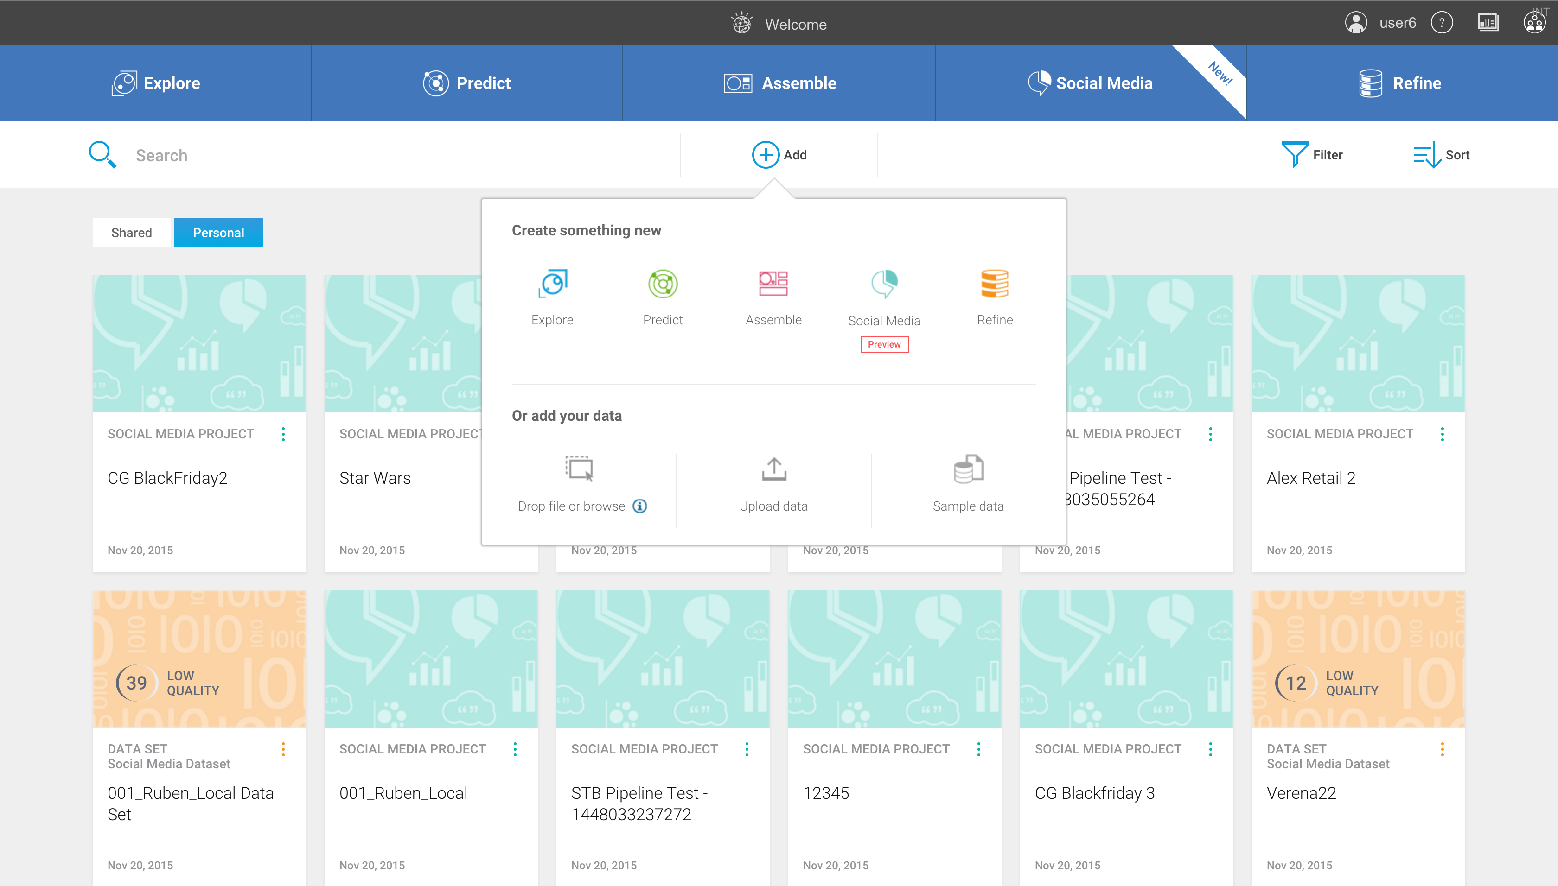](https://community.watsonanalytics.com/wp-content/uploads/2015/04/WelcomeWithBannerSmallSize.png)

The data set appears as a tile in the Welcome page and you’re ready to get to work.

[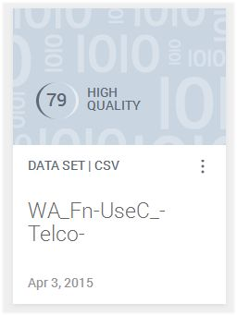](https://community.watsonanalytics.com/wp-content/uploads/2015/04/wa_telco2.jpg)

## Which customers are likely to leave?

1. To find the answer to this question, tap the WA_Fn-UseC_-Telco-Customer-Churn tile and tap **Prediction**.

[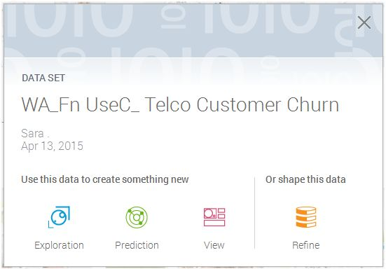](https://community.watsonanalytics.com/wp-content/uploads/2015/04/wa_telco3.jpg)  
You want to learn more about customers who’ve left the company in the past month – this is the target that you want to investigate. The data is in the column called Churn, which is the column we’ve already picked as the target for the prediction. Let’s find out which variables influence customers who leave.

1. Name the prediction and tap **Create Prediction**.

Watson Analytics analyzes the data and generates visualizations to provide insights into this issue.

The spiral shows you the top predictors, or key drivers, of churn in color; other drivers appear in gray. The closer the driver is to the center of the spiral, the stronger the predictive strength of the driver is.

[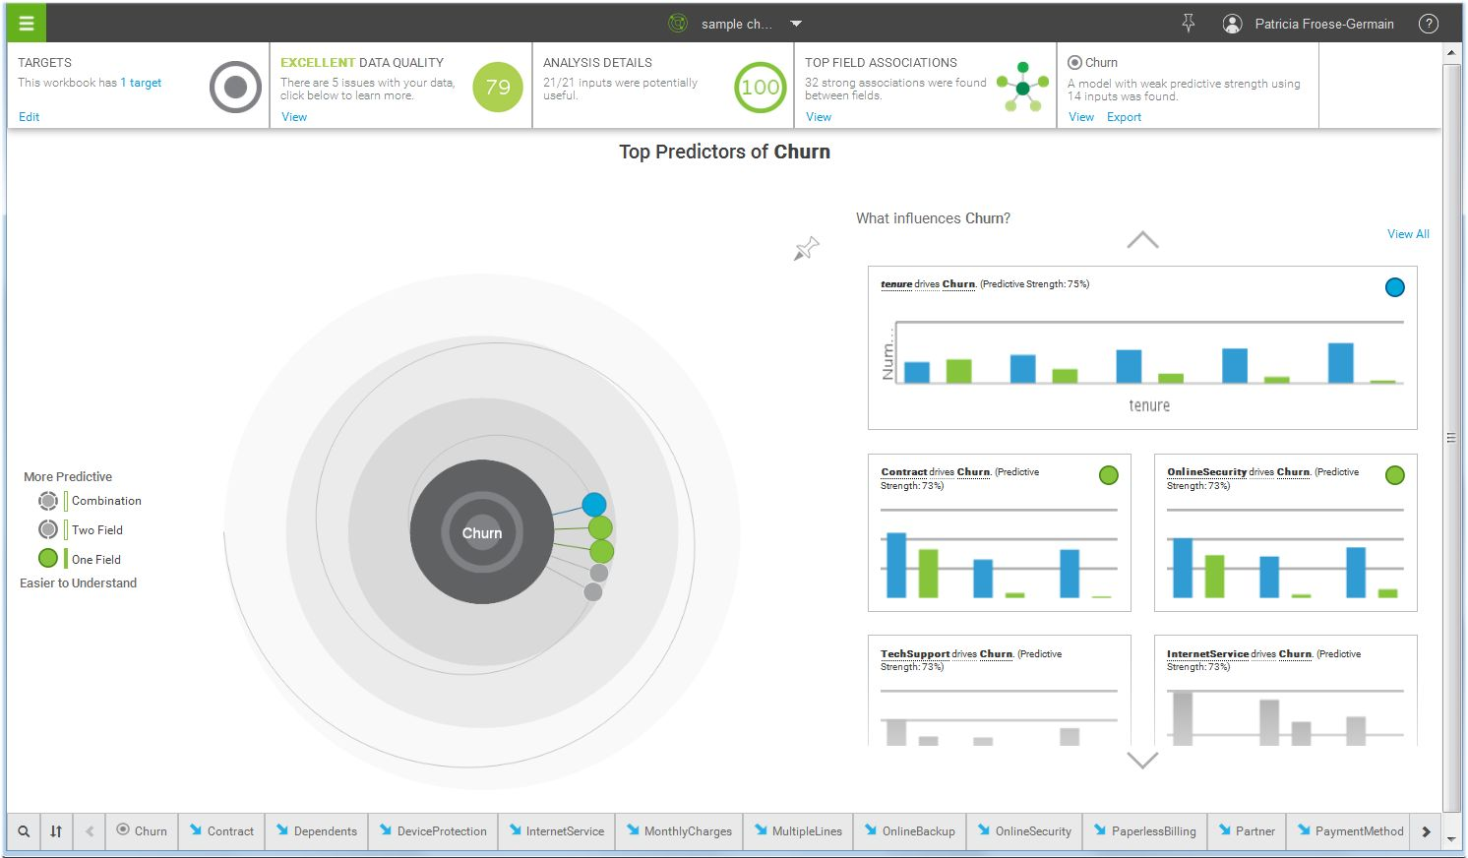](https://community.watsonanalytics.com/wp-content/uploads/2015/04/wa_telco4.jpg)

The key drivers are tenure, contract, and online security. The visualizations to the right of the spiral show how one driver at a time drives churn. The blue or green dots in the upper right of the visualizations identify which driver is being shown.

1. Tap **tenure drives Churn**.

This new visualization shows that customers who have been customers for shorter periods are more likely to leave.  
[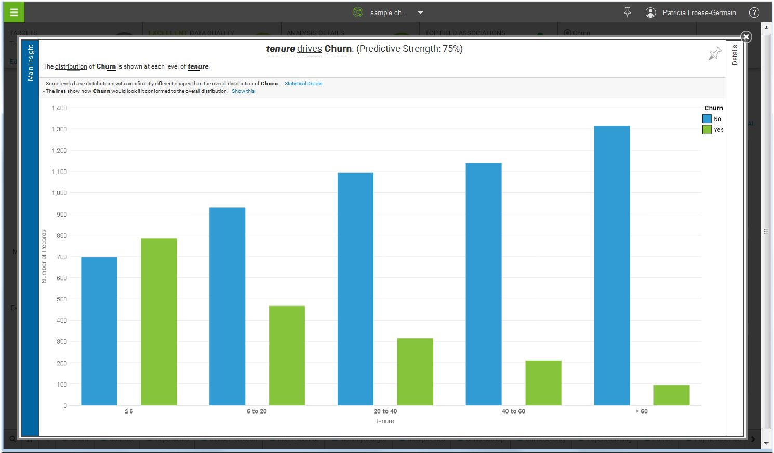](https://community.watsonanalytics.com/wp-content/uploads/2015/04/wa_telco5.jpg)

1. Close this visualization by tapping the X in its upper right corner.

You can look at the visualizations for the other drivers on your own. Let’s move on and explore churn in more depth.

To the left of the spiral are options for creating visualizations that show more than one driver at a time.

[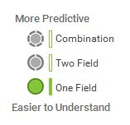](https://community.watsonanalytics.com/wp-content/uploads/2015/04/wa_telco6.jpg)

1. Let’s go straight to the deeper and more predictive analysis of the data. Tap **Combination**.

You get a new set of visualizations on the right, including a decision tree, that show the combination of variables that influence your target.

[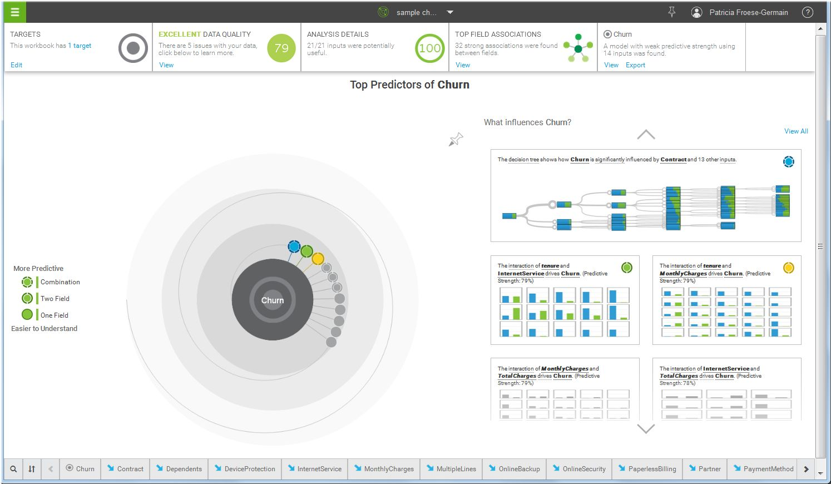](https://community.watsonanalytics.com/wp-content/uploads/2015/04/wa_telco7.jpg)

1. Let’s look at the combination of key drivers that influence whether customers leave. Tap the decision tree.

[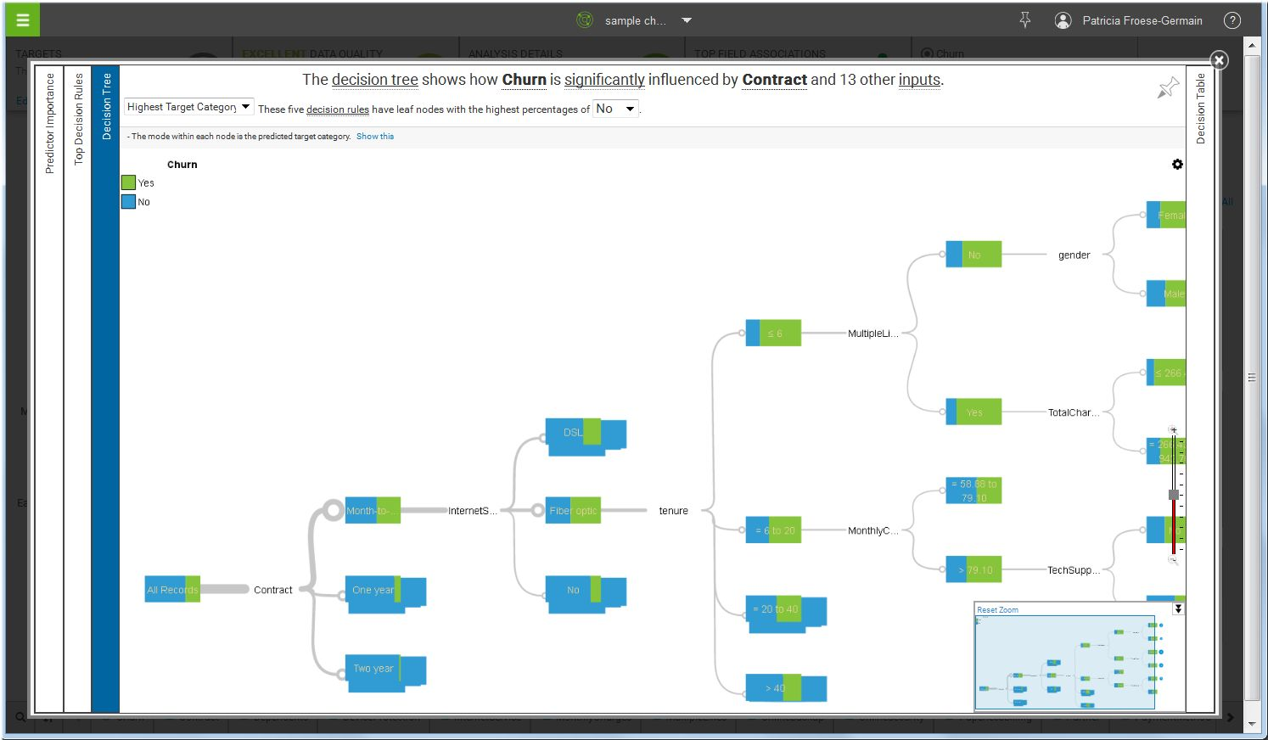](https://community.watsonanalytics.com/wp-content/uploads/2015/04/wa_telco8.jpg)

1. Let’s look at a word cloud about the key factors that influence churn. Tap **Predictor Importance**.

Contract, Internet Service, Tenure, and Total Charges are the most important factors.

[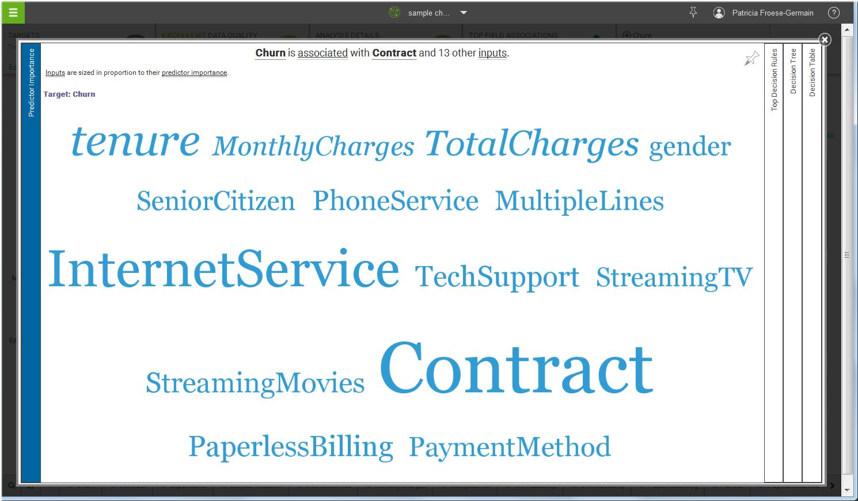](https://community.watsonanalytics.com/wp-content/uploads/2015/04/wa_telco9.jpg)

1. Let’s get some more details on who is leaving so we can predict who is likely to leave in the future. Tap **Top Decision Rules**.

The rules are specific and detailed, and are sorted by accuracy. They currently focus on customers who do not leave. We need to change that.

1. Change the **No** to **Yes**.

[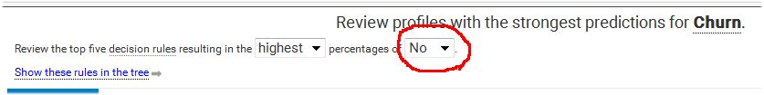](https://community.watsonanalytics.com/wp-content/uploads/2015/04/wa_telco10.jpg)  
A clearer view emerges. Customers who leave tend to be ones who are on a month-to-month contract, have fiber optic internet service, and have been customers for shorter periods.

You can now predict which customers are at risk to churn. Use the decision rules to identify customers who fit the churn profile so you can proactively offer them an incentive to stay.

[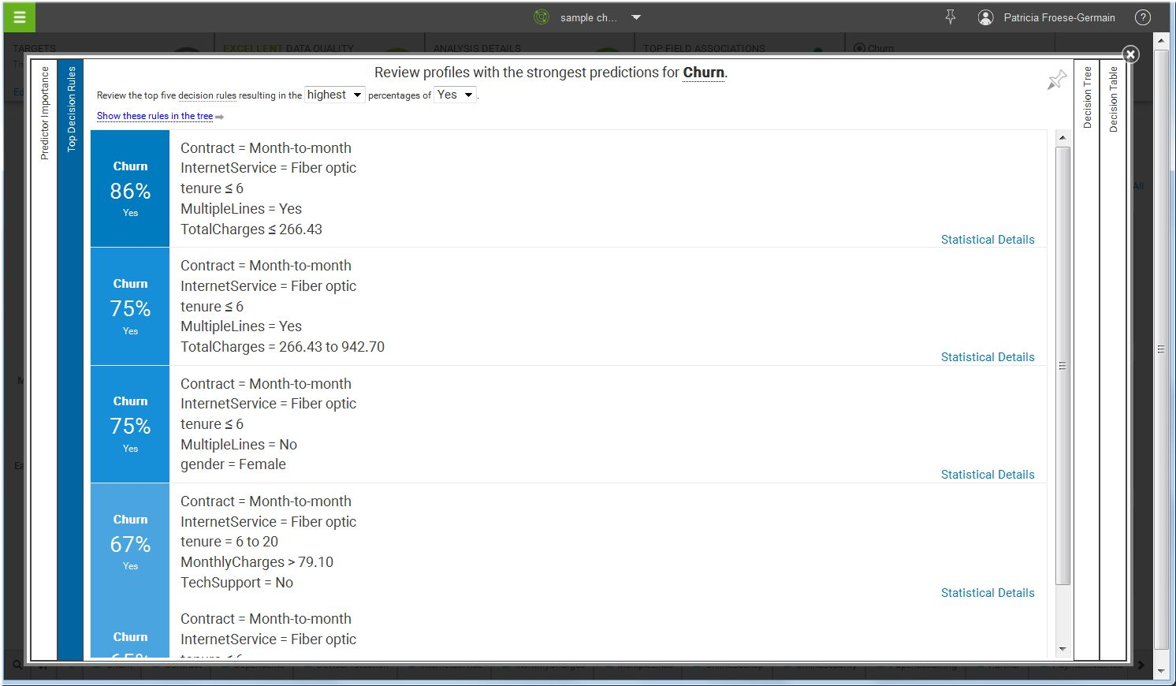](https://community.watsonanalytics.com/wp-content/uploads/2015/04/wa_telco11.jpg)