SUPPLEMENTAL MATERIALS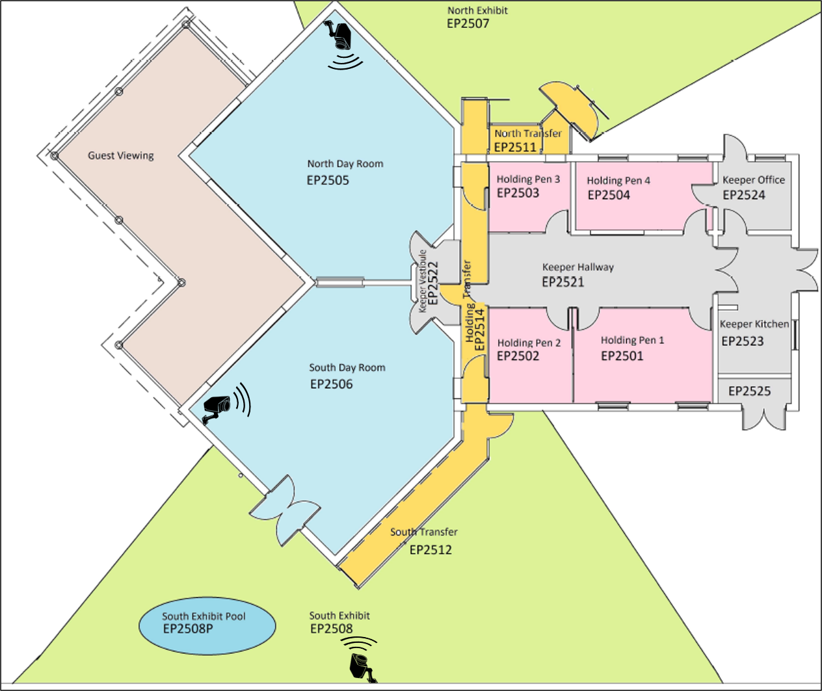
Figure S1. Amur Tiger south habitat at the Toronto Zoo. Three cameras, two AXIS P3265-LV Dome cameras (resolution = 1920x1080, fps = 30) and one wide angle AXIS P3715-PLVE camera (resolution = 2560x720, fps = 30) were used to capture the full habitat comprising three connected areas. The cameras were mounted at fixed positions at a height of approximately 12 feet, with the dome and wide angle cameras having a ~100° and 200° horizontal field of view, respectively.

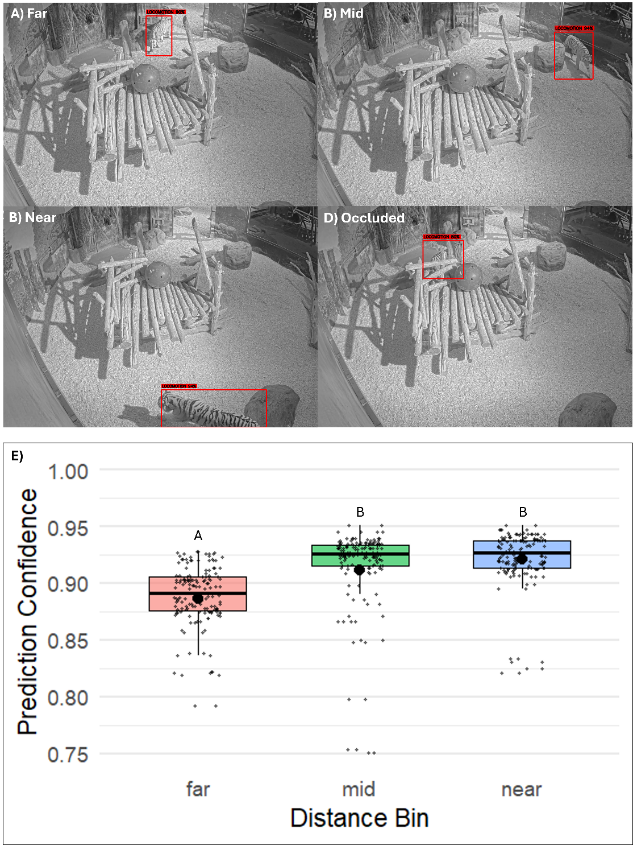
Figure S2. Representative video frames illustrating A) “far,” B) “mid-range,” and C) “near” proximity to the camera based on normalized bounding-box area tertiles, and D) an example of an occluded detection. Bounding-box size was used as a qualitative proxy for distance in confidence analyses. E) The prediction confidence was significantly lower (p < 0.05) when the tiger was far from the camera compared to when the tiger was in closer proximity to the camera. Significance differences between tertiles are indicated by differing Latin letters.
Supplemental Table 1. Logical workflow for sequential execution of customized scripts used for pre-processing, preparing, and analyzing video data for behavioural monitoring.
File Name | Function | Input* | Output*
1_relabel_train.py | Appends label to each specified frame in the train.txt file | Image and label directories; train.txt file | train.txt file linking file location for each frame with associated label
2_cleanup_images.py | Removes non-labeled frames (so that only annotated frames are used to train models) | Video frames and labels (imbalanced if there are impartially labeled videos) | Folders for images and labels
3_data_augmentation.py | Apply image augmentations (e.g., resizing, contrast, flip) to improve model generalization | Image and label directories | Images and associated labels (post-augmentation) in folder, “augmented”
4_samples_distribution.py | Counts # of annotated frames in behavioural class | Label directory | Printout # of samples/labels in each class
5_balance_dataset.py | Fix class imbalance by randomly selecting samples for removal from over-represented behavioural classes | Image and label directories | Remove excess images and move to folder, “val_extra”
6_split_data.py | Splits the global image and label dataset into separate datasets for training and validation | Image and label directories | Images and labels separated and organized into new folders, “train” and “val”
7_activity_budget.py | Activity budget is produced as a bar plot as well as in a spreadsheet format for further analysis | Trained model (“best.pt”), video sequence | “output.csv” and “activity_budget.png” are generated in project directory
8_heatmap_video.py | Space usage heatmaps produced, based off detection intensity for each behaviour of interest | Trained model (“best.pt”), video sequence | A “heatmap_output” folder containing heatmaps for each behaviour
10_video_inference.py | Conducts inference on raw video sequence to predict/draw bounding boxes and annotations | Trained model (“best.pt”), video sequence | “output.mp4” containing predicted bounding boxes and annotations
data_custom.yaml | Used by the YOLO model to specify the frames used for training and validation on which predictions will be made | - | -
train.txt | Contains the file path for each image frame; after applying the relabel_train script will contain relevant class assignment | - | -
common_commands.txt | Useful commands for setting project directory, code for starting a training run using yolov8m | Need to have followed steps above/described in methods for YOLO command to run | A “runs” folder containing model results will be added to project directory
yolov8m.pt | The YOLOv8 model backbone with pre-trained weights used for training and testing | Used as part of the yolo argument for training and testing | -
*Note for input/output column: the user must adjust script to reflect the correct file paths/directories for images, labels, models, etc.
Supplemental Table 2. List of terms and their descriptions for metrics used for assessing predictive model performance. Calculations for metrics are provided elsewhere (e.g., Chan et al., 2025). This table serves as a reference for interpreting model evaluation results presented in the manuscript. The goal for measures associated with loss or time is usually to minimize these as close to zero (0%) as possible, while accuracy, precision, recall, F1, and mAP indicate perfect performance as they approach one (100%).
Metric | Description
Epoch | Iteration count; measures the number of passes through the entire training data.
Time | Total training time (seconds) for each epoch. Helps track computational cost.
Train/Box_Loss | Measures localization error in bounding box prediction during training.
Train/Cls_Loss | Measures classification error for object classes during training.
Train/Dfl_Loss | Evaluates the loss for distributional focal loss to improve localization.
Precision (B) | Proportion of correct positive detections among all positive predictions.
Recall (B) | Proportion of ground truth bounding boxes the model correctly identifies, specifically true positives detected among all actual positives.
F1 | Harmonic mean of precision and recall
mAP50 (B) | Mean Average Precision at IoU threshold of 0.50. Measures overall detection accuracy.
mAP50-95 (B) | Mean Average Precision across IoU thresholds (0.50 to 0.95). Indicates agreement of bounding box overlap with the ground truth.
Val/Box_Loss | Localization error during validation. Indicates generalization to unseen data.
Val/Cls_Loss | Classification error for predicting using validation dataset.
Val/Dfl_Loss | Distributional focal loss during validation.
LR/PG0 | Learning rate for parameter group 0. Adjusts weights for specific layers.
LR/PG1 | Learning rate for parameter group 1.
LR/PG2 | Learning rate for parameter group 2.

Supplementary Document 1
Guide for utilizing a graphics card to enable accelerated video data processing
Developed by Li-Dunn Chen, Toronto Zoo, 2025

The following guide gives step-by-step instruction on how to set up an Anaconda Prompt environment for establishing a behavioural monitoring pipeline using video data. We also recommend Chan et al. (2025, https://doi.org/10.1111/2041-210X.14502) as a helpful resource.

Disclaimer: Be aware of your company/institution’s policies on data sharing guidelines and practices so that you can adhere to them appropriately. Be careful not to share sensitive information, such as proprietary code for a project or videos/images, that may be under legal protection (e.g., as intellectual property stated within a non-disclosure clause or similar).

Step 1: Install Anaconda Prompt (https://problemsolvingwithpython.com/01-Orientation/01.03-Installing-Anaconda-on-Windows/). Ensure you have added Anaconda Prompt to your computer’s PATH by adjusting the Environmental Variables.
Step 2: Install Compute Unified Device Architecture (CUDA). (https://developer.nvidia.com/cuda-toolkit).
Step 3: Install Docker (https://www.docker.com/products/docker-desktop/). During installation, ensure “Add Docker to PATH” is checked, and enable WSL2 integration if prompted (it helps with GPU access via Docker).
Step 4: Open Anaconda Prompt and run the following code snippets (italicized bolded purple font) by either typing or copying and pasting them into the command prompt and pressing the enter key.

conda create -n enviro
#Creates environment for the project called “enviro” (you can give any custom name relevant to your program).
conda activate enviro
#This activates your working environment. Replace “enviro” with the name of your project environment if you have chosen a different name.
docker --version
#Cofirms that Docker is installed properly.
docker run –gpus all nvidia/cuda:12.5.0-runtime-ubuntu20.04 nvidia-smi
#Shows if the GPU card is initialized.
conda install pip
#Installs pip (Python Package Installer)
pip
#Cofirms that pip is installed properly.
pip install ultralytics
#Installs the ultralytics package to access YOLO algorithms.
pip3 install –upgrade torch torchvision torchaudio –index-url https://download.pytorch.org/whl/cu121
#Installs PyTorch framework for integrating GPU interface between ultralytics and CUDA. Ensure PyTorch is installed with the matching CUDA version. Earlier/later version of PyTorch may need to be installed.
import torch
#Verify GPU Compatibility with PyTorch.
print(torch.cuda.is_available())
#Should return True.
print(torch.cuda.get_device_name(0))
#Should return the name of the graphics card installed on your computer.

#Your system should now be ready to deploy YOLO models.
conda deactivate
#This command exits the working environment; you do not have to specify the name of the environment.

