This document contains Supplementary Document 1 and Tables associated with the manuscript entitled, “
Description of the “ConcordanceTest.py” Script
Prior to deploying the behavioural-detection model to real-time CCTV livestreams, we evaluated its validity using recorded video clips. We assessed concordance between StereotypyAI and human observers for the five base behavioural categories by analyzing 30-min video samples (N = 13), where model predictions were compared directly against manually coded behaviours. This step established the model’s reliability in classifying routine behavioural states.
To automate extraction of model-predicted behaviours for concordance testing, we developed a Python script “ConcordanceTest.py” that subsampled each 30 minute video at fixed 2-min intervals following an interval scan-sampling approach (Altmann, 1974; see Supplemental Document 1 for details). Unlike a single instantaneous observation, each sample consisted of a short 1.5 second clip (~50 frames), and the model’s frame-wise predictions were aggregated using a majority-vote rule to estimate the behavioural state at each scan point. To avoid inflating bear counts due to duplicate or overlapping detections, all bounding boxes were filtered using intersection-over-union (IOU) suppression: detections with IOU ≥ 0.85 were treated as the same individual, and only the behaviour with the highest confidence score (minimum accepted confidence = 60%) was retained. After filtering, the script estimated how many bears were present by examining the number of detections across all sampled frames. Rather than relying on a single frame, which could contain spurious or missed detections, the script used the most commonly occurring number of detections (the statistical mode) as a stable estimate of group size. Additional frequency thresholds required that a second or third bear appear in at least 60% of sampled frames before being accepted as a true individual. This prevented momentary false positives from being misinterpreted as additional bears.
The final output included (1) a CSV file listing timestamps (in 2-min increments) and corresponding predicted behaviours for up to three bears, and (2) an annotated MP4 snapshot video showing model-generated bounding boxes, behaviour labels, and confidence scores for each sampled interval. These automated predictions were then used for concordance testing against human observers using measures of Cohen’s κ as well as Gwet’s AC1, as κ is widely used in behavioural studies but sensitive to class imbalance, whereas AC1 provides a more stable chance-corrected estimate under uneven behavioural frequencies (Giammarino et al., 2021).

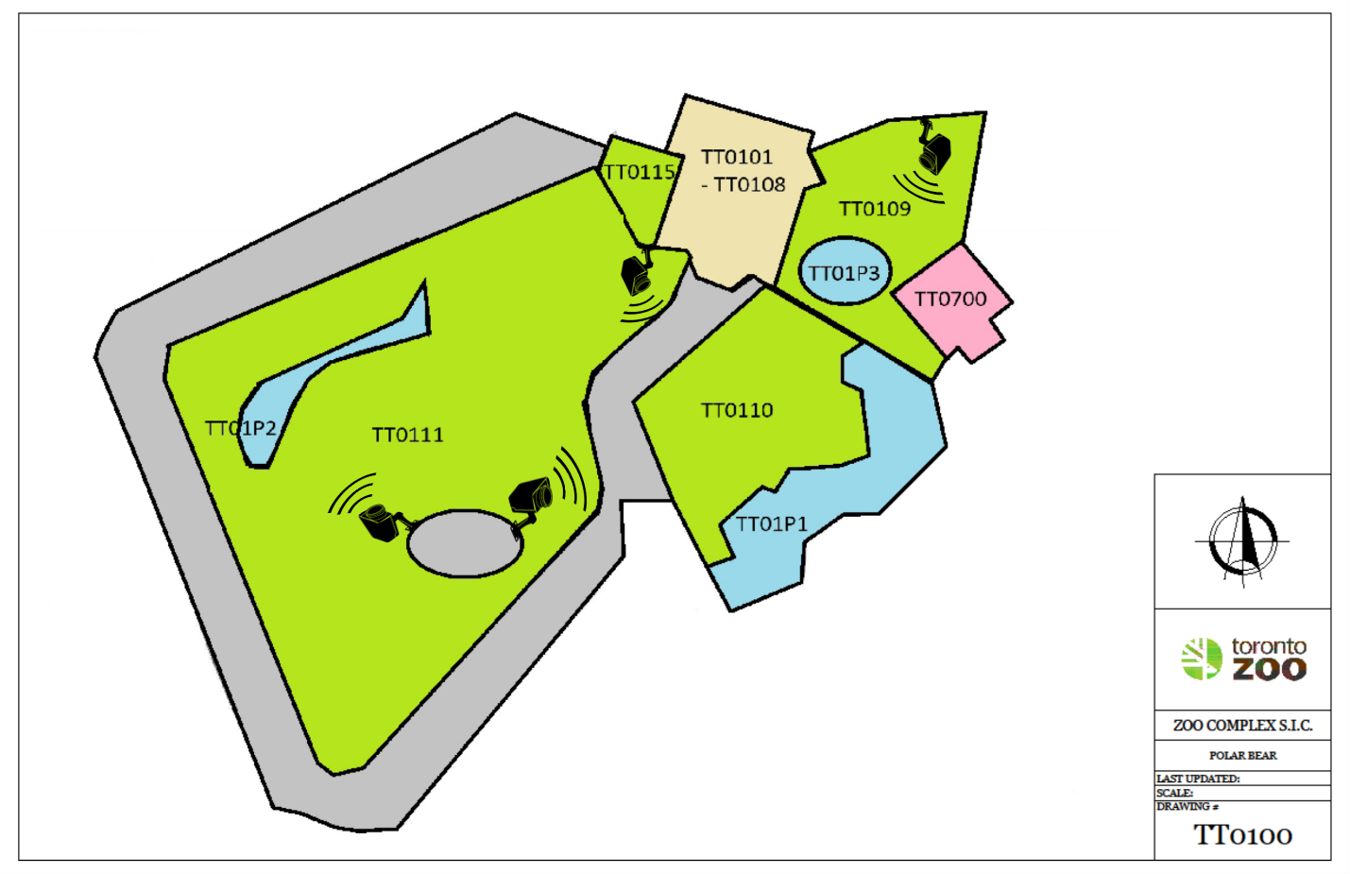
Figure S1. Polar bear habitat at the Toronto Zoo. Four AXIS P3265-LV Dome cameras (resolution = 1920x1080, fps = 30) were used to capture the full outdoor habitat comprising three connected areas depicted as TT109, 110, and T111. The cameras were mounted at fixed positions at a height of approximately 12 feet, with the cameras having a ~105° field of view.

Supplemental Table 1. Logical workflow for sequential execution of customized scripts used for pre-processing, preparing, and analyzing video data for behavioural monitoring.
File Name | Function | Input* | Output*
0_PB_Stereotypy.py | Executes monitoring and associated post-processing scripts | Trained model (“best.pt”), CCTV streams via RTSP | Date stamped project directory containing tabulated spreadsheets and visuals.
1_relabel_train.py | Appends label to each specified frame in the train.txt file | Image and label directories; train.txt file | train.txt file linking file location for each frame with associated label
2_cleanup_images.py | Removes non-labeled frames (so that only annotated frames are used to train models) | Video frames and labels (imbalanced if there are impartially labeled videos) | Folders for images and labels
3_samples_distribution.py | Counts # of annotated frames in behavioural class | Label directory | Printout # of samples/labels in each class
4_split_data.py | Splits the global image and label dataset into separate datasets for training and validation | Image and label directories | Images and labels separated and organized into new folders, “train” and “val”
5_ConcordanceTest.py | Runs YOLO model at fixed intervals to predict behaviours and generate annotated outputs for concordance testing | Trained model (best.pt), video sequence | CSV with interval predictions, annotated video, observer snippet video, and observer CSV file
6_PB_Analyzer.py | Analyzes activity logs to generate day/night polar plots and summary videos of behavioural patterns | activity_log.csv from session directory | Filtered excel log, polar plot images, and day/night summary videos
7_pacing_laps.py | Analyzes pacing lap data to compute hourly lap bouts and generate polar summary plot | pacing_laps.xlsx from session directory | Hourly lap summary Excel file and polar plot
8_heatmap_video.py | Space usage heatmaps produced, based off detection intensity for each behaviour of interest | Trained model (“best.pt”), video sequence | A “heatmap_output” folder containing heatmaps for each behaviour
9_video_inference.py | Conducts inference on raw video sequence to predict/draw bounding boxes and annotations | Trained model (“best.pt”), video sequence | “output.mp4” containing predicted bounding boxes and annotations
data_custom.yaml | Used by the YOLO model to specify the frames used for training and validation on which predictions will be made | - | -
train.txt | Contains the file path for each image frame; after applying the relabel_train script will contain relevant class assignment | - | -
common_commands.txt | Useful commands for setting project directory, code for starting a training run using yolov8m | Need to have followed steps above/described in methods for YOLO command to run | A “runs” folder containing model results will be added to project directory
yolov8m.pt | The YOLOv8 model backbone with pre-trained weights used for training and testing | Used as part of the yolo argument for training and testing | -
Supplemental Table 2. List of terms and their descriptions for metrics used for assessing predictive model performance. Calculations for metrics are provided elsewhere (e.g., Chan et al., 2025). This table serves as a reference for interpreting model evaluation results presented in the manuscript. The goal for measures associated with loss or time is usually to minimize these as close to zero (0%) as possible, while accuracy, precision, recall, F1, and mAP indicate perfect performance as they approach one (100%).
Metric | Description
Epoch | Iteration count; measures the number of passes through the entire training data.
Time | Total training time (seconds) for each epoch. Helps track computational cost.
Train/Box_Loss | Measures localization error in bounding box prediction during training.
Train/Cls_Loss | Measures classification error for object classes during training.
Train/Dfl_Loss | Evaluates the loss for distributional focal loss to improve localization.
Precision (B) | Proportion of correct positive detections among all positive predictions.
Recall (B) | Proportion of ground truth bounding boxes the model correctly identifies, specifically true positives detected among all actual positives.
F1 | Harmonic mean of precision and recall
mAP50 (B) | Mean Average Precision at IoU threshold of 0.50. Measures overall detection accuracy.
mAP50-95 (B) | Mean Average Precision across IoU thresholds (0.50 to 0.95). Indicates agreement of bounding box overlap with the ground truth.
Val/Box_Loss | Localization error during validation. Indicates generalization to unseen data.
Val/Cls_Loss | Classification error for predicting using validation dataset.
Val/Dfl_Loss | Distributional focal loss during validation.
LR/PG0 | Learning rate for parameter group 0. Adjusts weights for specific layers.
LR/PG1 | Learning rate for parameter group 1.
LR/PG2 | Learning rate for parameter group 2.
*Note for input/output column: the user must adjust script to reflect the correct file paths/directories for images, labels, models, etc.

