**LAPORAN PRAKTIKUM**

**PEMROGRAMAN WEB I**

**MODUL 3**



**FORM**

**Oleh:**

**Lidya Rahmi NIM. 2110817320001**

**PROGRAM STUDI TEKNOLOGI INFORMASI**

**FAKULTAS TEKNIK**

**UNIVERSITAS LAMBUNG MANGKURAT**

**MARET 2022**

# LEMBAR PENGESAHAN

**LAPORAN PRAKTIKUM PEMROGRAMAN WEB I**

**MODUL 3**

Laporan Praktikum Pemrograman Web I Modul 3: Form Sederhana ini disusun sebagai syarat lulus mata kuliah Praktikum Pemrograman Web I. Laporan Prakitkum ini dikerjakan oleh:

Nama Praktikan : Lidya Rahmi

NIM : 2110817320001

|  |  |
| --- | --- |
| Menyetujui,  Asisten Praktikum  Charles Phandurand  NIM. 2010817110006 | Mengetahui,  Dosen Penanggung Jawab Praktikum  Arief Trisno Eko Suryo, S.T., M.T.  NIP. |

# DAFTAR ISI

LEMBAR PENGESAHAN 1

DAFTAR ISI 2

DAFTAR GAMBAR 3

Latihan 1 4

A. Screenshot Source Code 4

B. Screenshoot Hasil Tampilan pada Browser 5

Latihan 2 6

A. Screenshot Source Code 6

B. Screenshoot Hasil Tampilan pada Browser 8

Latihan 3 9

A. Screenshot Source Code 9

B. Screenshoot Hasil Tampilan pada Browser 11

TAUTAN GIT 12

# DAFTAR GAMBAR

Gambar 1 Source code latihan 1 4

Gambar 2 Hasil tampilan source code latihan 1 5

Gambar 3 Source code latihan 2 8

Gambar 4 Hasil tampilan source code latihan 2 8

Gambar 5 Source code latihan 3 11

Gambar 6 Hasil tampilan source code latihan 3 11

# Latihan 1

## Screenshot Source Code

|  |  |
| --- | --- |
| 1  2  3  4  5  6  7  8  9  10  11  12  13  14  15  16  17  18  19 | <!DOCTYPE html>  <html lang="en">  <head>      <meta charset="UTF-8">      <meta http-equiv="X-UA-Compatible" content="IE=edge">      <meta name="viewport" content="width=device-width, initial-scale=1.0">      <title>Atribut Input</title>  </head>  <body>      <form action="" method="post" name="form">          Nama: <input type="text" name="nm"><br><br>          User password:<br>          <input type="password" name="psw"><br><br>          Warna Favorite:          <input type="color" name="favcolor"><br><br>          Tanggal Lahir:          <input type="date" name="bday"><br><br>          Masukkan Tanggal Sebelum 1980-03-01:          <input type="date" name="bday" max="1979-12-31"><br><br>          Masukkan Tanggal Setelah 2000-01-01:          <input type="date" name="bday" min="2000-01-02"><br><br>          Birthday (date and time):          <input type="datetime-local" name="bdaytime"><br><br>          E-mail:          <input type="email" name="email"><br><br>          select a file: <input type="file" name="myFile"><br><br>      </form>  </body>  </html> |

Gambar 1 Source code latihan 1

## Screenshoot Hasil Tampilan pada Browser

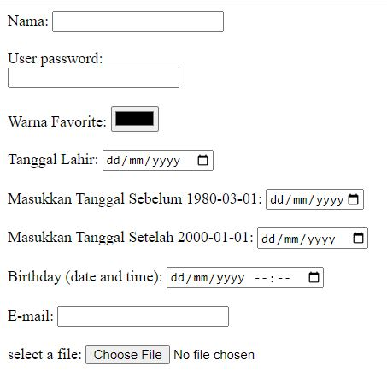

Gambar 2 Hasil tampilan source code latihan 1

# Latihan 2

## Screenshot Source Code

|  |  |
| --- | --- |
| 1  2  3  4  5  6  7  8  9  10  11  12  13  14  15  16  17  18  19 | <!DOCTYPE html>  <html lang="en">  <head>      <meta charset="UTF-8">      <meta http-equiv="X-UA-Compatible" content="IE=edge">      <meta name="viewport" content="width=device-width, initial-scale=1.0">      <title>Contoh Form</title>  </head>  <body>      <font type="arial black" font size="6">Data Diri</font>      <br><br>      <form action="Simpan data.html" method="post">          <font type=arial size="5">              Nama : <input type="text" name="nama" required>              <br><br>              Nim : <input type="text" name="nim" value="" maxlength="9" size="9">              <br>              <br>          </font>          E-mail:          <input type="email" name="email" required><br><br>          password: <input type="password" name="pass" size="11" maxlength="9" required>          <br>          <br>          Tanggal Lahir:          <input type="date" name="bday"><br><br>          Jenis Kelamin:          <br>          <input type="radio" name="jenis_kelamin" value="L">Laki-laki          <br>          <input type="radio" name="jenis_kelamin" value="P">Perempuan          <br>          <br>          Pilih Hobi Anda (Boleh lebiih dari satu) :          <br>          <input type="checkbox" name="hobi_1" value="Menonton">Manonton          <br>          <input type="checkbox" name="hobi_2" value="Main Gamr">Main Game          <br>          <input type="checkbox" name="hobi_3" value="Belanja">Belanja          <br>          <input type="checkbox" name="hobi_4" value="Mancing">Mancing          <br>          <input type="checkbox" name="hobi_5" value="Olahraga">Olahraga          <br>          <br>          Asal Kota:          <select name="asal_kota">              <option value="Kota Banjarmasin">Banjarmasin</option>              <option value="Kota Bandung">Bandung</option>              <option value="Kota Banjarbaru">Banjarbaru</option>          </select>          Komentar Anda:          <br>          <textarea name="komentar" rows="5" cols="20">              Silahkan isi komentar anda          </textarea>          <br>          <br>          <input type="reset" name="Ulangi" value="Reset">          <input type="submit" name="kirim" value="Submit">          <input type="reset" name="Batal" value="Cancel">          <br>          <br>          <input type="image" name="Gambar" img src="" width="150" height="150">      </form>  </body>  </html> |

Gambar 3 Source code latihan 2

## Screenshoot Hasil Tampilan pada Browser

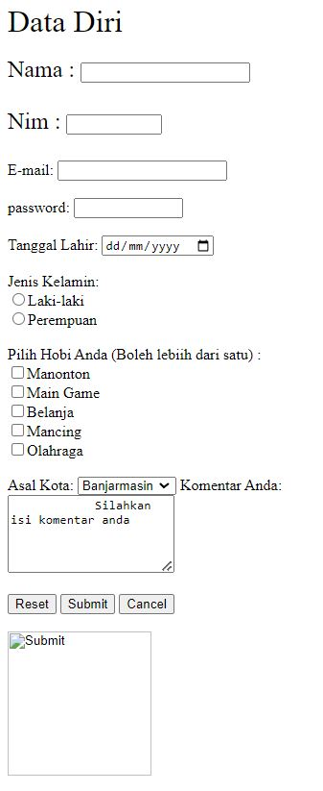

Gambar 4 Hasil tampilan source code latihan 2

# Latihan 3

## Screenshot Source Code

|  |  |
| --- | --- |
| 1  2  3  4  5  6  7  8  9  10  11  12  13  14  15  16  17  18  19 | <html>  <head>      <title> Latihan 3</title>  </head>  <body>      <center>          <table border="1" width="900px">              <tr bgcolor="lightskyblue">                  <td align="center" colspan="2" height="90px">                      <h1 style="color: red;"> Pendaftaran Kursus</h1>                  </td>              </tr>              <tr>                  <td width="600px" height="400px" bgcolor="gray" valign="top">                      <table border="0">              </tr>              <td>                  <h2>Data Diri</h2>              </td>              </tr>              <tr>                  <td>Nama</td>                  <td><input type="text" </td> </tr> <tr>                  <td>E-mail</td>                  <td><input type="text" </td> </tr> <tr>                  <td>Tanggal Lahir</td>                  <td><input type="date" </td> </tr> <tr>                  <td>Jenis Kelamin</td>                  <td><input type="radio" id="laki" value="laki" name="laki"> Laki-Laki</td>              </tr>              <tr>                  <td></td>                  <td><input type="radio" id="perempuan" value="perempuan" name="perempuan"> Perempuan</td>              </tr>              <tr>                  <td>Pilihan Program Kursus</td>                  <td><input type="checkbox" value="c#"> C#</td>              </tr>              <tr>                  <td></td>                  <td><input type="checkbox" value="java"> Java</td>              </tr>              <tr>                  <td></td>                  <td><input type="checkbox" value="SQL"> SQL</td>              </tr>              <tr>                  <td></td>                  <td><input type="checkbox" value="HTML dan PHP"> HTML dan PHP</td>              </tr>              <tr>                  <td>Pilihan Hari/jam Kursus</td>                  <td>                      <select name="jadwal">                          <option value="kamis">Senin- Rabu 09.00-11.00</option>                          <option value="kamis">Kamis- Sabtu 08.00-10.00</option>                      </select>                  </td>              </tr>          </table>          <tr bgcolor="salmon">              <b>                  <td colspan="2" height="120px" valign="top">Komentar Anda              </b><br>              <textarea name="komentar" rows="7" cols="70">              </textarea>              <br><br>              <input type="Reset" name="reset" value="Reset">              <input type="submit" name="submit" value="Submit">              <input type="button" name="cancel" value="Cancel">          </tr>      </center>  </body>  </head>  </html> |

Gambar 5 Source code latihan 3

## Screenshoot Hasil Tampilan pada Browser

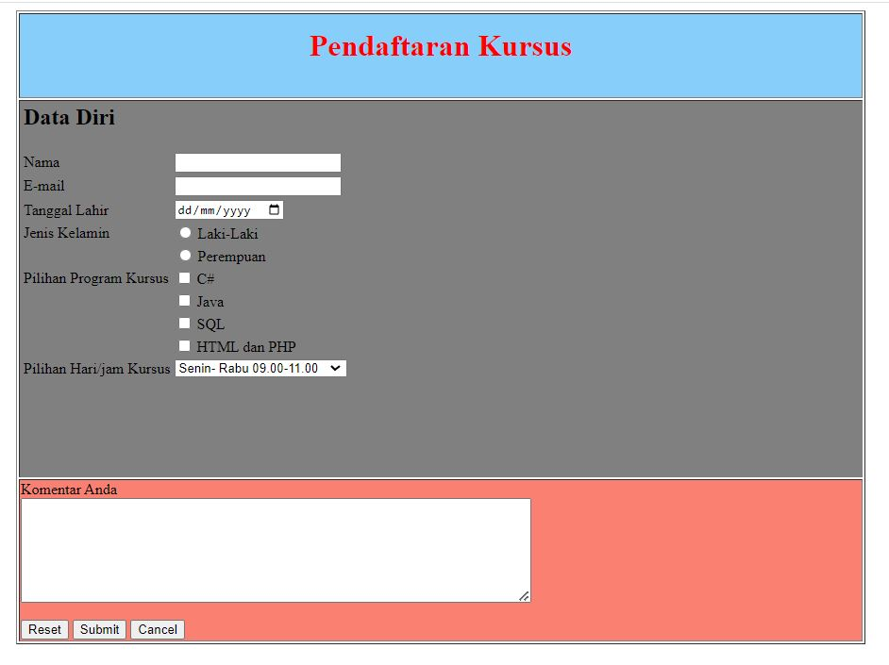

Gambar 6 Hasil tampilan source code latihan 3

# TAUTAN GIT

Berikut ini adalah link github

<https://github.com/lidyarahmi/Praktikum3_lidyarahmi_2110817320001_modul3>