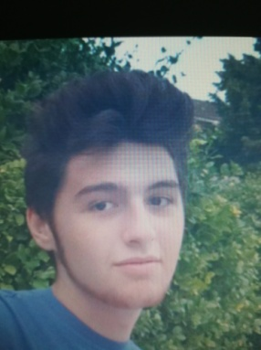 Dumitrescu Cristian-Mihail

19 years old

Student

Contacts

Email: dumi_cristi@yahoo.com

Phone number: 0770961690

Address: Bucharest, Sector 5, Str. Telita, nr.2, Block 66A, Ap.21

About me

Objective: Gaining the knowledge and aptitudes necessary for a programmer, always aiming for innovation, perseverance and trust.

Site and Social media

<https://cristian-mihail-dumitrescu.netlify.app/index.html> - The site I have made for myself

<https://www.facebook.com/cristi.dumitrescu.526/> - Facebook

<https://www.instagram.com/cristi_dumitrescu99/> - Instagram

 Professional experience

My professional experience is limited since I have just graduated highschool.

I have the ability to efficiently operate on different types of OS; a good understanding of Microsoft Office (Word, Excel şi PowerPoint), of corse; decent knowledge of some graphical popular aplications (Adobe Illustrator, PhotoShop).

C/C++, Javascript, HTML, CSS are just some of the programming languages I feel confident in.

I have an Oracle Certificate in SQL

I have a vivid team spirit, enthusiasm, flexibility and attention to details.

School  Projects

During the second semester of my first year in university, I was required to complete a number of asignments.

I have worked with some of my classmates, or alone, in several programming languages.

My most notable projects are:

-Netlogo project in which we simulated the market for a new hardware component. The code is linked below (you might need to download netlogo for it to open):



-C/C++ project. I have worked for longer than expected at this project, while trying to tackle a real life problem: Managing a simple databese for invoices. The code is linked below (you might need to download a C/C++ editor for it to open):



-I have also tried to develop the front-end of a website (HTML,CSS,JS) for a local firm and host it (on a linux vm), in my spare time, but under the current conditions I was unable to open it up to the public yet.

Education

2019 –Academy of economic studies-Faculty of Cybernetics, Statistics and Economical Informatics Year I at Economical Cibernetics –Entry grade 9,49.

Bac grade 9,36.

Caracal, Bac diploma , Highschool "Mihai Viteazul", 2019.

Foreign languages

Romanian-native language

English – experienced: writing, reading, speaking. Have CAE Cambridge Certificate 107 points.

French- experienced: writing, reading, speaking.