

|  |  |  |  |  |
| --- | --- | --- | --- | --- |
| Destin |  |  | Résilience |  |
| Chance |  |  | Résolution |  |
|  |  |  |  |  |
| Expérience | |  | Blessures |  |
| *Total* |  |  | *Calcul* | |
| *Actuel* |  |  | *Dur à cuir* |  |

Rognar Von Kroll

|  |  |  |  |
| --- | --- | --- | --- |
|  |  | |  |
|  | Origines | | Race |
|  | Age | Sexe, taille, poids | |
|  | Carrière | | |
|  | Cheminement | | |

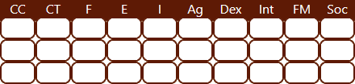

Mouvement

Mouv. Charge Course



|  |  |  |  |  |  |  |
| --- | --- | --- | --- | --- | --- | --- |
| Talents | Niv. |  |  | |  | | --- | | Signes distinctifs | |  | |
|  |  |  |  | Traits, psychologie |
|  |
|  |  |
|  |  |



|  |  |  |  |  |  |  |  |  |  |  |  |  |
| --- | --- | --- | --- | --- | --- | --- | --- | --- | --- | --- | --- | --- |
| Art | Dex | + |  | Esquive | Ag | + |  |  |  |  | + |  |
| Athlétisme | Ag | + |  | Intimidation | F | + |  |  |  |  | + |  |
| Charisme | Soc | + |  | Intuition | I | + |  |  |  |  | + |  |
| Canotage | F | + |  | Jeu | Int | + |  |  |  |  | + |  |
| Commandement | Soc | + |  | Marchandage | Soc | + |  |  |  |  | + |  |
| Commérage | Soc | + |  | Mélée | CC | + |  |  |  |  | + |  |
| Conduite d’attelage | F | + |  | Orientation | I | + |  |  |  |  | + |  |
| Discrétion urbain | Ag | + |  | Perception | I | + |  |  |  |  | + |  |
| Discrétion rural | Ag | + |  | Perception | Int | + |  |  |  |  | + |  |
| Discrétion souterrain | Ag | + |  | Résistance | E | + |  |  |  |  | + |  |
| Divertissement | Soc | + |  | Résist. A l’alcool | E | + |  |  |  |  | + |  |
| Emprise /animaux | FM | + |  | Sang froid | FM | + |  |  |  |  | + |  |
| Escalade | Ag | + |  | Subornation | Soc | + |  |  |  |  | + |  |
| Equitation | Ag | + |  | Survie | Int | + |  |  |  |  | + |  |

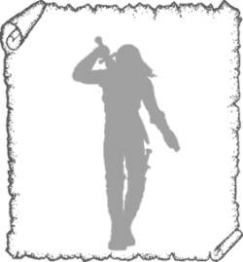

Points d’armure

|  |  |  |  |  |  |  |  |
| --- | --- | --- | --- | --- | --- | --- | --- |
| Armes & Armures | Enc | Dég/Prot | Allonge/Portée | Attributs, détails |  | 01-12 **Tête**  13-27 **Bras d.**  28-42 **Bras g.**  43-70 **Tronc**  71-85 **Jambe d.**  86-00 **Jambe g.** |  |
|  |  |  |  |  |



Ambitions, personnalité

|  |  |  |
| --- | --- | --- |
|  | Détails personnels |  |
|  | Yeux : | Main directrice : |
|  | Cheveux : | Coiffure : |
|  | Frères et sœurs : |  |
|  | Profession des parents : |  |
|  | Motivation : |  |

Richesses

Equipement



**Or Argent Cuivre**

**Or :** 1 co = 20/- = 240s **Argent :** 1/- = 12s

Personnalité

Contacts





Notes