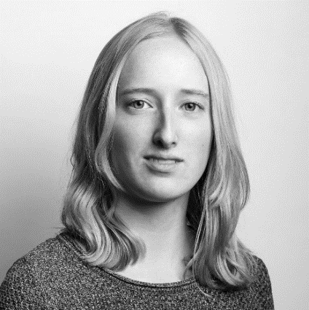t

# Lieke de Mare

## Industrial Designer

## Product developer, UX designer, Usability researcher

## *I want to improve healthcare by contributing a human-centered design view to the development of products or systems which don’t only have care efficiency but also care experience, as core value.*

# Education

**Master Industrial Design** | 2020 – 2022

Technical University of Eindhoven, The Netherlands

**Pre-master Human Technology Interaction** | 2019 – 2020

Technical University of Eindhoven, The Netherlands

**Bachelor Industrial Design** | 2016 – 2019

Technical University of Eindhoven, The Netherlands

Exchange semester | Aug. 2018 – Dec. 2018

## Georgia Tech, United States of America

# Relevant Experience

## **Graduate internship – Medical utensils** | 2019

LifeSense Group

Design of a smart urine collection system to support incontinent older adults and their caregivers in the collection of urine samples for healthcare purposes.

## **Student design Project – Physical rehabilitation** | 2019

Adelante Rehabilitation clinic

Design of a personal assistive system to guide stroke patients in their walking rehabilitation at home.

Presented at the Dutch Design Week: https://ddwtue.nl/projects/walker/

## **Student research project (published) – Assistive products** | 2018

Adelante Rehabilitation clinic

Research about how contoured wheelchair cushion bases can improve pressure distribution, stability and comfort for wheelchair users with paraplegia.

The research outcomes have been published in "Disability and Rehabilitation: Assistive Technology", by Taylor & Francis.

# Software Experience

**3D modeling** | Fusion 360, Solidworks

**2D editors** | Adobe (Photoshop, Illustrator, InDesign)

**Programming** | HTML, JavaScript, Java (native android), C++ (Arduino), Python

# Volunteer work

## **Scout leader** | 2013 - present

Scouting Jan Baloys

## Treasurer | 2019 - present

## Board | 2020 - present

## Personalia



Helmond, The Netherlands

06-38606869

liekedemare@outlook.com

linkedin.com/liekedemare

Dutch

04-09-1998

## Languages





NL

EN

## Hobbies

* Scouting
* Photography
* Cooking
* Tinkering

t