State of the Network Executive Report
College of Science, Engineering, and Technology, Grand Canyon University
ITT-216: Enterprise Route & Switch
Instructor Tim Collins
Liela Pressley
4/2/2023

State of the Network Executive Report
Last Updated: 4/2/2023
1. Overview
This written report is the documentation, presentation and explanation of the changes of infrastructure within the company’s wide area network and local area networks to accommodate the 5 new locations. We created 5 new LANs for each location within a network topology, each LAN is designed to be scalable, redundant and provide wired and wireless connectivity for users.
2. Pre-existing Network Structure
Provided in Figure 1-0, we see the pre-existing network had 1 Main Office Router, stationed for our headquarters. Here routers have 2 LANs established for remote work for our Manufacturing and Shipping Locations and 1 LAN for the Main Office. The Main Office has 2 subnets distributed by 2 switches to accommodate the Sales and Engineering departments and Servers. Each LAN has both wired and wireless connectivity, provided by ethernet cables(wired) and access points(wireless).
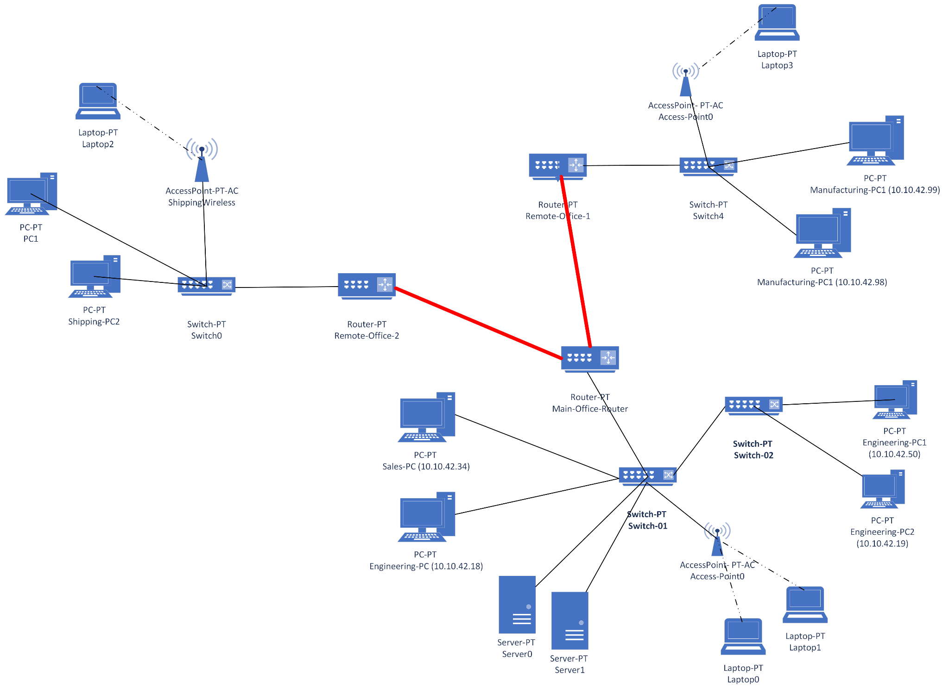
Figure 1-0
3. Network State Changes
To accommodate the additional 5 locations for our company, a total of 6 routers were added to the network. 1 Router was added to Main Office to provide redundancy and additional bandwidth for our newly added locations to access the Main Office LAN. Connected wirelessly as a wide area network, 5 routers were installed, one at each new location to provide connectivity to each of the 5 locations (labeled “NewLocation#) and Main Office. As see in Figure 2-0, a mesh topology was used between the 5 locations and Main Office routers in order to provide ensured connectivity even if a failure/error occurred somewhere within the network and to provent bottleneck data delivery.

At each location, there are 2 subnets, one focused on providing wireless connectivity via a access point for laptops and at least one workstation. The other subnet is focused on providing wired connectivity to workstations.

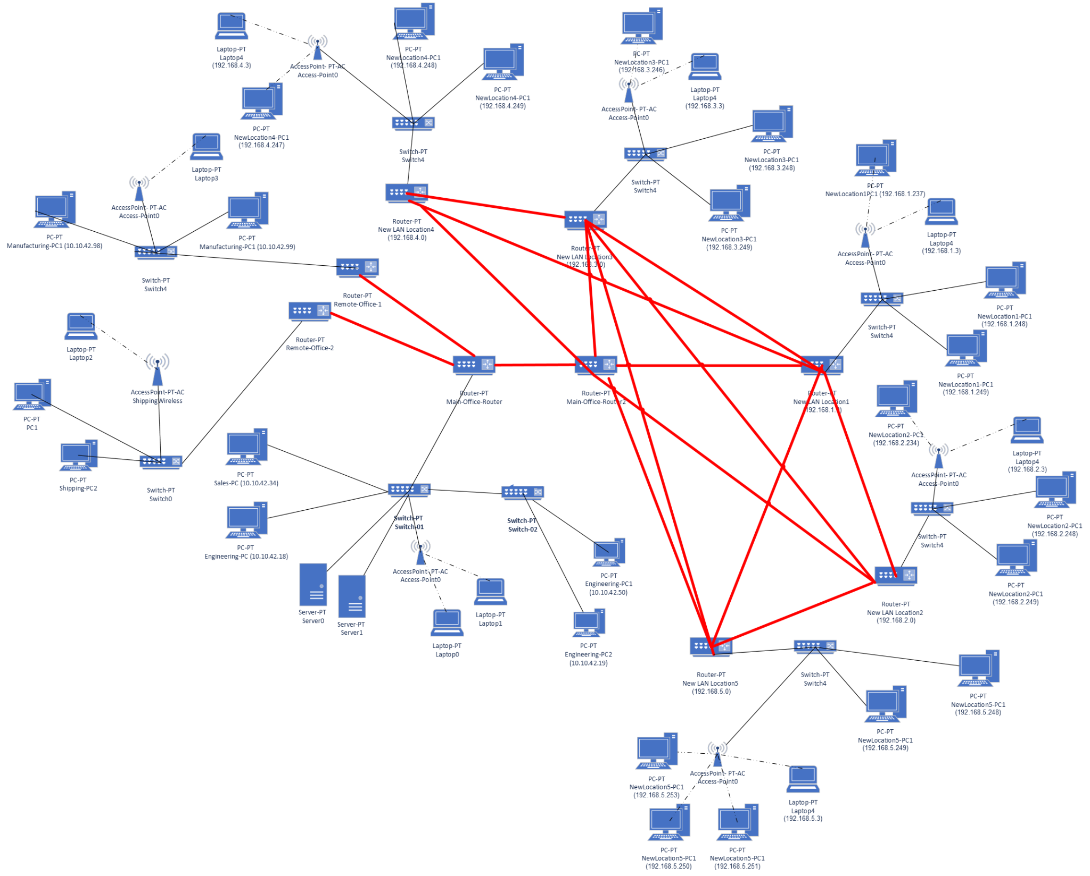
Figure 2-0
4. New Network State Configurations
In order to properly install these newly added networks, subnets and endpoint devices here are the major configuration steps the team implemented. First, we ensured that the main office routers had serial ports set and open for each of the additional location LANs to be added and connected. This is down by checking the ports, assigning each ip address of the routers, ensure that the port is active, and then create a default router to the new locations. This process is repeated with each new router on the network in order to implement the mesh topology/interconnectivity of the locations. Second, we ensure that each router has a dual serial port WAN interface cards and fast Ethernet GE connectivity. Third, each new switch installed at our locations need a single port GE copper connectivity and a multiple Fast Ethernet interface copper medias. Lastly our access points are responsible for aggregating wireless devices, we must set up a secure password, disable SSID and enable MAC filtering. Then configure wireless devices for the access point by entering the IP address in the endpoint (laptop for example)’s default gateway entry and the DNS server.

