Change Point Analysis of Brent Oil Prices
Interim Report — Task 1
Prepared for Birhan Energies
10 Academy — KAIM Week 10 Challenge
July 12, 2026

1. Executive Summary
Birhan Energies has commissioned this analysis to identify structural breaks (change points) in the historical Brent crude oil price series and connect those breaks to plausible real-world drivers, including geopolitical conflicts, OPEC/OPEC+ decisions, sanctions, and broader economic shocks. This interim report covers Task 1: defining the analysis workflow, compiling a dataset of major oil-market events, documenting key assumptions and limitations, and completing an initial exploratory data analysis (EDA) of the price series. Task 2 (Bayesian change point modeling with PyMC) and Task 3 (interactive dashboard) follow in subsequent submissions.

2. Business Objective
The goal is to help investors, policymakers, and energy companies understand how major events affect Brent oil prices. This supports investment strategy, policy development, and operational planning by clarifying not just that prices moved, but roughly when and by how much, and which events plausibly triggered each shift.

3. Data
Two datasets underpin this analysis:
- Brent spot price series (data/BrentOilPrices.csv): daily USD/barrel prices from 20-May-1987 to 14-Nov-2022, 9,011 observations.
- Key events dataset (data/key_events.csv): 16 manually researched major events spanning conflicts, OPEC/OPEC+ policy decisions, sanctions, and economic shocks, each with an approximate start date, category, and short description.
Data quality note: the raw price file mixes two different date formats (e.g. "20-May-87" and "Nov 08, 2022"), switching partway through the file around April 2020. This was identified and resolved with a dedicated parsing function so all dates are handled consistently; the fix is covered by automated unit tests.

4. Analysis Workflow
The end-to-end workflow for this project is:

4.1 Data Loading and Cleaning
Parse both raw date formats, sort chronologically, remove duplicate dates, and index the series by date.

4.2 Exploratory Data Analysis
Visualize the raw price trend, compute log returns, test for stationarity, and examine volatility clustering to determine the right inputs and structure for formal modeling.

4.3 Bayesian Change Point Modeling (Task 2)
Define a prior over the unknown switch point (tau), define regime parameters before and after tau, connect them to the data through a likelihood, and sample the posterior using PyMC. Model convergence will be checked (r-hat, trace plots) before interpreting results.

4.4 Interpretation and Event Association
Convert the estimated tau to a calendar date, quantify the size of the shift in the underlying parameters, and compare the date against the events dataset to propose plausible (not proven) triggers.

4.5 Reporting and Dashboard (Task 3)
Summarize findings for a non-technical audience via a Flask + React interactive dashboard.

5. Key Events Dataset (Sample)
A sample of the 16 compiled events is shown below; the full dataset is provided as data/key_events.csv.
Date | Event | Category | Description
1990-08-02 | Gulf War (Iraq invasion of Kuwait) | Conflict | Supply disruption fears from two large OPEC producers; sharp price spike.
2008-09-15 | Global Financial Crisis | Economic Shock | Lehman collapse triggered a global recession and historic demand collapse.
2014-06-01 | 2014 Oil Price Collapse | OPEC/Supply | Shale supply glut plus OPEC inaction crashed prices from $110+ to under $50.
2020-03-11 | COVID-19 Pandemic Declared | Economic Shock | Global lockdowns caused an unprecedented collapse in oil demand.
2022-02-24 | Russian Invasion of Ukraine | Conflict | Sanctions on a top-3 exporter drove Brent above $120/barrel.

6. Exploratory Data Analysis

6.1 Raw Price Trend
The full history shows a low, range-bound price through the 1990s, a sustained rally from the early 2000s peaking near $147/barrel in mid-2008, followed immediately by the sharpest crash in the series during the Global Financial Crisis. A second major collapse occurs in 2014-2016, and the fastest, most extreme single collapse occurs in early 2020 (COVID-19 demand shock combined with the Saudi-Russia price war). A sharp 2022 rally coincides with Russia's invasion of Ukraine.
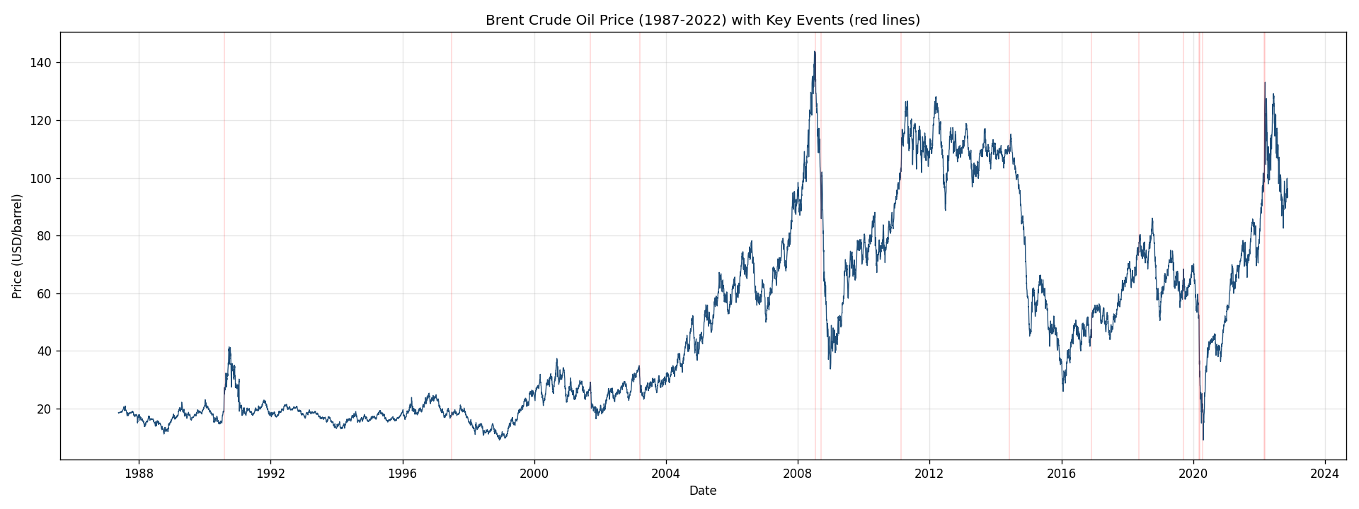
Figure 1. Brent crude oil price, 1987-2022, with key event dates marked in red.

6.2 Stationarity Testing
An Augmented Dickey-Fuller (ADF) test on the raw price series returns a test statistic of -1.99 (p = 0.29), so we fail to reject the null hypothesis of a unit root: the price level is non-stationary. Log returns, by contrast, return an ADF statistic of -16.43 (p < 0.001), strongly rejecting non-stationarity. This confirms that log returns, not raw prices, are the appropriate input for stationarity-dependent modeling steps.
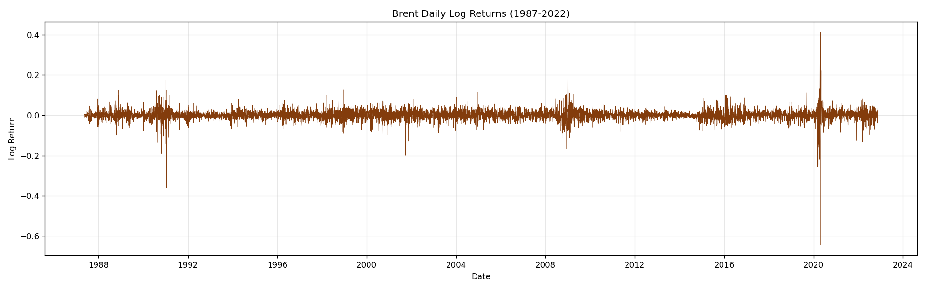
Figure 2. Daily log returns of Brent crude oil prices, 1987-2022.

6.3 Volatility Clustering
Large log-return swings cluster tightly around 2008-09, 2014-2016, and especially March-April 2020, rather than spreading evenly across history. This clustering — large changes followed by more large changes — is a hallmark of financial time series and motivates allowing variance, not just the mean, to shift at detected change points.
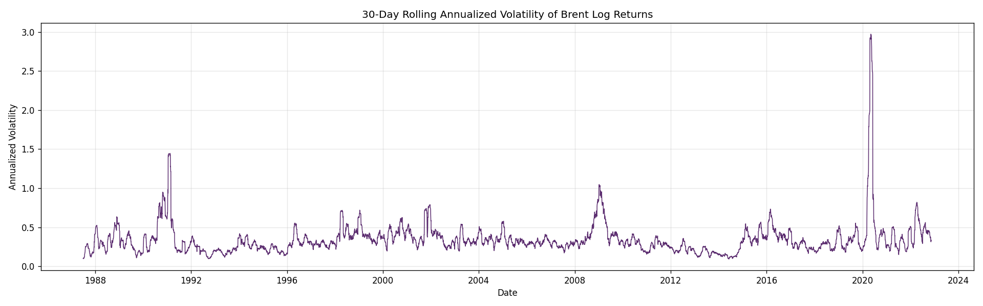
Figure 3. 30-day rolling annualized volatility of Brent log returns.

7. Purpose and Expected Outputs of Change Point Modeling
A Bayesian change point model formalizes the search for the point(s) in time where the statistical properties of the series shift abruptly. Rather than relying on visual inspection, it places a prior over the unknown switch point, estimates before/after regime parameters jointly with that switch point, and produces a full posterior distribution rather than a single point estimate. Expected outputs are: (1) a posterior distribution over the change point date(s), (2) posterior distributions for the before/after regime parameters, and (3) quantified impact statements, e.g. "the mean log price shifted by X, a Y% change, with probability Z based on the posterior."

8. Assumptions and Limitations

8.1 Key Assumptions
- The core model assumes a small number of discrete structural breaks with constant regime means (and optionally variances); gradual drift is not directly modeled.
- Log returns are treated as approximately stationary and roughly normal for the baseline Gaussian likelihood, though real returns have fatter tails.
- Event dates are approximate onsets; markets may anticipate or lag news, so a window is used when matching events to change points rather than requiring exact date matches.

8.2 Correlation vs. Causation (Critical Limitation)
This is the most important caveat in the project. A change point model can establish that the statistical properties of the price series changed at approximately a given date, and by how much, with a stated posterior probability. It cannot prove that a specific event caused that change. Any event associated with a detected change point is a plausible hypothesis supported by timing and domain knowledge, not a causal finding. Oil prices are driven by many simultaneous factors, so more than one candidate event can often sit near the same change point window. Rigorously establishing causation would require methods beyond change point detection, such as event-study designs with counterfactuals or structural econometric models with exogenous controls.

8.3 Other Limitations
- Confounding macro variables (USD strength, GDP growth, interest rates) that co-move with oil prices are not directly controlled for.
- With many candidate events across a 35-year span, some date matches may occur by chance.
- The baseline model detects a single change point; given the number of major shocks in this history, a multiple-change-point extension is planned for Task 2.
- The dataset ends in November 2022, so findings do not reflect any developments after that date.

9. Next Steps
- Implement the Bayesian change point model in PyMC, including convergence diagnostics (r-hat, trace plots).
- Quantify the size and direction of each detected shift and associate it with candidate events from the compiled dataset.
- Extend to multiple change points if a single switch point does not adequately represent the full history.
- Build the Flask + React dashboard to present findings interactively (Task 3).

