1. Present:

a. Definition of e-commerce. Styles/types of e-commerce and their features

Generally speaking, when we think of e-commerce, we think of an online commercial transaction between a supplier and a client. However, and although this idea is right, we can be more specific and actually divide e-commerce into six major types, all with different characteristics.

**There are 6 basic types of e-commerce:**

1. Business-to-Business (B2B)
2. Business-to-Consumer (B2C)
3. Consumer-to-Consumer (C2C)
4. Consumer-to-Business (C2B).
5. Business-to-Administration (B2A)
6. Consumer-to-Administration (C2A)

**1. Business-to-Business (B2B)**

Business-to-Business (B2B) e-commerce encompasses all electronic transactions of goods or services conducted ​​between companies. Producers and traditional commerce wholesalers typically operate with this type of electronic commerce.

**2. Business-to-Consumer (B2C)**

The Business-to-Consumer type of e-commerce is distinguished by the establishment of electronic business relationships between businesses and final consumers. It corresponds to the retail section of e-commerce, where traditional retail trade normally operates.

These types of relationships can be easier and more dynamic, but also more sporadic or discontinued. This type of commerce has developed greatly, due to the advent of the web, and there are already many virtual stores and malls on the Internet, which sell all kinds of consumer goods, such as computers, software, books, [shoes](http://josefinas.com/), cars, food, financial products, digital publications, etc.

When compared to buying retail in traditional commerce, the consumer usually has more information available in terms of informative content and there is also a widespread idea that you’ll be buying cheaper, without jeopardizing an equally personalized customer service, as well as ensuring quick processing and delivery of your order.

**3. Consumer-to-Consumer (C2C)**

Consumer-to-Consumer (C2C) type e-commerce encompasses all electronic transactions of goods or services conducted ​​between consumers. Generally, these transactions are conducted through a third party, which provides the online platform where the transactions are actually carried out.

**4. Consumer-to-Business (C2B)**

In C2B there is a complete reversal of the traditional sense of exchanging goods. This type of e-commerce is very common in crowdsourcing based projects. A large number of individuals make their services or products available for purchase for companies seeking precisely these types of services or products.

Examples of such practices are the sites where designers present several proposals for a company logo and where only one of them is selected and effectively purchased. Another platform that is very common in this type of commerce are the markets that sell royalty-free photographs, images, media and design elements, such as [iStockphoto](http://www.istockphoto.com/).

**5. Business-to-Administration (B2A)**

This part of e-commerce encompasses all transactions conducted online between companies and public administration. This is an area that involves a large amount and a variety of services, particularly in areas such as fiscal, social security, employment, legal documents and registers, etc. These types of services have increased considerably in recent years with investments made in e-government.

**6. Consumer-to-Administration (C2A)**

The Consumer-to-Administration model encompasses all electronic transactions conducted between individuals and public administration.

Examples of applications include:

* Education – disseminating information, distance learning, etc.
* Social Security – through the distribution of information, making payments, etc.
* Taxes – filing tax returns, payments, etc.
* Health – appointments, information about illnesses, payment of health services, etc.

Both models involving Public Administration (B2A and C2A) are strongly associated to the idea of efficiency and easy usability of the services provided to citizens by the government, with the support of information and communication technologies.

**Advantages of e-commerce**

The main advantage of e-commerce is its ability to reach a global market, without necessarily implying a large financial investment. The limits of this type of commerce are not defined geographically, which allows consumers to make a global choice, obtain the necessary information and compare offers from all potential suppliers, regardless of their locations.

By allowing direct interaction with the final consumer, e-commerce shortens the product distribution chain, sometimes even eliminating it completely. This way, a direct channel between the producer or service provider and the final user is created, enabling them to offer products and services that suit the individual preferences of the target market.

E-commerce allows suppliers to be closer to their customers, resulting in increased productivity and competitiveness for companies; as a result, the consumer is benefited with an improvement in quality service, resulting in greater proximity, as well as a more efficient pre and post-sales support. With these new forms of electronic commerce, consumers now have virtual stores that are open 24 hours a day.

Cost reduction is another very important advantage normally associated with electronic commerce. The more trivial a particular business process is, the greater the likelihood of its success, resulting in a significant reduction of transaction costs and, of course, of the prices charged to customers.

**Disadvantages of e-commerce**

The main disadvantages associated with e-commerce are the following:

* Strong dependence on information and communication technologies (ICT);
* Lack of legislation that adequately regulates the new e-commerce activities, both nationally and internationally;
* Market culture is averse to electronic commerce (customers cannot touch or try the products);
* The users’ loss of privacy, the loss of regions’ and countries’ cultural and economic identity;
* Insecurity in the conduct of online business transactions.

b. Technologies for developing e-commerce

### Front-End eCommerce Technologies

The front end is a client-facing suite of tech tools in web and app development. There are three main names here and the best thing is that there are no choices to be made (yes, no mistakes at this stage too).

Three front end technologies that are always used alongside each other are:

* HTML (Hyper Text Markup Language)
* CSS (Cascading Style Sheets)
* Java Script (the JS libraries used for front end development are React, Vue, Angular, jQuery)

### ****Back-End eCommerce Technologies****

The server-facing part of the technology, aka back end, employs an army of tools and frameworks to perform its functions.

#### **Operating systems**

Choosing an [operating system](https://www.wgu.edu/blog/5-most-popular-operating-systems1910.html) (OS) is the first decision to be made. This technology has the most familiar terms for non-techies: 4 major OS brands (with their [statcounter](https://gs.statcounter.com/os-market-share) June 2020 OS global market shares in brackets) are:

* Google’s [Android](https://www.android.com/) [38,3%]
* [Microsoft Windows](https://www.microsoft.com/en-us/windows) [36,55%]
* [Apple macOS](https://www.apple.com/macos/what-is/) [iOS 14,4% & OS X 8,35%][Linux OS](https://www.linux.com/what-is-linux/) [0,81%].
* **Web Server**
  + Web servers are software that takes requests from users, analyzes them, and provides an output of the requested documents to the user. Two major web servers that are both open source and free are [Apache and Nginx](https://kinsta.com/blog/nginx-vs-apache/).
  + [Apache](https://httpd.apache.org/) is nine years older, so it’s a more tried and tested system with 1995 as its founding year. [Nginx](https://www.nginx.com/) is younger but is gaining popularity among developers due to an architecture that’s different from Apache, and allows users to process an unlimited number of requests simultaneously, making it a perfect server for high-volume websites.

**Databases**

Databases are a vital part of the backend ecosystem, that allow you to maintain and process a lot of data points. The most popular databases are:

* [MySQL](https://www.mysql.com/)
* [MongoDB](https://www.mongodb.com/)
* [DynamoDB](https://aws.amazon.com/dynamodb/) by Amazon
* [Firebase database](https://firebase.google.com/docs/database) by Google
* [PostgreSQL](https://www.postgresql.org/)

#### **Storage**

The most popular storage solutions are:

* [AWS S3](https://aws.amazon.com/s3/) Amazon Simple Storage Solution
* [Firebase Storage](https://firebase.google.com/docs/storage) by Google

#### **Programming language**

Programming languages use different syntax to command a computer to do whatever is desired. These are the major [programming languages](https://www.businessinsider.com/most-popular-programming-languages-github-2019-11) used in a website technology stack with respective frameworks [in brackets].

* Ruby [Ruby on Rails]
* Java [Spring]
* Python [Django, Pylons, Flask]
* Scala [Play]
* PHP [Laravel]

**Popular Tech Stacks for Tried & Tested Web Development**

Wikipedia has an extensive list of ready-made [technology stack](https://www.cmswire.com/digital-experience/jamstack-vs-lamp-stack-vs-mean-vs-net-tech-stacks-compared/) examples, which it refers to as [solution stack](https://en.wikipedia.org/wiki/Solution_stack), but we detail four of the most popular ones here:

**LAMP**

The quickest tech stack for app development that has two drawbacks to fast release: it is not as scalable and it is rather low-performance.

* Operating System: **L**inux
* Web Server: **A**pache
* Database management: **M**ySQL or **M**ariaDB
* Scripting Language: **P**erl / **P**HP / **P**ython

**Python-Django**

The Django Framework that is used alongside Python provides a high-security level for backend development:

* Web Server: Apache
* Database management: MySQL or PostgreSQL
* Scripting Language: Python

**MEAN Stack**

Probably the best technology stack for an eCommerce website, this one is widely used to develop online stores:

* Database management: **M**ongoDB / **M**ySQL
* Backend framework: **E**xpress
* Web Application Framework: **A**ngular
* Backend platform: **N**ode.js

**.NET Stack**

Microsoft’s proprietary stack developed during the early 2000s has partially become open source, prompting further traction.

* Operating System: Windows (but you can use Linux & MacOS)
* Framework: ASP.NET
* Web Server: Microsoft SQL
* Database management: various
* Scripting Language: C# & JavaScript

2. Investigate 4 web pages (2 from our nation and 2 from other nations) and write a report with the following topics and related pictures:

a. Describe functionalities.

GIỚI THIỆU HỆ THỐNG BOEC: Các hệ thống BoEC là cổng thông tin trực tuyến tạo điều kiện thuận lợi cho các giaodịchtrựctuyến hàng hóa và dịch vụ thông qua phương tiện chuyển thông tin và tiền qua Internet. Thương mại điện tử không là gì ngoài một loại hình thương mại. Phong cách hoạt độngcủanókhá giống với phong cách của ngành bán lẻ vật lý. Sự khác biệt duy nhất là ở đâytoànbộquátrìnhdi ễn ra trực tuyến. Thương mại điện tử dựa trên một số công nghệ như chuyển tiền điện tử, quản lýchuỗi dâychuyềncung ứng, tiếp thị Internet, quá trình giao dịch trực tuyến, trao đổi dữ liệu điện tử(EDI), cáchệthống quản lý hàng tồn kho, và các hệ thống tự động thu thập dữ liệu. Hệ BOEC là một hệ thống thương mại điện tử quản lý các mặt hàng Book (sách), Electronics(đồ điện tử) và Clothes (quần áo). Hệ thống bao gồm 2 site: một site cho phép khách hàng thực hiện các hành độngmuabán,thanhtoán, yêu cầu vận chuyển và một site cho quản lý : cho phép người quản lý thêmsảnphẩm, xoásảnphẩm, tạo đơn hàng…

2. PHÂN TÍCH HỆ THỐNG

2.1 Khảo sát các trang thương mại điện tử :

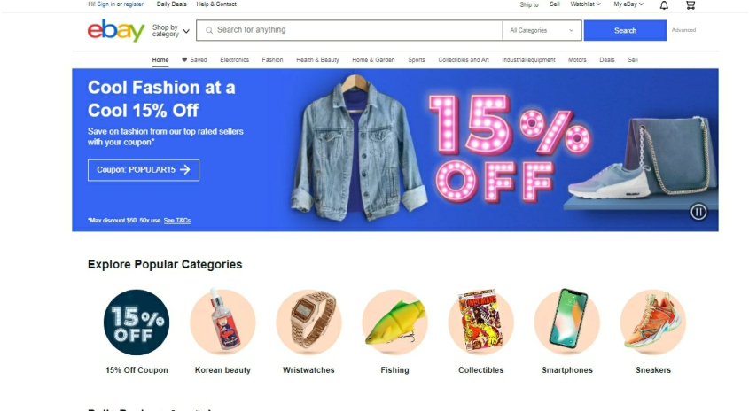

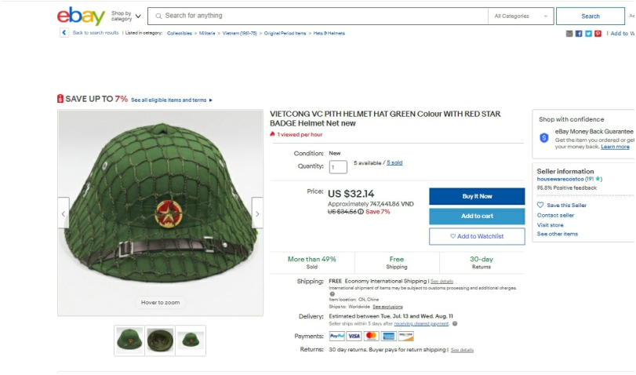

EBay là một website đấu giá trực tuyến, nơi mà mọi người khắp nơi trên thế giới có thể mua hoặc bán hàng hóa và dịch vụ. Tập đoàn eBay cũng sở hữu thương hiệu nổi tiếng khác là Paypal. Ebay đang áp dụng chủ yếu là mô hình C2C.

Khi tham gia vào trang Ebay, mọi thứ đều sẽ được bán theo hình thức đấu giá. Hình thức đấu giá trên internet cũng không giống với hình thức đấu giá truyền thống mà mọi người vẫn thấy

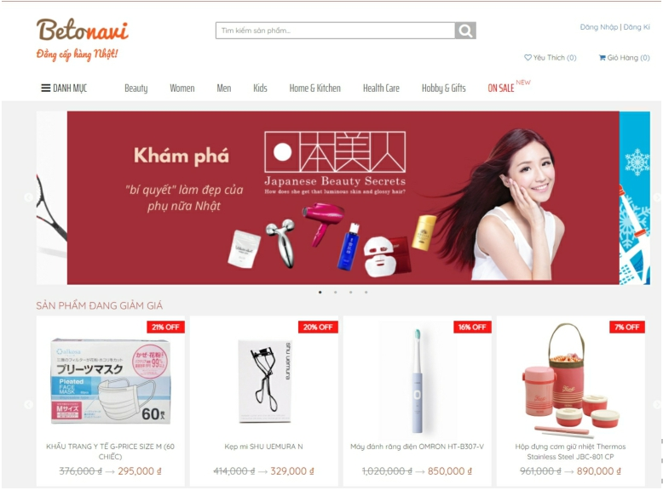- **Betonavi**

Betonavi Team được thành lập từ đầu năm 2017 bởi các thành viên đang sống và làm việc tại các công ty lớn tại Nhật Bản như CoWell-Asia.

Với mục tiêu xây dựng một kênh chính thống giúp người tiêu dùng Việt có thể tiếp cận các sản phẩm chất lượng cao tại Nhật Bản

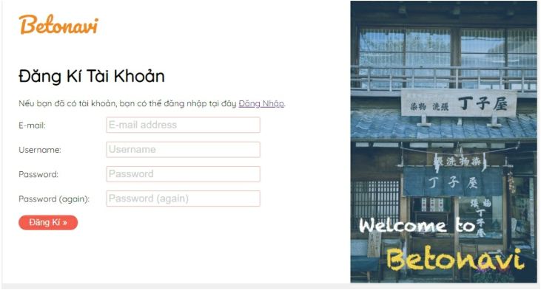

**- Shopee**

Shopee là một trong những trang thương mại điện tử lớn không chỉ ở tại Việt Nam mà còn đối với các nước Đông Nam Á khác.

**Khách hàng Có các chức năng chính sau:**

* Đăng nhập, đăng xuất, đổi mật khẩu

▪ Chọn loại sản phẩm

▪ Tìm kiếm sản phẩm

▪ Xem thông tin thương hiệu

* Đặt mua sản phẩm
* Nhắn tin (chat)

▪ Xem giỏ hàng

▪ Thanh toán hóa đơn: Địa chỉ giao hàng, Phương thức thanh toán

▪ Quản lý tài khoản: Thông tin cá nhân, Theo dõi đơn hàng

**Các giao diện chính của Shopee:**

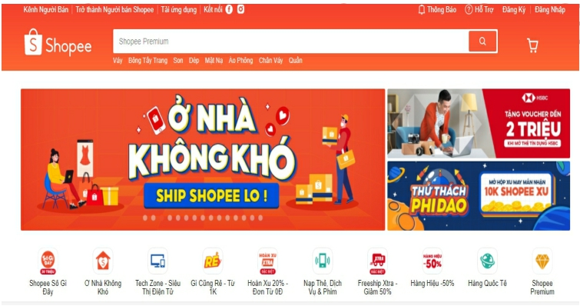

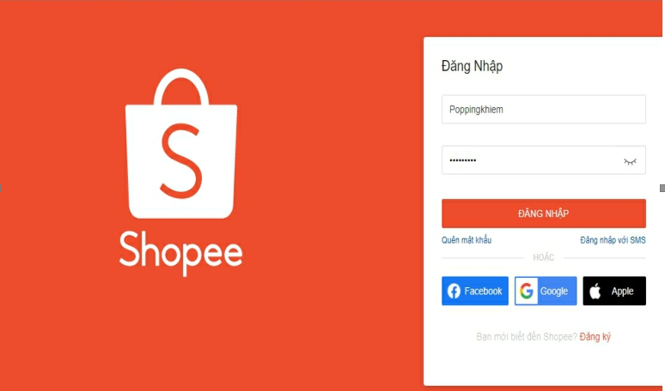

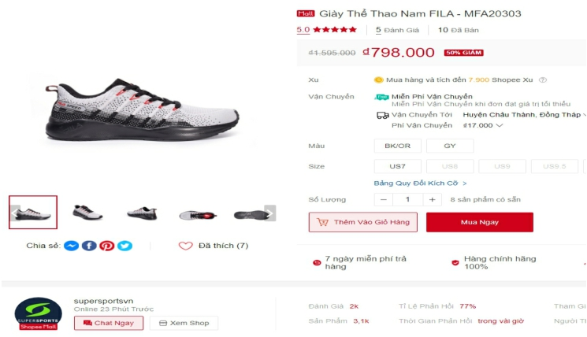

**Phụ Lục A:**

**1. Xác định các chức năng:**

Hệ thống gồm các chức năng:

**Với bên bán:**

- Tìm kiếm, nhập hàng, cập nhật (CRUD) các thông tin mặt hàng,

- Quản lý danh mục hàng hóa (CRUD)

- Quản lý giá mặt hàng

- Quản lý đơn hàng ( xem chi tiết đơn hàng, cập nhật trạng thái đơn hàng, tìm kiếm đơn hàng )

- Quản lý danh mục kho ( thêm , sửa , xóa , tìm kiếm danh mục kho) .

- Quản lý thông tin kho ( thêm , sửa , xóa , tìm kiếm thông tin kho ) .

- Quản lý xuất, nhập hàng

- Quản lý thông tin người dùng

- Phân tích ý kiến khách hàng, đề xuất sản phẩm

- Báo cáo tồn kho

- Báo cáo bán hàng

- Báo cáo doanh thu theo tháng

- Bảo mật người dùng

**Với bên mua**

- Thêm giỏ hàng

- Đặt hàng

- Tìm kiếm sản phẩm

- Xem chi tiết sản phẩm

- Xem hóa đơn

- Đánh giá, bình luận sản phẩm

- Theo dõi đơn hàng