Bai 1:

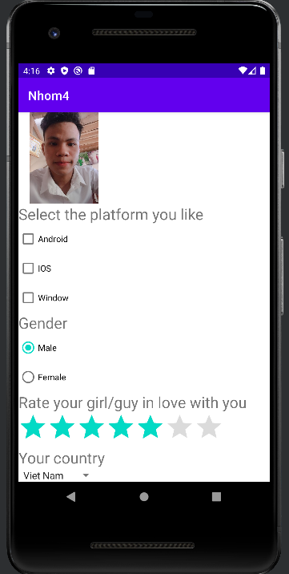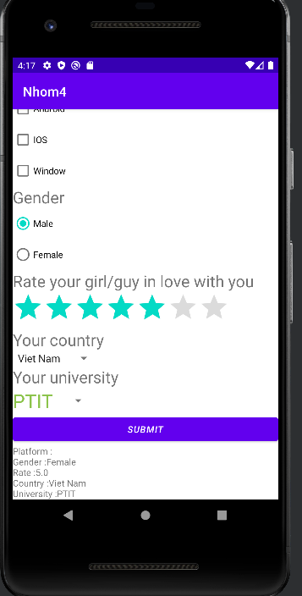

|  |
| --- |
| package com.example.nhom4;  import androidx.appcompat.app.AppCompatActivity;  import android.os.Bundle; import android.view.View; import android.widget.ArrayAdapter; import android.widget.CheckBox; import android.widget.RadioButton; import android.widget.RatingBar; import android.widget.Spinner; import android.widget.TextView;  public class MainActivity extends AppCompatActivity {  private Spinner sp,sp1,sp2;  private CheckBox c1,c2,c3;  private RadioButton r1,r2;  private RatingBar rb1;  private TextView tv1;    @Override  protected void onCreate(Bundle savedInstanceState) {  super.onCreate(savedInstanceState);  setContentView(R.layout.*test1*);  sp=findViewById(R.id.*sp2*);  String[] list={"PTIT","HUC","HUST","NUCE"};  ArrayAdapter<String> adapter=new ArrayAdapter<>(this,R.layout.*item*,list);  sp.setAdapter(adapter);  initView();  }   private void initView() {  c1=findViewById(R.id.*c1*);  c2=findViewById(R.id.*c2*);  c3=findViewById(R.id.*c3*);  r1=findViewById(R.id.*r1*);  r2=findViewById(R.id.*r2*);  rb1=findViewById(R.id.*rb1*);  sp1=findViewById(R.id.*sp1*);  sp2=findViewById(R.id.*sp2*);  tv1=findViewById(R.id.*tv1*);  }   public void hienthi(View v){  String kq="";  String temp="",temp1="";  if(c1.isSelected()) {  temp+=c1.getText().toString()+",";  }  if(c2.isSelected()) {  temp+=c2.getText().toString()+",";  }  if(c3.isSelected()) {  temp+=c3.getText().toString();  }  if(r1.isSelected()){  temp1+=r1.getText().toString();  }else temp1+=r2.getText().toString();   try {  kq = "Platform :"+ temp +"\n"  +"Gender :"+temp1 +"\n"  +"Rate :"+rb1.getRating()+"\n"  +"Country :"+sp1.getSelectedItem().toString()+"\n"  +"University :"+sp2.getSelectedItem().toString();  tv1.setText(kq);  }catch (NumberFormatException e){   }    } } |

|  |
| --- |
| <?xml version="1.0" encoding="utf-8"?> <LinearLayout xmlns:android="http://schemas.android.com/apk/res/android"  android:layout_width="match_parent"  android:layout_height="match_parent"  android:orientation="vertical">  <ScrollView  android:layout_width="match_parent"  android:layout_height="wrap_content">  <LinearLayout  android:layout_width="match_parent"  android:layout_height="wrap_content"  android:orientation="vertical">  <ImageView  android:src="@drawable/img"  android:layout_width="150dp"  android:layout_height="150dp"/>  <TextView  android:text="Select the platform you like"  android:textSize="25dp"  android:layout_width="wrap_content"  android:layout_height="wrap_content"/>  <CheckBox  android:id="@+id/c1"  android:text="Android"  android:layout_width="wrap_content"  android:layout_height="wrap_content"/>  <CheckBox  android:id="@+id/c2"  android:text="IOS"  android:layout_width="wrap_content"  android:layout_height="wrap_content"/>  <CheckBox  android:id="@+id/c3"  android:text="Window"  android:layout_width="wrap_content"  android:layout_height="wrap_content"/>  <TextView  android:text="Gender"  android:textSize="25dp"  android:layout_width="wrap_content"  android:layout_height="wrap_content"/>  <RadioGroup  android:layout_width="wrap_content"  android:layout_height="wrap_content">  <RadioButton  android:id="@+id/r1"  android:checked="true"  android:text="Male"  android:layout_width="wrap_content"  android:layout_height="wrap_content"/>  <RadioButton  android:id="@+id/r2"  android:text="Female"  android:layout_width="wrap_content"  android:layout_height="wrap_content"/>  </RadioGroup>  <TextView  android:text="Rate your girl/guy in love with you"  android:textSize="25dp"  android:layout_width="wrap_content"  android:layout_height="wrap_content"/>  <RatingBar  android:id="@+id/rb1"  android:numStars="7"  android:rating="3"  android:stepSize="1"  android:layout_width="wrap_content"  android:layout_height="wrap_content"/>  <TextView  android:text="Your country"  android:textSize="25dp"  android:layout_width="wrap_content"  android:layout_height="wrap_content"/>  <Spinner  android:id="@+id/sp1"  android:entries="@array/country"  android:layout_width="wrap_content"  android:layout_height="wrap_content"/>  <TextView  android:text="Your university"  android:textSize="25dp"  android:layout_width="wrap_content"  android:layout_height="wrap_content"/>  <Spinner  android:id="@+id/sp2"  android:layout_width="wrap_content"  android:layout_height="wrap_content"/>  <Button  android:text="SUBMIT"  android:textStyle="italic"  android:onClick="hienthi"  android:layout_width="match_parent"  android:layout_height="wrap_content"/>  <TextView  android:id="@+id/tv1"  android:layout_width="match_parent"  android:layout_height="wrap_content"/>  </LinearLayout>  </ScrollView> </LinearLayout> |

|  |
| --- |
| <resources>  <string name="app_name">Nhom4</string>  <string-array name="country">  <item>Viet Nam</item>  <item>Han Quoc</item>  <item>Angola</item>  <item>Canada</item>  </string-array> </resources> |

|  |
| --- |
| <?xml version="1.0" encoding="utf-8"?> <TextView xmlns:android="http://schemas.android.com/apk/res/android"  android:layout_width="match_parent"  android:layout_height="match_parent"  android:textColor="#8BC34A"  android:textSize="30dp"> </TextView> |

Bài 2:

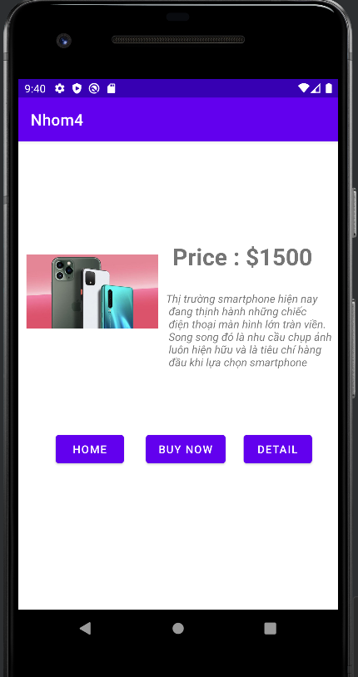

|  |
| --- |
| package com.example.nhom4;  import androidx.appcompat.app.AppCompatActivity;  import android.os.Bundle;  public class bai2 extends AppCompatActivity {   @Override  protected void onCreate(Bundle savedInstanceState) {  super.onCreate(savedInstanceState);  setContentView(R.layout.*test2*);  } } |

|  |
| --- |
| <?xml version="1.0" encoding="utf-8"?> <androidx.constraintlayout.widget.ConstraintLayout xmlns:android="http://schemas.android.com/apk/res/android"  xmlns:app="http://schemas.android.com/apk/res-auto"  xmlns:tools="http://schemas.android.com/tools"  android:layout_width="match_parent"  android:layout_height="match_parent">   <ImageView  android:id="@+id/imageView"  android:layout_width="170dp"  android:layout_height="250dp"  android:src="@drawable/img"  app:layout_constraintBottom_toBottomOf="parent"  app:layout_constraintEnd_toStartOf="@+id/textView2"  app:layout_constraintStart_toStartOf="parent"  app:layout_constraintTop_toTopOf="parent"  app:layout_constraintVertical_bias="0.195" />   <TextView  android:id="@+id/textView"  android:layout_width="wrap_content"  android:layout_height="wrap_content"  android:layout_marginStart="12dp"  android:layout_marginTop="128dp"  android:text="Price : $1500"  android:textSize="30dp"  android:textStyle="bold"  app:layout_constraintEnd_toEndOf="parent"  app:layout_constraintHorizontal_bias="0.157"  app:layout_constraintStart_toEndOf="@+id/imageView"  app:layout_constraintTop_toTopOf="parent" />   <TextView  android:id="@+id/textView2"  android:layout_width="wrap_content"  android:layout_height="wrap_content"  android:layout_marginEnd="8dp"  android:text="Thị trường smartphone hiện nay\n đang thịnh hành những chiếc\n điện thoại màn hình lớn tràn viền.\n Song song đó là nhu cầu chụp ảnh\n luôn hiện hữu và là tiêu chí hàng\n đầu khi lựa chọn smartphone"  android:textStyle="italic"  app:layout_constraintBottom_toBottomOf="parent"  app:layout_constraintEnd_toEndOf="parent"  app:layout_constraintTop_toBottomOf="@+id/textView"  app:layout_constraintVertical_bias="0.073" />   <Button  android:id="@+id/button2"  android:layout_width="wrap_content"  android:layout_height="wrap_content"  android:layout_marginStart="48dp"  android:text="Home"  app:layout_constraintBottom_toBottomOf="parent"  app:layout_constraintStart_toStartOf="parent"  app:layout_constraintTop_toBottomOf="@+id/imageView"  app:layout_constraintVertical_bias="0.227" />   <Button  android:id="@+id/button"  android:layout_width="wrap_content"  android:layout_height="wrap_content"  android:layout_marginStart="28dp"  android:text="Buy now"  app:layout_constraintBottom_toBottomOf="@+id/button2"  app:layout_constraintStart_toEndOf="@+id/button2"  app:layout_constraintTop_toTopOf="@+id/button2"  app:layout_constraintVertical_bias="0.0" />   <Button  android:layout_width="wrap_content"  android:layout_height="wrap_content"  android:text="Detail"  app:layout_constraintBottom_toBottomOf="@+id/button"  app:layout_constraintEnd_toEndOf="parent"  app:layout_constraintHorizontal_bias="0.411"  app:layout_constraintStart_toEndOf="@+id/button"  app:layout_constraintTop_toTopOf="@+id/button"  app:layout_constraintVertical_bias="0.0" />  </androidx.constraintlayout.widget.ConstraintLayout> |

Bài 3 :

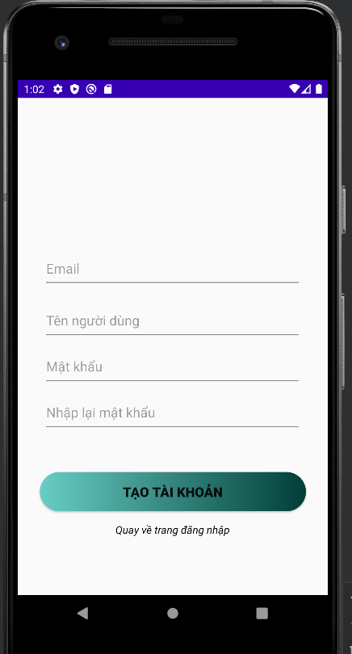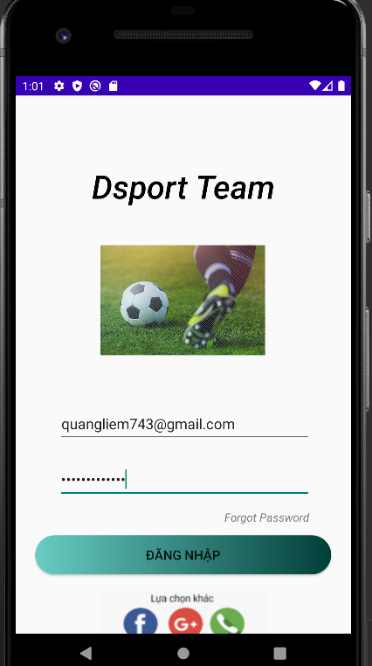

|  |
| --- |
| <?xml version="1.0" encoding="utf-8"?> <androidx.constraintlayout.widget.ConstraintLayout xmlns:android="http://schemas.android.com/apk/res/android"  xmlns:app="http://schemas.android.com/apk/res-auto"  xmlns:tools="http://schemas.android.com/tools"  android:layout_width="match_parent"  android:layout_height="match_parent">   <TextView  android:id="@+id/textView3"  android:layout_width="245dp"  android:layout_height="87dp"  android:layout_marginTop="84dp"  android:fontFamily="sans-serif-light"  android:textColor="@color/black"  android:text="Dsport Team"  android:textAlignment="center"  android:textAppearance="@style/TextAppearance.AppCompat.Display1"  android:textSize="40sp"  android:textStyle="bold|italic"  app:layout_constraintEnd_toEndOf="parent"  app:layout_constraintStart_toStartOf="parent"  app:layout_constraintTop_toTopOf="parent" />   <ImageView  android:id="@+id/imageView2"  android:layout_width="268dp"  android:layout_height="135dp"  android:layout_marginTop="12dp"  android:src="@drawable/img"  app:layout_constraintEnd_toEndOf="parent"  app:layout_constraintHorizontal_bias="0.496"  app:layout_constraintStart_toStartOf="parent"  app:layout_constraintTop_toBottomOf="@+id/textView3" />   <EditText  android:id="@+id/editTextTextEmailAddress"  android:layout_width="311dp"  android:layout_height="48dp"  android:layout_marginTop="60dp"  android:ems="10"  android:hint="Email"  android:inputType="textEmailAddress"  app:layout_constraintEnd_toEndOf="parent"  app:layout_constraintHorizontal_bias="0.52"  app:layout_constraintStart_toStartOf="parent"  app:layout_constraintTop_toBottomOf="@+id/imageView2" />   <EditText  android:id="@+id/editTextTextPassword"  android:layout_width="311dp"  android:layout_height="48dp"  android:layout_marginTop="20dp"  android:ems="10"  android:hint="Password"  android:inputType="textPassword"  app:layout_constraintEnd_toEndOf="parent"  app:layout_constraintHorizontal_bias="0.515"  app:layout_constraintStart_toStartOf="parent"  app:layout_constraintTop_toBottomOf="@+id/editTextTextEmailAddress" />   <TextView  android:id="@+id/textView4"  android:layout_width="111dp"  android:layout_height="21dp"  android:layout_marginTop="12dp"  android:text="Forgot Password"  android:textAlignment="center"  android:textColor="#7E7A7A"  android:textStyle="italic"  app:layout_constraintEnd_toEndOf="parent"  app:layout_constraintHorizontal_bias="0.84"  app:layout_constraintStart_toStartOf="parent"  app:layout_constraintTop_toBottomOf="@+id/editTextTextPassword" />   <Button  android:id="@+id/button3"  android:layout_width="363dp"  android:layout_height="48dp"  android:layout_marginTop="44dp"  android:text="Đăng nhập"  android:textSize="16sp"  app:cornerRadius="15dp"  android:background="@drawable/button"  android:theme="@style/CardView"  app:layout_constraintEnd_toEndOf="parent"  app:layout_constraintHorizontal_bias="0.495"  app:layout_constraintStart_toStartOf="parent"  app:layout_constraintTop_toBottomOf="@+id/editTextTextPassword" />   <ImageView  android:id="@+id/imageView3"  android:layout_width="wrap_content"  android:layout_height="wrap_content"  android:layout_marginTop="20dp"  android:src="@drawable/img_1"  app:layout_constraintBottom_toBottomOf="parent"  app:layout_constraintEnd_toEndOf="parent"  app:layout_constraintStart_toStartOf="parent"  app:layout_constraintTop_toBottomOf="@+id/button3"  app:layout_constraintVertical_bias="0.0" />   <TextView  android:id="@+id/textView5"  android:layout_width="wrap_content"  android:layout_height="wrap_content"  android:text="Tạo tài khoản"  android:textStyle="italic"  app:layout_constraintBottom_toBottomOf="parent"  app:layout_constraintEnd_toEndOf="parent"  app:layout_constraintStart_toStartOf="parent"  app:layout_constraintTop_toBottomOf="@+id/imageView3" />  </androidx.constraintlayout.widget.ConstraintLayout> |

|  |
| --- |
| <?xml version="1.0" encoding="utf-8"?> <androidx.constraintlayout.widget.ConstraintLayout xmlns:android="http://schemas.android.com/apk/res/android"  xmlns:app="http://schemas.android.com/apk/res-auto"  xmlns:tools="http://schemas.android.com/tools"  android:layout_width="match_parent"  android:layout_height="match_parent">   <EditText  android:id="@+id/editTextTextEmailAddress2"  android:layout_width="343dp"  android:layout_height="53dp"  android:layout_marginTop="200dp"  android:ems="10"  android:hint="Email"  android:inputType="textEmailAddress"  app:layout_constraintEnd_toEndOf="parent"  app:layout_constraintHorizontal_bias="0.497"  app:layout_constraintStart_toStartOf="parent"  app:layout_constraintTop_toTopOf="parent" />   <EditText  android:id="@+id/editTextTextPersonName"  android:layout_width="343dp"  android:layout_height="53dp"  android:layout_marginTop="16dp"  android:ems="10"  android:hint="Tên người dùng"  android:inputType="textPersonName"  app:layout_constraintEnd_toEndOf="parent"  app:layout_constraintHorizontal_bias="0.497"  app:layout_constraintStart_toStartOf="parent"  app:layout_constraintTop_toBottomOf="@+id/editTextTextEmailAddress2" />   <EditText  android:id="@+id/editTextTextPassword2"  android:layout_width="343dp"  android:layout_height="53dp"  android:layout_marginTop="8dp"  android:ems="10"  android:hint="Mật khẩu"  android:inputType="textPassword"  app:layout_constraintEnd_toEndOf="parent"  app:layout_constraintHorizontal_bias="0.497"  app:layout_constraintStart_toStartOf="parent"  app:layout_constraintTop_toBottomOf="@+id/editTextTextPersonName" />   <EditText  android:id="@+id/editTextTextPassword3"  android:layout_width="343dp"  android:layout_height="53dp"  android:layout_marginTop="8dp"  android:ems="10"  android:hint="Nhập lại mật khẩu"  android:inputType="textPassword"  app:layout_constraintEnd_toEndOf="parent"  app:layout_constraintHorizontal_bias="0.497"  app:layout_constraintStart_toStartOf="parent"  app:layout_constraintTop_toBottomOf="@+id/editTextTextPassword2" />   <Button  android:id="@+id/button4"  android:layout_width="353dp"  android:layout_height="52dp"  android:layout_marginTop="52dp"  android:background="@drawable/button"  android:text="Tạo tài khoản"  android:textSize="18sp"  android:textStyle="bold"  app:layout_constraintEnd_toEndOf="parent"  app:layout_constraintStart_toStartOf="parent"  app:layout_constraintTop_toBottomOf="@+id/editTextTextPassword3" />   <TextView  android:id="@+id/textView6"  android:layout_width="wrap_content"  android:layout_height="wrap_content"  android:text="Quay về trang đăng nhập"  android:textColor="@color/black"  android:textSize="14sp"  android:textStyle="italic"  app:layout_constraintBottom_toBottomOf="parent"  app:layout_constraintEnd_toEndOf="parent"  app:layout_constraintHorizontal_bias="0.498"  app:layout_constraintStart_toStartOf="parent"  app:layout_constraintTop_toBottomOf="@+id/button4"  app:layout_constraintVertical_bias="0.156" />  </androidx.constraintlayout.widget.ConstraintLayout> |

|  |
| --- |
| <?xml version="1.0" encoding="utf-8"?> <shape xmlns:android="http://schemas.android.com/apk/res/android">  <corners  android:radius="30dp"/>  <gradient  android:startColor="#68CDC4"  android:endColor="#013E38"/> </shape> |