Bootstrap5

Lấy bootstrap ở :

## Bootstrap 5 CDN

## <!-- Latest compiled and minified CSS --> <link href="https://cdn.jsdelivr.net/npm/bootstrap@5.1.2/dist/css/bootstrap.min.css" rel="stylesheet"> <!-- Latest compiled JavaScript --> <script src="https://cdn.jsdelivr.net/npm/bootstrap@5.1.2/dist/js/bootstrap.bundle.min.js"></script>

## Downloading Bootstrap 5

## go to <https://getbootstrap.com/>,

## <!DOCTYPE html> <html lang="en"> <head>   <title>Bootstrap Example</title>   <meta charset="utf-8">   <meta name="viewport" content="width=device-width, initial-scale=1">   <link href="https://cdn.jsdelivr.net/npm/bootstrap@5.1.2/dist/css/bootstrap.min.css" rel="stylesheet">   <script src="https://cdn.jsdelivr.net/npm/bootstrap@5.1.2/dist/js/bootstrap.bundle.min.js"></script> </head> <body>

## </body> </html>

## Học

## Bootstrap 5 Containers

The .container class provides a responsive **fixed width container**

The .container-fluid class provides a **full width container**, spanning the entire width of the viewport

## 

## *Container Padding

## For example, .pt-5,p-9,mb-4 means "add a large **top padding**" :*padding top 5px,padding 9px, margin bottom 4px*

## <div class="container pt-5"></div>

## * Responsive Containers

## .container-sm|md|lg|xl|xxl

## Grid Classes( Lưới bố cục)

.col-

.col-sm-x--🡪 x này là từ 1 đến 12,vì chiều dài lưới chia dc max 12 cột

.col-md-

.col-lg-

.col-xl-

.col-xxl-

## <div class="row">   <div class="col">.col</div>   <div class="col">.col</div>   <div class="col">.col</div> </div>

## <div class="row">   <div class="col-sm-3">.col-sm-3</div>   <div class="col-sm-3">.col-sm-3</div>   <div class="col-sm-3">.col-sm-3</div>   <div class="col-sm-3">.col-sm-3</div> </div>--vì 4 cột nên 12/4=3

## *2 cột không bằng nhau:

## <div class="row">   <div class="col-sm-4">.col-sm-4</div>   <div class="col-sm-8">.col-sm-8</div> </div>

# **Text/Typography**

## *Class .h1🡪6 có thể thay cho các thẻ h1🡪6

## <p class="h1">h1heading</p> <p class="h2">h2heading</p> <p class="h3">h3heading</p> <p class="h4">h4heading</p> <p class="h5">h5heading</p> <p class="h6">h6heading</p>

## Display Headings

## .display-1 to .display-6

## <small>

## HTML <small> element (and the .small class) is used to create a smaller, secondary text in any heading

## <mark>

## style <mark> and .mark with a yellow background color and some padding

## <abbr>

## HTML <abbr> element with đường viền chấm dưới cùng và con trỏ có dấu chấm hỏi khi di chuột

## <blockquote>

## Thêm .blockquotelớp vào a <blockquote> khi trích dẫn các khối nội dung từ một nguồn khác. Và khi đặt tên cho một nguồn, chẳng hạn như "từ trang web của WWF", hãy sử dụng .blockquote-footerlớp

## 

## <dl>

## <dl>

## <dt>Coffee</dt>

## <dd>- black hot drink</dd>

## <dt>Milk</dt>

## <dd>- white cold drink</dd>

## </dl>

## <code>

## <kbd>

## 

## <pre>

## 

## 

## Color

## .text-muted, .text-primary, .text-success, .text-info, .text-warning, .text-danger, .text-secondary, .text-white, .text-dark, .text-body (default body color/often black) and .text-light:

## 

## You can also add 50% opacity for black or white text with the .text-black-50 or .text-white-50 classes:

## Background-color

## .bg-primary, .bg-success, .bg-info, .bg-warning, .bg-danger, .bg-secondary, .bg-dark and .bg-light.

## Table

## The .table class adds basic styling to a table:

## 

## The .table-striped class adds zebra-stripes to a table:

## 

## The .table-bordered class adds borders on all sides of the table and cells:

## 

## The .table-hover class adds a hover effect (grey background color) on table rows: ( khi hover vào thì nó nổi xám lên theo dòng)

## 

## The .table-dark class adds a black background to the table:

## 

## Combine .table-dark and .table-striped to create a dark, striped table:

## 

## The .table-borderless class removes borders from the table:

## 

## [Contextual classes](https://www.w3schools.com/bootstrap5/bootstrap_colors.php) can be used to color the whole table (<table>),  the table rows (<tr>) or table cells (<td>).

## 

|  |
| --- |
| .table-primary |
| .table-success |
| .table-danger |
| .table-info |
| .table-warning |
| .table-active |
| .table-secondary |
| .table-light |
| .table-dark |  |

## The .table-sm class makes the table smaller by cutting cell padding in half:

## The .table-responsive class adds a scrollbar to the table when needed (when it is too big horizontally):

## <div class="table-responsive">    <table class="table">     ...    </table> </div>

## .table-responsive-sm|md|lg|xl|xxl

## Image

## The .rounded class adds rounded corners to an image:

## <img src="cinqueterre.jpg" class="rounded" alt="Cinque Terre">

## The .rounded-circle class shapes the image to a circle:

## <img src="cinqueterre.jpg" class="rounded-circle" alt="Cinque Terre">

## The .img-thumbnail class shapes the image to a thumbnail (bordered):

## <img src="cinqueterre.jpg" class="img-thumbnail" alt="Cinque Terre">

## Float an image to the left with the .float-start class or to the right with .float-end:( ảnh sang lề trái/phải):

## <img src="paris.jpg" class="float-start"> <img src="paris.jpg" class="float-end">

## Center an image by adding the utility classes .mx-auto (margin:auto) and .d-block (display:block) to the image:

## <img src="paris.jpg" class="mx-auto d-block">

## The .img-fluid class applies max-width: 100%; and height: auto; to the image:

<img class="img-fluid" src="ny.jpg" alt="New York">

## Jumbotron( hộp đệm)

## Alerts

## .alert class, followed by one of the contextual classes :.alert-success, .alert-info, .alert-warning, .alert-danger, .alert-primary, .alert-secondary, .alert-light or .alert-dark

## <div class="alert alert-success">

## * .alert-link:

## <div class="alert alert-success">   <strong>Success!</strong> You should <a href="#" class="alert-link">read this message</a>. </div>

## * Closing Alerts

## To close the alert message, add a .alert-dismissible class to the alert container. Then add class="btn-close" and data-bs-dismiss="alert" to a link or a button element (when you click on this the alert box will disappear).

## <div class="alert alert-success alert-dismissible">   <button type="button" class="btn-close" data-bs-dismiss="alert"></button>   <strong>Success!</strong> This alert box could indicate a successful or positive action. </div>

## * Animated Alerts

The .fade and .show classes adds a fading effect when closing the alert message:

<div class="alert alert-danger alert-dismissible fade show">

1. Button

<button type="button" class="btn">Basic</button>  
<button type="button" class="btn btn-primary">Primary</button>  
<button type="button" class="btn btn-secondary">Secondary</button>  
<button type="button" class="btn btn-success">Success</button>  
<button type="button" class="btn btn-info">Info</button>  
<button type="button" class="btn btn-warning">Warning</button>  
<button type="button" class="btn btn-danger">Danger</button>  
<button type="button" class="btn btn-dark">Dark</button>  
<button type="button" class="btn btn-light">Light</button>  
<button type="button" class="btn btn-link">Link</button>



The button classes can be used on <a>, <button>, or <input> elements:

<a href="#" class="btn btn-success">Link Button</a>  
<button type="button" class="btn btn-success">Button</button>  
<input type="button" class="btn btn-success" value="Input Button">  
<input type="submit" class="btn btn-success" value="Submit Button">  
<input type="reset" class="btn btn-success" value="Reset Button">

## Button Outline

Move the mouse over them to see an additional "hover" effect:



<button type="button" class="btn btn-outline-primary"> Primary</button>  
<button type="button" class="btn btn-outline-secondary"> Secondary</button>  
<button type="button" class="btn btn-outline-success"> Success</button>

## Button Sizes

Use the .btn-lg class for large buttons or .btn-sm class for small buttons:

## Block Level Buttons

To create a block level button that spans the entire width of the parent element, use the .d-grid "helper" class on the parent element:

<div class="d-grid">  
  <button type="button" class="btn btn-primary btn-block">Full-Width Button</button>  
</div>

If you have many block-level buttons, you can control the space between them with the .gap-* class:

<div class="d-grid gap-3">  
  <button type="button" class="btn btn-primary btn-block">Full-Width Button</button>  
  <button type="button" class="btn btn-primary btn-block">Full-Width Button</button>  
  <button type="button" class="btn btn-primary btn-block">Full-Width Button</button>  
</div>

## Active/Disabled Buttons

The class .active makes a button appear pressed, and the disabled attribute makes a button unclickable. Note that <a> elements do not support the disabled attribute and must therefore use the .disabled class to make it visually appear disabled.

## Spinner Buttons



<button class="btn btn-primary">  
  <span class="spinner-border spinner-border-sm"></span>  
</button>  
  
<button class="btn btn-primary">  
  <span class="spinner-border spinner-border-sm"></span>  
  Loading..  
</button>  
  
<button class="btn btn-primary" disabled>  
  <span class="spinner-border spinner-border-sm"></span>  
  Loading..  
</button>  
  
<button class="btn btn-primary" disabled>  
  <span class="spinner-grow spinner-grow-sm"></span>  
  Loading..  
</button>

## Button Groups

Use a <div> element with class .btn-group to create a button group:(mặc định gộp thành hàng ngang)

Use the class .btn-group-vertical to create a vertical button group( hàng dọc)

## Nesting Button Groups & Dropdown Menus

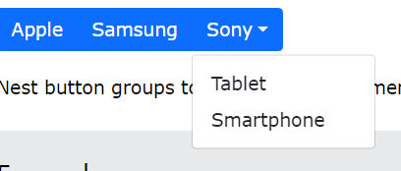

<div class="btn-group">  
  <button type="button" class="btn btn-primary">Apple</button>  
  <button type="button" class="btn btn-primary">Samsung</button>  
  <div class="btn-group">  
    <button type="button" class="btn btn-primary dropdown-toggle" data-toggle="dropdown">Sony</button>  
    <div class="dropdown-menu">  
      <a class="dropdown-item" href="#">Tablet</a>  
      <a class="dropdown-item" href="#">Smartphone</a>  
    </div>  
  </div>  
</div>

## Badges

Use the .badge class together with a contextual class (like .bg-secondary) within <span> elements to create rectangular badges

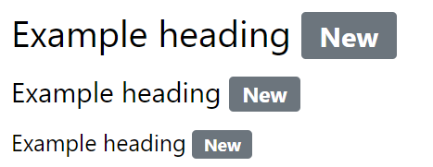

<h3>Example heading <span class="badge bg-secondary">New</span></h3>  
<h4>Example heading <span class="badge bg-secondary">New</span></h4>  
<h5>Example heading <span class="badge bg-secondary">New</span></h5>

## Pill Badges

Use the .rounded-pill class to make the badges more round:

<span class="badge rounded-pill bg-success">Success</span>  
<span class="badge rounded-pill bg-danger">Danger</span>



## Badge inside an Element

<button type="button" class="btn btn-primary">  
  Messages <span class="badge bg-danger">4</span>  
</button>

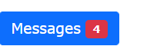

## Progress Bar

To create a default progress bar, add a .progress class to a container element and add the .progress-bar class to its child element. Use the CSS width property to set the width of the progress bar:

<div class="progress">  
  <div class="progress-bar" style="width:70%"></div>  
</div>



The height of the progress bar is 1rem (usually 16px) by default. Use the CSS height property to change it. Note that you must set the same height for the progress container and the progress bar:

<div class="progress" style="height:20px">  
  <div class="progress-bar" style="width:40%;height:20px">40%</div>  
</div>

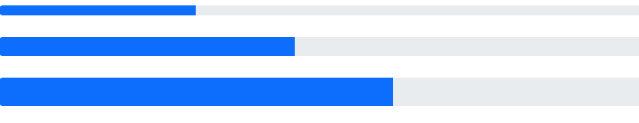

*Chỉnh màu progessbar:

<!-- Green -->  
<div class="progress">  
  <div class="progress-bar bg-success" style="width:20%"></div>  
</div>

*kẻ sọc( striped) progessbar:

Use the .progress-bar-striped class to add stripes to the progress bars:

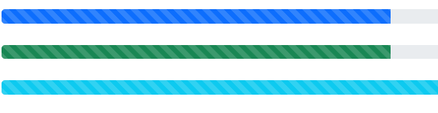

*kẻ sọc chạy hiệu ứng animation:

Add the .progress-bar-animated class to animate the progress bar:

## Spinners

use the .spinner-border class:

<div class="spinner-border"></div>

*Spinners màu-color*

<div class="spinner-border text-muted"></div>  
<div class="spinner-border text-primary"></div>  
<div class="spinner-border text-success"></div>  
<div class="spinner-border text-info"></div>

.spinner-grow: load hình tròn từ tâm ra ngoài

## * Spinner Size

## Use .spinner-border-sm or .spinner-grow-sm to create a smaller spinner:

## <div class="spinner-border spinner-border-sm"></div>

## Pagination( phân trang)

## To create a basic pagination, add the .pagination class to an <ul> element. Then add the .page-item to each <li> element and a .page-link class to each link inside <li>:

## 

## <ul class="pagination">   <li class="page-item"><a class="page-link" href="#">Previous</a></li>   <li class="page-item"><a class="page-link" href="#">1</a></li>   <li class="page-item"><a class="page-link" href="#">2</a></li>   <li class="page-item"><a class="page-link" href="#">3</a></li>   <li class="page-item"><a class="page-link" href="#">Next</a></li> </ul>

## The .active class is used to "highlight" the current page:

## 

## <li class="page-item active"><a class="page-link" href="#">2</a></li>

## The .disabled class is used for un-clickable links:

## Add class .pagination-lg for larger blocks or .pagination-sm for smaller blocks: chỉnh kích cỡ

## * Pagination Alignment( vị trí)

## <!-- Center-aligned --> <ul class="pagination justify-content-center" style="margin:20px 0">   <li class="page-item">...</li> </ul> <!-- Right-aligned --> <ul class="pagination justify-content-end" style="margin:20px 0">   <li class="page-item">...</li> </ul>

## * Breadcrumbs( hoặc)

## 

## <ul class="breadcrumb">   <li class="breadcrumb-item"><a href="#">Photos</a></li>   <li class="breadcrumb-item"><a href="#">Summer 2017</a></li>   <li class="breadcrumb-item"><a href="#">Italy</a></li>   <li class="breadcrumb-item active">Rome</li> </ul>

## List Groups

## use an <ul> element with class .list-group, and <li> elements with class .list-group-item:

## 

## <ul class="list-group">   <li class="list-group-item">First item</li>   <li class="list-group-item">Second item</li>   <li class="list-group-item">Third item</li> </ul>

## Use the .active class to highlight the current item:

## 

## a list group with linked items, use <div> instead of <ul> and <a> instead of <li>. Optionally, add the .list-group-item-action class if you want a grey background color on hover:

<div class="list-group">  
  <a href="#" class="list-group-item list-group-item-action">First item</a>  
  <a href="#" class="list-group-item list-group-item-action">Second item</a>  
  <a href="#" class="list-group-item list-group-item-action">Third item</a>  
</div>

The .disabled class adds a lighter text color to the disabled item. And when used on links, it will remove the hover effect

Use the .list-group-flush class to remove some borders and rounded corners:

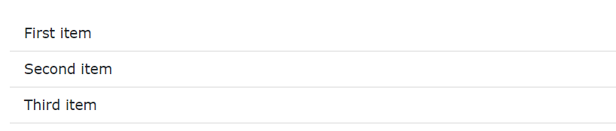

<ul class="list-group list-group-flush">  
  <li class="list-group-item">First item</li>  
  <li class="list-group-item">Second item</li>   
</ul>

Use the .list-group-numbered class to create list items with numbers in front of them:

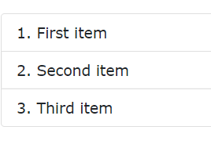

Hiển thị theo hàng ngang, thay vì dọc như mặc định thì : add the .list-group-horizontal class to .list-group:

The classes for coloring list-items are: .list-group-item-success, list-group-item-secondary, list-group-item-info, list-group-item-warning, .list-group-item-danger, .list-group-item-primary, list-group-item-dark and list-group-item-light,:

1. Card

A basic card is created with the .card class, and content inside the card has a .card-body class:

The .card-header class adds a heading to the card and the .card-footer class adds a footer to the card

Use .card-title to add card titles to any heading element. The .card-text class is used to remove bottom margins for a <p> element if it is the last child (or the only one) inside .card-body. The .card-link class adds a blue color to any link, and a hover effect.

Add .card-img-top or .card-img-bottom to an <img> to place the image at the top or at the bottom inside the card. Note that we have added the image outside of the .card-body to span the entire width:

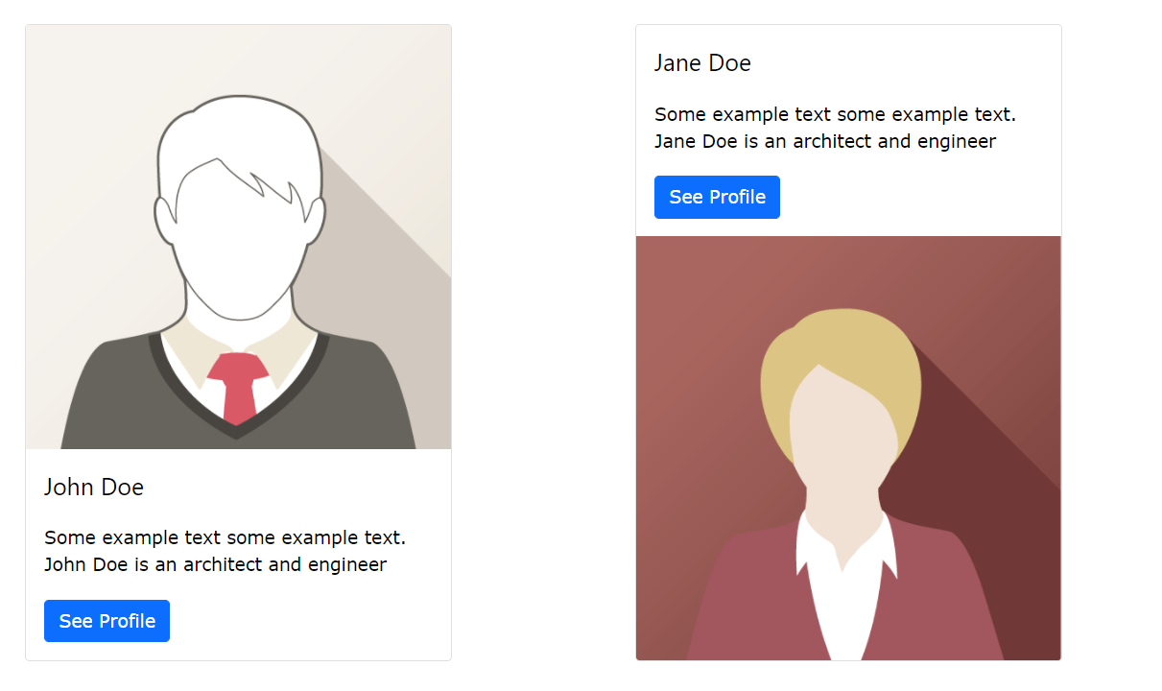

<div class="card" style="width:400px">  
  <img class="card-img-top" src="img_avatar1.png" alt="Card image">  
  <div class="card-body">  
    <h4 class="card-title">John Doe</h4>  
    <p class="card-text">Some example text.</p>  
    <a href="#" class="btn btn-primary">See Profile</a>  
  </div>  
</div>

Ảnh làm nền thì use .card-img-overlay to add text on top of the image:

## Dropdown

## 

## <div class="dropdown">   <button type="button" class="btn btn-primary dropdown-toggle" data-bs-toggle="dropdown">     Dropdown button   </button>   <ul class="dropdown-menu">     <li><a class="dropdown-item" href="#">Link 1</a></li>     <li><a class="dropdown-item" href="#">Link 2</a></li>   </ul> </div>

## The .dropdown-divider class is used to separate links inside the dropdown menu with a thin horizontal border: ( tách bằng thêm đường kẻ ngang)

## <li><hr class="dropdown-divider"></hr></li> -- đường kẻ ngang

## The .dropdown-header class is used to add headers inside the dropdown menu:

<li><h5 class="dropdown-header">Dropdown header 1</h5></li>

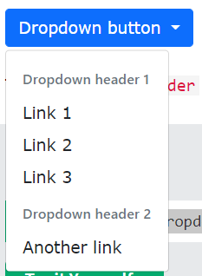

Highlight a specific dropdown item with the .active class (adds a blue background color).

To disable an item in the dropdown menu, use the .disabled class (gets a light-grey text color and a "no-parking-sign" icon on hover):

*Position:

<div class="dropdown dropend">-- bên phải

<div class="dropdown dropstart">-- bên trái

<div class="dropup">--lên trên

## Collapsible( ẩn hiện nội dung)

## <button data-bs-toggle="collapse" data-bs-target="#demo">Click me</button> <div id="demo" class="collapse"> Lorem ipsum dolor text.... </div>

## 

Thẻ <a> thì dùng href thay vì data-bs-target:

<a href="#demo" data-bs-toggle="collapse">Collapsible</a>  
  
<div id="demo" class="collapse">  
Lorem ipsum dolor text....  
</div>

can add the .show class to show the content by default

## *Accordion

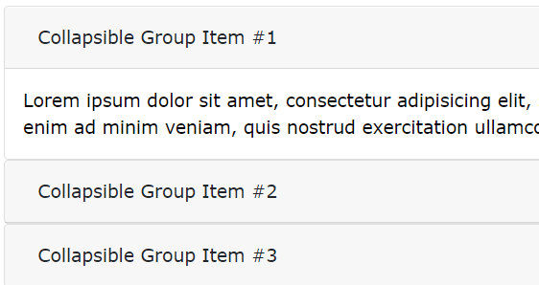

<div id="accordion">  
  
  <div class="card">  
    <div class="card-header">  
      <a class="btn" data-bs-toggle="collapse" href="#collapseOne">  
        Collapsible Group Item #1  
      </a>  
    </div>  
    <div id="collapseOne" class="collapse show" data-bs-parent="#accordion">  
      <div class="card-body">  
        Lorem ipsum..  
      </div>  
    </div>  
  </div>  
  
  <div class="card">  
    <div class="card-header">  
      <a class="collapsed btn" data-bs-toggle="collapse" href="#collapseTwo">  
        Collapsible Group Item #2  
      </a>  
    </div>  
    <div id="collapseTwo" class="collapse" data-bs-parent="#accordion">  
      <div class="card-body">  
        Lorem ipsum..  
      </div>  
    </div>  
  </div>  
</div>