<Name of the project>
CM Plan

Project Code: <Code of the project>
Document Code: <Code of the document >– v<x.x>

Note: Text displayed in blue italics is included to provide guidance to the author and should be deleted or hidden before publishing the document.
This template can be used at it is, or to complete and improve an already existing template.

Help:
- Don’t remove headlines level 1 and level 2 (Heading1 and Heading2)
- Reasons why a section is not applicable shall be documented under the respective headline

<Location, issued date of the Document>
SIGNATURE PAGE
AUTHOR: <Name> <Date>
Configuration Controller

REVIEWERS: <Name> <Date>
Project Technical Leader

<Name> <Date>
QA

APPROVAL: <Name> <Date>
Project Manager

Record of change
*A - Added M - Modified D – Deleted
Effective Date | Changed Item | A*  M, D | Change Description | Reason for Change | Revision Number

TABLE OF CONTENTS
1. Introduction 3
1.1. Role & Responsibility 3
1.2. Definitions and Acronyms 3
2. configuration management Process 3
2.1. CI Identification & Naming convention 3
2.2. CI Baseline Procedure 3
2.3. Project Baseline Schedule 3
2.4. Directory structure & Access right 3
2.5. Version numbering rule 3
2.6. Change control 3
2.7. Backup strategy 3
2.8. Other CM rules 3

Introduction
The purpose of this document is to identify and describe configuration management (CM) process implementing in the project <Project code>

Role & Responsibility
Refer to Project Organization section in Project Plan

Definitions and Acronyms
Help: Define, or provide references to documents or annexes containing the definition of all terms and acronyms required to properly understand this Plan.

Acronym | Definition | Note
ADD | Architecture Design Document
CC | Infrastructure Configuration Controller
CI | Configuration Item
CM | Configuration Management
CSCI | Computer Software Configuration Items
DDD | Detail Design Document
PM | Project Manager
PTL | Project Technical Leader
PIC | Person in Charge
QA | Quality Assurance Officer
SRS | Software Requirement Specification
Source | Source Code
URD | User Requirement Document
TP | Test Plan
TC | Test Case
WIP | Work in Progress
WP | Work product

configuration management Process

CI Identification & Naming convention
<List here all items identified as CIs in the project. It’s recommended to refer to guideline of CI identification in CM Process for proper CI identification
Sheet CI Identification in Template_CM Report could be used for the section.>

CI Baseline Procedure
<Specify CI baseline criteria in CI Identification in Template_CM Report>

Help: Customize the below flows to fit with your project. Be noted that CI baseline could be logical (by labeling or naming convention) or physical (through storage). The movement among project repositories described here must be consistent with the section Directory Structure

For Document
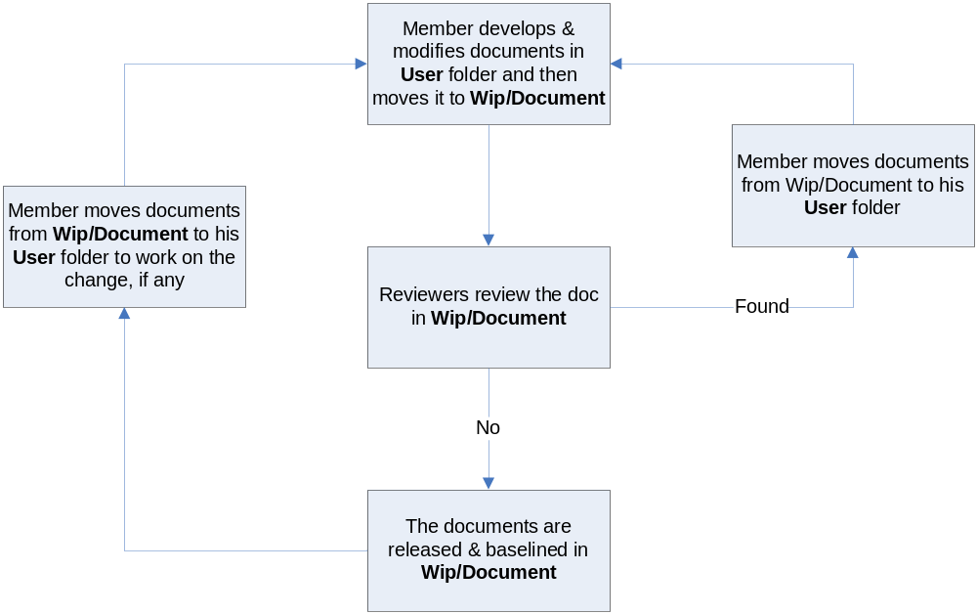

For Source code:

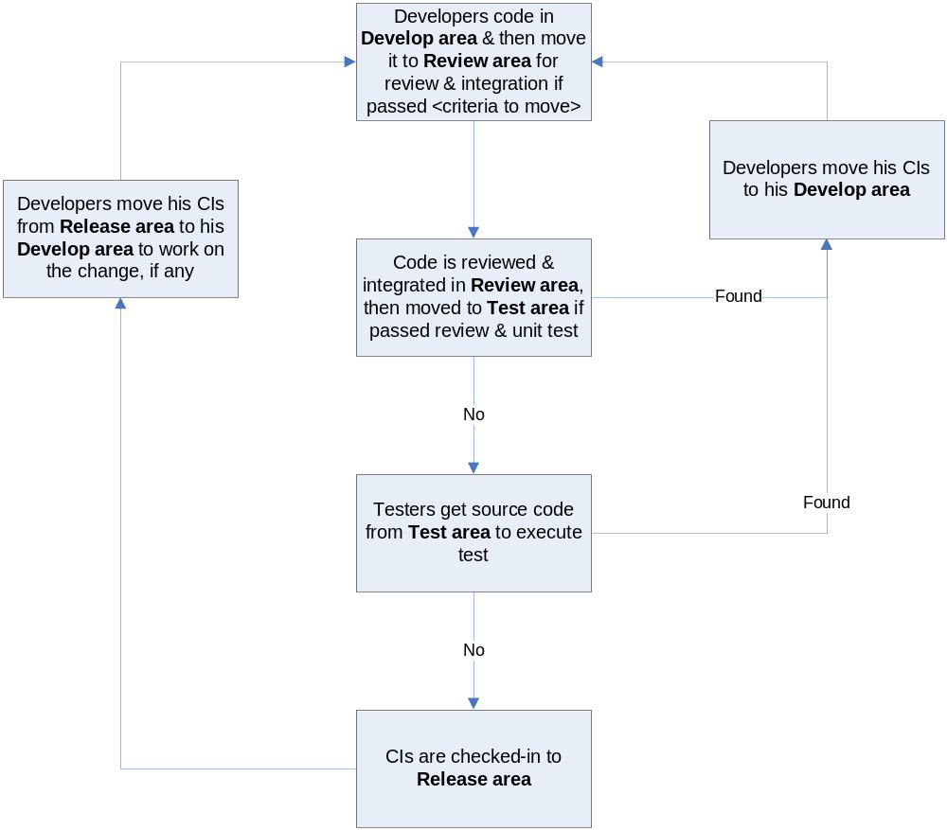

Project Baseline Schedule
Example:

No. | Baseline Name | Baseline Criteria | PIC
1 | <Name of baseline, it is usually get the name of the Stage in which the baseline is performed> | <Trigger/criteria to perform the baseline> | <Name of the person responsible for performing Baseline activities>
2 | Startup | Within 7 days from WO 1.0 approval. It is mandatory requirement that version of all CI at Startup baseline to be archived in separate folders in Archive area | CC
3 | Definition | Baseline to adapt new methodology to project solution | CC
 | Solution | When Architectural design v1.0 is released and baselined | CC
4 | Construction | Right the end of development phase | CC
5 | Wrap-up | After the final release. It is mandatory requirement that version of all CI at Wrap-up baseline to be archived in separate folders in Archive area | CC

Directory structure & Access right

Promotion Areas
Help: List Promotion Areas used in the project.
Specify purpose + criteria to be in of these areas

Example:

Area | Purpose
Develop Area | Area for different users to store his/her owned items
Review Area | To store items that is ready for review.  Reviewer get to be-reviewed items from this area
Test Area | Just applicable for Source items.  To store items passed Unit Test and Code Review
Release Area | To store the items ready for release and all released versions of items  Users get the most recent items for their usage from this area
Archive Area | To archive all released versions of each CI  Archive area is a protected area for project baselines where all the CIs can not be changed by any member

Directory structure
Help: Customize the directory structure to fit the project’s need
Define the project’s own access right

Example:
Main Folder | Sub Folder | Purpose | Map to Area |  | Access right
Project Directory : \\fsoft.fpt.vn\Gx\Projects\ABC
WIP | Deliverables | Store all CIs that are delivered to customer, be possible to add date to folder name | Release | Modify: PM, CC  Read: All
WIP | Documents | Documents of Requiements, Design, Test, … | Release + Review | Modify: PM, CC,PIC  Read: All
WIP | Meeting minutes | Store project meeting minutes, including meeting minutes with customer | NA | Modify: All
WIP | Plan | Store Proposal, Estimation, Project Plans, Project schedule, Task list | Review + Release | Modify: PM,CC,PTL  Read: All
WIP | Report | Store Project Reports: Weekly , Milestone, Post-mortem, Acceptance note, other Event-driven reports | NA | Modify: PM, CC,PIC  Read: All
WIP | Record | Store project records, divided into  Review: include Review, Test and Inspection records  Change request  Acceptance  Mails  ... | NA | Modify: All
WIP | Source | Store VSS file of Source code | Archive | Refer to VSS directory
WIP | User | User’s working area, store user’s owned items | Develop | Modify: All
Reference | Customer supplied | store Documents and Other materials/data supplied by customer or those support software development and production operation in the project… | Release | Modify: PM, CC,PIC  Read: All
Reference | Process Template | Store Guidelines/Standards/Forms/Templates/Checklist specified for the project usage | Release
Audit |  | Store QA work products  Process review  Final inspection  Work product review | NA | Modify right: Project QAs  Read right: All
Archive | Baseline Name | To released versions of CIs at baselines | Archive | Modify: PM, CC  Read: All
VSS Directory: \\101.102.103.4
<Develop> | Sub folder 1 | <purpose> | Develop |  | Modify: Developers  Read: All
<Develop> | Sub folder 2 | <purpose>
<Next Build> | Sub folder 1 | <purpose> | Review |  | Modify: PM, CC, PIC  Read: All
<Next Build> | Sub folder 2 | <purpose>
<Test> | Sub folder 1 | <purpose> | Test |  | Modify: PM, CC, PTL  Read: All
<Test> | Sub folder 2 | <purpose>
<Release> | Sub folder 1 | <purpose> | Release |  | Modify: PM, CC  Read: All
<Release> | Sub folder 2 | <purpose>

For physically stored items
Items | Location | Person in charge | Usage rule
<describe specification of the items and what is it used for on the project> | <where are the items placed> | <Name of person in charge of storage physical items> | <describe Usage rule applied to those items>

Access right control
Access right of non-project team members (ex: auditor, external reviewer, etc) must be get permission of PM and granted in the pre-defined duration, then revoked at expiry date by CC. As soon as a member is out of the project, his or her access right is revoked also.
The access right is reviewed frequently and updated by CC at <baseline point and project closure time>.
After project asset is approved by QA at project closure time, QA.Accounting informs to IT Department to revoke the access right of all project team members. If someone has a request for data reference, audit, etc, he or she must get the approval of authorized person, normally Group Leader or Division Leader, and then send the request to IT Department. IT Department is responsible for implementing such kind of requests.

Version numbering rule
Help: Specify version numbering rule applied to the project
Example:

For Documents:
The version level is maintained as numbered identifier with two components
1.1

Revision
Version

The original version will be numbered 0.1. Subsequent revisions will be numbered 0.2, 0.3. The release version will be 1.0.
Version number, which appears to the left of the decimal. It changes only when the core architecture of the item changes. For example: when an item is completely overhauled, with substantial internal changes, the version 1.0 would become version 2.0
Revision number, which appears to the right of the decimal. It changes when existing content is changed, but the overall structure and flow of the item remains the same. The normal sequence of revision is 1.1, 1.2 and so on.

For Software Source Files:
Software executables and support files are generally identified by name and version number, such as “Main DB v1.1.a”. The scratch edition will be 1.0. The version numbering scheme consists of three components:
1.1a

Revision

Version

Update

view

Version number, which appears to the left of the decimal. It changes only when the core architecture of the software item changes, as when moving from one area of the development tool to another, when an application is completely overhauled, or the user interface changes fundamentally. In this case, version 1.1a would become version 2.0.
Revision number, which appears to the right of the decimal. It changes when new features, functionality or other content are added or significantly changed. In normal case, the core architecture or user interface have been extended or limited in some manner. The most common reason for changing the revision number is when adding a new module or other functionality to the software. The normal sequence of revision is 1.0, 1.1, and 1.2 and so on.
Update level is appended or incremented when the only change to the software item is to correct one or more defects, without the addition of any new functionality. Version 1.1 would become v1.1a, v1.1b and so on. This updating is over ridden when a combination revision, involving bug fixes and new feature additions, is performed. In such a case, the software revision number is incremented and any update indicator is dropped, as in v1.1b to v1.2

Change control
<Describe Change control procedure applied in the project
<Refer to Requirement Change Management section in Project Plan and Change Control Report sheet in CM Report could be refered.>.

Backup strategy
Storage Area to be Backed up | Items to be Backed up | Backup To | Backup Type | Backup Frequency | PIC
 |  | <Where is the backup file is archive> | <Incremental, Full>
VSS repository | VSS repository | ITLKEC02\\\\ ProjectBackup |  | Twice a week | CC

Other CM rules
Specify other CM rules applied in the projects, such as mail subject naming convention, rule for deployment, rule for product releases or deliverables releases.

