Data Structuration & Transportation

Project

# Context

You oversee developing a batch to send emails automatically for a company marketing campaigns.

The marketing campaigns are targeting inhabitants of specific cities, but unfortunately the marketing tool used is not able to send emails automatically nor to observe tracking of the emails sent. On another hand, you have already a bot that does this, but needs specific data structuration to achieve that.

The global schema is as follows:

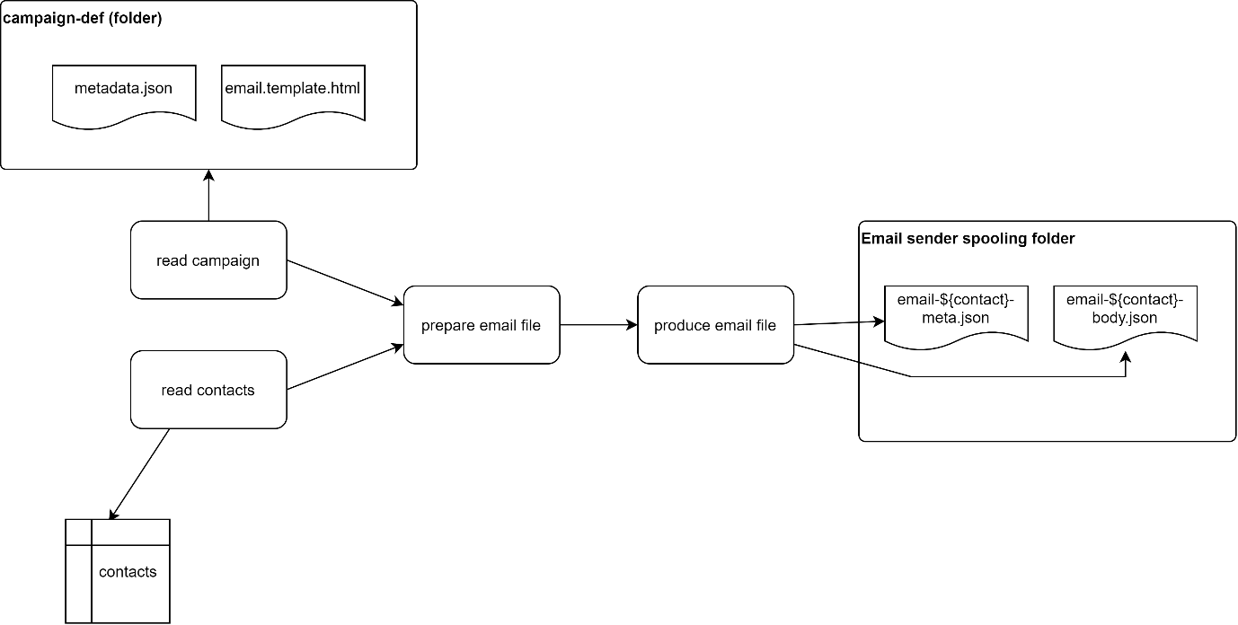

# Tasks

This project is split in several tasks, to facilitate your evaluation.

1. Load the contacts.sql in the database (postgres is preferred)
2. Choose a framework among:
   1. Spring batch

https://docs.spring.io/spring-batch/docs/current/reference/html/readersAndWriters.html#JdbcCursorItemReader

* 1. Bonobo

https://www.bonobo-project.org/getting-started

To read the contacts items from the database

1. For each contact selected (thanks to the campaign meta), create an email body (html format) from the provided email template, each wildcard should be replaced by the appropriate contact info.

Example: in the file :

<td class="hero-subheader__title" style="font-size: 43px; font-weight: bold; padding: 80px 0 15px 0;" align="left">A special offer for you in your city of ${city}</td>

Will become:

<td class="hero-subheader__title" style="font-size: 43px; font-weight: bold; padding: 80px 0 15px 0;" align="left">A special offer for you in your city of New York</td>

If the current contact city field is ‘New York’

1. Drop the resulting email file in the output folder “email-spool” (can be anywhere on your file system)
2. Make everything configurable (no hardcoded conf entries)
3. Make everything trackable (have the state of the contact processing; is it “selected for campaign”, “email ready”, “email sent”?

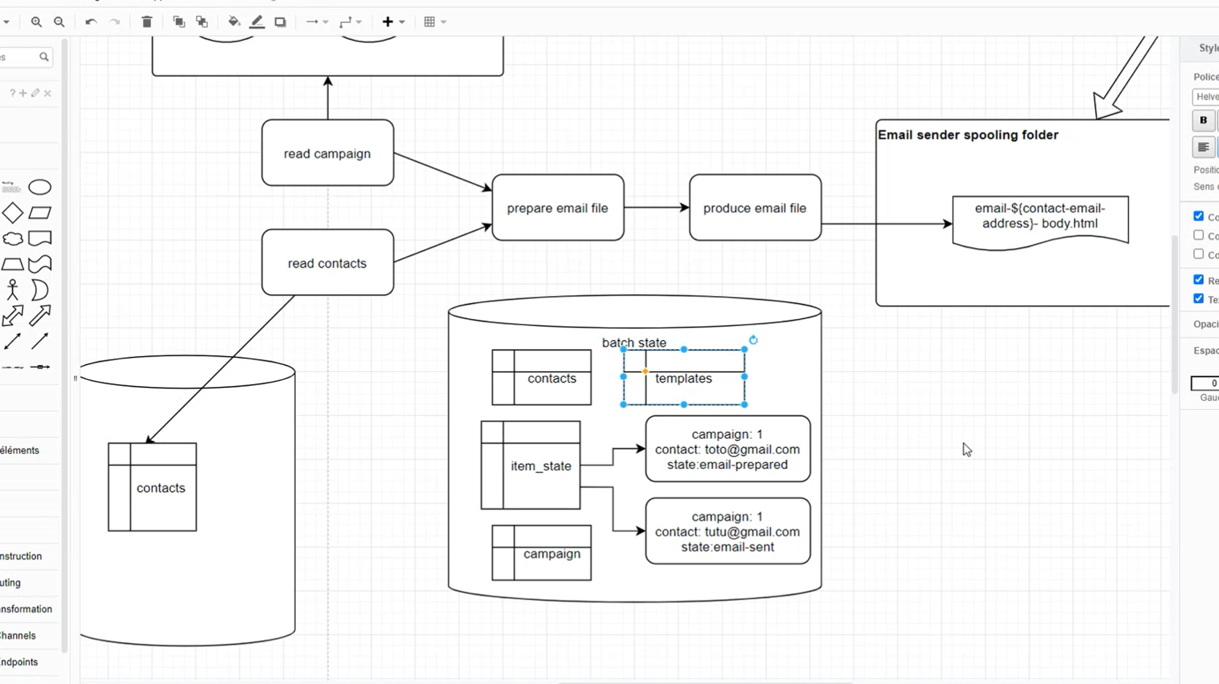

unexpected token: ) in statement [

SELECT contacts.contact_email, contacts.contact_first_name) FROM contacts INNER JOIN item_state ON item_state.contact_email = contacts.contact_email

]

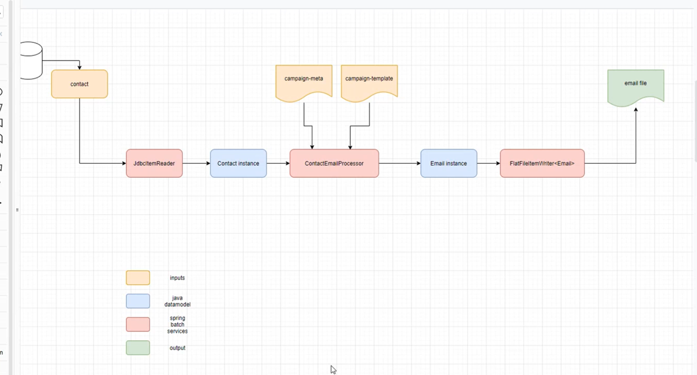

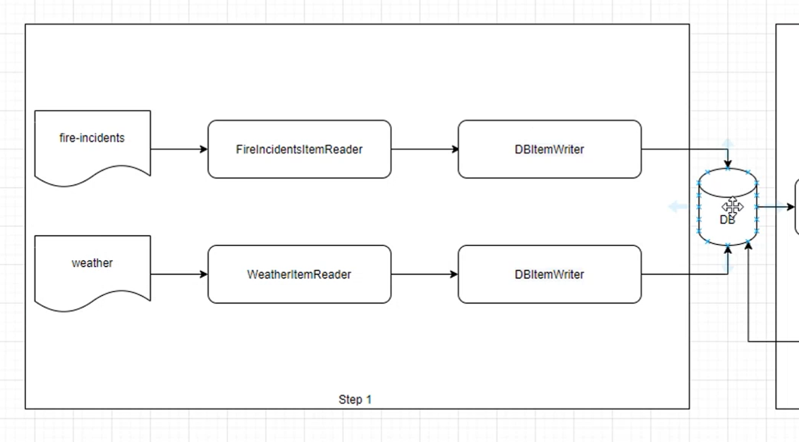

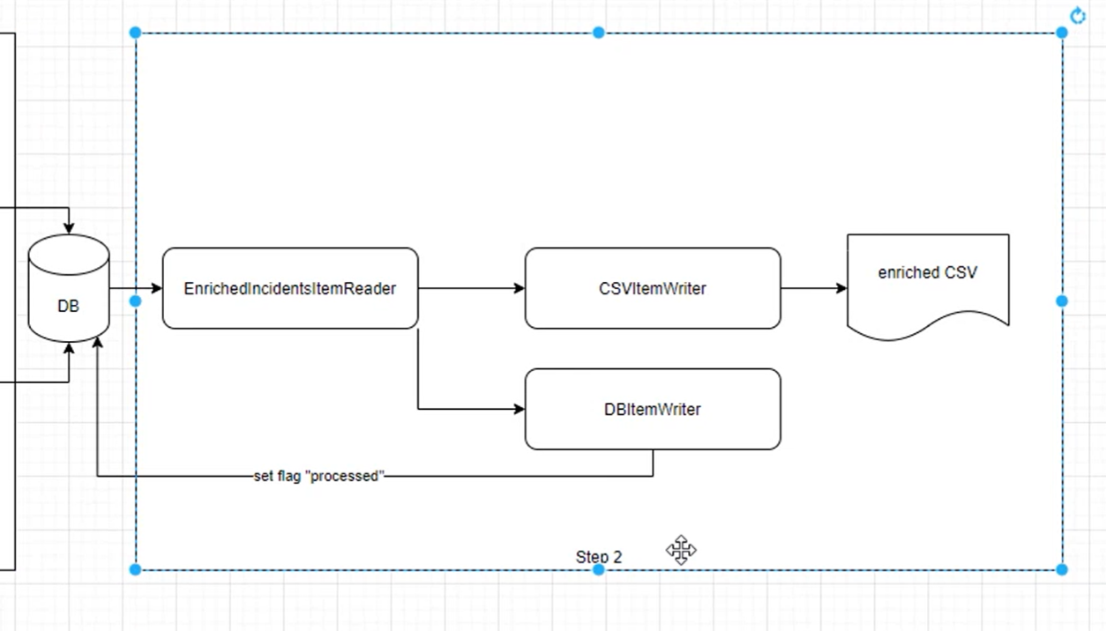

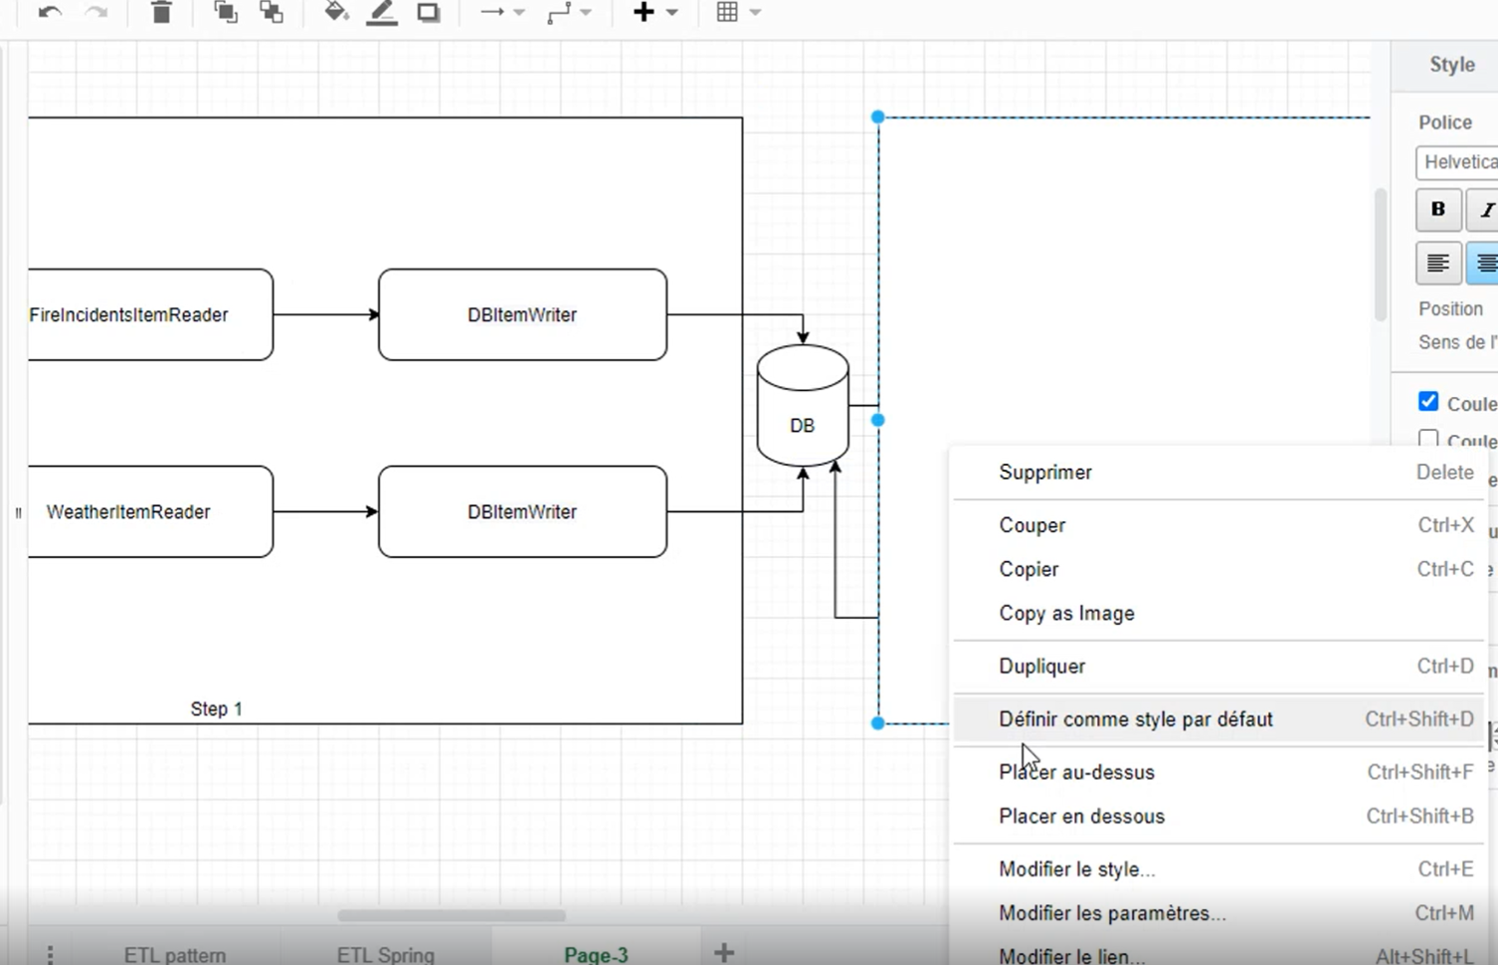

<https://docs.spring.io/spring-batch/docs/current/reference/html/job.html#runningAJob>

<https://docs.spring.io/spring-batch/docs/current/reference/html/readersAndWriters.html#itemReader>

java CommandLineJobRunner io.spring.EndOfDayJobConfiguration endOfDay \schedule.date(date)=2007/05/05 -vendor.id=123