Thi Lien KIM

[thi-lien.kim@epita.fr](mailto:thi-lien.kim@epita.fr)

**MOVIES PROJECT**

Table of Contents

**Instruction videos** 2

**Nodejs – Reactjs app** 2

**Java app** 4

**API Gateway – Authorization server** 5

**Instruction videos**

<https://drive.google.com/drive/folders/1MdIcQiDQwBLzSSBr88kGB5gHWsb9G4_G?usp=sharing>

**Nodejs – Reactjs app**

* Unzip movie_app_node_react.zip file.
* Or go to github link: <https://github.com/lienkt/movie_app_node_react>
* Open cmd and cd to movie_app_node_react\movie_node. Run “npm install” for Nodejs app. Then run “npm start”. Open <http://localhost:5000/> on Browsers.
* Open cmd and cd to movie_app_node_react\movie_react. Run “npm install” for Reactjs app. Then run “npm start”. Open <http://localhost:4000/> on Browsers.
* Login with admin account by [lienadmin@gmail.com/123](mailto:lienadmin@gmail.com/123)
* Login with user account by [lienuser@gmail.com/123](mailto:lienuser@gmail.com/123)
* This app uses only data from MongoDB:

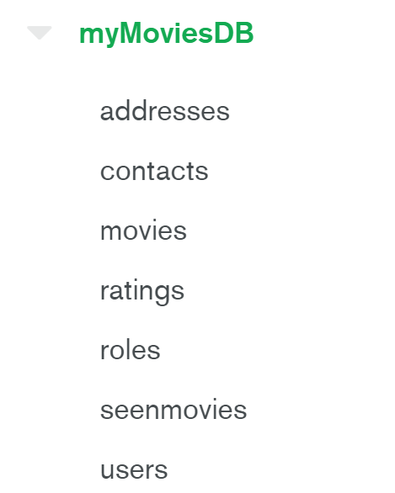

**Java app**

* Unzip movies_java.zip file.
* Or got to github link: <https://github.com/lienkt/movie_java>
* Run “maven install” for Java database app in movies-adv-java-lienkt folder. Then run by Junit to test the app.
* Run “maven install” for Springboost app in movies-adv-java-web-lienkt folder. Then run by java application in \src\main\java\fr\epita\movies\ MoviesApplication.java file to start the Tomcat server.
* Open <http://localhost:8080/> on Browsers.
* This app uses only data from PostgresSQL:



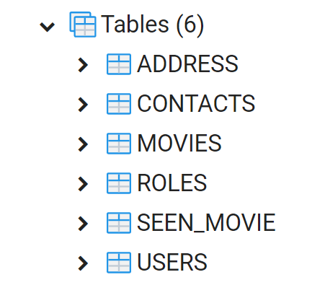

**API Gateway – Authorization server**

Open APIMAN in http://localhost:8080/apimanui

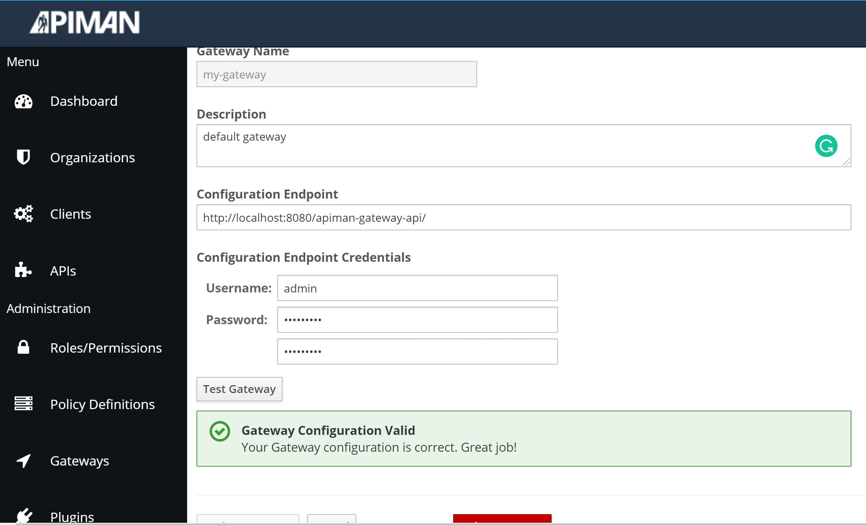

API: get movie

<http://localhost:8080/apiman-gateway/lienkt/get-movies/1.0>

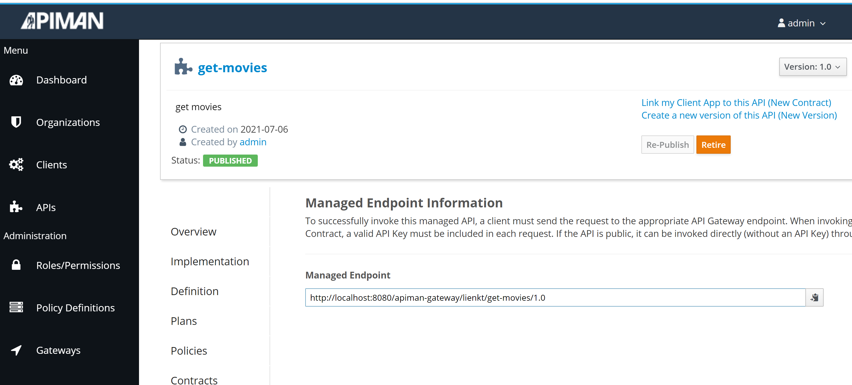

Create API:

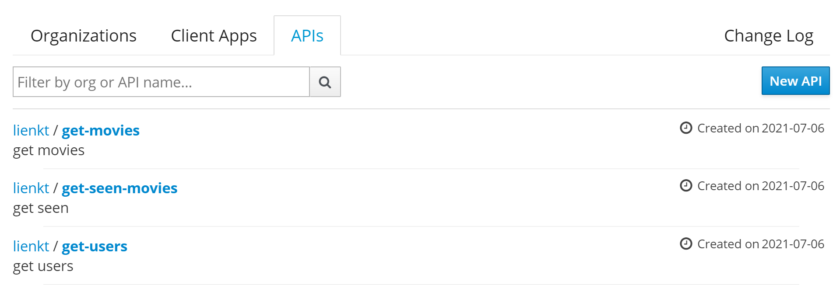

Then test the endpoint on Postman:

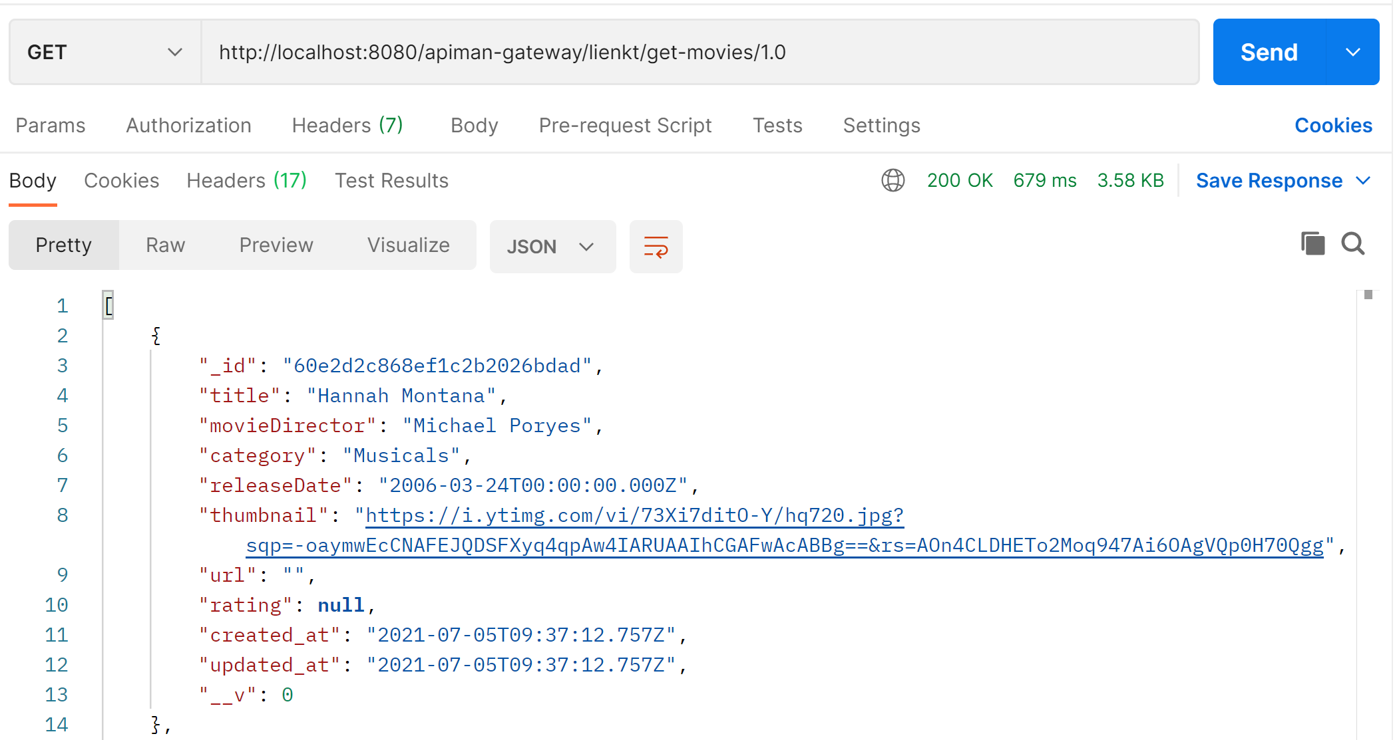

<http://localhost:8080/apiman-gateway/lienkt/get-users/1.0>

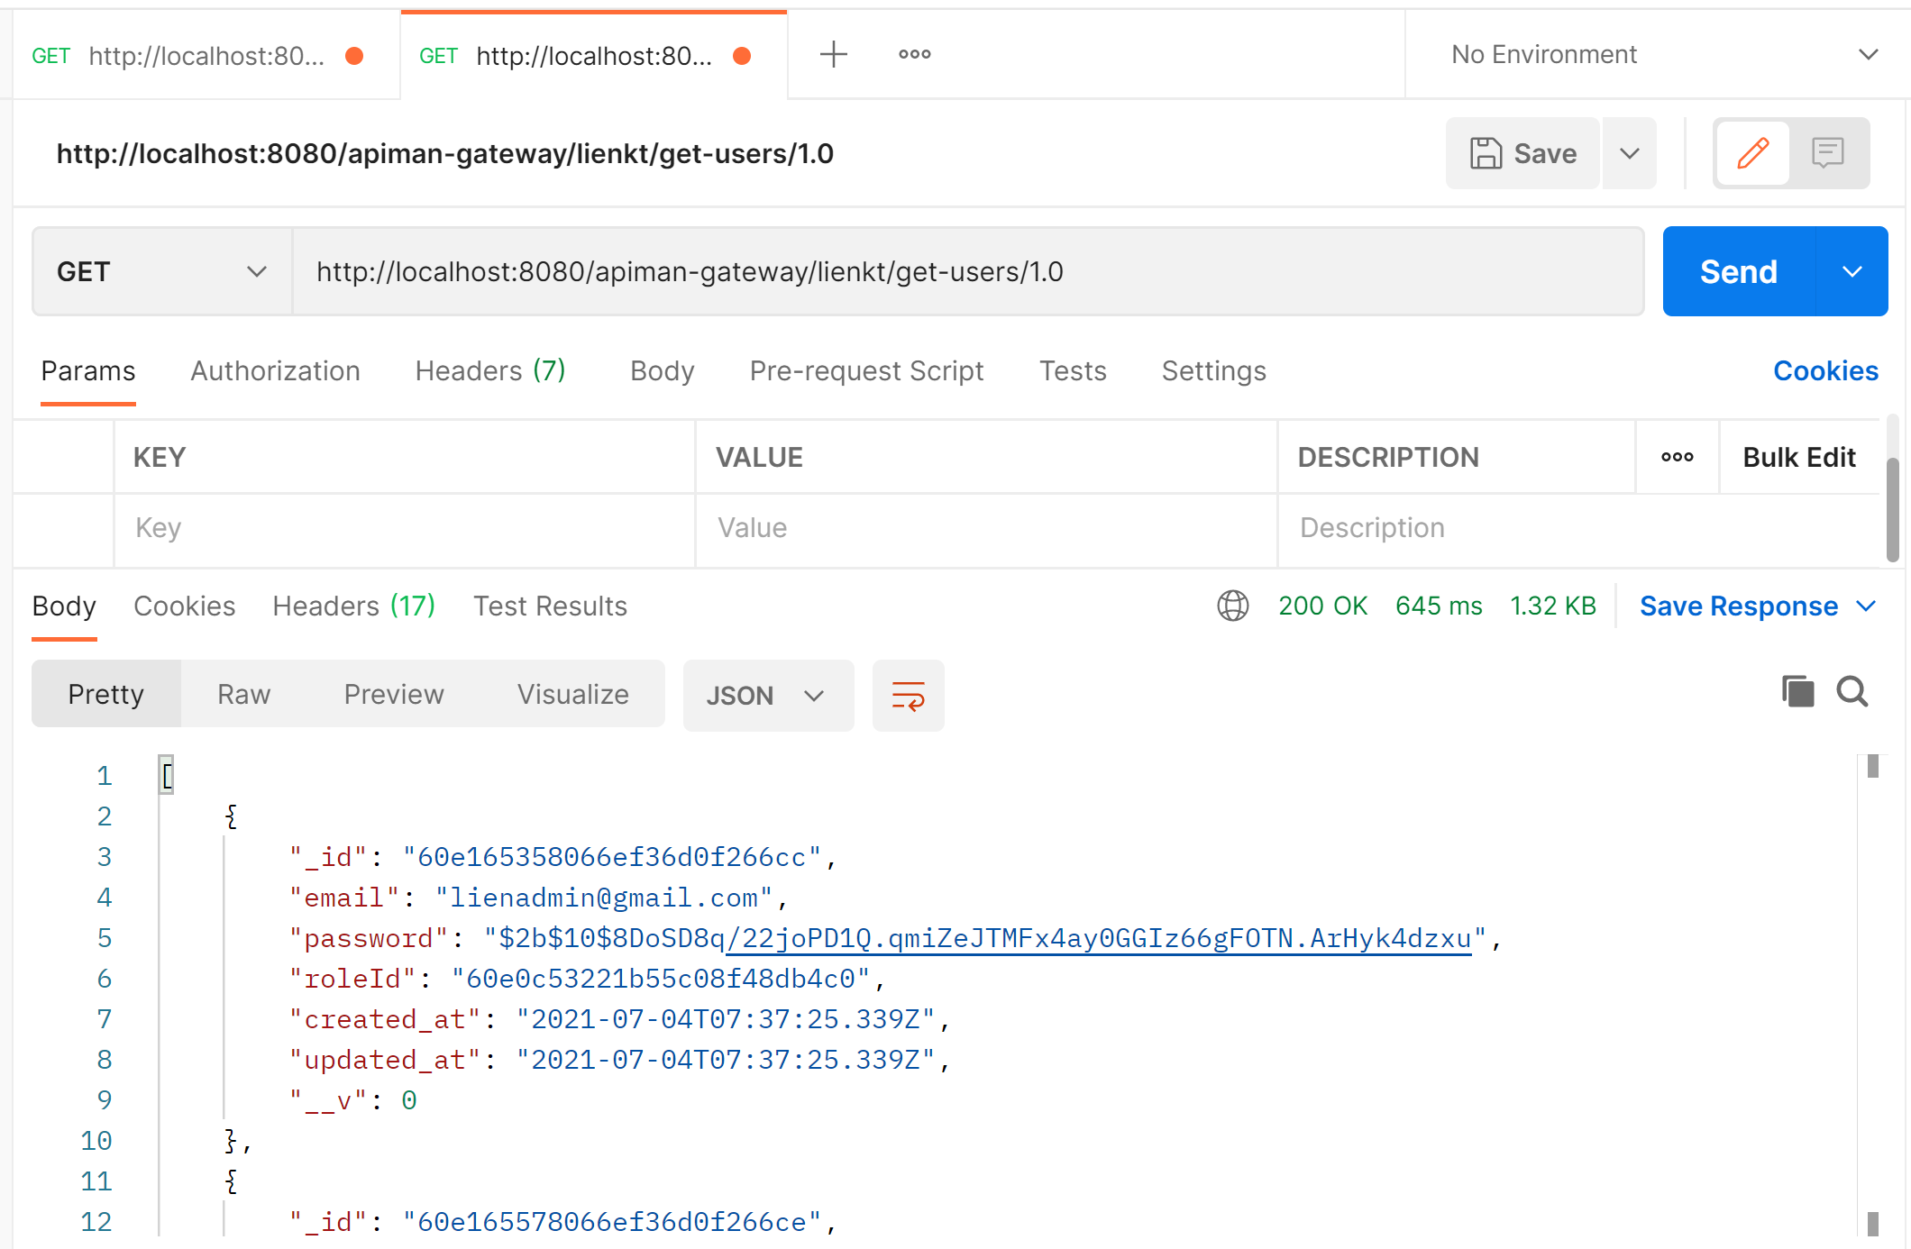

http://localhost:8080/apiman-gateway/lienkt/get-seen-movies/1.0

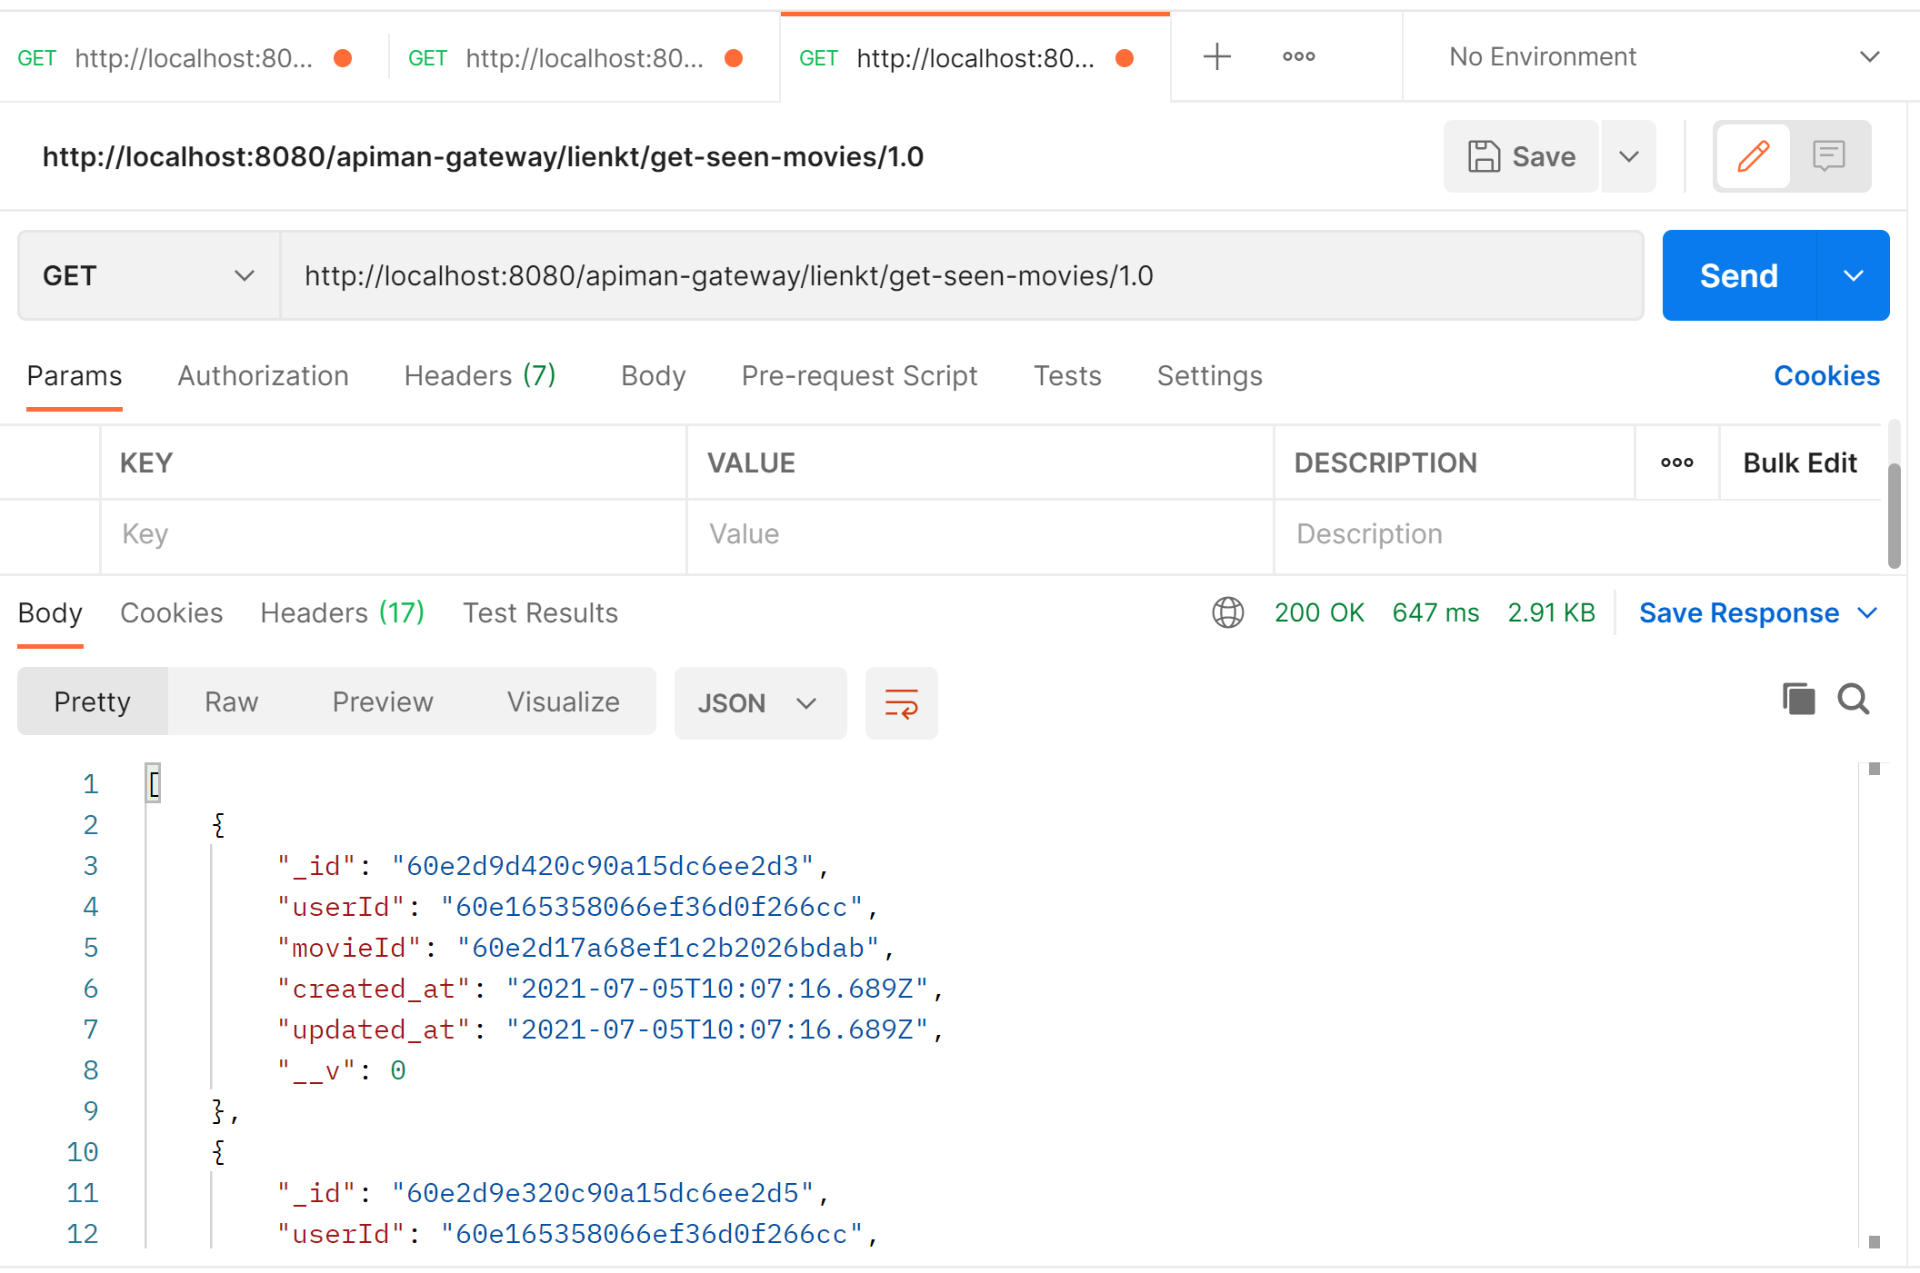

**Go to the Authorization server:**

http://localhost:8080/auth/

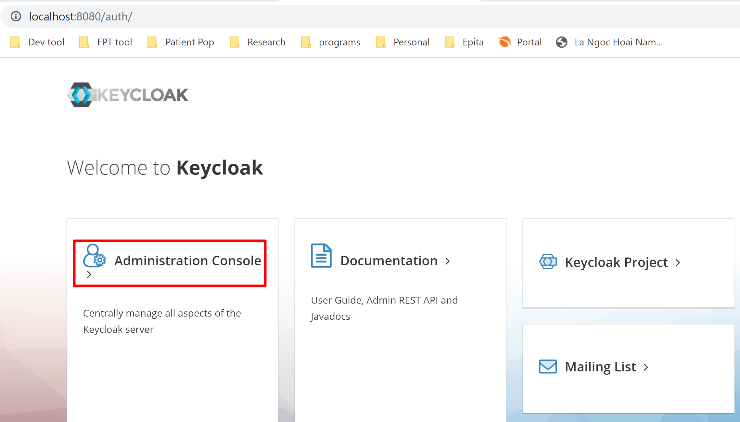

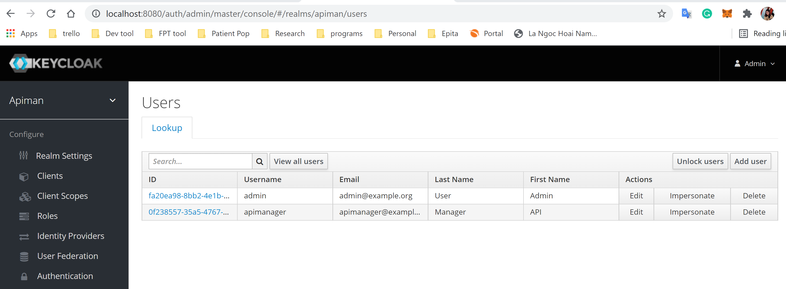

Go to Realm and open ID endpoint:

