

Bachelor of Computer Science (Hons)
Bachelor of Software Engineering (Hons)
Module Code: ITS66704 (Sept 2024)
Module Name: Advanced Programming
Assignment No./Title | Assignment Task 2 & Task 3 (Group Project)  15% (PART A - ANALYSIS AND DESIGN)  15% (PART B - DEVELOPMENT)
Course Tutor/Lecturer | Ts. Dr. Steve Teoh Chee Hooi
Submission Date | Week 09: 24/11/2024 (PART A - ANALYSIS AND DESIGN)  Week 12: 15/12/2024 (PART B - DEVELOPMENT)

Student Name, ID and Signature
1. Nur Aisya Shasmeen Binti Ruzaime Effendi (0356999)
2. Wong Chin Wen (0374047) Xena
3. Wong Li En (0374089) Lien

4. Tanuushre Vejayan (0357308) 
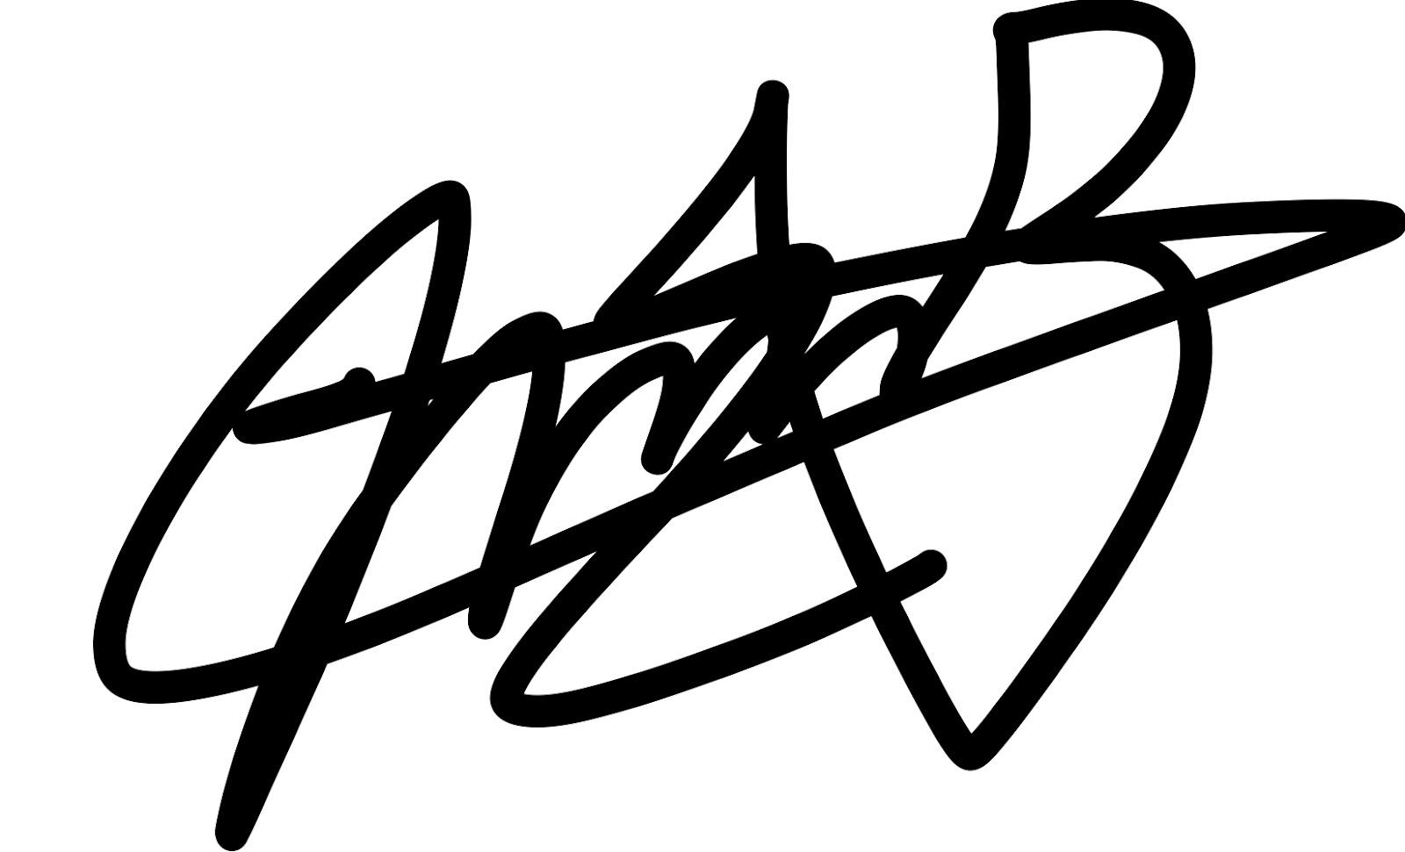
5. Kashfa Mirza Bhasha (0336176)
6. Homma Nanako (0370563)

Declaration (need to be signed by students. Otherwise, the assessment will not be evaluated)
Certify that this assignment is entirely my own work, except where I have given fully documented references to the work of others, and that the material contained in this assignment has not previously been submitted for assessment in any other formal course of study.
Marks/Grade: | Evaluated by:
Evaluator's Comments:
* Please include this cover page for your project submission

Link to Source Code:
ProjectPartBProgram_Group14

Table of Contents
1.0 Introduction 4
2.0 System Specifics 5
2.1 Core Functionality: User Profile and System Login 5
2.2 Fitness Goals 9
2.3 Exercise Logging 11
2.4 Nutrition and Diet Tracking 14
2.5 Progress Visualization 15
3.0 Data Access Objects (DAO) and Persistent Storage 16
3.1 Further Implementations for Data Storage 16
4.0 Features Not Implemented & Future Enhancements 18
4.1 The Connectivity Feature for Wearable Devices Has Not Been Implemented 18
4.2 SparkFit Does Not Include a Password Recovery Feature 18
4.3 Workout Plans Are Not Implemented in the Fitness Application 19
5.0 References 20
MARKING SCHEME – PART B 21

1.0 Introduction
SparkFit is a multifunctional application that is designed for women’s fitness. It provides the simplest ways to set and manage fitness goals in a healthy lifestyle, tailored to meet the needs of women. Even if users are beginners or looking for a fitness coach to improve their fitness levels, SparkFit is an application that can help them better. SparkFit provides users with essential and meaningful support and guidance for their health journey, helping them achieve success in their fitness goals.
The application has a user-friendly and customizable platform. It creates a multifunctional fitness feature for women. The app achieves real-time synchronization of fitness data, ensuring the accuracy of data. Besides that, it also emphasizes the importance of security for every user, aiming to build a safe fitness environment. SparkFit not only helps users to track their fitness progress accurately, it also provides some tools that help in improving the fitness experience of users. It allows users to grab the steering wheel of their own health journey with both hands.
The app contains five (5) core features such as User Profile, Exercise Logging, Nutrition and Diet Tracking, Fitness Goal Setting and also Progress Visualisation. With these features, users can integrate their fitness goals into their lifestyle. This will make the fitness journey easier, and the data stored in the app will serve as proof of the effort. Therefore, the features provided on the SparkFit application not only allow users to take the first step, but also ensure that they remain motivated throughout their fitness journey. The detailed description of the features successfully implemented in part B of the project.

2.0 System Specifics

2.1 Core Functionality: User Profile and System Login

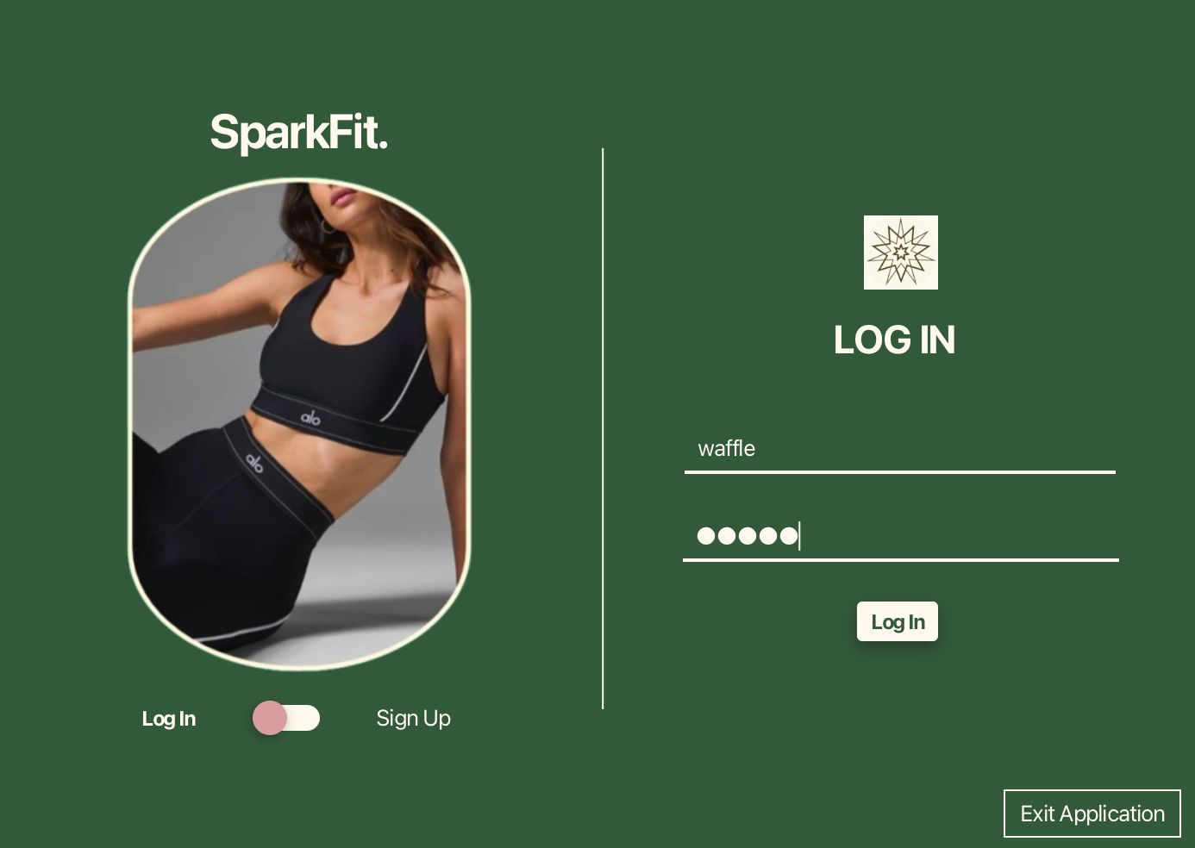
Figure 2.1.1: Login Page

Upon launching the application, users are greeted with the Login Page. This page is designed for existing users to access their accounts by entering their username and password. The interface is simple, featuring a minimalist design with the SparkFit logo prominently displayed at the top. If the user wishes to exit the application at any point, they can do so by clicking the Exit Application button located at the bottom right corner. Additionally, there is a toggle at the bottom left, allowing users to seamlessly switch to the Sign Up page if they do not have an account. This toggle is clearly labelled for ease of use, ensuring smooth navigation within the application.
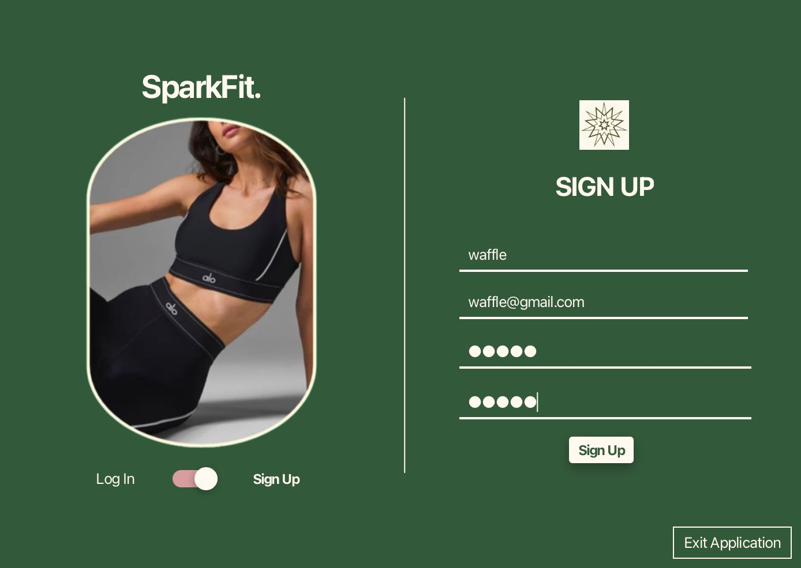
Figure 2.1.2: Sign-Up Page

If a user clicks the toggle to the Sign-Up Page, they are presented with a form to create a new account. This page allows users to input their name, email address, and a secure password. The form is accompanied by password fields that support the confirmation of the entered password for accuracy. The sleek and functional design aligns with the brand’s aesthetic, making the onboarding process user-friendly. Similar to the Login Page, the Exit Application button remains available at the bottom right corner for users who wish to leave the application. The inclusion of the toggle allows users to return to the login Page if needed, ensuring they can switch back easily without restarting the app.
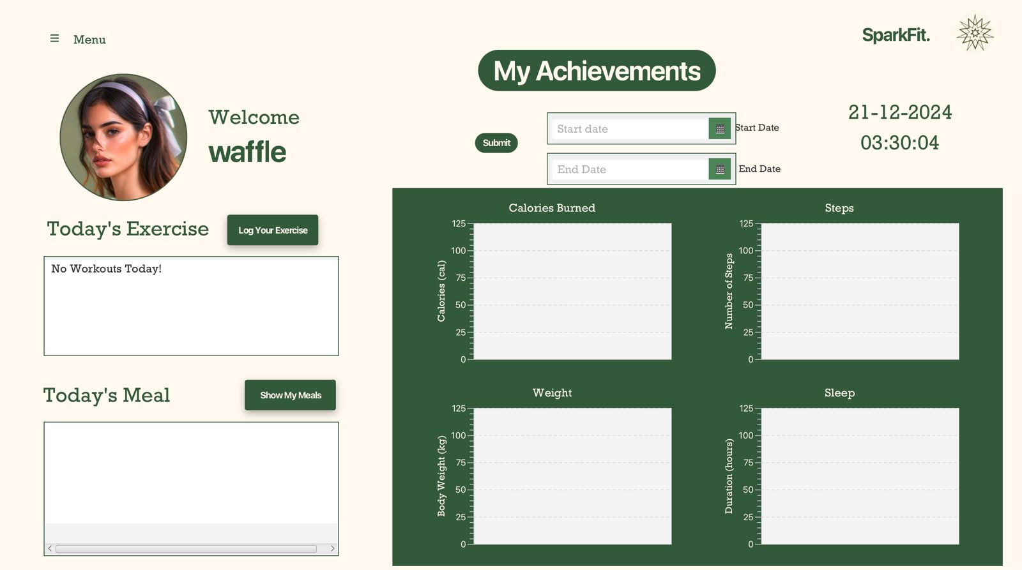
Image 2.1.3: User Home Page and Dashboard

After successfully logging in, users are redirected to their personalised dashboard. For new users, the dashboard initially appears empty, as no data has been logged yet. This page provides an overview of the application’s core functionalities, with options to log exercises, meals, and track progress.

A drop-down menu is accessible in the top-left corner, offering various navigation options such as “Home,” “Log Exercise,” “My Nutrition,” “Set Fitness Goal,” “Check Your Progress,” “My Profile,” and “Log Out.” This layout provides users with clear pathways to explore and utilise the app’s features, ensuring an intuitive user experience. The dashboard also displays key metrics, such as calories burned, steps taken, weight tracked, and sleep duration, motivating users to start inputting their data.

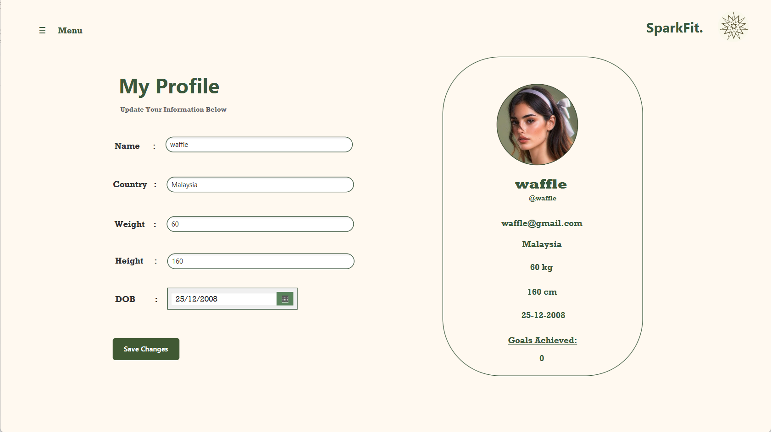
Figure 2.1.4: Profile Page

Selecting “My Profile” from the drop-down menu will direct users to their Profile Page, where they can customize their personal information. Users can input details such as their name, country, weight, height, and date of birth through clearly labelled text fields.

On the right-hand side of the page, users’ avatars or profile photos are displayed, accompanied by a summary of their information, including the number of their fitness goals achieved. This page acts as a central hub for personalising the user experience and keeping their profile up to date. Additionally, the “Save Changes” button is located at the bottom of the form, allowing users to securely update their profile details. This page maintains the clean, professional aesthetic consistent across the application, ensuring that users can manage their data effortlessly.

2.2 Fitness Goals
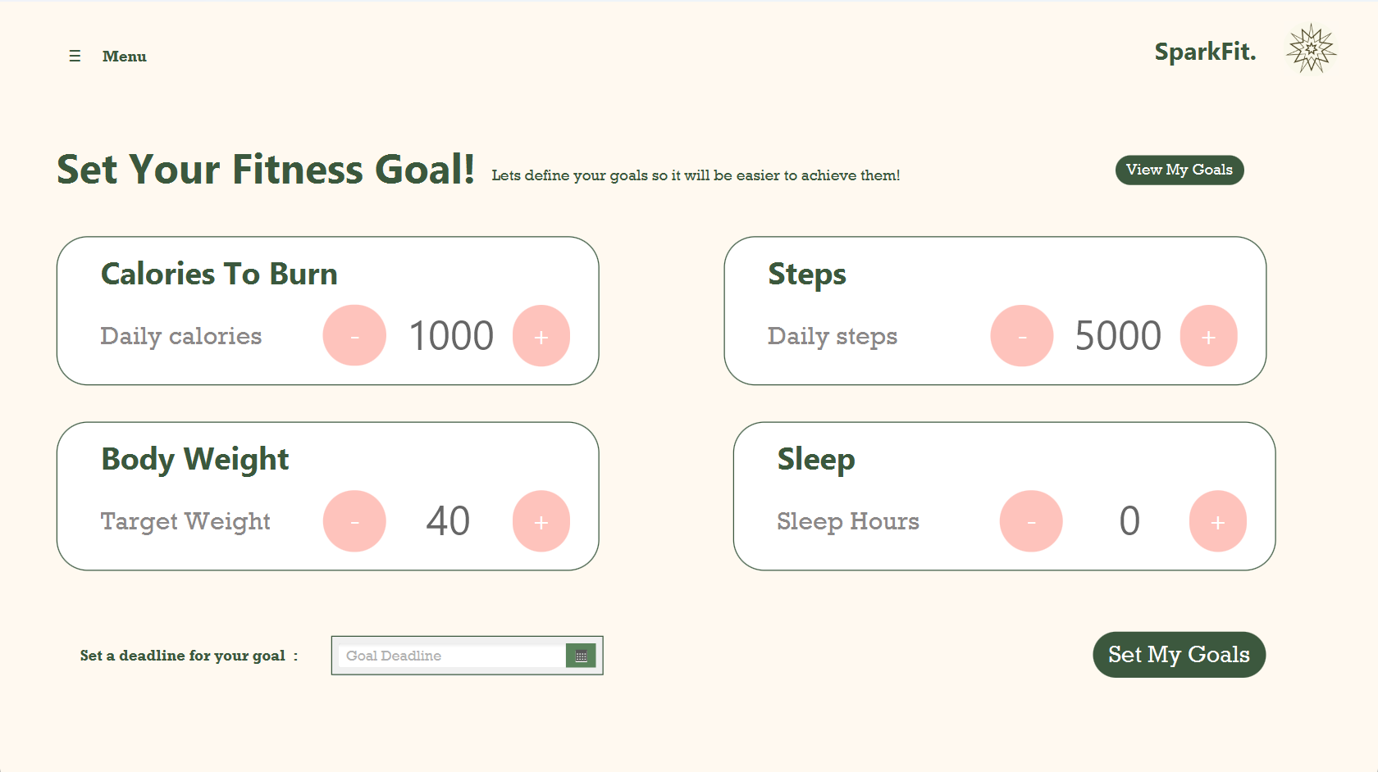
Figure 2.2.1: Set Your Fitness Goal

Here is the goals setting page. On this page, the user can define their fitness goals such as calories burned, steps taken, weight goals, and sleep duration. By clicking the - and + button the user can easily adjust and set their goals. The new implementation added from Assignment 1 is the goal deadline. After setting a fitness goal, the user will be able to click on the “Goal Deadline” button, which will open up a calendar in order to choose the preferred goal deadline easily. After the user has completed entering their fitness target digits, and then clicking the “Set My Goals” button, a "Goal Saved Successfully" message will pop up, confirming that the goal-setting process is complete.

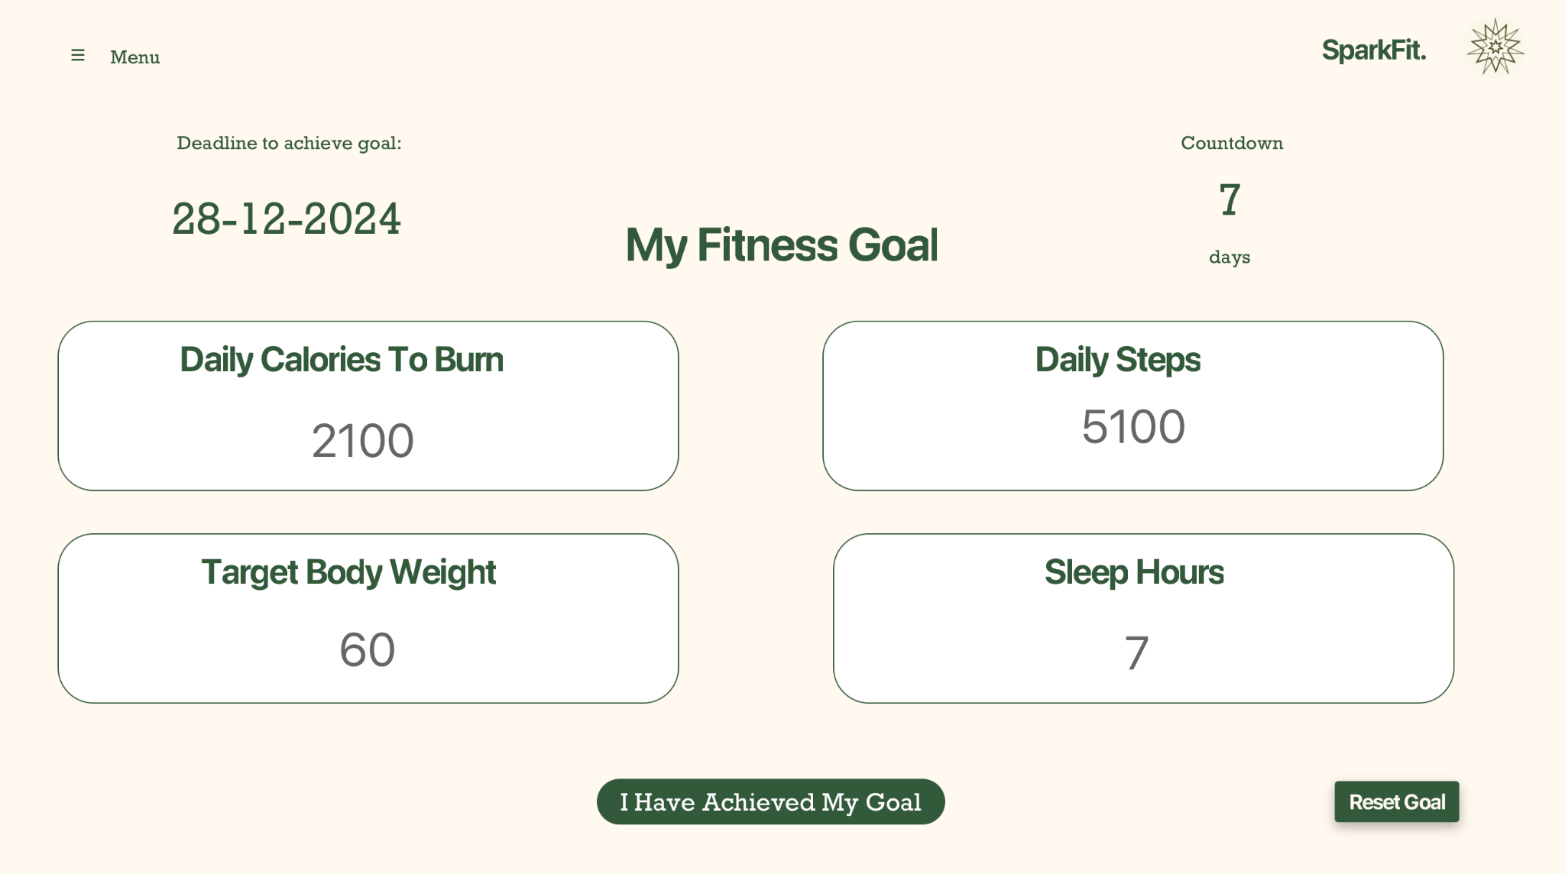
Figure 2.2.2: My Fitness Goal
After setting their goals, the user can check their fitness progress. The application will count down the days from the date set during goal creation, enabling the user to track how many days remain until their deadline. This feature helps users stay motivated and achieve their goals.
Once a goal is achieved, the user can click the "I Have Achieved My Goal" button, which will update the goal counter on their profile and allow them to set new goals.
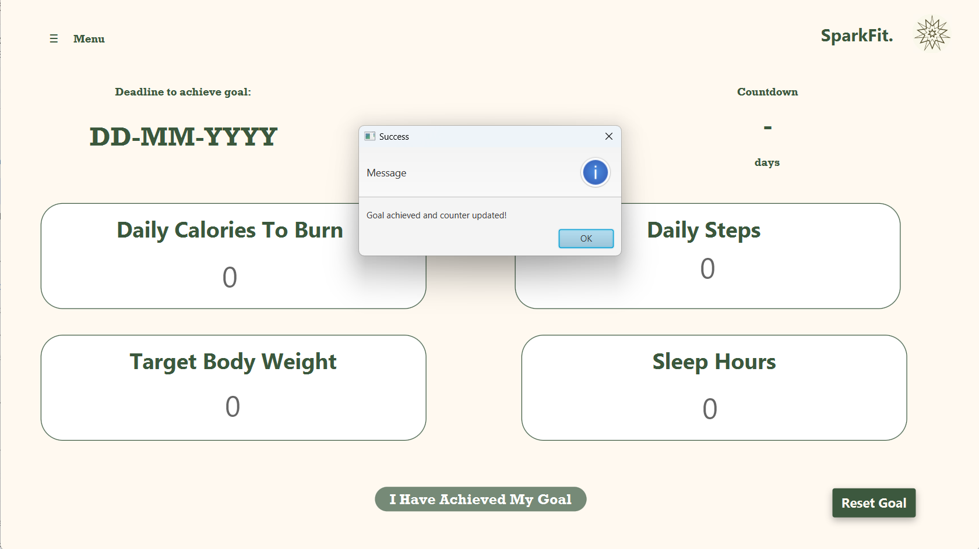
Figure 2.2.3 User Achieves Their Goal

2.3 Exercise Logging
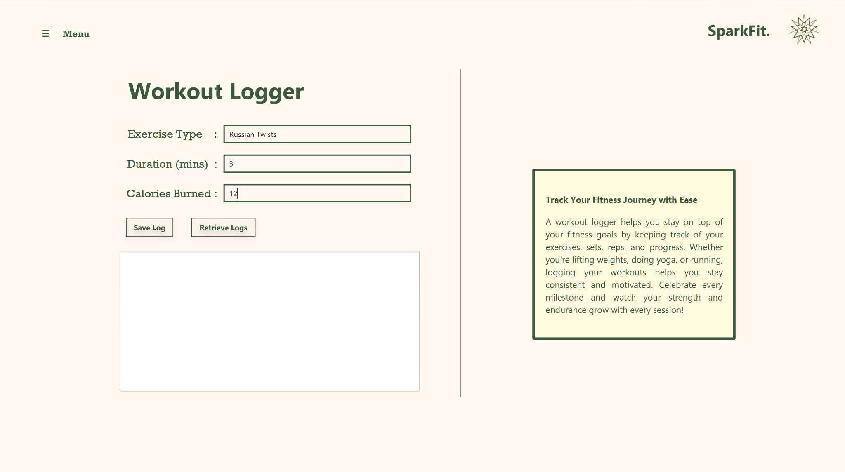
Figure 2.3.1: Workout Logger Page

The figure above (Figure 2.3.1), depicts the initial state of the Workout Logger user interface, designed for tracking fitness activities.This section prominently features input fields where users can enter relevant workout details. These fields include “Exercise Type,” where the name of the exercise (e.g., “Russian Twists”) is specified, “Duration (mins),” for logging the time spent on the exercise in minutes, and “Calories Burned,” for capturing the estimated caloric expenditure. Below the input fields, two buttons namely “Save Log” and “Retrieve Logs,” are aligned horizontally for user actions. The layout prioritizes clarity and simplicity, with fields organised vertically to enhance usability. Adjacent to the input section, the right-hand side contains an informational box titled “Track Your Fitness Journey with Ease.” This box offers motivational content, emphasising the importance of consistent workout logging to achieve fitness goals. Its positioning balances the page visually, ensuring that the functional input area on the left is complemented by engaging content on the right. The page uses a soft beige and green colour scheme, fostering a calming aesthetic that aligns with the fitness theme.
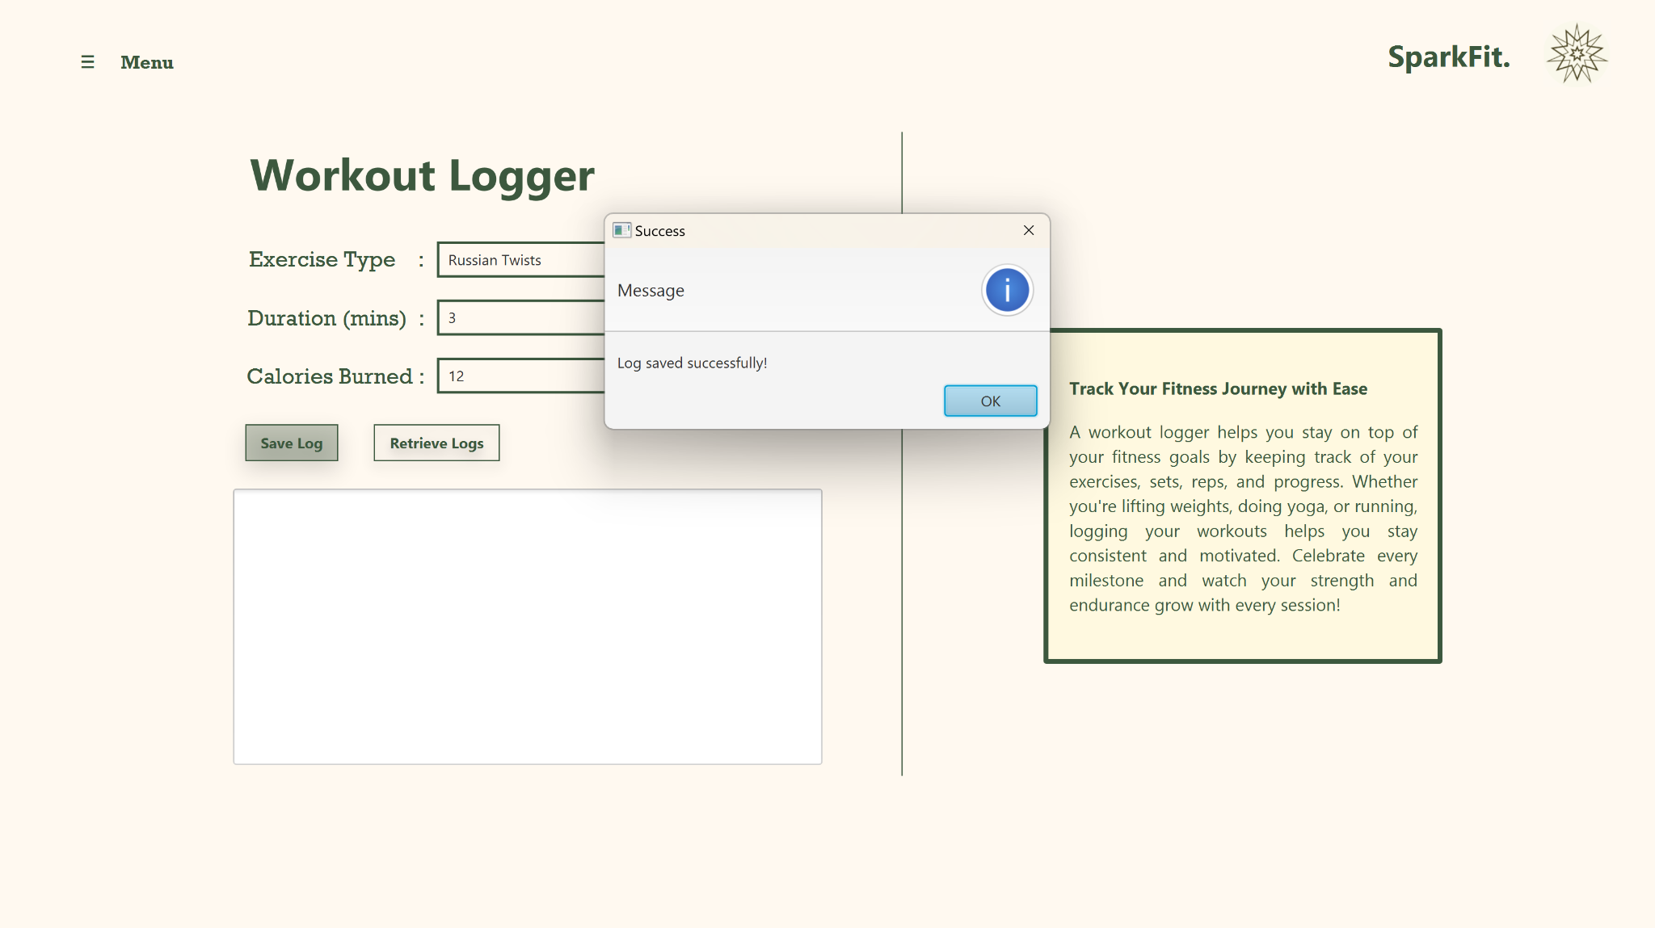
Figure 2.3.2: Workout Logger Page (Log saved successfully)

The figure above (Figure 2.3.2), showcases the confirmation feedback mechanism in the interface after a user action. Upon entering workout details and pressing the “Save Log” button, a pop-up dialog appears at the center of the screen with the title “Success” and the message “Log saved successfully!”. This modal serves as immediate feedback, confirming that the user’s input has been successfully saved. The dialog features a prominent “OK” button, allowing users to dismiss it and return to the main interface. This feature improves user experience by ensuring transparency and confidence in the system’s functionality. The rest of the interface remains unchanged, with the left section displaying the input fields and action buttons and the right-hand informational box maintaining its motivational content. This confirmation mechanism highlights a key principle of user-centric design by providing clear and timely responses to user actions.

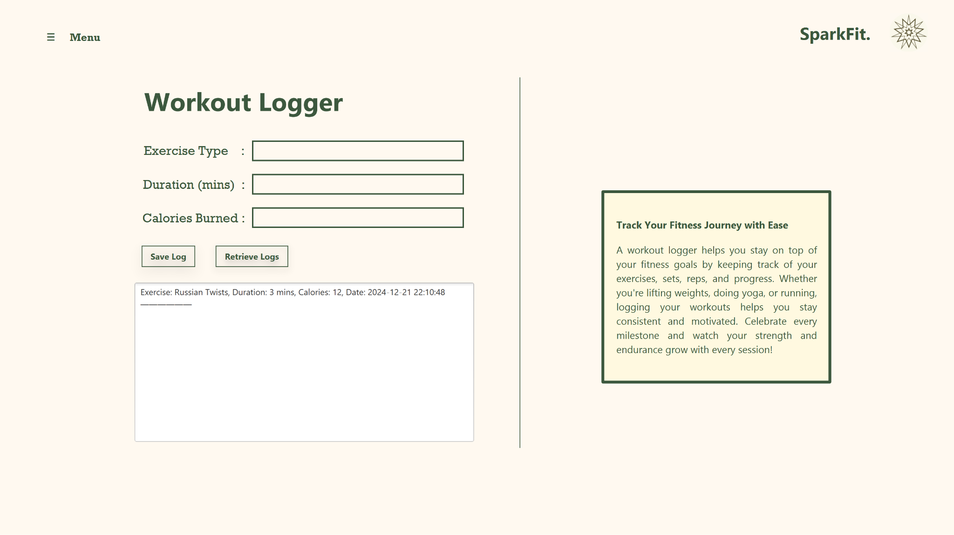
Figure 2.3.3: Workout Logger Page (Retrieved Logs)

The figure above (Figure 2.3.3), illustrates the state of the interface after the user retrieves saved workout data. Upon clicking the “Retrieve Logs” button, the entered log details are displayed in a text area below the action buttons. The retrieved log includes details such as the exercise type (“Russian Twists”), duration (3 minutes), calories burned (12), and a timestamp of when the data was logged. This output area is strategically positioned directly beneath the input fields to ensure a logical flow of interaction, where users can quickly view their stored data without navigating away from the input section. After retrieving the logs, the input fields above are cleared, preparing the interface for new entries. This right-hand informational box remains static, continuing to provide motivational and educational content. This design choice ensures that the primary focus remains on the user’s interaction with their workout data while still encouraging consistency in tracking their fitness journey.

2.4 Nutrition and Diet Tracking
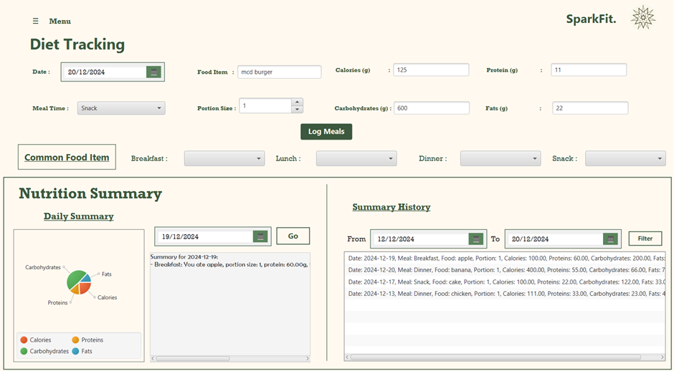
Figure 2.4.1: Diet Tracking Page
This interface is designed to track user daily nutrition and diet data. The main function of the interface is to allow users to enter and track their daily diet data. The user should select the date of the day, the meal time (breakfast, lunch, dinner or snack). At the same time, users should also fill in the name of the food, portion size, and the nutrients that are contained in the food. Once the user completes the input and clicks the “Log Meals” button, the system will save the user data for future analysis. In addition, the interface includes a “Common Foods Item” section that provides examples of various types of meals. Users can refer from these examples for more efficient daily meal planning.
The interface provides a “Nutritional Summary” function, which allows the user to view nutritional summary based on the specific date. By selecting the date, the system will display a pie chart that contains the proportion of calories, carbohydrates, proteins and fats that have been taken in a day. This helps users quickly understand their nutritional distribution. Next to the pie chart, it will have a list of the diet details that are taken in by the user on that day. It presents a clear picture of the user's diet for the day.
The interface also has a “Summary History” function, which allows users to check their diet records for a specific period of time by filtering the start and end dates. This feature helps users to keep track of their long-term eating habits and better manage their health goals.

2.5 Progress Visualization
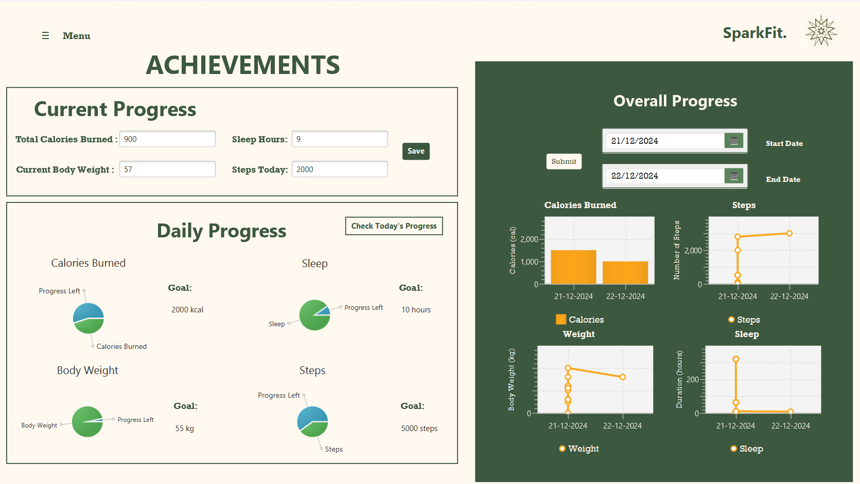
Figure 2.5.1: Achievements Page

According to the figure above (Figure 2.5.1), the Achievements page consists of two main features that enable users to track their daily and overall performance in areas such as calories burned, body weight, sleep duration, and steps taken. Users can key in and save their daily metrics (calories burned, current body weight, sleep hours and steps taken). In doing so, pie charts will be generated based on the real-time metrics and fitness goals accordingly, monitoring daily progress for each category. Furthermore, to visually monitor overall performance periodically, users can customize the data view by selecting their desired start and end dates, allowing charts (bar charts and line graphs) to be created based on the chosen time period and fitness metrics.

3.0 Data Access Objects (DAO) and Persistent Storage

The table below outlines relevant files we used to store user data, their workout logs, nutrition logs, their user profile data as well as information on their fitness goals.

File Name | Description | Binary/Text File
user_data.dat | Saves user’s username, email and password | Binary
user_goals.txt | Saves data on users’ fitness goal | Text
user_profile.txt | Saves data on user’s personal information | Text
workout_logs.dat | Saves workout logs (in binary) | Binary
workout_logs.dat | Saves workout logs (in text) | Text
meals.txt | Saves data on recorded meals, time and date of meal taken, total calories taken, etc. | Binary
daily_progress.txt | Saves data on the user’s daily progress | Text

3.1 Further Implementations for Data Storage
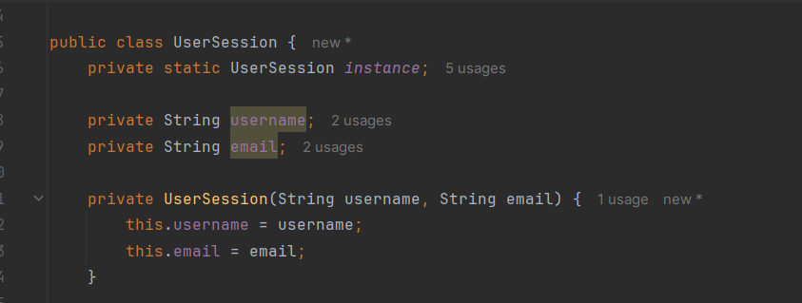
Figure 3.1.1: Excerpt of Code from UserSession Class

A UserSession Class was implemented to manage users that logged in and their sessions. Data such as workout logs, fitness foals and user profile information will also be saved according to the user that is logged in to the current session

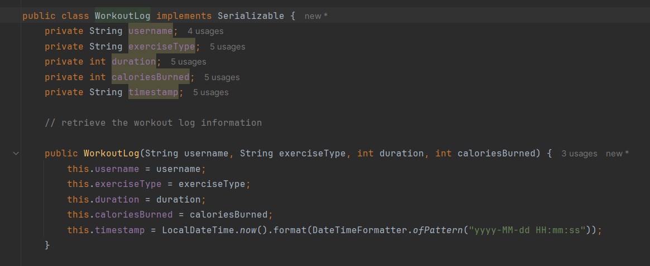
Figure 3.1.2: Excerpt of Code from Serializable WorkoutLog Class

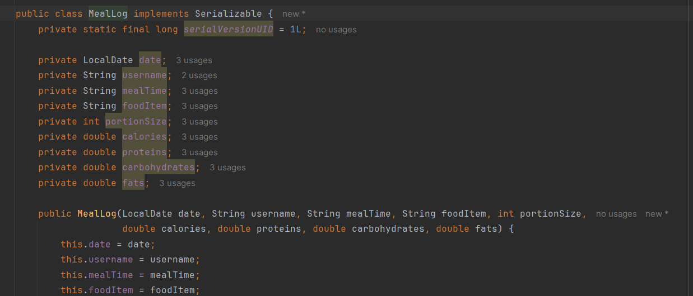
Figure 3.1.3: Excerpt of Code from Serializable MealLog Class

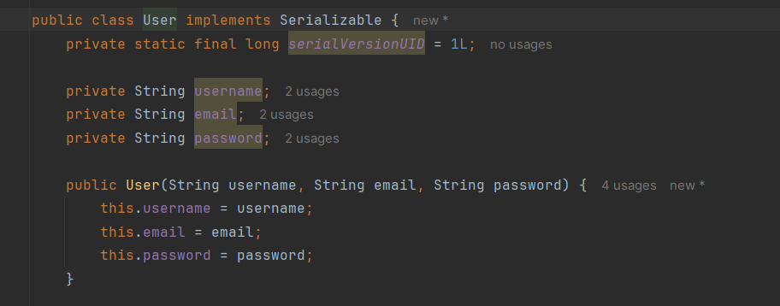
Figure 3.1.4: Excerpt of Code from Serializable User Class

Using Serializable Classes allows the data objects to be converted into streams of bytes when they are written into their respective files. This ensures the data is encrypted, providing better security for potentially sensitive information.

4.0 Features Not Implemented & Future Enhancements
Although significant progress has been made, there are a few areas, such as the absence of wearable device integration feature, password recovery feature and exercise plans, that require attention to improve overall performance and efficacy of the application.

4.1 The Connectivity Feature for Wearable Devices Has Not Been Implemented
Wearable devices are smart technologies that are integrated into accessories and clothings, using sensors to collect real time user data, such as movements and heart rate (Repsol, n.d.). Their functionality, versatility, lightweight design and stylish appearance, offer unmatched convenience for today’s modern lifestyle. According to Research Nester (2024), the smart wearable devices market size was valued at around USD 82.93 billion in 2024, and is forecasted to reach over USD 946.73 billion by the end of 2037, reflecting a compound annual growth rate (CAGR) of more than 20.6% from 2024 to 2037. This shows that a distinct increase in the population is expected to adopt wearables into their daily lives. Moreover, the adoption of wearables into workout routines is rising rapidly due to their flexibility and convenience in collecting, tracking and managing personal data and activity. Hence, the integration with wearable devices into the fitness application is inevitable to address market demands.

4.2 SparkFit Does Not Include a Password Recovery Feature
A password recovery feature provides users with the ability to regain access to their account if they forget their password. One major reason for recovering a password is due to forgetfulness. Based on a survey gathering feedback from 1,450 respondents, approximately half of them reset a password at least once a month as they cannot remember it (Entrust, 2024). Without a password recovery tool, users would not be able to access their account and data if they forgot their password. This would lower the user experience as significant data would be lost permanently. Hence, a password recovery mechanism should be added into the application. A solution such as receiving verification codes through email can be used to double-check a user’s identity, ensuring security when renewing user password (PC Laptops, n.d.).

4.3 Workout Plans Are Not Implemented in the Fitness Application
Curated exercise plans offer a wide variety of workout routines such as aerobics, high-intensity interval training (HIIT) and bodyweight exercises, that come in different levels (beginner, intermediate and advanced). According to Pratt (2023), the listed best workout apps such as Nike Training Club, FitOn and Apple Fitness Plus, include workout plans that specialize in different aspects. For this reason, the inclusion of this feature is now a conventional standard. Furthermore, this would improve user experience as they can customize their exercise plans according to their circumstances. For example, they can work out at home, at the gym, or even outdoors, offering the flexibility to choose what best fits their schedule and preferences. To keep up with market trends and increase usability, SparkFit should introduce pre-designed fitness plans into the application.

In conclusion, a connectivity feature for wearable integration, password recovery feature and pre-designed workout plans, should be added into the fitness application for future improvements. These improvements can enhance user experience and optimize usability.

5.0 References

- Entrust. (2024, April 2). The future of identity: Exploring trends, challenges, and solutions. Entrust. Retrieved December 21, 2024, from https://www.entrust.com/sites/default/files/documentation/reports/csi-future-of-identity-re.pdf?la=en&hash=AC8375292688DC14AB8F82D7A7F42B77
- PC Laptops. (n.d.). SMS codes and two-factor authentication: What you need to know. PC Laptops. Retrieved December 21, 2024, from https://www.pclaptops.com/blog_post/blog/110.html#:~:text=SMS%20Codes,field%20to%20reset%20the%20password.
- Pratt, M. (2023, December 13). The best workout apps to crush your fitness goals. CNET. Retrieved December 21, 2024, from https://www.cnet.com/health/fitness/best-workout-apps/
- Repsol. (n.d.). Wearable technology: What is it and how does it work? Repsol. Retrieved December 21, 2024, from https://www.repsol.com/en/energy-and-the-future/technology-and-innovation/wearable-technology/index.cshtml
- Research Nester. (2024, October 22). Smart wearable devices market: Global demand analysis and opportunity outlook 2035. Research Nester. Retrieved December 21, 2024, from https://www.researchnester.com/reports/smart-wearable-devices-market/5935
- Stadnik, M. (2024, June 19). UI/UX Design Principles and Best Practices Fitness Apps Should Know. [Web log message]. Retrieved from https://easternpeak.com/blog/fitness-app-design-best-practices/

MARKING SCHEME – PART B

Item | Marks
Creativity and Originality | /4
System specific:
i) Core functionality - User profile, system login & authentication | /4
ii) Fitness Goals | /2
iii) Exercise Logging | /2
iii) Exercise Logging | /2
v) Progress Visualization | /2
Data Access Objects (DAO) and persistent storage | /2
UI Design and Interface Esthetics | /4
Working program and functionality | /4
Source code - proper variable name, indentation & comments | /2
Proper submission, file organization and documentation | /2
TOTAL | /30

