TAYLOR’S UWE DUAL AWARDS PROGRAMMES
APRIL 2024 SEMESTER(ITS62904)
DATABASE SYSTEMS ASSESSMENT 3
(GROUP ASSIGNMENT) 30%
DUE DATE:12/07/2024, 6:00pm
STUDENT DECLARATION:
- I confirm that I am aware of the University’s Regulation Governing Cheating in a University
Test and Assignment and of the guidance issued by the School of Computing and Engineering (SCE) concerning plagiarism and proper academic practice, and that the assessed work now submitted is in accordance with this regulation and guidance.
- I understand that, unless already agreed with the School of Computing and Engineering (SCE), assessed work may not be submitted that has previously been submitted, either in whole or in part, at this or any other institution.
- I recognize that should evidence emerge that my work fails to comply with either of the above declarations, then I may be liable to proceedings under Regulation.

GROUP NAME:
No. | Student Name | Student ID | Date | Signature | Score
1 | Xu Jing | 0372834 | 07/10/2024
2 | Tian Xinyu | 0373276 | 07/10/2024
3 | Wong Chin Wen | 0374047 | 07/10/2024 | Chin Wen
4 | Woo Xuan Zhi | 0352185 | 07/10/2024 | Xuan Zhi
5 | Teoh Jian Yang | 0359042 | 07/10/2024 | Ben
6 | Wong Li En | 0374089 | 07/10/2024 | Li En
7 | Vincent Tee Win Sum | 0373292 | 07/10/2024 | 
Table of Contents
- WORK PLANS AND TASK ALLOCATION……………………………………………………3
- INTRODUCTION………………………………………………………………………………....4
- DESIGN
  - ENTITY-RELATIONSHIP DIAGRAM(ERD)
  - PHYSICAL MODEL
  - ENHANCED ENTITY-RELATIONSHIP DIAGRAM(EER)
- DEPLOYMENT
  - CREAT DATABASE
  - CREAT TABLE FOR MEMBERS
  - CREAT TABLE FOR
  - CREAT TABLE FOR FRIENDS
  - CREAT TABLE FOR REFERRAL
  - CREAT TABLE FOR ATTENDANCE
  - CREAT TABLE FOR
  - CREAT TABLE FOR
  - CREAT TABLE FOR
  - CREAT TABLE FOR
  - CREAT TABLE FOR
  - CREAT TABLE FOR
  - CREAT TABLE FOR
  - CREAT TABLE FOR
  - CREAT TABLE FOR
  - CREAT TABLE FOR
  - CREAT TABLE FOR
  - CREAT TABLE FOR
  - ACTION OUTPUT FOR ALL THE TABLES
- SQL REPORT
- ANALYSING DATABASE STRUCTURES AND DESIGNING REPORTS
- UNFORSEEN CHALLENGES
- CONCLUSION AND SELF-REFLECTION
- REFERENCE LIST

1.0 WORK PLANS AND TASK ALLOCATION
Table 1. Work Plan for Task Separation
Student Name | Student ID | Task Description
Xu Jing | 0372834 | -Make the physical model (Part A)  -Create tables for members, reservation, social media (Part B)  -Answered Question 14 (Part C)  -Make a report (Part D)  - Participated and contributed in video making (Part E)  -Conclusion
Woo Xuan Zhi | 0352185 | - Participated and contributed in video making (Part E)  - Created tables for friends, referrals, and attendance  - Adjusted and labelled relationships (Part A)
Wong Chin Wen | 0374047 | -Make EER (Part A）  -Contribute in the database design (Part A）  -Create table for Equipment, Merchandise, and UsesClass_Equipment (Part B）  -Answered Question 7 and 8 (Part C）  -Described unforeseen challenges (Part E)  - Participated and contributed in video making (Part E)
Wong Li En | 0374089 | - Make EER (Part A)  - Contribute in the database design (Part A）  - Create table for Equipment Rentals, Point System, Brand Affiliation, Manager, Employee, Instructors and Class (Part B)  - Answer Question 5 and 6 (Part C)  - Participated and contributed in video making (Part E)  - Described unforeseen challenges (Part E)
Teoh Jian Yang | 0359042 | - Make and adjusted Entity-Relationship Diagram Part (A）  - Contributed in database design (Part B)  - Made SQL tables for packages, join, personal trainning session  - Answered question 9 and 10 (Part C)  - Participated and contributed in video making (Part E)
TIAN XINYU | 0373276 | -Make the physical model (Part A)  -Create tables for members, reservation, social media record (Part B)  -Made a report B and C  -Introduction report  -Shoot and edit video
VINCENT TEE WIN SUM | 0373292 | -Make physical model (Part A)  -Created tables for vip benefits, membership options, discounts, individual, family plan and exclusive classes (Part B)  -Answered Question 12 and 13 (Part C)  -Participated in video shooting. (Part E)

2.0 INTRODUCTION
The swift development of the fitness and wellness sectors demands the adoption of sophisticated management systems to improve member experience and operational effectiveness. The main goal of this project is to create an extensive database system for a Chicago-based fitness facility. Aside from fitness classes, equipment rentals, and personal training sessions, the fitness facility offers a wide range of services under two different brands: "Silver Sneakers" for seniors and "Fit & Fab" for young adults.

The database system has a complex point system to encourage member involvement in addition to streamlining the administration of members, classes, equipment, and teachers. Online registration, reservations for classes and equipment, attendance monitoring, and comprehensive reporting options are some of the key features. The system is designed to handle complex membership structures, including individual and family plans, VIP memberships, and referral programs.
The system must be able to adapt to changes in business processes, such as tracking trainer revenue, storing comprehensive member contact information, and projecting revenue, in order to meet the ever-changing needs of the fitness facility. To further increase functionality, the design team has proposed two new features that will be added to the system.
This project calls for the following crucial tasks:

Design: To precisely map the relationships and data requirements, create an Entity-Relationship Diagram (ERD), Physical Model, and Enhanced Entity-Relationship Diagram (EER).
Deployment involves putting the database into use, adding sample data to the tables, and making that the data is accurate and consistent.
SQL reporting: creating SQL queries to provide informative reports on member activity, equipment rentals, package sales, and attendance in class.
Analysis and Reporting: Creating reports with comprehensive information for the fitness facility requires an analysis of the database structure.
Managing Unexpected Difficulties: Developing marketing materials to draw in new members and modifying the database to accept new products, including outdoor exercise bootcamp programs.
The project's goal is to provide a scalable and reliable database system that boosts the fitness center's operational effectiveness and greatly enhances the member experience by carefully completing these duties.

- DESIGN
  - ENTITY-RELATIONSHIP DIAGRAM(ERD)

Map the entities with appropriate relationships:

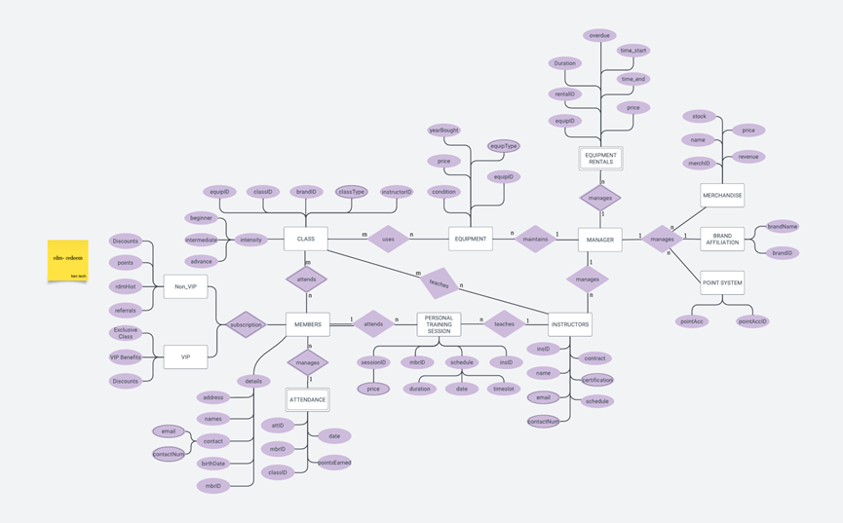
Figure 3.1.1 ERD

  - PHYSICAL MODEL

Provide the necessary information for the Model (Relational Model – ensure data integrity):

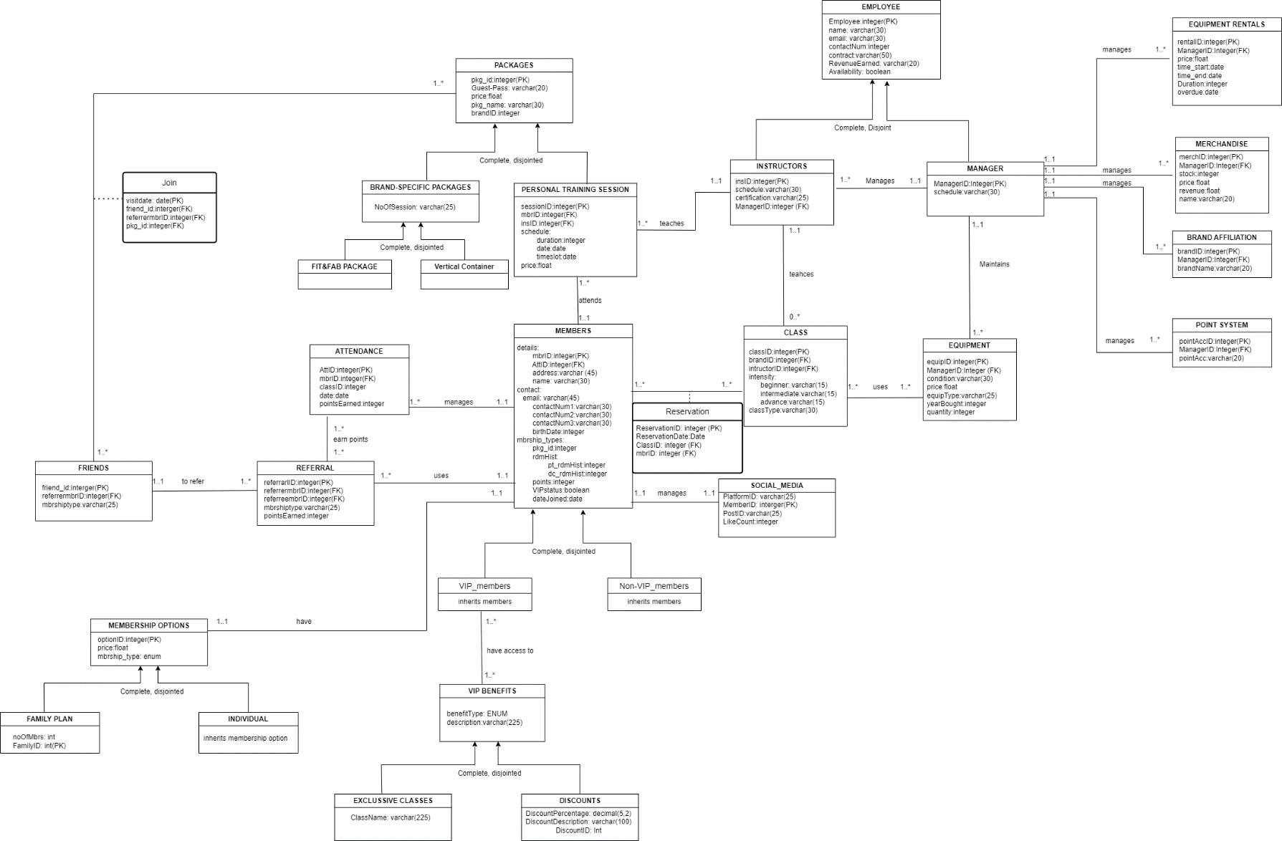
Figure 3.2.1 Physical Model

  - ENHANCED ENTITY-RELATIONSHIP DIAGRAM(EER)

Capture the intricate relationships between entities and consider the concept of inheritance for brand specific packages ：

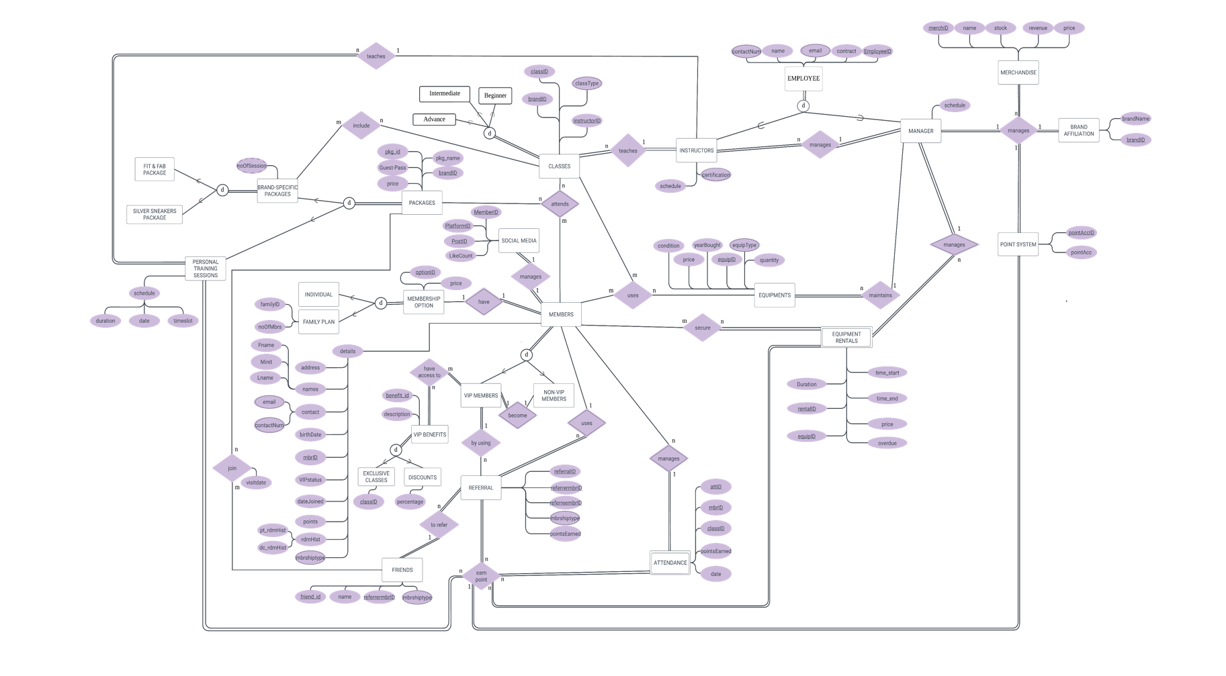
Figure 3.3.1 EER
- DEPLOYMENT
Implementation: create database, tables and populate the data (each table should have 20+ rows of valid records if it’s applicable). This may not be applicable for all table but ensure that the sample data reflects the complex membership structure, package options, and "Bring a Friend" program. Ensure data across tables is consistent and adheres to the defined rules. Member and class tables should have at least 30 records.

  - CREATE DATABASE
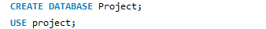
Figure 4.1.1 create database
  - CREATE TABLE FOR MEMBERS
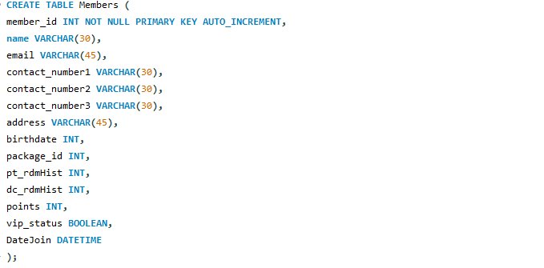
Figure 4.2.1 create table members

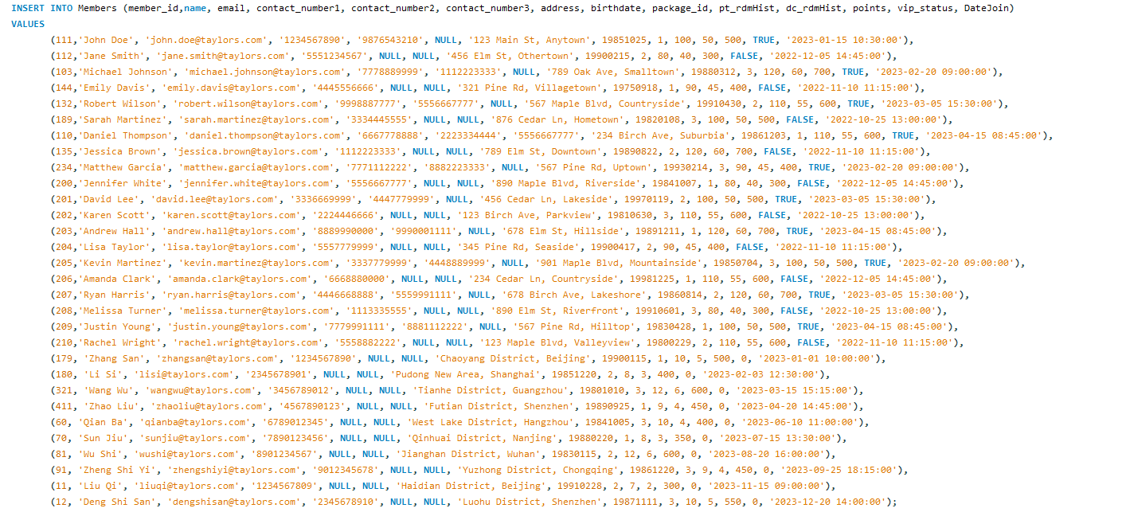
Figure 4.2.2 insert into members
Figure 4.2.3 the output of table members

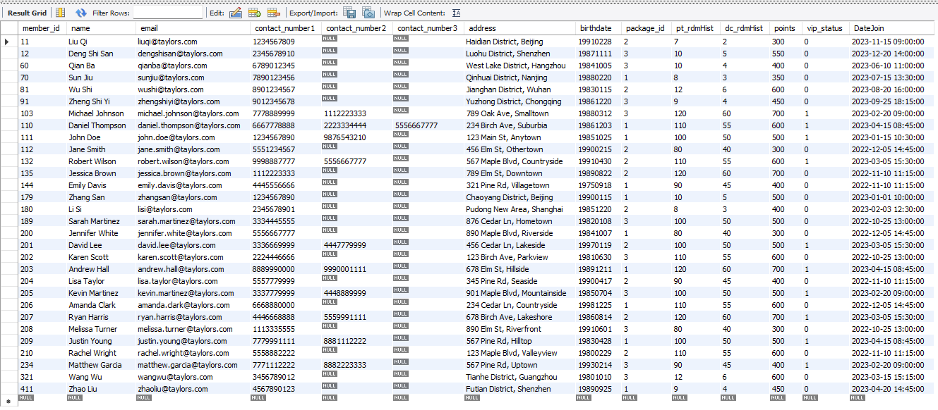

  - CREATE TABLE FOR
  - CREATE TABLE FOR FRIENDS
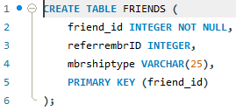
Figure 4.4.1 create table friends
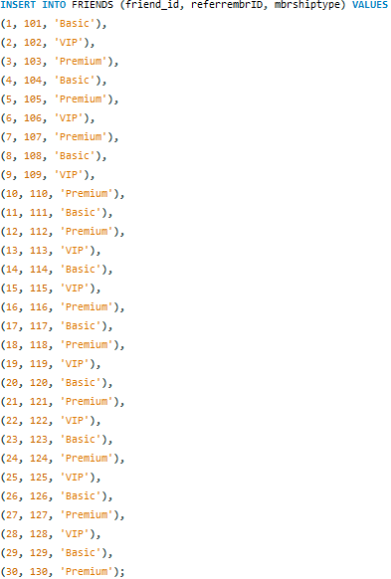
Figure 4.4.2 insert into friends
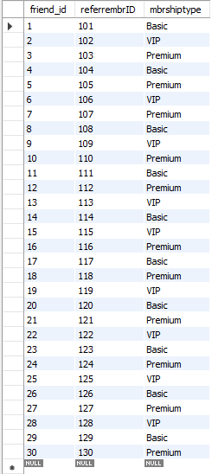
Figure 4.4.3 the output of table friends
4.5 CREATE TABLE FOR REFERRAL
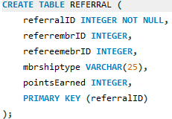
Figure 4.5.1 create table referral
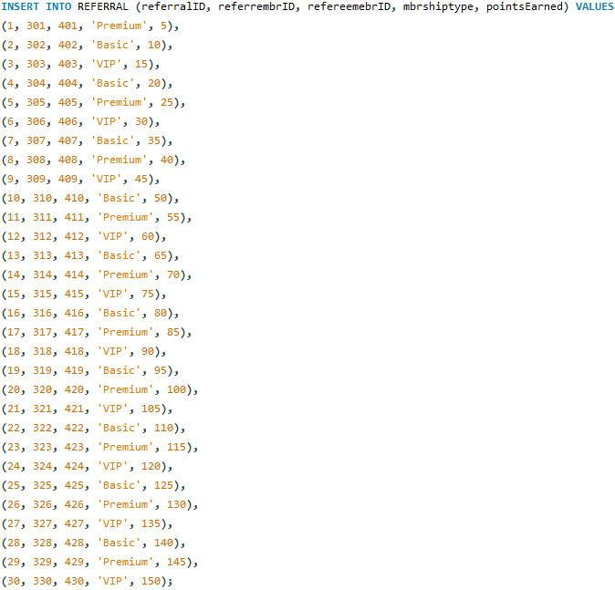
Figure 4.5.2 insert into referral
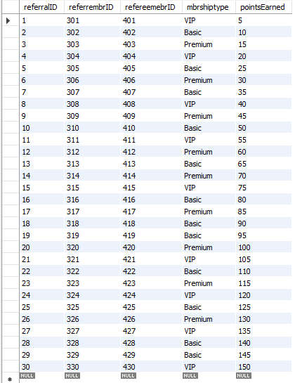
Figure 4.5.3 the output of table referral
4.6 CREATE TABLE FOR ATTENDANCE
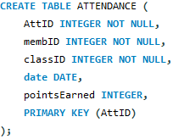
Figure 4.6.1 create table attendance
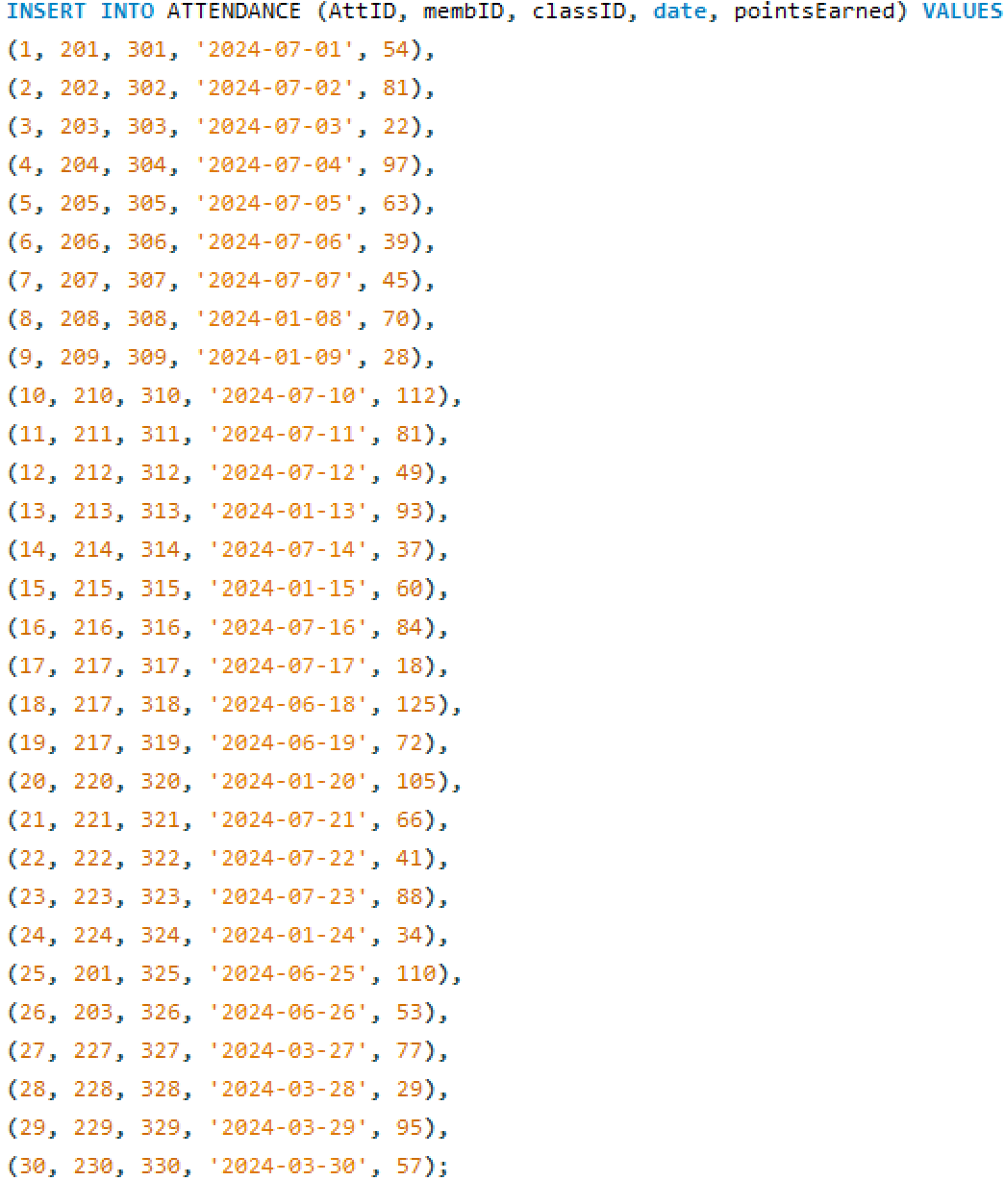
Figure 4.6.2 insert into attendance
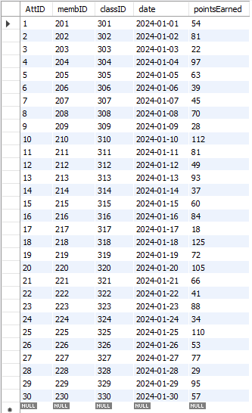
Figure 4.6.3 the output of table attendance

8.0 conclusion and self-reflection
9.0 reference list
- Database Star: A Guide to the Entity Relationship Diagram (ERD)
https://www.databasestar.com/entity-relationship-diagram/ (December 21, 2023)
- GoodData: Physical Data Model vs. Logical Data Model
https://www.gooddata.com/blog/physical-vs-logical-data-model/ (March 7, 2023)
- CNN: Dozens killed in Kenya as weeks of heavy rain devastate region
https://edition.cnn.com/2024/04/29/africa/kenya-floods-mai-mahiu-intl-hnk/index.html (April 29, 2024)
- GeeksforGeeks: Enhanced ER Model
https://www.geeksforgeeks.org/enhanced-er-model/ (March 15, 2023)
- W3Schools: SQL Tutorial
https://www.w3schools.com/sql/default.asp (n.d.)
- Lucidchart: Database Structure and Design Tutorial
https://www.lucidchart.com/pages/database-diagram/database-design (n.d.)

The unexpected construction work has resulted in a reduction of available room in the fitness centre. Due to the limited workout area and space in the fitness centre, the cancellation of classes and decrease in the use of facilities subsequently resulted in a significant decrease in revenue for the fitness centre. The gym is considering to offer outdoor fitness bookcamp sessions as a temporarily measure to solve the issue. Hence, modications have to be made to the database for better management of the situation.
First and foremost, existing tables such as members table and class table have to be modified. In order to increase the gym’s understanding of its customers, an attribute for “member preferred class type” can be added into the members table, so that it develops a clearer comprehension of its members’ preferred type of indoor or outdoor activities, which facilitates the decsion process for offering an activity that is favourable amongst the members. Moreover, an additional attribute for including the emergency contacts of the members can be added into the members table as well. As exercising outdoors increases the risks of encountering unforeseen hazards and conditions, an “emergency contacts” attribute is advised to be added for safety purposes.
In the class table, attributes that specify the location and location description of the classes can be added accordingly as well. As opposed to indoor activities, outdoor activities are often held at locations that some members might be unfamiliar with, making them feel skeptical towards the environment and condition of the chosen location. Hence, the “location description” attribute can provide the members with more insight into the type of condtion and level of danger of the designated venue before they sign up for the class, while the “location” attribute can help locate the site.
In addition, a weather table consisting of attributes “weather conditions” and “equipmentID” are needed as well. Weather conditions contribute significantly to the availability of the location and activity as it might have an impact on the risks and safety of performing an activity at the venue. According to a news article, “Dozens killed in Kenya as weeks of heavy rain devastate region”, published on CNN World, the flood crisis in Kenya has severely damaged the housing area and causing at least 71 lives. Hence, weather condition plays a significant role to prevent devastating events from occuring. The severity of the weather condition has to be assessed where the “weather conditions” column records the weather on each class, while the “equipment needed” column can record the tools needed for conducting the outdoor sessions.
In conclusion, potential database modifications and additional data capture requirements are provided as considerations to be imposed on the fitness management system when offering outdoor fitness bootcamp sessions. According to the suggestions listed above, it is recommended to create a new table and field to include the specifics about the outdoor sessions such as class location and equipment. Additionally, data capture requirements such as weather and safety compliance are also important because they can directly determine the overall availability of conducting the outdoor sessions. These modifications can assist the fitness management system in efficiently managing the new outdoor fitness bootcamp sessions, while providing high quality service to the gym’s customers.

DATABASE SYSTEMS
ITS62904
Assignment – Group
Marking Rubrics (April 2024)
Criteria | Score
 | Excellent | Good | Average | Poor
 | >= 90% of the marks | < 90% to  >= 75% of the marks | < 75% to  >= 40% of the marks | < 40% of the marks
A. Database design (ERD,  Physical  Model and EER) | Both ERD, EER and  Physical models are designed and drawn accurately. All the relationships are considered and highlighted properly. All the primary and foreign keys are defined and linked correctly. Necessary information for the physical model is provided sufficiently. The similarity is less than 2%. | Both ERD, EER  and  Physical models are designed and drawn accurately. Most of the relationships are considered and highlighted properly. All the primary and foreign  keys are defined and  linked correctly. Necessary information for the physical model is provided acceptably. The similarity is less than 4%. | Both ERD, EER and  Physical models are designed and drawn with minor mistakes. Some of the relationship are considered and highlighted properly. Some the  primary and  foreign keys are defined and linked correctly. Necessary information for the physical model is provided acceptably or the information is missing. The similarity is less than 4%. | Both ERD, EER and Physical models having major mistakes or any of them is missing. A few of the relationships are considered and highlighted. Rarely the primary and foreign keys are defined and linked correctly. Necessary information for the physical model is missing. The similarity is more than 5%.
B. Database deployment | The deployment is done with no error. All the tables having a sufficient number or records.  The similarity is less than 2%. | The deployment is done with minor errors. Most of the tables having a sufficient number or records. The  similarity is less than 4%. | The deployment is done with Major errors OR only a few of the tables having a sufficient number or records. The similarity is less than 4%. | The deployment is done with Major errors AND only a few of the tables having a sufficient number or records. The similarity is more than 5%.
C. SQL Report | All the SQL script are accurate with no error and the results  are demonstrated.  The similarity is less than 2%. | Most of the SQL script are accurate  with no error and the results are demonstrated. The similarity is less than 4%. | Some of the SQL script are accurate with no error and the results are demonstrated with minor errors. The | Only a few of the SQL script are accurate with no error and the results are demonstrated with major errors. The similarity is more than 5%.
D.Analysing database structure and designing useful reports | All the SQL script are accurate with no error and the results are  demonstrated. The similarity is less than 2%. | Most of the SQL script are accurate with no error and  the results are  demonstrated. The similarity is less than 4%. | Some of the SQL script are accurate with no error and the results are demonstrated with minor errors. The similarity is less than 4%. | Only a few of the SQL script are accurate with no error and the results are demonstrated with major errors. The similarity is more than 5%.
E. Handling with unforeseen challenges and video presentation | Explanation and video are detailed and valid with relevant samples. The similarity is less than 2%. | Explanation and video are detailed and valid with samples but not very relevant. The similarity is less than 4%. | Explanation and video are available with samples but not very relevant. The similarity is less than 4%. | The explanation and video are not detail and valid. It’s without relevant examples. The similarity is more than 5%.

**************************END OF QUESTION***************************************

