1. Test Strategy

https://cdn2.hubspot.net/hubfs/2912187/Leapwork_FactSheet-TestAutomationStrategy-v2.pdf

1. Automation Plan
2. Git Project - Skeleton
3. Manage Git Proj

<https://github.com/features/project-management/>

-----------------------------

**THE INTERNET HEROKUAPP AUTOMATION TEST PLAN**

1. **OVERVIEW**

The Internet HerokuApp is an example application that captures prominent and ugly functionality found on the web. Perfect for writing automated acceptance tests against.

Deployed and available at [http://the-internet.herokuapp.com](http://the-internet.herokuapp.com/).

1. **SCOPE OF AUTOMATION**

The automation is to be done on all example features that are shown in Homepage.

|  |  |  |
| --- | --- | --- |
| [A/B Testing](http://the-internet.herokuapp.com/abtest) | [Exit Intent](http://the-internet.herokuapp.com/exit_intent) | [Key Presses](http://the-internet.herokuapp.com/key_presses) |
| [Add/Remove Elements](http://the-internet.herokuapp.com/add_remove_elements/) | [File Download](http://the-internet.herokuapp.com/download) | [Large & Deep DOM](http://the-internet.herokuapp.com/large) |
| [Basic Auth](http://the-internet.herokuapp.com/basic_auth) (user and pass: admin) | [File Upload](http://the-internet.herokuapp.com/upload) | [Multiple Windows](http://the-internet.herokuapp.com/windows) |
| [Broken Images](http://the-internet.herokuapp.com/broken_images) | [Floating Menu](http://the-internet.herokuapp.com/floating_menu) | [Nested Frames](http://the-internet.herokuapp.com/nested_frames) |
| [Challenging DOM](http://the-internet.herokuapp.com/challenging_dom) | [Forgot Password](http://the-internet.herokuapp.com/forgot_password) | [Notification Messages](http://the-internet.herokuapp.com/notification_message) |
| [Checkboxes](http://the-internet.herokuapp.com/checkboxes) | [Form Authentication](http://the-internet.herokuapp.com/login) | [Redirect Link](http://the-internet.herokuapp.com/redirector) |
| [Context Menu](http://the-internet.herokuapp.com/context_menu) | [Frames](http://the-internet.herokuapp.com/frames) | [Secure File Download](http://the-internet.herokuapp.com/download_secure) |
| [Digest Authentication](http://the-internet.herokuapp.com/digest_auth) (user and pass: admin) | [Geolocation](http://the-internet.herokuapp.com/geolocation) | [Shadow DOM](http://the-internet.herokuapp.com/shadowdom) |
| [Disappearing Elements](http://the-internet.herokuapp.com/disappearing_elements) | [Horizontal Slider](http://the-internet.herokuapp.com/horizontal_slider) | [Shifting Content](http://the-internet.herokuapp.com/shifting_content) |
| [Drag and Drop](http://the-internet.herokuapp.com/drag_and_drop) | [Hovers](http://the-internet.herokuapp.com/hovers) | [Slow Resources](http://the-internet.herokuapp.com/slow) |
| [Dropdown](http://the-internet.herokuapp.com/dropdown) | [Infinite Scroll](http://the-internet.herokuapp.com/infinite_scroll) | [Sortable Data Tables](http://the-internet.herokuapp.com/tables) |
| [Dynamic Content](http://the-internet.herokuapp.com/dynamic_content) | [Inputs](http://the-internet.herokuapp.com/inputs) | [Status Codes](http://the-internet.herokuapp.com/status_codes) |
| [Dynamic Controls](http://the-internet.herokuapp.com/dynamic_controls) | [JQuery UI Menus](http://the-internet.herokuapp.com/jqueryui/menu) | [Typos](http://the-internet.herokuapp.com/typos) |
| [Dynamic Loading](http://the-internet.herokuapp.com/dynamic_loading) | [JavaScript Alerts](http://the-internet.herokuapp.com/javascript_alerts) | [WYSIWYG Editor](http://the-internet.herokuapp.com/tinymce) |
| [Entry Ad](http://the-internet.herokuapp.com/entry_ad) | [JavaScript onload event error](http://the-internet.herokuapp.com/javascript_error) |  |

**2.1. Resources Allocation**

No. of Resources - 2

Nhien - Automation Test Lead

Lien Ngo - Automation Engineer

Thuong Le - Automation Engineer

Platforms & Devices

Win 10, Mac OS

iOS Devices, Android Devices.

**2.2. Timeline**

No. of Features to be implemented - 44 Example Features.

Release Planning - Every 3 Sprints (6 Weeks)

* Start Date - End Date: **01/11/2020 - 31/01/2021**
* Phases
  + Initial Phase
  + Alpha 1 - Features in 1st columns.
  + Alpha 2 - Features in 2nd columns.
  + Alpha 3 - Features in 3rd columns.
  + Beta - Full Regression on all implemented features
* Entry/Exit Criteria
  + Initial Phase - Documents (Automation Test Plan, Requirement Documents, etc.) are in place.
  + Alpha Phases
    - Entry - Initial Phase is done.
    - Exit when all tasks under user stories for intended features are done.
  + Beta
    - Entry - All Features in Alpha are implemented.
    - Exit when a full regression with pass rate is more than 98% without high priority test cases (P1 and P2) to be failure.

Sprint Release - Every 2 Weeks

* No. of Sprints - **9 Sprints/18 Weeks**
* No. of Features to be implemented for each Sprint - **5 Example Features**.
* Activities in Sprint  
    
  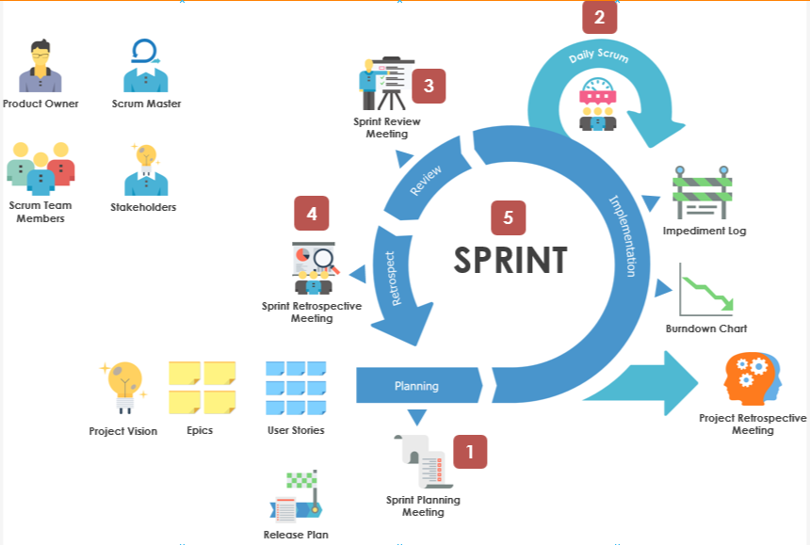

**2.3. Automation/Manual Scope**

* Automation is to cover 80% of testing, focus on:
  + High Priority test cases (P1 + P2, and P3 if required)
  + Repetition steps and take time to run the manual.
* Manual is to cover 20% of testing for:
  + Features are not stable, frequently failed by automation tests (>50% fail over run times).
  + The requirement keeps changing.
  + Test cases with low priority (P4 + P5).

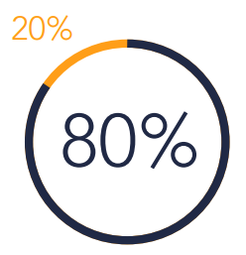

1. **TEST AUTOMATION APPROACH**

Processes

When test case will develop in Sprint

Which feature will be tested by manual

Technology

Roles

* Automation Lead/Engineer  
  Test Case Designer
* Test Manager  
  Quality Analyst

Reusability of scripts - Process to reuse script, how/where to store these script  
Include manual testing

Release control

1. **RISKS ANALYSIS**

Description

Severity  
Probability

Mitigation

Estimate (cost)

1. **TEST AUTOMATION ENVIRONMENT**

identify the req. of test environment

Acquire required tools with licenses

Consider test data req.s

1. Executing & management of test cases  
   Define the process (Day to day tasks, automation procedures)  
   Try to make test cases resistant to changes  
   Use Pipeline (Jenkins, TFS)  
   After excuting assign status “Pass or Fail”  
   6. Failure Analysis & Reporting results  
   Environment Issues, Bug in scripts, Application bug  
   Document the results, analysis and recomendations  
     
   6. AUTOMATION MATURITY MODEL

initial Phase  
Managed Phase

Define Phase  
Measured Phase - Analyse metric

Optimize Phase

1. **EXECUTION PLAN**
2. **RELEASE CONTROL**
3. **FAILURE ANALYSIS**

How different errors are handled?

* Environment issues **=>** Raise a ticket with the DevOps team.
* A bug in the application under test **=>** Flag a bug for Development.
* A bug in the automation scripts **=>** Create a task for the test team.