# J2EE中web.xml配置文件详解

<http://blog.csdn.net/zhangliangzi/article/details/50651128>

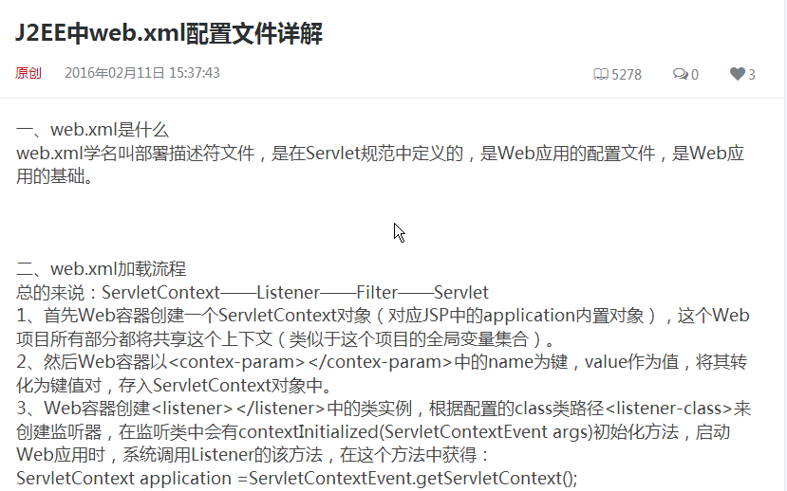

gg